

LEADER OVERVIEW

Volume Overview—My Savior
In these sessions, kids will hear about the importance of serving others. Jesus provided the perfect example at the Last Supper and on the Cross. This is an opportunity for kids to respond to God’s offer of salvation and realize their purpose here on earth—to share Jesus with those around them.

SESSION 1: The Last Supper—John 13:1–17  Faith Fact: Jesus shows me how to live. | SESSION 2: The Crucifixion—Luke 23:32–49  Faith Fact: Jesus is my Savior.
SESSION 3: The Resurrection—Luke 24:1–12  Faith Fact: Jesus defeated death. | SESSION 4: The Great Commission—  Matthew 28:16–20; Acts 1:3–11  Faith Fact: With Jesus, I can change the world.

SESSION OVERVIEW

In this session, we are studying the Great Commission. Kids will learn about their purpose here on earth—to be a light to those around them, sharing Jesus with those they come in contact with.

Bible Lesson | Faith Fact
The Great Commission  Matthew 28:16–20; Acts 1:3–11 | With Jesus, I can change the world.
Faith Verse
Romans 5:8 (NLT)
But God showed his great love for us by sending Christ to die for us
while we were still sinners.

Listen Kids is part of an entire kids’ discipleship strategy. Get access at KidminRoadmap.com.
PREPARING FOR THE SESSION
You Will Need | Getting Ready
Large Group  - Bible  - Worship songs (Song suggestions: “All of Me” by Gateway Kids Worship; “Deep Cries Out” by Bethel Music Kids; “More Like Jesus” by Passion)  - Paper, one sheet per kid  - Pencils or pens, one per kid  - For groups not using a phone or tablet only, add:  - Projector or TV  - Laptop  - Countdown 5-Minute Video  - Theme Intro Video  - Faith Fact Slide or Motion Graphic  - Game Time Slide or Motion Graphic  - Bible Lesson Slides 1–3  - Bible Lesson Video A  - Bible Lesson Video B  - Faith Verse Video or Slide  Small Group  - Inflatable globe ball or beach ball drawn to look like a globe  - Black permanent marker  - Bibles, one per kid  - Small Group Faith Verse Review, one or more as needed  - Scissors  - Small Group Activity Page, one per kid  - Markers or colored pencils | Large Group  - Download videos and slides if needed.  - Selet worship song(s) and have them ready to play.  Small Group  - Print the Small Group Faith Verse Review, one or more as needed.  - Cut apart the Faith Verse segments.  - Inflate ball. If needed, use the black marker to draw the continents on the beach ball to resemble a globe.  - Print the Small Group Activity Page, one per kid plus an extra.  - Create a sample map on the Small Group Activity Page.
Check out all the promotional and extra media files available for this theme. To access the Bible Engagement Project from a computer, visit App.BibleEngagementProject.com.

LARGE GROUP (30 Minutes)
See what’s needed at the beginning of the session.

INTRODUCTION
- Optional: Play the Countdown 5-Minute Video.



Welcome

Welcome! This is going to be a fun day as we talk about how each one of us can make a difference in this world. We’ve already talked about how Jesus died for us and then defeated death. Because Jesus did those things for us, we have the opportunity to live forever with Him. But before we do that, Jesus wants us to tell others about Him here on earth. I can’t wait to get started! Let’s watch this video, and then we’ll discover what comes next.
- Play Theme Intro Video.

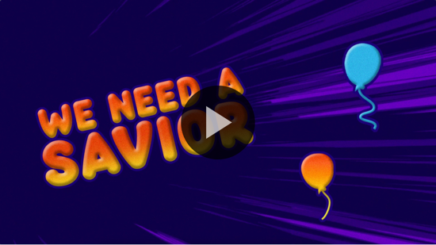

As we begin, I have a question. Who has ever traveled away from home? (Allow responses.) Who has gone on a road trip? (Allow responses.) Has anyone ever traveled on a bus or train? (Allow responses.) How about an airplane? (Allow responses.) What is the farthest away you have gone? (Allow responses.)

Today, we are going to hear that Jesus wants us to help spread the good news about Him all over the world. Wherever we go, we should tell people about Jesus every chance we get. Today, we are learning that: With Jesus, I can change the world.

Faith Fact
- Show the Faith Fact Slide or Motion Graphic.

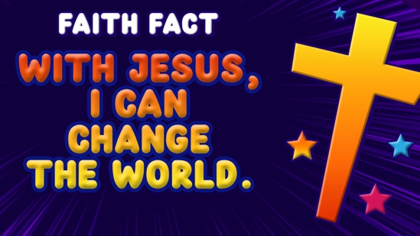

That’s our Faith Fact for today. Let’s say it all together. With Jesus, I can change the world. Let’s say it one more time, but this time let’s act like we are flying like an airplane around the world. With Jesus, I can change the world. Great job!

GAME | Red Light, Green Light
You Will Need | Getting Ready
No supplies are needed for this activity. | No prep is needed for this activity.

- Show the Game Time Slide or Motion Graphic.


Since we are learning today about making a difference wherever we go, we’re going to play Red Light, Green Light. Does everyone know how to play? (Group response) I will be the first one to give directions.

Red light means you stop. Yellow light means you can go slow. Green light means go. The catch is I have to keep my eyes closed the entire time. If you don’t obey the traffic rules, you have to go back and start over.

Everybody needs to line up on this side of the room (point) and I’ll stand on the opposite side. The first one to reach me wins. Are you ready to begin?
- Play a couple of rounds so several kids have a turn to be the leader.

Later, we will hear how Jesus instructed His disciples to go into the world and tell people about Him. He wants us to do the same. First, let’s take some time to worship by singing.

WORSHIP

There are lots of ways to worship God. I love to sing when I worship. Let’s worship Him together with singing.
- Lead the kids in singing one or two praise songs. See suggestions at the beginning of the session.

BIBLE LESSON | The Great Commission (Matthew 28:16–20; Acts 1:3–11)

I love worshipping God, and I know He loves it when we sing to Him like that. Let’s bow our heads and pray together.

Prayer

Dear God, thank You for loving us. Thank You for forgiving our sins and saving us from the punishment our sins deserve. You’ve given us the opportunity to tell others about that love. Teach us today from Your Word. Amen.

Video Intro

We have a lot to do today, but before we get started with the Bible story, let’s check in with the Challenge Accepted team and see what they’re up to. I’ve got a feeling that they’re going to do another crazy challenge!
- Play Bible Lesson Video A.

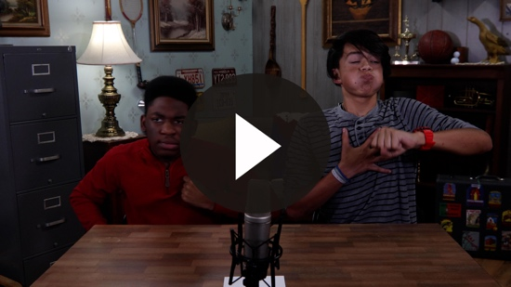

That was incredible! Would you attempt that challenge? (Group response) Now, let’s get into our Bible story for today.

Teaching Time

We have learned so much over the last couple of sessions about the last few days of Jesus’ life here on earth. Do you remember the Last Supper when Jesus washed His disciples’ feet? Then, we heard about Jesus dying on the Cross and coming back to life, which is the Resurrection.

Who remembers the first thing that happened after the women found the empty tomb? (Allow responses.) That’s right! They told the disciples about it, but they didn’t really believe the women. In fact, Peter had to check it out himself.
- Show the Bible Lesson Slide 1.

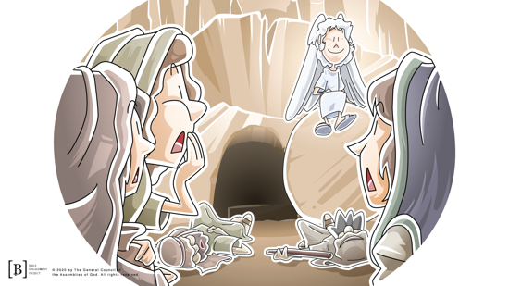

Soon after that, Jesus appeared to His disciples while they were in a room behind a locked door. He appeared to other followers, and some of them doubted it was really Him. Jesus not only had to convince them that He was really alive, but He also had to get them ready to change the world.
- Show the Bible Lesson Slide 2.

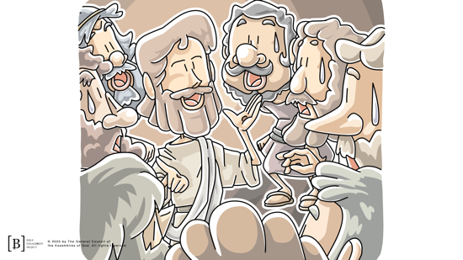

If you have your Bible, go ahead and open it. We will be in two Bible books today—Acts and Matthew. We’re going to start with Acts 1:3. Acts is the fifth book in the New Testament.

After His resurrection, what kinds of things do you think Jesus talked about with His disciples? (Allow responses.) Do you think they just talked about their sandals or what they bought in the market that day? (Group response) No, Jesus talked to His followers about how they were going to change the world. Look what Jesus told them.
- Read Acts 1:3.

Now turn to Matthew 28:19. Matthew is the very first book in the New Testament. Let’s see what Jesus said. If the words are red in your Bible, that means these are words that Jesus said.
- Read Matthew 28:19–20.

We often call this command of Jesus the Great Commission. Jesus told His disciples to do three things. Everyone hold up your pointer finger. (Pause for kids to hold up a pointer finger.) First, Jesus told them to go and make disciples. He wanted them to tell others the good news about Him so those people could have a relationship with Him and receive God’s forgiveness for their sins.

Now, hold up two fingers. (Pause for kids to hold up two fingers.) Next, they were to baptize the new disciples. Water baptism is a symbol to announce to the world their commitment to God.

Finally, let’s hold up three fingers. (Pause for kids to hold up three fingers.) Then, Jesus told them to teach others what they had been taught. Part of being a disciple is learning about God. This is why we read our Bible and go to church. Another part of being a disciple is telling others what we have learned.

Well, that seems like kind of a hard thing. I mean these were the disciples who ran away from Jesus’ side when He was arrested. How were they ever going to do what Jesus wanted? It’s a good thing that God’s plans are greater than ours. Now we’re going to jump back over to the Book of Acts.
- Read Acts 1:4–5.

Jesus told them that there would also be another kind of baptism. The disciples had seen Jesus being baptized in water. Now, Jesus said there was going to be another different baptism. Let’s read more about the coming of the Holy Spirit.
- Read Acts 1:8.

This is a really important verse. I know that God’s Holy Spirit comforts me and gives me peace. I know the Holy Spirit gives me wisdom. In the Old Testament, the Holy Spirit would help some people to do great things. Here, Jesus is saying that the Holy Spirit is going to give His followers power to be witnesses. They are going to receive a boldness to tell others about Jesus.

He takes it a step farther. It isn’t just about telling the people around you about Jesus. He wants to use us to change the world. He told them to share with the people in Jerusalem, the town they were in, and in Judea, the country they lived in. Then, they were to share in Samaria, which was the neighboring country. Then, Jesus told them to keep going and to go and tell the whole world.

Immediately after He said this, Jesus ascended into heaven. He went into the sky right in front of them. Two angels appeared and told the disciples that Jesus would come back the same way that He had left.
- Show the Bible Lesson Slide 3.

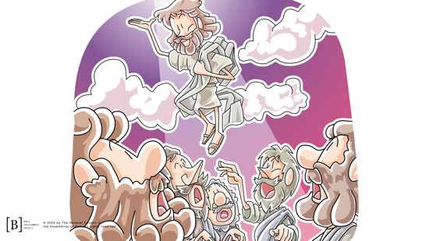

Jesus will return some day! Until He does, we have a job to do and a world that needs to hear the good news about Jesus. Teaching Time Matthew 28:19–20 is what we call the Great Commission. Jesus told us to share the good news and make disciples of people not only right around us but also all over the world. We do this best with the power of the Holy Spirit that Jesus offered to us. Just like our Faith Fact says, With Jesus, I can change the world.

Jesus had spent about three years teaching His disciples and showing them what it means to be His follower. We can learn the same things by reading our Bible and listening to Bible teaching.

But, Jesus didn’t stop there. He gave them instructions to wait for God to send the Holy Spirit with special power to help them follow Jesus’ instructions. Later in the Book of Acts, we see that the Holy Spirit came and baptized these same disciples. Then they obeyed Jesus’ command, and they went to tell others the good news about Jesus. Their obedience would change the world forever. They shared with the people around them. They went to Judea, Samaria, and all over the world and told people about Jesus.

Jesus’ command hasn’t changed. You and I have the same responsibility. It is our job to share about Jesus with others—to tell people about Jesus so they can be forgiven for their sins, be saved, and be baptized. Then, we are to teach them what the Bible says, just like you are hearing today. That’s how our Faith Fact can be true: With Jesus, I can change the world.

Faith Verse
What is it that we are supposed to share with others? (Allow responses.) You’ve got it—the good news that Jesus died to take the punishment for our sins. That’s why our Faith Verse is so important. It reminds us of why Jesus died for us, which should make us want to share His love with others. Let’s say the Faith Verse and do the actions together.
- Show the Faith Verse Video or Slide.

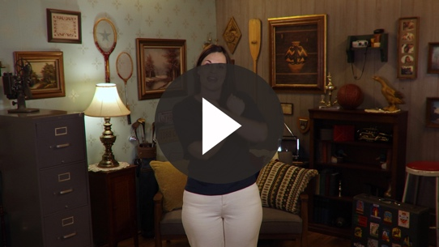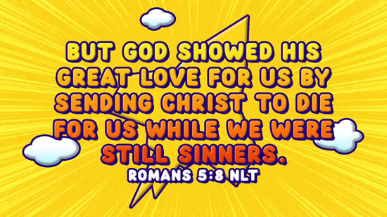

Romans 5:8 (NLT)
But God showed his great love for us by sending Christ to die for us while we were still sinners.

PRAYER AND RESPONSE
You Will Need | Getting Ready
- Paper, one sheet per kid  - Pens or pencils, one per kid | No prep is needed for this activity.

Consider playing a worship song softly in the background while kids pray.

Today, we will ask God to show us through His Holy Spirit someone who needs to hear the good news about Jesus. Here is a sheet of paper and a pencil.

Prayer

Dear God, please talk to us through Your Holy Spirit. Show us people we can share the good news about Jesus with this week. Amen.

Now, quietly listen for the Holy Spirit to speak to you. Write the name or draw the first person you think of. Be sure to only write on one side of the paper.

Like the disciples, some of you may be called to share Jesus with the people in our town or state. God may want you to be a pastor and move to another place to share the good news. God may want some of you to be missionaries and preach in other countries. Some of you will be truck drivers, teachers, stay-at-home parents, dentists, grocery store clerks, or have any kind of work. All of us can tell others about Jesus. Let’s ask God and see what He says.

Prayer

Dear God, what is the place You would like me to tell others about Jesus in the future? I want to obey You. Amen.

Listen to the Holy Spirit and write on the back of your paper whatever the Holy Spirit is saying to you.
- Give kids time to pray. Then introduce the worship song. This could play in the background while kids pray or could be a worship song to sing together.
- Kids may take their paper home if they choose.

Worship Song
Play one or two worship songs.

Video Wrap-Up

That was a great prayer time! I love how you all listened for God’s voice. Now, let’s check back in to see how Challenge Accepted team’s challenge worked out.
• Play Bible Lesson Video B.

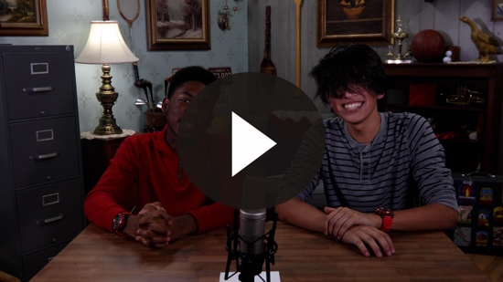

Let’s all choose to obey Jesus’ command and change the world by telling others about Jesus. Sometimes it can be a little scary, but that is why we need to remember our Faith Fact.
- Show the Faith Fact Slide or Motion Graphic.

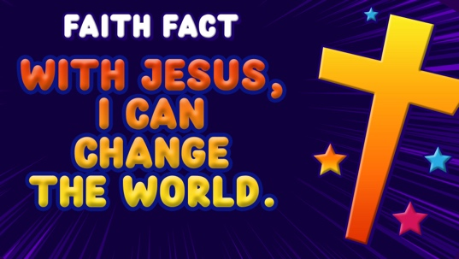

Say it with me. With Jesus, I can change the world. Aren’t you thankful the Holy Spirit helps us in every part of our lives? If you have asked Jesus to forgive your sins and chosen to follow Him, He has given you the Holy Spirit in your life. You can ask Him to baptize you with the Holy Spirit just like the disciples in the Book of Acts. Then you’ll have the Holy Spirit’s power to help you be bold when you tell others about Jesus.

What a great, fun learning time we’ve had! See you soon!
- Dismiss kids to Small Group time or to go home if your group time ends here.

SMALL GROUP (30 Minutes)
This section can be done in conjunction with the large group, or on its own if you do small groups with your kids. During Small Group time, the goal is to connect the kids with the Word of God and to each other. All activities are led by the small group leader.

GROUP CONNECTION | Where in the World?
You Will Need | Getting Ready
- Inflatable globe ball or beach ball drawn to look like a globe  - Black permanent marker | - Inflate ball. If needed, use the marker to draw the continents on the beach ball to resemble a globe.

Today, we discovered that Jesus wants us to be witnesses for Him in our town, state, country, and all over the world. We are going to pass this globe around the circle. When you catch it, you have to say the name of a city, a state, or a country before you can pass it on. Let’s see how creative we can get. I am going to start off with Jerusalem.
- You may need to assist some kids. This is about realizing how big the world really is.
- After a few times going around, try going around one more time and have kids pray for the city, state, or country they name.

BIBLE LESSON RECAP | The Great Commission (Matthew 28:16–20 ; Acts 1:3–11)
You Will Need | Getting Ready
- Bibles, one per kid | No prep is needed for this activity.

We are going to read the instructions that Jesus left for us. Jesus wants us to obey Him so we can change the world. He gave the Holy Spirit to be the Helper who would give us power to be bold. Let’s read about it in Matthew 28:18–20 and Acts 1:1–12.
- Divide the Bible reading into smaller chunks for kids to read aloud if needed.

There is so much in these verses. We can see that Jesus was truly alive. We read the mission that Jesus has for you and me. We found out He sent the Holy Spirit to help us accomplish this mission. It all comes together with a promise that He will return someday.

Faith Fact

Now that I know Jesus has given me a mission, I need to remember our Faith Fact for today.
- Show the Faith Fact Slide or Motion Graphic.

Let’s say it again together. With Jesus, I can change the world.

GROUP DISCUSSION

Feel free to use all or just a few questions as a jumping-off place for good discussion. Questions marked with * are designed for more conversation. Adjust the questions based on the age or maturity of your group. Typically, older kids will be able to dive a little deeper than younger ones.

Questions

What does our Faith Fact mean to you? How can you change the world?

Why do you think Jesus had to convince His followers that He was really alive? What are some of the ways that He was able to convince them?

What kinds of things did Jesus do during His ministry here on earth? Can we do those kinds of things also?

What is the Great Commission?

Jesus taught His disciples in Matthew to go do three things. What are they? How is our church doing those things today?

Jesus told His disciples that they would receive a new kind of power. Who was that power? What was the power going to be able to help them do?

Jesus told His disciples to go to several places—Jerusalem, Judea, Samaria, and the whole world. How can we fulfill this part of the Great Commission?

* What does it mean to be a witness? How can you share the good news with other people?

Can you receive the power of the Holy Spirit? How can we receive His power?

APPLICATION AND RESPONSE

Jesus was given all authority to change the world. He then commissioned the disciples, His followers, and us to go and change the world. We do that through sharing the good news, helping people to begin a relationship with God, and teaching them God’s Word.

But we can’t do it on our own. We need the help of the Holy Spirit to give us the power to be His witnesses. Thankfully, Jesus sent the Holy Spirit for us today.

Make It a Habit
Select a simple visual reminder of the session’s Faith Fact

Today’s Faith Fact is kind of a long one, so we can learn actions to help us remember it.

With Jesus,: Point to heaven because that is where Jesus is right now.

I can: Point to yourself with your thumbs, one thumb for each word.

change: Put your hands together and move them like you are molding clay.

the world: Make a giant circle with both hands in front of you.

Let’s practice this a couple of times. When you go home today, your job is to teach this to your family.
- Repeat as many times as needed and time allows.

Prayer
Let’s pray and ask Jesus to help us.

Jesus, thank You for giving us a job to do in the Great Commission to change the world. Thank You for sending the Holy Spirit who helps us and gives us power to be witnesses. Help me not to forget that with You, I can change the world. Amen.

FAITH VERSE REVIEW
You Will Need | Getting Ready
- Faith Verse Review, one or more as needed  - Scissors | - Print the Faith Verse Review, one or more as needed.  - Cut apart the Faith Verse segments.

Our Faith Verse is Romans 5:8. This is a very important verse to memorize, so let’s say the Faith Verse and do the actions for the verse together.
- Show the Faith Verse Video or Slide.

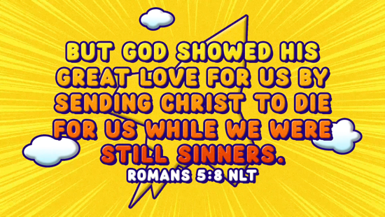

Romans 5:8 (NLT)
But God showed his great love for us by sending Christ to die for us while we were still sinners.

Faith Verse Fun | Pop-Up Verse

You did a great job reviewing the Faith Verse. We are going to do an activity now where each of you will be given words from the Faith Verse on a piece of paper. As we say the Faith Verse together, jump to your feet when your words are said. Then quickly sit down. We are going to do it a couple of times to see how fast we can do it.
- Say the verse. If time permits, mix up the paper slips and redistribute to play again.

Hey! You kids have really got this Faith Verse down! Excellent work!

ACTIVITY PAGE | My World
You Will Need | Getting Ready
- Activity Page, one per kid plus an extra  - Markers or colored pencils | - Print copies of the Activity Page, one per kid plus an extra.  - Create a sample map on the extra Activity Page.

On your Activity Page, you will see a big box in the middle. I want you to create a map of your community. Draw your church, home, and where you go to school. Include places you enjoy going to. Here is what I drew. (Show your sample.) It doesn’t have to be perfect; just have fun with it!
- On your map, include places you visit, such as church, home, grocery store, etc.
- Don’t worry about it being accurate. The goal is for them to see they can impact more than where their physical church is.

Now, I want you to circle a couple of places where you see people and may have the opportunity to share the good news about Jesus with them. Remember our Faith Fact: With Jesus, I can change the world.

Prayer

Dear God, please help us to make a difference in the world. We want to see lives changed for You, not only here at church but also everywhere we go. Help us to be bold witnesses for You. Amen.

FAITH FACT RECAP
- Display the Faith Fact Slide or Motion Graphic as parents are coming into the room.
- Maximize the time you have with your kids, so that parents see what their kids have learned. Have the kids repeat the Faith Fact, and then dismiss them to their parents.

Today as you go home, let’s remember our Faith Fact. It’s one of the most important things that we talked about today.

This is the answer to the question your adults are going to ask: “What did you learn today?” Let’s say the Faith Fact together: With Jesus, I can change the world.

DISMISSAL
- Send home the Activity Page and the Prayer and Response paper.
- Remind parents that there are Family Devotions available on the app to do with their kid.
- Tell everyone the date and time for the next session.

