

LEADER OVERVIEW

Volume Overview—My Savior
In these sessions, kids will hear about the importance of serving others. Jesus provided the perfect example at the Last Supper and on the Cross. This is an opportunity for kids to respond to God’s offer of salvation and realize their purpose here on earth—to share Jesus with those around them.

SESSION 1: The Last Supper—John 13:1–17  Faith Fact: Jesus shows me how to live. | SESSION 2: The Crucifixion—Luke 23:32–49  Faith Fact: Jesus is my Savior.
SESSION 3: The Resurrection—Luke 24:1–12  Faith Fact: Jesus defeated death. | SESSION 4: The Great Commission—  Matthew 28:16–20; Acts 1:3–11  Faith Fact: With Jesus, I can change the world.

SESSION OVERVIEW

In this session, we are exploring Jesus’ Resurrection after covering His Crucifixion in the last session. Kids can celebrate that Jesus is alive. There is another opportunity for kids to respond to God’s offer of salvation. There is also the challenge to share the good news with others. As you go through this session, take time to think about the emotions of the people in our story today—fear and excitement. Then, celebrate because Jesus defeated death.

Bible Lesson | Faith Fact
The Resurrection  Luke 24:1–12 | Jesus defeated death.
Faith Verse
Romans 5:8 (NLT)
But God showed his great love for us by sending Christ to die for us
while we were still sinners.

Listen Kids is part of an entire kids’ discipleship strategy. Get access at KidminRoadmap.com.
PREPARING FOR THE SESSION
You Will Need | Getting Ready
Large Group  - Bible  - Worship songs (Song suggestions: “All of Me” by Gateway Kids Worship; “Deep Cries Out” by Bethel Music Kids; “More Like Jesus” by Passion)  - Paper, one sheet per kid  - Pencils or pens, one per kid  - For groups not using a phone or tablet only, add:  - Projector or TV  - Laptop  - Countdown 5-Minute Video  - Theme Intro Video  - Faith Fact Slide or Motion Graphic  - Game Time Slide or Motion Graphic  - Bible Lesson Slides 1–3  - Bible Lesson Video A  - Bible Lesson Video B  - Faith Verse Video or Slide  Small Group  - Bibles, one per kid  - Small Group Activity Page, one per kid  - Markers or colored pencils | Large Group  - Download videos and slides if needed  - Select worship song(s) and have them ready to play.  Small Group  - Print the Small Group Activity Page, one per kid.
Check out all the promotional and extra media files available for this theme. To access the Bible Engagement Project from a computer, visit App.BibleEngagementProject.com.

LARGE GROUP (30 Minutes)
See what’s needed at the beginning of the session.

INTRODUCTION
- Optional: Play the Countdown 5-Minute Video.



Welcome

Welcome! I’m so glad you’re here! We’ve been talking about how Jesus was arrested, convicted at an unfair trial, sentenced to die, and killed. Thankfully, the story doesn’t end there. Let’s watch this video, and then we’ll get started.
- Play Theme Intro Video.



How many of you like playing video games or games on your phone or tablet? (Group response) Have you ever lost when you were out of lives? (Group response) How did it feel? (Group response) Doesn’t it feel good when you die, but are able to come back to life in the game? (Group response)

I wish that we could make that happen in real life anytime we wanted. When a loved one or even a pet dies, don’t you wish that they could come back and be with us forever? (Group response) That just isn’t how it works. However, Jesus changed how death works by doing something really special. Jesus defeated death and came back to life. Today, we are going to talk about one of the most exciting events in the Bible, the Resurrection.

Faith Fact
- Show the Faith Fact Slide or Motion Graphic.



Our Faith Fact today is about Jesus’ Resurrection. When He came back to life, Jesus defeated death. Let’s say it all together. Jesus defeated death. We are going to say it one more time, but this time we are going to say it in our best professional sports announcer’s voice. Jesus defeated death. Great job!

GAME | Resurrection Tag
You Will Need | Getting Ready
No supplies are needed for this activity. | No prep is needed for this activity.

- Show the Game Time Slide or Motion Graphic.


We are going to play a game called Resurrection Tag, which is similar to Freeze Tag. One person will be “It.” When you get tagged, you’re dead, so you drop to the ground and curl up in a ball. If one of the other kids tags you, you come back to life. That is what resurrection means, to come back to life after being dead.
- Play as long as time permits and kids are interested.

That was fun. I laughed watching you drop to the floor and then pop back up. Now, it’s time to get up on our feet and get ready to praise Jesus.

WORSHIP
Raise your hands to the sky with me and repeat this prayer after me. Then we’ll worship together.

Prayer

Dear Jesus, open my heart to hear what You want me to hear today. Help me to listen for Your voice. Amen.
- Lead the kids in singing one or two praise songs. See suggestions at the beginning of the session.

BIBLE LESSON | The Resurrection (Luke 24:1–12)

That was an incredible time of worshipping God by singing! I am so thankful that we get to worship together. We are going to be learning about His love today and the victory we have because of Jesus. We will learn directly from the Bible. (Hold up the Bible.) Before we dive into our Bible story today, let’s bow our heads and pray together.

Prayer

Jesus, thank You for loving me. Thank You for giving Your life for all of us and providing a way for us to have a relationship with God. I love You and praise Your name. Amen.

Video Intro

Do you know what’s next? We need to catch up with our Challenge Accepted friends and see just what they’re doing today. Put your eyes on the screen and check it out.
- Play Bible Lesson Video A.

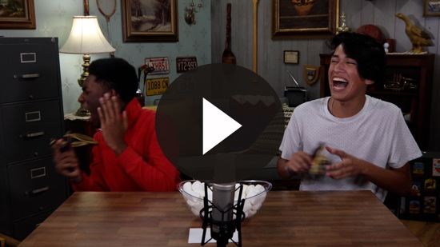

Do you think you could accept the challenge? (Group response) I like marshmallows, but wouldn’t want one in my face. I wonder how that leads in to our Bible story today. I guess we’ll see how it develops.

Teaching Time

Today, we will look at a very important passage of Scripture when it comes to our faith in Jesus. Being a Christian is very special because our Savior, Jesus, died for us even though we did not deserve it. He didn’t stop there. Jesus defeated death and came back to life.

This is a two-part story. Last time, we were in Luke 23 and discovered that Jesus was crucified, or nailed to a cross, between two criminals. Then, He died. Many people who saw Jesus’ death were shocked. People realized there was something different about Jesus.
- Show the Bible Lesson Slide 1.

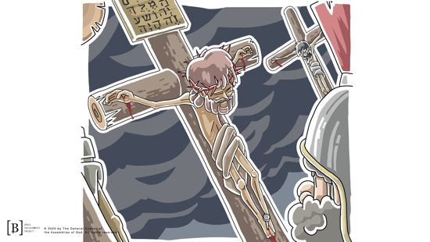
After Jesus died, they took His body and put it in a tomb. A man named Joseph donated his tomb for Jesus’ body. Then he rolled a massive stone in front of the tomb’s opening. The next day, the Jewish leaders asked the Roman leader to post guards at the tomb, so no one could steal the body.
- Show the Bible Lesson Slide 2.

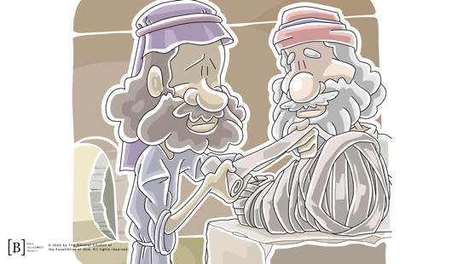

Because of the time of day when Jesus died, the disciples didn’t have time to properly prepare His body for burial before the Sabbath, their day of rest. Jesus’ followers were following the Sabbath rules and not doing any kind of work. Let’s see what happened next.

If you have your Bible with you, turn with me to Luke 24. Luke is the third book in the New Testament. (Hold up the Bible.)
- Read Luke 24:1–4.

What had happened? The rock was moved! The women looked inside, but Jesus’ body was gone! Can you imagine the emotions they must have been feeling? They wanted to know what was going on. Suddenly, two angels appeared. Let’s read what the angels said to them.
- Read Luke 24:5–7.
- Show the Bible Lesson Slide 3.

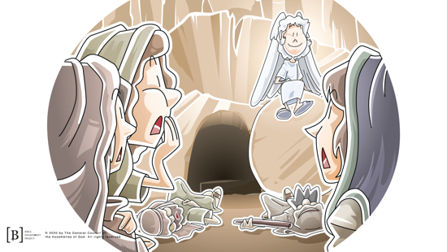

The Bible says the women were terrified and fell to the ground. Jesus was alive! He had defeated death, and the first people to know about it were these women who had followed Jesus.

The angels reminded them that Jesus had predicted He would be betrayed and crucified. They also reminded the women that Jesus had said He would come back to life. Suddenly, they remembered and realized in that moment that Jesus defeated death.

The women hurried back to the disciples. These women were the first people to tell others the good news that Jesus was alive. Sadly, when the disciples heard the report from the women, they couldn’t believe it. Jesus had told them they would not believe He rose from the dead when they first heard the reports.

Finally, Peter ran back to the tomb to see for himself. He looked inside, and you know what Peter found? (Group response) You guessed it; Jesus defeated death. The tomb was empty, and Jesus was alive. Peter didn’t really understand everything that meant yet, but he was starting to!

There have been lots of great leaders throughout history. All those leaders from the past have died, and they have stayed dead—except one. Jesus came to earth for one reason—to provide a way for us to have a relationship with God. Sin separates us from God, and only death could pay the punishment for that sin.

Jesus lived a perfect life. He was crucified even though He did nothing wrong. Then, three days later, the impossible happened. Jesus fulfilled God’s plan by showing that He is more powerful than even death itself. Jesus defeated death. Jesus did not stay in the tomb; He is alive!

That is important for each of us. Jesus died so that we could have eternal life with God. We can have a relationship with God here on earth. The Bible tells us that there is a time for everything and that one day all of us will die. We don’t have to worry about that or be sad about that. You know why? Jesus defeated death. I know that when I die I will be alive with Jesus for all eternity. If you have asked Jesus to forgive your sins and help you make right choices, you will, too. That is exciting!

In a video game, when I die, I have to start the whole level again. But in life, when I die, I level up because of Jesus! I automatically go to the winner level and spend forever with God! I get to do that because Jesus defeated death.

Faith Verse
We are reminded of this in our Faith Verse. Let’s watch the video and do the actions together.
- Show the Faith Verse Video or Slide.

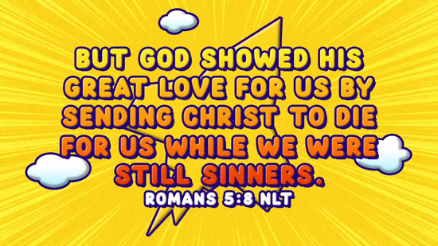

Romans 5:8 (NLT)
But God showed his great love for us by sending Christ to die for us while we were still sinners.

I know I’m not perfect, but Jesus still died for me. That is more love than I could ever understand. Let’s say that verse one more time together. (Pause for kids to repeat the Faith Verse.)

PRAYER AND RESPONSE
You Will Need | Getting Ready
- Paper, one sheet per kid  - Pencils or pens, one per kid | No prep is needed for this activity.

Consider playing a worship song softly in the background while kids pray.

Last time, we talked about where we were at in our relationship with Jesus. We learned that Jesus forgives our sin when we ask because He died for us. Today, I want to make sure that we have all had the opportunity to make that relationship with God.

Here is your paper and pencil. On your paper, draw Jesus’ tomb but leave the center of the tomb empty. This is similar to what the women found when they went to prepare Jesus’ body for burial. The tomb was empty. Why? (Group response)

We know that Jesus defeated death. Maybe you feel empty inside just like the tomb you drew is empty. When we ask Jesus to be our Savior, He defeats that emptiness inside us and fills us with His presence.

If you have prayed for Jesus to forgive your sins, then you already have Jesus in your heart, filling that empty space. If you haven’t, we want to give you the opportunity today to change that.

If you have asked Jesus to forgive your sins or you want to ask Him to forgive you, draw a heart inside your picture of a tomb. This represents God’s love in you. As you draw it, pray and ask Jesus to take the emptiness away and fill you with His love. Jesus loves you so much that He will always answer a prayer for forgiveness.
- Adapt as needed, depending on the age and understanding of your kids.
- Give kids time to pray. Then introduce the worship song. This could play in the background while kids pray or could be a worship song to sing together.
- Kids may take their paper home if they choose.

Worship Song
Play one or two worship songs.

Aren’t you glad for Jesus and His love for us? Now, let’s check in with our Challenge Accepted friends.

Video Wrap-Up

I have got to know how it worked out with the team. Are you ready to see what happened? (Group response) Eyes on the screen.
• Play Bible Lesson Video B.

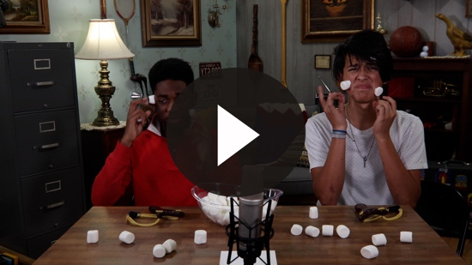

Let’s all accept the challenge that Dash and Austin gave us to thank Jesus for dying in our place and defeating death. Do you think you can do that? (Group response) See you soon!
- If your group time ends here, see the Small Group Faith Fact Recap as a final review of the Faith Fact.
- Dismiss kids to Small Group time or to go home if your group time ends here.

SMALL GROUP (30 Minutes)
This section can be done in conjunction with the large group, or on its own if you do small groups with your kids. During Small Group time, the goal is to connect the kids with the Word of God and to each other. All activities are led by the small group leader.

GROUP CONNECTION | Victorious Endings
You Will Need | Getting Ready
No supplies are needed for this activity. | No prep is needed for this activity.

Today, we learned that Jesus defeated death. That means Jesus is victorious. When I think of that, I think of ways you can win in sports. We are going to do a little trivia challenge. Let’s form teams. I will say the name of a sport and give you multiple choices. Your team selects what is needed to defeat another team in that sport.
- You can choose how many teams to have and the size of the teams.
- Here is the list of sports and the multiple-choice answers. The correct answers are in bold.
- Boxing: A. Touchdown B. Nosedive C. Knockout
- Baseball: A. Tackle B. Home run C. Free throw
- Volleyball: A. Spike B. Knock down C. Hole in one
- Football: A. Slam dunk B. Touchdown C. Home run
- Wrestling: A. Volley B. Fumble C. Pin
- Bowling: A. Par B. Strike C. Grand slam
- Soccer: A. Goal B. Ace C. Double
- Basketball: A. Slide B. Hook shot C. Ace
- Tennis: A. Ace B. Strikeout C. Punt
- Golf: A. Upper cut B. Slider C. Birdie

Now, that was fun!

BIBLE LESSON RECAP | The Resurrection (Luke 24:1–12)
You Will Need | Getting Ready
- Bibles, one per kid | No prep is needed for this activity.

Now, grab your Bible and let’s review our Bible lesson. Remember, our story is from Luke 24.
- Divide the Bible reading into smaller chunks for kids to read aloud if needed.

When someone dies and the body is placed in a tomb, is the body usually still there a few days later? Yes, of course it is. In our Bible story, Jesus’ body was gone. His tomb was empty. Jesus defeated death and rose from the dead.

Faith Fact
- Show the Faith Fact Slide or Motion Graphic.



Jesus isn’t dead; He is alive. That’s why our Faith Fact is so important. Say it with me. Jesus defeated death.

GROUP DISCUSSION

Feel free to use all or just a few questions as a jumping-off place for good discussion. Questions marked with * are designed for more conversation. Adjust the questions based on the age or maturity of your group. Typically, older kids will be able to dive a little deeper than younger ones.

Questions

Today, we read and heard how the impossible happened. What happened to Jesus?

How did Jesus defeat death?

Why did the women go to the tomb on Sunday? What did they see when they got there?

How did the women respond? How would you have responded?

What was the message the two angels gave to the women? Why was that important?

What did the women do after they discovered Jesus was alive?

How did the disciples respond to the news that Jesus was alive?

What did Peter do after hearing that Jesus was alive? What did he discover?

What good news did we hear about today? Do you think that it’s important to tell others that Jesus died and rose again?

* Jesus provides a way for us to have a relationship with God, and Jesus defeated death. How can those facts help you respond the next time you are lonely or afraid?

APPLICATION AND RESPONSE

God desires a relationship with us, but sin gets in the way. Jesus died on the Cross to pay for our sin and fix that relationship, but He didn’t stay dead. Jesus defeated death. Because He is alive, we know that one day we can live in heaven and be even closer to God.

Make It a Habit
Select a simple visual reminder of the session’s Faith Fact

The most popular icon, image, or piece of jewelry for a Christian is a cross. How many of you have a cross in your house? (Group response) Did you ever notice that most of the time there is no one on the cross? Why? (Group response) That’s exactly right. Jesus isn’t on the cross. He is alive. We don’t worship the cross like an idol, but seeing a cross can remind us that Jesus defeated death.

Prayer
Let’s pray and celebrate what He has done.

Jesus, thank You for defeating death and providing a way for us to have a relationship with God. Help us never to forget how important this is and always to trust You no matter what. Amen.

FAITH VERSE REVIEW
You Will Need | Getting Ready
No supplies are needed for this activity. | No prep is needed for this activity.

Our Faith Verse for today is Romans 5:8. It explains the real reason Jesus came to earth. Let’s say the Faith Verse and do the actions for the verse together.
- Show the Faith Verse Video or Slide.

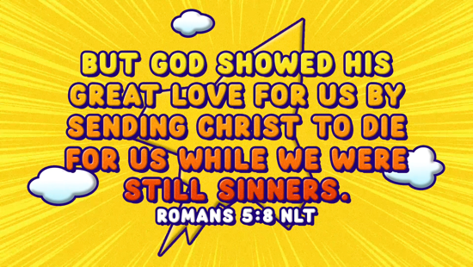

Romans 5:8 (NLT)
But God showed his great love for us by sending Christ to die for us while we were still sinners.

Faith Verse Fun | One Word at a Time
Today, we are going to play a simple game to help us review the Faith Verse. We all need to get into a circle and sit down.

I’ll say the Scripture reference. Then I will point to someone in the circle. That kid will say the first word of the Faith Verse. Then, the kid to their right will say the next word until the verse is repeated one word at a time around our circle. When the last word is said, everyone jumps up and says the Faith Fact: Jesus defeated death. Are you ready to play?
- Play this through a few times until kids can say the whole verse without long delays.
- Consider mixing up the order by throwing a ball to choose the next person.
- Let kids help each other when they are struggling for the next word.

ACTIVITY PAGE | The Victor’s Trophy
You Will Need | Getting Ready
- Activity Page, one per kid  - Markers or colored pencils | - Print copies of the Activity Page, one per kid.

On your Activity Page for today is an outline of a trophy. We are going to decorate this trophy because Jesus defeated death. Jesus is the winner, so He gets the trophy!

In the middle of the trophy, draw an image to represent our Faith Fact. Last time, we learned that Jesus died on the Cross for our sins. Jesus defeated death when He came back to life. Draw a cross in the middle of the trophy.

On the trophy, you can draw or write the names of other things that Jesus defeated. Some examples might be fear, loneliness, or sin. You can also write things that remind you of how victorious Jesus is. Some examples might be love, peace, joy, or freedom.

Prayer

God, Your plan to defeat death and give us victory through Jesus is beyond what we can imagine. You did the impossible. Thank You for allowing us to defeat death because of what Jesus did. Amen.

FAITH FACT RECAP
- Display the Faith Fact Slide or Motion Graphic as parents are coming into the room.
- Maximize the time you have with your kids, so that parents see what their kids have learned. Have the kids repeat the Faith Fact, and then dismiss them to their parents.

Today, as you go home, let’s not forget our Faith Fact. It is one of the most important things we learned today.

This is the answer to the question your adults are going to ask: “What did you learn today?” Let’s say the Faith Fact together: Jesus defeated death.

DISMISSAL
- Send home the Activity Page.
- Remind parents that there are Family Devotions available on the app to do with their kid.
- Tell everyone the date and time for the next session.

