

LEADER OVERVIEW

Volume Overview—My Savior
In these sessions, kids will hear about the importance of serving others. Jesus provided the perfect example at the Last Supper and on the Cross. This is an opportunity for kids to respond to God’s offer of salvation and realize their purpose here on earth—to share Jesus with those around them.

SESSION 1: The Last Supper—John 13:1–17  Faith Fact: Jesus shows me how to live. | SESSION 2: The Crucifixion—Luke 23:32–49  Faith Fact: Jesus is my Savior.
SESSION 3: The Resurrection—Luke 24:1–12  Faith Fact: Jesus defeated death. | SESSION 4: The Great Commission—  Matthew 28:16–20; Acts 1:3–11  Faith Fact: With Jesus, I can change the world.

SESSION OVERVIEW

In this session, kids will hear about the crucifixion of Jesus. It was a somber experience, and should not be taken too lightly. Tell the kids that this is only part of the story and next time things get better. Treat it like a two-part experience because it really is just that. Allow the kids to deal with the seriousness of this experience. Some kids may open up to share their own hurts. Allow the Holy Spirit to guide as you share the salvation experience with the kids.

Bible Lesson | Faith Fact
The Crucifixion  Luke 23:32–49 | Jesus is my Savior.
Faith Verse
Romans 5:8 (NLT)
But God showed his great love for us by sending Christ to die for us
while we were still sinners.

Listen Kids is part of an entire kids’ discipleship strategy. Get access at KidminRoadmap.com.
PREPARING FOR THE SESSION
You Will Need | Getting Ready
Large Group  - Bible  - Worship songs (Song suggestions: “All of Me” by Gateway Kids Worship; “Deep Cries Out” by Bethel Music Kids; “More Like Jesus” by Passion)  - Two large stuffed animals  - Paper, one sheet per kid  - Pencils or pens, one per kid  - For groups not using a phone or tablet only, add:  - Projector or TV  - Laptop  - Countdown 5-Minute Video  - Theme Intro Video  - Faith Fact Slide or Motion Graphic  - Countdown60 Video  - Game Time Slide or Motion Graphic  - Bible Lesson Video A  - Bible Lesson Video B  - Faith Verse Video or Slide  Small Group  - Small Group Group Connection, one per team  - Scissors, two per team  - Craft sticks, eleven per team  - Black marker  - Bibles, one per kid  - Small Group Activity Page, one per kid  - Pencils or pens, one per kid | Large Group  - Download videos and slides if needed.  - Select worship song(s) and have them ready to play.  Small Group  - Print copies of the Small Group Group Connection Page, one per team.  - Write two words from the verse per craft stick until the verse is complete, one set per team.  - Print the Small Group Activity Page, one per kid.
Check out all the promotional and extra media files available for this theme. To access the Bible Engagement Project from a computer, visit App.BibleEngagementProject.com.

LARGE GROUP (30 Minutes)
See what’s needed at the beginning of the session.

INTRODUCTION
- Optional: Play the Countdown 5-Minute Video.



Welcome

Welcome! I’m so glad you’re here! Last time we talked about how Jesus shows us how to live even when we’re facing hard things. We’ve got even more to learn from Him today. Let’s watch this video, and then we’ll get started.
- Play Theme Intro Video.



Have you ever watched a movie where halfway through it, the main character is in trouble and it doesn’t look like they will make it? (Group response) In the end, does everything work out okay? (Group response)

Today’s Bible story is kind of like that. It is a two-part story. The first part will leave our main character in a horrible situation where it seems like nothing good will ever happen. Then, next time we will finish the story and see how our main character saves the day. Raise your hand if you think you know who our main character is. (Group response) We’re talking about Jesus!

Faith Fact
- Show the Faith Fact Slide or Motion Graphic.


Today we are learning that Jesus is my Savior. That is our Faith Fact for today. Let’s take a look at our Faith Fact and say it all together. Jesus is my Savior. Let’s say it one more time. This time let’s say it in our favorite movie actor’s voice. Jesus is my Savior. Great job!

GAME | Save the Animal
You Will Need | Getting Ready
- Two large stuffed animals  - Countdown60 Video–60 seconds | No prep is needed for this activity.

- Show the Game Time Slide or Motion Graphic.


In our game today, we will save a stuffed animal from hitting the ground. That reminds us of our Faith Fact: Jesus is my Savior.

Let’s all gather into two circles. When I say, “Go,” toss the stuffed animal across the circle to someone else without letting it hit the ground. We are going to see which circle can save its animal the most times in 60 seconds. If you drop the animal, the count starts over again. You can’t toss it to the kid next to you because that won’t count. Are you ready to play? Go!
- Play Countdown60 Video.



- Play a couple of rounds as time allows.

Great job of saving the animal! Sometimes we dropped our animal, but do you know who never drops us? (Group response) That’s right. Jesus will never drop us. That is what makes Him our perfect Savior. Now, we are going to move on to the next part of our time together where we get to worship Jesus.

WORSHIP

Today as we worship by singing, we are going to remind ourselves about how much God loves us and about how Jesus gave His life to save us so we can have life and a relationship with God.
- Lead the kids in singing one or two praise songs. See suggestions at the beginning of the session.

BIBLE LESSON | The Crucifixion (Luke 23:32–49)

That was such a great time of worshipping God! I know He loves it when you sing with your whole heart to Him. We will hear about His love and salvation today. Before we dive into our Bible story, let’s bow our heads and pray together.

Prayer

Jesus, thank You for the love You showed when You died so we could have a relationship with God. Show us today the way to know You. Amen.

Video Intro

Why don’t we check in with the Challenge Accepted team and see what they’re up to? You just know they’re going to do another crazy challenge. Let’s watch the video!
- Play Bible Lesson Video A.

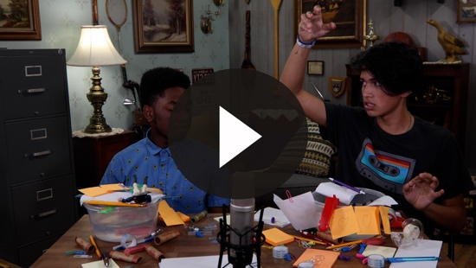

Oh my, do you think you could accept that challenge? (Group response) Those guys are so crazy but also so much fun! Okay, it’s time to turn our attention to God’s Word, the Bible.

Teaching Time

It is time for our faith to grow as we learn about Jesus. Let me tell you, today’s Bible lesson is not a fun-filled story with lions and giants. Today’s story is about one of the saddest days in history that leads to the greatest day in history, which we will talk about next time.

Jesus was born and lived a perfect life here on earth. He healed people and helped people understand that God wants to have a relationship with them. But some of the things that Jesus said about who He is and the things He did made the religious leaders very angry.

Do you remember what we talked about last time? (Allow responses.) That’s right. We talked about the Last Supper, Jesus’s last meal with His disciples. Later that same night, the religious leaders arrested Jesus. Then, He was put on trial and falsely accused of things because these religious leaders didn’t like Him. They beat Jesus and called Him names.

The Roman leader in Israel at the time gave in to the requests of the religious leaders who hated Jesus. This Roman leader agreed to their demand that Jesus die a horrible death on a cross. This method of execution is called crucifixion, and it is one of the most horrible ways a person could die.

Did Jesus do anything wrong? Did Jesus deserve to be punished? Let’s go to the Book of Luke and read together. (Hold up the Bible.)
- Read Luke 23:32–33.

You may have seen pictures before of three crosses. That is because Jesus was sentenced to die with two criminals. The Roman soldiers nailed Him to a cross. What happened next is one of the saddest things ever as Jesus prepared to die. Remember, this story will have a happy ending because Jesus is my Savior.

Even though very bad things were happening to Jesus, He still loved those who were doing this to Him. Rather than being angry, Jesus cried out for God to forgive them.

While Jesus hung there on the cross, the soldiers placed bets to see who would get His clothes. They mocked Jesus, laughed at Him, and put up a sign calling Him the “King of the Jews.”

Then, we see something happen with the two criminals hanging next to Jesus. One of them started to make fun of Him as well.
- Read Luke 23:39.

Jesus didn’t answer him; someone else did. Let’s keep reading.
- Read Luke 23:40–42.

God’s Holy Spirit was doing something in the heart of that second criminal. He was starting to realize that he had sinned and deserved to be punished, but Jesus had done nothing wrong. The man asked Jesus to remember him when Jesus came into His kingdom. The man realized that Jesus could save him for eternity.

Jesus shows us the reason He allowed all of this to happen to Him. In one statement Jesus reveals the plan that God had made from the beginning of time. Jesus is my Savior.
- Read Luke 23:43.

In the next two verses, we see that the sun suddenly went dark for about three hours even though it was the middle of the day. The curtain in the temple was torn in half from top to bottom. Finally, Jesus cried out.
- Read Luke 23:46.

At that moment, the people who were there understood that what happened to Jesus was wrong. They left with sorrow knowing that He had done nothing wrong. Because of His willingness to die on the cross, it made a way for us to have a relationship with God. Because of Jesus, our Faith Fact can be true for each one of us. Jesus is my Savior.

This final day of Jesus’ life on earth seems like a horrible ending, but the story isn’t over yet. Next time, we are going to look at what happened after this. Who knows what occurred three days later? It’s the reason we celebrate Easter. (Group response)

We are going to look at our Faith Verse again, which shows us so much about this event. Let’s pause for a minute and think about the two criminals. They had a choice. One chose to think only about himself and mock Jesus. The other chose to turn his attention to Jesus. He understood in that moment who Jesus was to him personally and to all people in the future. He understood that Jesus was his Savior.

Today, you have the same choice. You can choose to ignore Jesus and do your own thing or to ask for forgiveness for your sinful choices. If you choose to ask Jesus for forgiveness, you will be in a right relationship with God the Father and you can spend the rest of your life with Him.

Faith Verse
Our Faith Verse speaks specifically to what happened in our Bible story today. Let’s say our verse one more time while you think about how Jesus is my Savior.
- Show the Faith Verse Video or Slide.

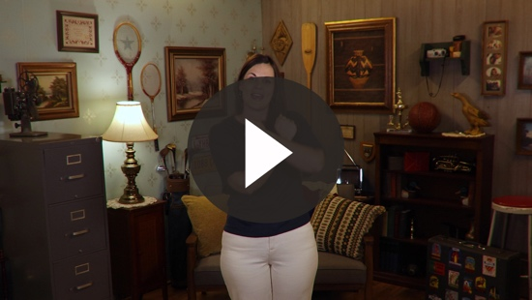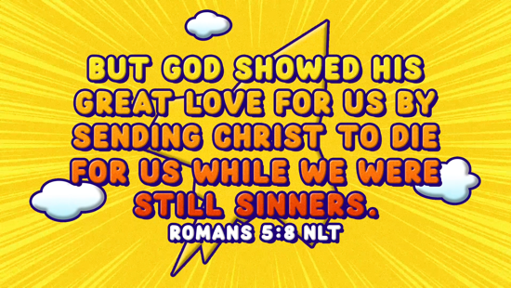

Romans 5:8 (NLT)
But God showed his great love for us by sending Christ to die for us while we were still sinners.

That is exactly what we learned today. Jesus was sent to die for us because God’s love is greater than any sin we could ever do. It’s not about anything that we could have ever done to be a better person; it is about what Jesus did for us. Let’s say our Faith Verse again. (Lead kids in saying the Faith Verse again.)

Aren’t you glad that God loves us no matter what? (Group response) I am thankful that Jesus died for me even though I don’t deserve it.

PRAYER AND RESPONSE
You Will Need | Getting Ready
- Paper, one sheet per kid  - Pencils or pens, one per kid | No prep is needed for this activity.

Consider playing a worship song softly in the background while kids pray.

Today, God offers you the same choice the criminals had that day. You can choose to do your own thing and see what happens, or you can choose to say, “Jesus, remember me. Jesus, please forgive me and make me a new person. I want a relationship with God.”

Here is your paper and pencil. I want you to draw a picture of three crosses. If you have prayed and asked Jesus to forgive your sins and to be the Lord of your life, then draw a sun above the crosses because you don’t live in darkness anymore.

If you have not yet prayed for Jesus to be your Savior, then you have a choice. You can choose to ask Jesus to forgive your sins or you can choose to wait. If you want to pray for Jesus to forgive your sins, circle the middle cross. If you are not yet ready to make that choice, I want you to draw a question mark on your page.
- Recap the three options: draw a sun, circle the middle cross, or write a question mark.
- Give kids time to pray. Play a worship song in the background.

We are going to pray together and ask Jesus to forgive our sins and bring us into a relationship with Him. I would like all the kids to repeat this after me, even if you’ve done it before.

Prayer

Jesus, thank You for dying for me so I can have life. Please forgive me for the things I’ve done wrong and my wrong choices. Make me a new person. I want to be like You. Thank You for saving me. Amen.

If you meant that prayer, you are now part of God’s family. We can all say the same thing now. Jesus is my Savior. Without putting your name on the paper, hand it to me. If you meant what you said in that prayer, make sure you tell someone: Jesus is my Savior.

Worship Song
Play one or two worship songs.

I think we should celebrate what just happened today by singing another worship song! Jump up on your feet and join me.

Video Wrap-Up

Before we go to our small group activities, we have got to see what happened with the Challenge Accepted team.
• Play Bible Lesson Video B.

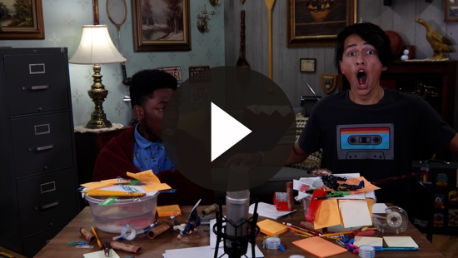

Let’s all remember the challenge that Austin gave us. Can we celebrate the fact that Jesus forgives us? Let’s remember our Faith Fact.
- Show the Faith Fact Slide or Motion Graphic.



Say it with me. Jesus is my Savior. Let’s say it one more time together. Jesus is my Savior. Thanks for a great time learning about God together.
- Dismiss kids to Small Group time or to go home if your group time ends here.

SMALL GROUP (30 Minutes)
This section can be done in conjunction with the large group, or on its own if you do small groups with your kids. During Small Group time, the goal is to connect the kids with the Word of God and to each other. All activities are led by the small group leader.

GROUP CONNECTION | Sequence the Story
You Will Need | Getting Ready
- Group Connection, one per team  - Scissors, two per team | - Print copies of the Group Connection, one per team.

Today, we heard an incredibly difficult story. When you look at the facts, it is hard to find a positive part. It’s a good thing that the story isn’t over.

This is such an important story for us to know. It’s a constant reminder of God’s unconditional love for us. Let’s divide our group into smaller teams. We are going to cut out these Bible story tiles. With your team, put the tiles in the order of the story.
- Give assistance if needed.
- Below is a description of each of the sequencing cards in the correct order.
1. Jesus and two criminals on crosses – Jesus was crucified next to two criminals (verse 32).
2. Soldiers laughing – The Roman soldiers mocked and laughed at Jesus (verse 36).
3. Jesus and criminal on the cross – Jesus told the criminal that he would be with Jesus in paradise (verse 43).
4. Sun – The light from the sun went away and the sky was dark (verse 44).
5. Torn curtain – The temple’s curtain tore down the middle, from top to bottom (verse 45).
6. Soldier kneeling – The Roman officer realized Jesus was innocent (verse 47).
7. Women crying – The women from Galilee watched from a distance (verse 49).

Great job, kids! This is the most important story. Let it be a constant reminder of God’s love for you and a reminder that you can say: Jesus is my Savior.

BIBLE LESSON RECAP | The Crucifixion (Luke 23:32–49)
You Will Need | Getting Ready
- Bibles, one per kid | No prep is needed for this activity.

We are going to explore our Bible story by looking at the events of the Crucifixion. We will see that because of what Jesus did, we can choose to make the Faith Fact our choice: Jesus is my Savior. Turn to the Book of Luke and let’s read this together.
- Divide the Bible reading into smaller chunks for kids to read aloud if needed.

Faith Fact

Today, we discovered as we read about the Crucifixion that when we ask Him to forgive our sins, we can say: Jesus is my Savior.
- Show the Faith Fact Slide or Motion Graphic.

That’s our Faith Fact. Say it with me. Jesus is my Savior. Let’s say it again and emphasize the first word. (Allow kids to respond.) Now let’s emphasize the word “is” and say it again. (Allow kids to respond.) Now say it and emphasize “my.” (Allow kids to respond.) And let’s wrap it up by emphasizing the word “Savior.” (Allow kids to respond.) That will help it stay in your memory for a while.

GROUP DISCUSSION

Feel free to use all or just a few questions as a jumping-off place for good discussion. Questions marked with * are designed for more conversation. Adjust the questions based on the age or maturity of your group. Typically, older kids will be able to dive a little deeper than younger ones.

Questions

Today, we learned that Jesus is my Savior. What does that mean to you?

How does it make you feel to know Jesus willingly died for you?

Jesus was crucified with two criminals. How did the two men respond to Jesus? What can we learn from the second criminal?

* When people are hurting or feeling guilty, sometimes they are mean to others. That is what the first criminal did. Have you ever been mean to someone when you are hurting? Is that a wise choice?

* In our Bible story today, we heard Jesus talk to God at two different times. What did He say? Why are those statements important?

The religious rulers and the criminals kept telling Jesus to save himself. Could Jesus have saved himself? If so, why didn’t He?

At noon something happened for about three hours; what was it? How would you have responded if you were there at the crucifixion and this occurred?

After Jesus died, how did the Roman officer respond? Why do you think the Roman officer realized there was something different about this man?

How did the crowd respond after Jesus died on the cross? Why? How would you have responded?

* How has Jesus changed your life?

APPLICATION AND RESPONSE

Jesus did not come to earth to save himself, but to save others. I am thankful that He loves me and provides a way for me to have a relationship with God. I don’t ever want to take that for granted or forget how great God’s love is for me. Because I have accepted His forgiveness for my sins, I can say: Jesus is my Savior.

Make It a Habit
Select a simple visual reminder of the session’s Faith Fact

It is important to make it a habit to remember what we learned today. One of the best ways to make it a habit in our life is to add a little something when we pray.

After Jesus died, the Roman officer worshipped God. What is an action we do when we worship God? (Group response) Those are all options. One action we can do is raise our hands. When you finish a prayer, what do you say to make it complete? I usually say, “Amen.”

This week when you pray, raise your hands in worship when you say, “Amen.” This will help you remember when you pray that Jesus is my Savior.

Prayer

Let’s pray and ask God to help us.

Father God, thank You for sending Jesus to make a way for us to have a relationship with You. Jesus, thank You for being willing to give yourself so I can have life. Thank You for saving me. Amen.

FAITH VERSE REVIEW
You Will Need | Getting Ready
- Craft sticks, eleven per team  - Black marker | - Write two words from the verse per craft stick until the verse is complete, one set per team.

Our Faith Verse is Romans 5:8. It ties in perfectly with what we heard today. Let’s say the Faith Verse and do the actions for the verse together.
- Show the Faith Verse Video or Slide.

Romans 5:8 (NLT)
But God showed his great love for us by sending Christ to die for us while we were still sinners.

Faith Verse Fun | A Stick Challenge

You did a great job! Let’s see if we can pass this Faith Verse challenge. On these craft sticks are the words from our Faith Verse. We’re going to divide the group into smaller teams. Let’s see which team can put their craft sticks in order the fastest. When you have it put together, you have to say it as a team in order to complete the challenge.
- Give kids a chance to put the Faith Verse words in order. Repeat as time allows.

Great job! How does this verse help me understand that Jesus is my Savior? (Allow responses.)

ACTIVITY PAGE | Savior Search
You Will Need | Getting Ready
- Activity Page, one per kid  - Pencils or pens, one per kid | - Print the Activity Page, one per kid.

Today’s Activity Page is a word search. There are a lot of elements in the Bible verses we read today. See if you can find the words that are part of our story as we learned that Jesus is my Savior.
- Give kids time to complete the word search. Assist any kid who needs help.

Prayer

Jesus, thank You for choosing to give Your life for us rather than saving yourself. I don’t deserve the love You showed. Thank You for dying to forgive my sins and save me! Amen.

FAITH FACT RECAP
- Display the Faith Fact Slide or Motion Graphic as parents are coming into the room.
- Maximize the time you have with your kids, so that parents see what their kids have learned. Have the kids repeat the Faith Fact, and then dismiss them to their parents.

Today as you go home, let’s remember our Faith Fact. It is one of the most important things we heard today.



This is the answer to the question your adults are going to ask: “What did you learn today?” Let’s say the Faith Fact together: Jesus is my Savior.

DISMISSAL
- Send home the Activity Page.
- Remind parents that there are Family Devotions available on the app to do with their kid.
- Tell everyone the date and time for the next session.

