

LEADER OVERVIEW

Volume Overview—My Savior
In these sessions, kids will hear about the importance of serving others. Jesus provided the perfect example at the Last Supper and on the Cross. This is an opportunity for kids to respond to God’s offer of salvation and realize their purpose here on earth—to share Jesus with those around them.

SESSION 1: The Last Supper—John 13:1–17  Faith Fact: Jesus shows me how to live. | SESSION 2: The Crucifixion—Luke 23:32–49  Faith Fact: Jesus is my Savior.
SESSION 3: The Resurrection—Luke 24:1–12  Faith Fact: Jesus defeated death. | SESSION 4: The Great Commission—  Matthew 28:16–20; Acts 1:3–11  Faith Fact: With Jesus, I can change the world.

SESSION OVERVIEW

In this session, kids will discover why it’s important to serve others. Jesus provided the perfect example at the Last Supper when He washed the feet of His disciples. Kids will see how they can serve others in the same pattern that Jesus did. This is a good day to remind yourself that you are here to serve the kids as well. Love them and accept them just as if you were accepting Jesus into the room today.

Bible Lesson | Faith Fact
The Last Supper  John 13:1–17 | Jesus shows me how to live.
Faith Verse
Romans 5:8 (NLT)
But God showed his great love for us by sending Christ
to die for us while we were still sinners.

Listen Kids is part of an entire kids’ discipleship strategy. Get access at KidminRoadmap.com.
PREPARING FOR THE SESSION
You Will Need | Getting Ready
Large Group  - Bible  - Sponge or washcloth, one per team  - Small buckets, two per team  - Masking tape  - Towels to place under the buckets  - Paper, one sheet per kid  - Pencils or pens, one per kid  - Worship songs (Song suggestions: “All of Me” by Gateway Kids Worship; “Deep Cries Out” by Bethel Music Kids; “More Like Jesus” by Passion)  - For groups not using a phone or tablet only, add:  - Projector or TV  - Laptop  - Countdown 5-Minute Video  - Theme Intro Video  - Faith Fact Slide or Motion Graphic  - Game Time Slide or Motion Graphic  - Bible Lesson Slides 1–3  - Bible Lesson Video A  - Bible Lesson Video B  - Faith Verse Video or Slide  Small Group  - Streamers, tissue paper, or cloth material that is all the same color  - Smartphone timer or clock  - Bibles, one per kid  - Whiteboard or poster board  - Dry-erase marker or large black marker  - Eraser  - Small Group Activity Page, one per kid  - Crayons or markers | Large Group  - Download videos and slides if needed.  - Select worship song(s) and have them ready to play.  - For each team, fill one bucket with water. Use masking tape to mark a fill line inside the other bucket.  - Set a pair of buckets on a towel at one end of the room for each team.  Small Group  - Write the Faith Verse on the whiteboard or poster board.  - Print the Small Group Activity Page, one per kid.
Check out all the promotional and extra media files available for this theme. To access the Bible Engagement Project from a computer, visit App.BibleEngagementProject.com.

LARGE GROUP (30 Minutes)
See what’s needed at the beginning of the session.

INTRODUCTION
- Optional: Play the Countdown 5-Minute Video.



Welcome

Welcome! Are you glad you came today? I know I’m glad you are here. We’ve been talking about Jesus’ ministry and about how He wants all of us to have a relationship with Him. Today we’ll learn about how Jesus served others. Let’s watch this video, and then we’ll get started.
- Play Theme Intro Video.



I have a question. Have you ever walked into your house with muddy shoes before? (Group response) Have you ever smelled stinky feet—yours or someone else’s? (Group response)

I know all of us have experienced smelly feet at some point, whether it was our feet or someone else’s feet. And all of us have gotten mud or something on our shoes before. Our feet can be a mess, can’t they?

Today, we are going to learn about a time when Jesus had to deal with other people’s feet. We are going to see what it means to serve others and treat people the way Jesus treated people.

Faith Fact
- Show the Faith Fact Slide or Motion Graphic.



In our time together, we will see how Jesus shows me how to live. That is our Faith Fact for today! Let’s say it all together. Jesus shows me how to live. Let’s say it one more time, but this time, let’s do it while holding our nose like there are smelly socks in the room. Here we go. Jesus shows me how to live. Great job!

GAME | Sponge Soaker Relay
You Will Need | Getting Ready
- Sponge or washcloth, one per team  - Small buckets, two per team  - Masking tape  - Towels to place under the buckets | - For each team, fill one bucket with water. Use masking tape to mark a fill line inside the other bucket.  - Set a pair of buckets on a towel at one end of the room for each team.

- Show the Game Time Slide or Motion Graphic.


We’re going to form teams for today’s game. Each team should have the same number of kids. When I say, “Go!” one kid from each team will take the sponge and run to the bucket of water. The kid will soak up as much water as the sponge will hold. Then, the kid will squeeze the water from the sponge into the empty bucket. Finally, the kid will run to give the damp sponge back to the next teammate in line. The team that fills the second bucket to the fill line first without spilling either of the buckets wins.
- Form teams of four or five kids. If not, create smaller groups.

Are you ready? Go! (Cheer on kids as they run the race.)

You did a great job! That was a fun game to play. Aren’t you glad it wasn’t a used sock? Now, it’s time to transition into a time of worship. Let’s bow our heads and pray as we get ready to sing to God.

Prayer

Dear God, thank You for the privilege of worshipping You. Help us to sing with our whole heart because we are so grateful for who You are. In Jesus’ name. Amen.

WORSHIP

Let’s sing these songs together.
- Lead the kids in singing one or two praise songs. See suggestions at the beginning of the session.

BIBLE LESSON | The Last Supper (John 13:1–17)

You did such a great job worshipping God by singing! I love worshipping in every part of my life. It is the kind of lifestyle that Jesus wants us to have. Let’s bow our heads and pray together.

Prayer

Dear God, thank You for loving us. Thank You for showing us how You want us to live our life. Help us today to see how we should treat others. Amen.

Video Intro

Are you ready for a little Challenge Accepted? Me, too! Let’s see what our friends are up to today.
- Play Bible Lesson Video A.

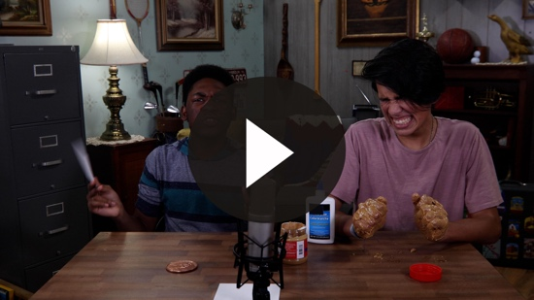

Wow! I don’t think that I would want to do that challenge. Would you? (Group response) Next, let’s look at our Bible story today.

Teaching Time

Now, it is time to challenge our faith and look at a real event that happened in the Bible. We are going to continue learning about Jesus in the Book of John. If you have your Bible, turn to John 13. (Hold up Bible.) John is the fourth book in the New Testament. (Allow kids time to find the chapter.)

Our story picks up today at the start of a very important festival for God’s people, called Passover. Do you know what Old Testament event the Jewish people celebrated at Passover? (Allow responses.)

Passover is when they remembered how God had freed them from slavery in Egypt. At the first celebration of Passover in Egypt, every Israelite family sacrificed a lamb to God and used the blood to cover their doorposts. Their obedience to God’s instructions saved them from the final plague and freed them from Egypt. Every year, the Israelites celebrated that event with a special meal.
- Show Bible Lesson Slide 1.

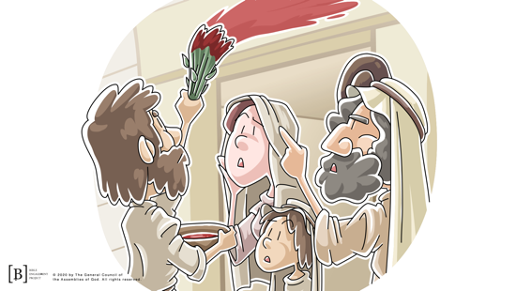

Being freed from slavery was an important part of Israel’s history, but God knew there was a bigger issue that His people needed to be freed from. Sin was a big issue for all people, and God sent Jesus to do something about it.

In the verses we’re going to read, Jesus knew it was almost time for His life to be sacrificed like the Passover lamb so all people could be freed from their sin.
- Read or have a kid volunteer read John 13:1–2.
- Use as many volunteers as possible for the rest of the readings.

Okay, what can we learn from these verses? (Allow responses.) Jesus loved His disciples. They had followed Him and lived with Him for the last three years, but now He knew His time left with them was short. Jesus was about to eat His last meal, and He knew one of the disciples was about to betray Him and turn Him over to His enemies. Instead of being angry or upset, He did something very unexpected. Let’s read the next few verses.
- Read John 13:4–5.
- Show Bible Lesson Slide 2.

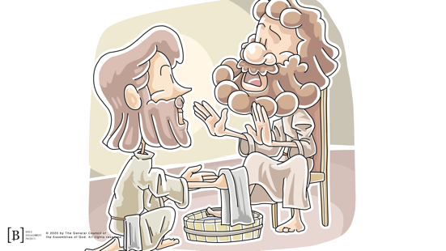

Jesus took the role of a servant and washed the feet of all the disciples, even Judas who was about to betray Him. Jesus was showing us to love everyone, including our enemies or those who have hurt us.

It might be a little strange for us to think about washing other people’s feet, but in Jesus’ time, this was something done every day. Back then, they didn’t have full shoes like we do that keep all the dirt out. They wore sandals.
- If you have one, use your own personal story of stinky, muddy feet.

During the time of Jesus, people walked everywhere and had very dirty feet because of it. Sweaty feet, dust, and dirt together don’t make a good combination. Back in that time, it was common for disciples to wash the feet of their teacher. What do we see Jesus do? (Allow responses.)
- Read John 13:6–8.
- Show the Bible Lesson Slide 3.

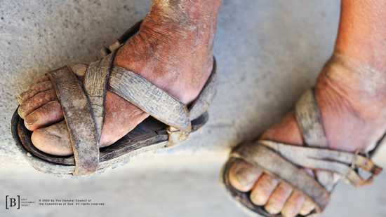

Jesus was the Teacher here. He was the Leader of His disciples. They should have washed His feet. That’s why Peter was so upset. He basically told Jesus, “There is no way You are washing my feet.” But, Jesus continued on and washed the feet of all the disciples. Why do you think Jesus chose to wash their feet? Let’s keep reading and find out.
- Read John 13:12–17.

Jesus was teaching them a principle that they should live by. Jesus was showing them how to serve others.

Sometimes we might think we are better than other people or that other people are better than us. Jesus shows me how to live in a way that is different from the pattern in the world. Whether I am important or not important to other people doesn’t matter because I am important to Jesus.

Jesus chose to serve His disciples. We need to serve the people around us just like Jesus did. Jesus didn’t do this to say that we have to wash each other’s feet every time we get together. He was showing us the way we need to live our life. That means that I need to be willing to help people even if I don’t want to.

When I love others and respect who they are, I want to help them and serve their needs. When I think I am better than others, I am not living my life the way that Jesus wants me to. I need to be a servant, not a master. Remember, we learned that Jesus shows me how to live and that we should live a life that helps and serves others.

Faith Verse
We know that Jesus showed how much He loved His disciples by serving them. Let’s take a minute and learn our new Faith Verse from God’s Word that talks about God’s love. Let’s learn the actions together.
- Show the Faith Verse Video or Slide.

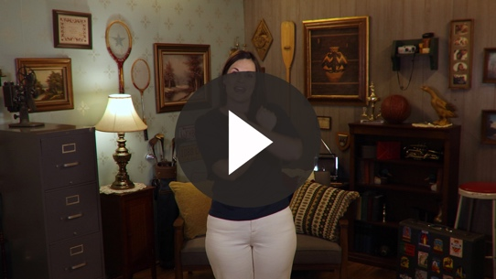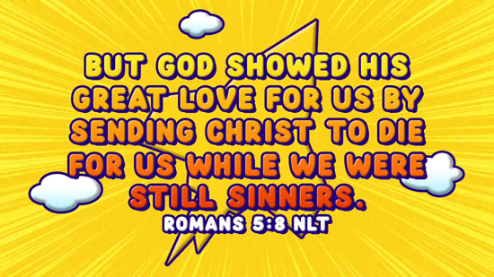

Romans 5:8 (NLT)
But God showed his great love for us by sending Christ to die for us while we were still sinners.

Even though we have all messed up, Jesus doesn’t expect us to be perfect before we can have a relationship with Him. Jesus loves us no matter what.

PRAYER AND RESPONSE
You Will Need | Getting Ready
- Paper, one sheet per kid  - Pencils or pens, one per kid | No prep is needed for this activity.

Consider playing a worship song softly in the background while kids pray.

Let’s pray that God will help us see others the way He sees them. We know that Jesus shows me how to live, but sometimes it is hard to respect and serve certain people. Because we have experienced God’s love, we need to show that same love to others.

We are going to pause right now and ask the Holy Spirit to show us someone in our life that we need to serve, someone we need to honor more than ourself. That could be your parents, your teacher, or maybe a sibling. How can you show them respect the way that Jesus showed love to His disciples?

On the piece of paper, I want you to draw a picture of you doing something to serve the person the Holy Spirit shows you. Remember we are learning to be a servant because Jesus shows me how to live.

Let’s pray quietly and ask God to help us show respect and serve others, even when we don’t want to. Ask Him for the Holy Spirit to show us how we can serve others and change our attitudes not to think of ourself as better than anyone else.
- Give kids time to pray and draw. Then introduce the worship song. This could play in the background while kids pray or could be a worship song to sing together.
- Kids may take their paper home if they choose.

Worship Song
Play one or two worship songs.

Video Wrap-Up

There are a couple of people we need to check back in with to see how the challenge worked out. Let’s see what happened with the Challenge Accepted team.
- Play Bible Lesson Video B.

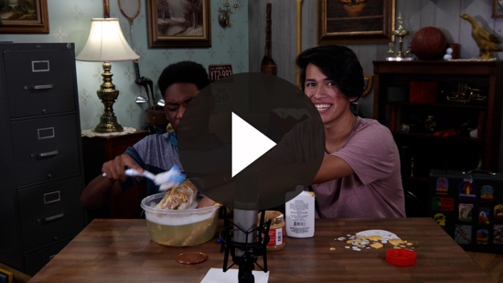

Let’s all accept the challenge that they gave us and choose to live the way Jesus wants us to live. Find someone you can serve. When we are around others, we need to treat them with the same love and respect that Jesus gave, not only to His disciples, but also to us. Let’s remember our Faith Fact.
- Show the Faith Fact Slide or Motion Graphic.

Say it with me. Jesus shows me how to live. Even though it wasn’t fun to clean His disciples’ feet, Jesus served others. Let’s say it one more time together. Jesus shows me how to live. Thanks for a great time learning about God together.
- Dismiss kids to Small Group time or to go home if your group time ends here.

SMALL GROUP (30 Minutes)
This section can be done in conjunction with the large group, or on its own if you do small groups with your kids. During Small Group time, the goal is to connect the kids with the Word of God and to each other. All activities are led by the small group leader.

GROUP CONNECTION | Dressed for Dinner
You Will Need | Getting Ready
- Streamers, tissue paper, or fabric that is all the same color  - Smartphone timer or clock | No prep is needed for this activity.

Jesus and His disciples had dinner together as they celebrated Passover. Have you ever gone out for a fancy dinner before? (Allow responses.) What would you wear if you were going to a special dinner at an expensive restaurant? (Allow responses.) What if you were going to a fast food place? (Allow responses.) What if you were going over to a backyard barbecue at someone’s house? (Allow responses.)

We are going to test how well you can dress up someone in your group for dinner. The groups will have five minutes to see who can dress their person in an outfit with the material provided. The best outfit wins. Ready? Go!
- Divide the kids into groups. Have one person from each group volunteer to be “dressed” by the rest of the group. If no one volunteers, you may need to choose.

If you were going to have dinner with Jesus, how would you want to present yourself? (Allow responses.) Now let’s clean up our mess and grab our Bibles.

BIBLE LESSON RECAP | The Last Supper (John 13:1–17)
You Will Need | Getting Ready
- Bibles, one per kid | No prep is needed for this activity.

We are going to review our Bible story by getting into our Bible and seeing that Jesus shows me how to live. Turn to John 13:1–17 and let’s split this up into sections to read.
- Divide the Bible reading into smaller chunks for kids to read aloud.

Some people think they should be treated better than others. Some people refuse to do certain things because they are “better than that.” But Jesus shows me how to live by serving others. If He did it, so should we.

Faith Fact

- Show the Faith Fact Slide or Motion Graphic.

Jesus shows us over and over again how to treat others, and that is our Faith Fact. Say it with me. Jesus shows me how to live.

GROUP DISCUSSION

Feel free to use all or just a few questions as a jumping-off place for good discussion. Questions marked with * are designed for more conversation. Adjust the questions based on the age or maturity of your group. Typically, older kids will be able to dive a little deeper than younger ones.

Questions

We learned that Jesus shows me how to live. What does that mean?

Why do you think Peter was so bothered when Jesus started to clean his feet?

Do you think you would have responded differently than Peter did if someone you looked up to tried to clean your feet?

* Today we remember the meal that Jesus shared with His disciples that night. It is known as the Last Supper. Why do you think it was so important to Jesus that this was one of the last things He taught His disciples?

How would you have felt if you were Jesus when you got to Judas? If you knew Judas was going to betray you and turn you over to be killed, would it have been hard to wash his feet?

What can we learn from the way Jesus interacted with Judas?

Can you share times when you have seen other people serving like Jesus did?

* Give an example of a time you were served by someone who surprised you.

Based on what we heard today, does sharing the message of Jesus go beyond just telling people about Him?

Jesus showed His disciples the message of serving. Can we do the same?

Earlier you prayed for someone that you can serve like Jesus did because Jesus shows me how to live. What are some ways we can serve the other kids in this group?

APPLICATION AND RESPONSE

Our Faith Fact is Jesus shows me how to live. In our Bible lesson, Jesus willingly served His disciples. He showed love goes beyond titles or authority. Being a leader means serving the people around you and loving them more than yourself. Jesus did that. Let’s not forget the importance of respecting and serving others.

Make It a Habit
Select a simple visual reminder of the session’s Faith Fact

It is important to make it a habit to remember what we heard today. Right now, I want you to look at your shoes. As you look at your shoes, I want you to say our Faith Fact: Jesus shows me how to live. Every time you put on your shoes this week, think about how Jesus showed us to serve others first.

Prayer

Let’s pray and ask God to help us.

Dear God, thank You for sending Jesus to show us how You want us to live. Jesus, thank You for being the perfect example for us. Help us to respect and serve others the way You would. Amen.

FAITH VERSE REVIEW
You Will Need | Getting Ready
- Whiteboard or poster board  - Dry-erase marker or large black marker  - Eraser | - Write the Faith Verse on the whiteboard or poster board.

Our Faith Verse for today is Romans 5:8. It shows us how great God’s love really is. Let’s say the Faith Verse and do the actions for the verse together.
- Show the Faith Verse Video or Slide.
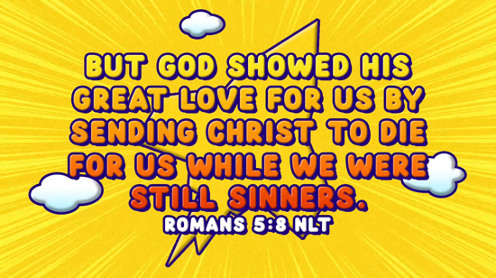

Romans 5:8 (NLT)
But God showed his great love for us by sending Christ to die for us while we were still sinners.

Faith Verse Fun | Erase It

You did a great job! Let’s see if we can pass this Faith Verse challenge. On this whiteboard, I have written our Faith Verse. We are going to say it together one more time. Then, one of you will erase one word and draw a line to represent the missing word. Then, we will see if we can say it without being able to see all of it. Ready?
- Say the verse together with kids.
- Have volunteers erase words and replace them with lines until all the words are gone.
- If you are using a poster board, have the volunteers scribble out a word at a time.

Now that we have erased all the words of the Faith Verse, can you say our Faith Fact for today? (Pause for kids to respond.) Right. Jesus shows me how to live. How did Jesus show us the way we are to live according to our Faith Verse? (Allow responses.)

ACTIVITY PAGE | Serving Feet
You Will Need | Getting Ready
- Small Group Activity Page, one per kid  - Crayons or markers | - Print the Activity Page, one per kid.

On your Activity Page, you see a picture of Jesus washing the feet of the disciples. Jesus explained that He was teaching them to serve others and that they were to go and do the same. As you color the picture, think of ways you can serve others. When you finish coloring the picture, flip the page over and write down ways you can serve others.

Prayer

Jesus, thank You for giving us the perfect example of the way You want us to live and the way You want us to serve others. Help us to treat others with respect and be willing to serve in every situation. Amen.

FAITH FACT RECAP
- Display the Faith Fact Slide or Motion Graphic as parents are coming into the room.
- Maximize the time you have with your kids, so that parents see what their kids have learned. Have the kids repeat the Faith Fact, and then dismiss them to their parents.

Today as you go home, let’s not forget our Faith Fact. It is something important that we learned today.

This is the answer to the question your adults are going to ask: “What did you learn today?” Let’s say the Faith Fact together: Jesus shows me how to live.

DISMISSAL
- Send home the Activity Page and each kid’s Prayer and Response paper.
- Remind parents that there are Family Devotions available on the app to do with their kid.
- Tell everyone the date and time for the next session.

