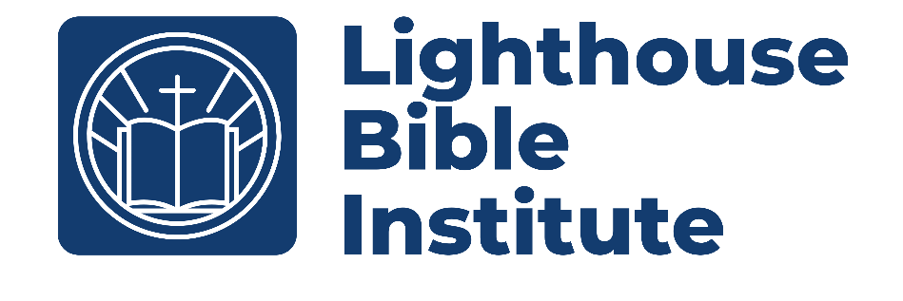
churc

Church History II (Pre-Reformation – Today)
Class Syllabus
Instructor: Alexander Martin
Contact: 937-532-4675
Email: Alex@lbcxenia.com

Course Description
This course will go from the papal decline in the 13th and 14th centuries to the expanse of modern-day Christianity. This course will cover important developments regarding the reformation, Christianity’s globalization, times of revival, and Christianity in the modern day. This is a three-credit course.

Course Objective
By the End of this course, you should have a cursory knowledge of what led to the Reformation and Counter-Reformation, the main players in each, the vital church councils, and the changes and expansion of Christianity to and through the modern day. This should allow the student to think critically about what has happened and why particular distinctions are essential.

Required Course Materials
- Shelley, Bruce L. Church History in Plain Language. Edited by Marshall Shelley. 5th ed. Grand Rapids, MI: Zondervan Academic, 2021.
- Ferguson, Sinclair B. In the Year of Our Lord: Reflections on Twenty Centuries of Church History. Orlando, FL: Reformation Trust, 2018.
- Laptop with Logos 10
- Class handouts will be provided by the class instructor. It is advised to use a three-ring binder for these handouts.

Additional Resources
- Noll, Mark A. Turning Points: Decisive Moments in the History of Christianity. Third Edition. Grand Rapids, MI: Baker Academic, 2012.
- Early, Joseph. A History of Christianity: An Introductory Survey. Nashville, TN: B & H Academic, 2015.
- Walton, Robert C., Chronological and Background Charts of Church History. Revised Edition, ZondervanCharts Zondervan, 2018.
Required Course Costs
- $10 plus books if you are not working toward certification.
- $20 plus books of you are seeking certification.
- Church History in Plain Language $18
- In the Year of our Lord $15

Class Schedule
Week | Assignments | Total Points | Percent of  Final Grade
1 | Quiz (60) and Reading (30) | 90 | 9%
2 | Quiz (60) and Reading (30) | 90 | 9%
3 | Quiz (60) and Reading (30) | 90 | 9%
4 | Quiz (60) and Reading (30) | 90 | 9%
5 | Midterm Test | 140 | 14%
6 | Quiz (60) and Reading (30) | 90 | 9%
7 | Quiz (60) and Reading (30) | 90 | 9%
8 | Quiz (60) and Reading (30) | 90 | 9%
9 | Quiz (60) and Reading (30) | 90 | 9%
10 | Final Test | 140 | 14%
 | Total Points | 1,000 | 100%

- All sessions for this course will be on Saturdays from 8:00 am - 9:15 am.
- This is a ten-week course starting on January 10th and running through March 14th

Class Grading/Assignments

- To pass the class, you must:
  - Have an average of 70% or better (C average or better).
- All assignments may be turned in up to two weeks late.
  - Within the first week, there is up to a 10% penalty for late work.
  - In the second week, there is up to a 20% penalty for late work.
  - After two full weeks, the assignment will be graded as zero.
  - Prior planned excused absences may receive extra grace at the professor’s discretion.
  - It is your responsibility to seek out the work you miss in a timely fashion.

Course Outline
- All reading is to be done before class!
- The quizzes and tests will cover the assigned reading and new information from that day's Class handout.
- Papal Decline Reformers Arise – January 10th
  - Read Shelley Pages: 260-282
  - Read Ferguson Pages: 135-152
  - Quiz 1
  - Reading acknowledgement
- Luther, Anabaptists, and Calvin – January 17th
  - Read Shelley Pages: 283-311
  - Read Ferguson Pages: 153-170
  - Quiz 2
  - Reading acknowledgement
- The English and Catholic Reformation – January 24th
  - Read Shelley Pages: 312-329
  - Read Ferguson Pages: n/a
  - Quiz 3
  - Reading acknowledgement

- The Spread of Christianity, Reform or Separation – January 31st
  - Read Shelley Pages: 330-364
  - Read Ferguson Pages: 173-181
  - Quiz 4
  - Reading acknowledgement

- Reason and Feeling – February 7th
  - Read Shelley Pages: 365-386
  - Read Ferguson Pages: n/a
  - Midterm Test

- The Wesley’s and the Great Awakening – February 14th
  - Read Shelley Pages: 387-412
  - Read Ferguson Pages: 183-191
  - Quiz 5
  - Reading acknowledgement

- Rome, England, and the Uttermost – February 21st
  - Read Shelley Pages: 413-447
  - Read Ferguson Pages: n/a
  - Quiz 6
  - Reading acknowledgement

- American Christianity, Liberalism, and the Social Gospel – February 28th
  - Read Shelley Pages: 448-488
  - Read Ferguson Pages: 193-201
  - Quiz 7
  - Reading acknowledgement

- The Age of Ideologies – March 7th
  - Read Shelley Pages: 489-538
  - Read Ferguson Pages: n/a
  - Quiz 8
  - Reading acknowledgement

- The Movements of Technology and the Spirit – March 14th
  - Read Shelley Pages: 539-568
  - Read Ferguson Pages: 203-211
  - Final Test

