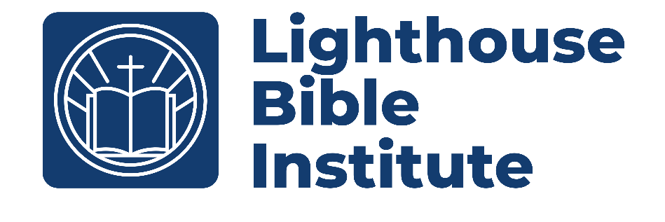

Biblical Counseling
Class Syllabus
Course Teacher: Pastor Josh Bevan
Email: pastorjosh@lbcxenia.com
Church: 937-372-9188

Course Description
This 10-week course introduces the foundational principles of biblical counseling to equip participants to counsel others effectively. It contrasts biblical approaches with secular psychology, explores theological underpinnings, and provides practical methodologies for addressing common life issues. Emphasis is placed on the sufficiency of Scripture, the role of the Holy Spirit, and integration within the local church. Participants will engage with key texts to develop skills for personal ministry and soul care. This is a 3 Credit Course

Course Objective
The course is divided into three main units: Foundations (Weeks 1-5), Methodology (Weeks 7-8), and Application (Weeks 9-10). Each week includes readings, discussion topics, and assignments. Readings from MacArthur's book focus on the foundations, methods, and application of Biblical Counseling, while Clinton and Hawkins' guide provides issue-specific insights.

Course Materials
- Counseling: How to Counsel Biblically by John MacArthur and the Master's College Faculty (Thomas Nelson, 2005).
- The Quick Reference Guide to Biblical Counseling” (Second Edition) - Dr. Tim Clinton & Dr. Ron Hawkins
- Bible
- Laptop with Logos 10
- Class Handouts will be provided by the class instructor. It is advised to have a 3-ring binder for these handouts.

Course Costs
- $10 plus books if you are not working toward certification.
- $20 plus books of you are seeking certification.
- Counseling: How to Counsel Biblically by John Macarthur, Paperback (2022)- $17
- The quick reference guide to biblical counseling by Tim Clinton
and Ron Hawkins 2nd ed. (2024) - $32

Class Schedule
- All classes will be Saturdays from 9:30am-10:45am
- This is a ten-week course starting on January 10th and running through March 14th
Class Grading/Assignments

Week | Assignments | Total Points | Percent of  Final Grade
1 | Quiz (60) and Reading (30) | 90 | 9%
2 | Quiz (60) and Reading (30) | 90 | 9%
3 | Quiz (60) and Reading (30) | 90 | 9%
4 | Quiz (60) and Reading (30) | 90 | 9%
5 | Midterm | 140 | 14%
6 | Quiz (60) and Reading (30) | 90 | 9%
7 | Quiz (60) and Reading (30) | 90 | 9%
8 | Quiz (60) and Reading (30) | 90 | 9%
9 | Quiz (60) and Reading (30) | 90 | 9%
10 | Final Test (140) | 140 | 14%
 | Total Points | 1,000 | 100%
- To pass the class, you must:
  - Have an average of 70% or better (C average or better).
- All assignments may be turned in up to two weeks late.
  - Within the first week, there is up to a 10% penalty for late work.
  - In the second week, there is up to a 20% penalty for late work.
  - After two full weeks, the assignment will be graded as zero.
  - Prior planned excused absences may receive extra grace at the professor’s discretion.
  - It is your responsibility to seek out the work you miss in a timely fashion.

Course Outline
- What is Biblical Counseling – January 10th
  - Read MacArthur: Introduction and chapter 1 (pgs. xi-xiv; 3-17).
  - Read Clinton & Hawkins – Introduction (pgs. 7-11); “Abortion” (pgs. 13-18).
  - Quiz 1 (over readings)
  - Reading acknowledgement
  - Class Handout
- Biblical Counseling and Psychology – January 17th
  - Read MacArthur: Chapter 2-3 (pgs.18-50)
  - Read Clinton & Hawkins: “Anger, Bitterness, Forgiveness” (pgs. 39-46, 47-53, 123-129)
  - Quiz 2
  - Reading acknowledgement
  - Class Handout
- Biblical Counseling and the Glory of God – January 24th
  - Read MacArthur: Chapter 4 (pgs.51-63)
  - Read Clinton & Hawkins: “Guilt, Perfectionism, Self-esteem” (pgs. 136-141, 189-194, 214-220)
  - Quiz 3
  - Reading acknowledgement
  - Class Handout
- Biblical Counseling and Human Sinfulness – January 31st
  - Read MacArthur: Chapter 5 (pgs. 64-78)
  - Read Clinton & Hawkins: “Sexual Abuse in Childhood, Suicide, Trauma” (pgs. 221-227, 254-265)
  - Quiz 4
  - Reading acknowledgement
  - Class Handout
- Biblical Counseling and The Holy Spirit – February 7th
  - Read MacArthur: Chapter 6 (pgs. 79-87)
  - Read Clinton & Hawkins: “Adultery, Divorce, Domestic Violence” (pgs. 26-32, 85-94, 95-100)
  - Midterm Test
  - Class Handout
- Keys to Being an Effective Biblical Counselor – February 14th
  - Read MacArthur: Chapter 7 (pgs. 88-100)
  - Read Clinton & Hawkins: “Death, Grief & Loss, and Loneliness” (pgs. 60-66, 130-135, 150-155)
  - Quiz 5
  - Reading acknowledgement
  - Class Handout
- Building Relationships and Instilling Hope – February 21st
  - Read MacArthur: Chapter 8-9 (pgs. 101-130)
  - Read Clinton & Hawkins: “Depression & Discouragement” (pgs. 73-84)
  - Quiz 6
  - Reading acknowledgement
  - Class Handout
- Gathering and Interpreting Data – February 28th
  - Read MacArthur: Chapter 10-11 (pgs. 131-161)
  - Read Clinton & Hawkins: “Addictions, Eating Disorders, Pornography, Workaholism” (pgs. 19-25, 101-108, 195-201, 266-271)
  - Quiz 7
  - Reading acknowledgement
  - Class Handout
- Implementing Biblical Counsel – March 7th
  - Read MacArthur: Chapter 12-14 (pgs. 162-202)
  - Read Clinton & Hawkins: “Fear & Anxiety, Stress, Worry” (pgs. 117-122, 241-246, 272-278)
  - Quiz 8
  - Reading acknowledgement
  - Class Handout
- Biblical Counseling and the Church – March 14th
  - Read MacArthur: Chapter 15-17 (pgs. 203-230)
  - Read Clinton & Hawkins: “Homosexuality, Mental Disorder, Spiritual Warfare” (pgs. 142-149, 162-168, 234-240)
  - Final Test

