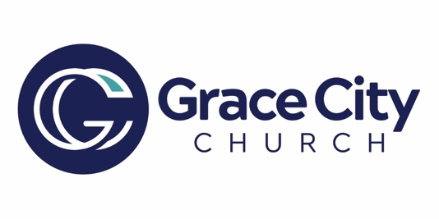

Life Groups- Fall 2025

SUNDAYS
📍 On Campus – 10:45 AM
- Ed Gilman / Jim Jackson- Coed -Study of Revelation (Room 5-105)
  - Edgilman44@gmail.com
  - oneoftheflock22@yahoo.com
- Tom Hudgins – Men’s Group -Discussion on Sermon (Teachers’ Lounge)
  - tom@gracecitychurch.us
- Karen Bennett & Karen Hudgins. -Women’s Group- “So Long, Insecurity” by Beth Moore (Media Center)
  - Karenb6191@gmail.com
  - firstladyjh@yahoo.com
- Mason Rousseaux-Students-Discussion on Sermon (Media Center)
  - mason@gracecitychurch.us
- Alex Vinot- Coed -Study of Creation (Room 5-104)
  - alex@dentalintranet.com

MONDAYS
- Debra Miller – Women’s Group- Book of 1, 2, 3 John by Pastor Gary Hamrick, Cornerstone Chapel
  - dmiller6717@yahoo.com
📍 6717 Collingswood Ct, New Port Richey, FL 34655-7:00-8:30 PM
- Karen Bennett –Women’s Group- “He Calls You Beautiful” by Dee Brestin
  - karenb6191@gmail.com
📍 2023 Winding Oaks Drive, Palm Harbor, FL 34683-10:30 AM

TUESDAYS
- Debra Miller / Karen Fandrick- Women’s Group– Book of Jonah by Pastor Gary Hamrick, Cornerstone Chapel (Sept. only), then TBD
  - dmiller6717@yahoo.com
  - karen.fandrick@verizon.net

📍 3574 Indigo Pond, Bldg. 6, Palm Harbor, FL 34685-10:30 AM-12:00 PM

WEDNESDAYS
- Tom & Karen Hudgins – Couples Group- Book of James – 2nd & 4th Wednesdays, begins Aug 27
  - tom@gracecitychurch.us
  - firstladyjh@yahoo.com
📍 13892 Oak Forest Blvd S, Seminole, FL 33776 - 6:30-8:00 PM
- Shawn & Jessica Liebegott – Coed- “Everyone Communicates, Few Connect” by John Maxwell
  - liebs21@yahoo.com
📍 1435 Gopher Lp, Tarpon Springs, FL 34689- 7:00 PM

THURSDAYS
- Jake & Kayleigh Trimble – Young Adults
  - Jaketrimble98@gmail.com
📍 2733 Scobee Drive, Palm Harbor, FL 34683-7:00 PM
- Survivors of Addiction- Coed- Tom Hudgins, Kevin Gordon & Mark Araujo
  - tom@gracecitychurch.us
📍 906 San Salvador Dr, Dunedin, FL 34698-7:00 PM

SATURDAYS
- Keith Scott – Men’s Breakfast- 2nd Saturday of each month
  - 727-259-3006
📍 Oldsmar Village Inn, 3682 Tampa Rd, Oldsmar-8:30 AM
- Joyce Sharp – Women’s Group- Book of John (Starting with Chapter 13)-Every other Saturday beginning Sept. 6
  - jsharp6803@gmail.com
📍3574 Indigo Pond Bldg. 6 Palm Harbor, 34685- 11 AM-12:30 PM

Life Groups are the core of Grace City: a place to deepen your faith, find community, and live life together.

