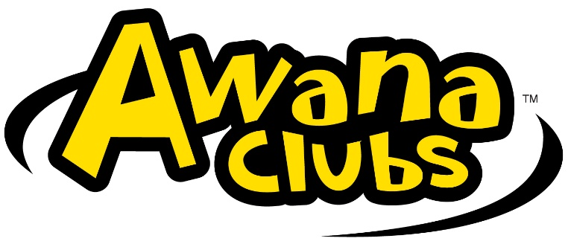

Southside Club Members Uniform Order Form

AWANA clubbers will be asked to wear uniforms to club each week. Points will be given to clubbers for wearing uniforms.

Please complete order form and turn in to the Awana office.

Clubber Name: ______________________________________________

Telephone Number _______________________

|  |  |  |  |  |
| --- | --- | --- | --- | --- |
| Quantity | Uniform | Size | Price | Total |
|  | Puggles T-shirt – light blue (2 yr olds)  Sizes 2T, 3T, 4T, 5T/6T |  | $13.00 |  |
|  | Cubbie Vest – royal blue (3-4 yr olds)  Sized Med (5), Lg (6), XL (8), 2X (10) |  | $15.00 |  |
|  | Sparky Vest – red (Kindergarten – 2nd Grade)  Sized Med (8), Lg (10),  XL (12), 2X (14), 3X (16) |  | $15.00 |  |
|  | T&T Adventure & Challenge Jersey (Grade 3-6)  Y-Sm (10), Y-Med (12), Y-Lg (14),  A-Sm, A-Med, A-Large, A-XL, 2X, 3X |  | $20.00 |  |
|  |  |  |  |  |