**First Step – Teacher’s Guide**

May the people raise you, O God. Then the earth will yield its harvests.

1. Who is Jesus?

A journey to **discover** **who** Jesus is. What the Bible says about Him and what He has done for us.

**To Prepare:**

**1st Step Notes**

**7 Miracles of Jesus**

**Progress Chart**

**Welcome:**

A warm welcome to each and everyone of you – how was the food?

For those of you who are new here, we are happy you are with us. We look forward for the opportunity to know you better. The reason we are gathered today is so we can enjoy some tasty food, fellowship, and fun. We are confident that everyone will have an awesome time.

And no matter where you are from, God has good things in store for you. Your life is not an accident. The fact that you are here today is not a coincidence. I believe God has chosen you and He has a good plan for you.

**MAIN RULES:**

**1. Respect each other’s privacy**

**(do not ask for contact number, no business transactions)**

**2. Honor the vision of this church**

**(do not promote or invite to other church events and programs)**

**3. Humility and Order**

**(humble despite disagreements. Other questions can be discussed after the class)**

**Introduction:**

That’s the beginning: Creation.

When God created the earth, He created humans and told them: “Be fruitful and multiply.” We were meant to thrive and succeed and do well in our field.

However, the first Adam sinned and as a result, there was a barrier between man and God.

**Attempt:**

As a result of sin, the world now had huge problems to which we still face today using the acronym **SIN**:

1. **S**eparation from God

2. **I**ncompletion

3. **N**eediness

Or SELF-INFLICTED NONSENSE

**Failure:**

Now how many of us have tried to fix problems in our life and it didn’t work?

We used our human ways to repair the relationship, fix the business, do everything and visit every doctor

We have all tried the many ways to make things work but sometimes we fall short. And our bad days have become a bad year.

**Pivot:**

But God did not intend to leave **YOU** all alone by yourselves.

God loved **YOU** too much to destroy and start all over again. God is not taken by surprise.

In fact, He had a plan which is to send His son, Jesus Christ.

Let’s take a look at one of the most beautiful verses in the Bible:

John 3:16

For God so loved the world that He gave His one and only Son, that whoever believes in Him shall not perish but have eternal life. NKJV

So what can we take away from this verse? Firstly,

SUGGESTED FOR INTERACTIVE DISCUSSION

Have you ever had questions about life, God and eternal life?

What do you think about a God who still wants to be friends with us?

1. God so love you!

**Explanation:**

Yes you! Each and everyone of you sitting here are beautifully made and so loved.

You are precious to God.

Psalms 139 tells us even before we were formed in our mother’s womb, God knew us.

God knows you PERFECTLY,

yet God loves you INFINITELY!

In Greek, there are different words for “love” such as phileo (friendship), pragma (companionship), eros (romantic love) and agape (selfless love).



In Greek, the word love in John 3:16 is called Agape. This is the **highest** form of love because this is selfless, sacrificial and unconditional.

I’ll unpack this for you now:

**Illustration:**

I overheard my niece say “I love ice-cream.” But then later on, she said, “I love you mommy.”

And I just wonder: is ice-cream the same as mommy?

In English, we say “love” generally e.g. “I love hotpot, I love apples yet I also love my spouse and children.”

Love has been used as a general term for even likes and dislikes and for items and for people (between parent or grandparent and child, between couples)

But do you love your children the same level as apples? Or the same level as hotpot and apples?

You may feel a deeper love for your children. For them you would sacrifice a lot more.

Like my sister signing up a membership to take them to the petting zoo every week.

Like my brother in law teaching them how to play sports or how to swim. There is a love that goes beyond mere interests.

Like a parent, that is how God loves you. In fact the depth of Hi love is so great. It is selfless, sacrificial and unconditional love.

God loves us so much He gave us His only Son, Jesus to die on the cross for us.

So this is what I mean:

**Application:**

(Teachers, please use your own illustration if you have)

My sister and her husband has a son and daughter with two different interests. The son loved animals and her daughter loved sports. So what do the parents do? They love them so much that on their day off and every available time, they’ll take the kids to either play sports or to the petting zoo.

They even got the annual pass because they knew their kids just loved going to the petting zoo.

As a parent, they’d sacrifice their time, money and effort. While there is no perfect parent who can perfectly love, you have a heavenly Father who loves you. God is your heavenly Father.

So we see that God so love you!

SUGGESTED for INTERACTIVE DISCUSSION

1. Do you believe that there is a God there who loves you?

2. What does love mean to you?

Secondly,

2. God gave His one and only Son!

**Explanation:**

Jesus is both Almighty God and Perfect Man. When He came to this earth 2000 years ago, He performed many miracles, healing the sick and encouraging the weary.

Jesus healed the deaf, blind, paralyzed, sick and injured. And He can do the same for you TODAY!

In our low’s, His compassion flows!

Now because God is a just God, there has to be judgment for sin just like there is a punishment for a crime committed whether big or small.

Jesus came to be the punishment for us and be the sacrifice for EVERYONE

He didn’t come to give more laws, merely as a teacher or prophet. He came as our Savior.

His heart is filled with COMPASSION, not CONDEMNATION.

Jesus did so much good in the world i.e. healing, comforting, encouraging.

But as God knew, humans had become so full of hatred and harshness that they then caught hold of him, beat him and brought him to the cross.

This is done on the cross, an old Roman way to prolong torture and eventual death.

It would have looked like this:



He took the punishments that we deserve. As we receive what He has done, God can forgive you righteously.

So we don’t have to carry that shame, guilt and condemnation anymore because

We receive what He has done and receive His forgiveness

Now this is what I mean:

**Application:**

(Teachers, please use your own illustration if you have)

When I was younger, my family went to the mall. It had plenty of decorations one of which involved the colorful art of powder on the floor. When my parents were not looking, I jumped into one of the exhibits and messed it all up. I thought it was like a colorful playground floor.

The guards came to stop me and demanded repayment. But I was so young. What could I do? What money did I have to repay? Can I even re-do the art for the mall?

My father took out his wallet and paid the fine. My father gave what I could never.

So we see that God loves us so much that He gave His only Son, Jesus Christ.

Discussion:

Why is sin so destructive?

How does God show His love for us?

Is it possible to ever repay God fully?

SUGGESTED for INTERACTIVE DISCUSSION

1. If we messed up, how could God choose to react?

2. How would you feel if someone gave you compassion instead of condemnation?

3. Why does God need to give us His only son?

Now lastly,

3. Whoever believes shall not perish but have eternal life !

**Explanation:**

Jesus Christ is the Son of God whom God sent to die on the cross and who 3 days later was resurrected.

Now because of Jesus Christ, when we believe in Him, there is a place that awaits us when we leave this earth and it is called heaven.

It is also described as eternal life or everlasting life.

But the word for eternal applies not just in the future in heaven but on the quality of the age, i.e. the quality of life with God now. (HELPS Word Studies)

1 Corinthians 5:17

Therefore, if anyone is in Christ, the new creation has come: The old has gone, the new is here!

Jesus Christ wants to give YOU happiness, peace and hope this very day!

We don’t have to wait until we get to heaven for it.

Right now, with Jesus it is like heaven on earth.

Eph 2:8

8 For it is by grace you have been saved, through faith-and this not from yourselves, it is the gift of God.

We call this “grace”. Because we don’t deserve to live life like heaven on earth yet because of Jesus, we can. He was righteous where we are not.

Here's a practical way to illustrate justice, mercy and grace.

**Illustration:**

Let’s say there was a youth without a driving license who took his father’s car and whilst driving, he lost control and he crashed it into your gate.

What would you do?

So here’s the difference between justice, mercy and grace:

Mercy: “It’s alright boy, I’ll let it go. You just leave now.”

Justice: “This requires a repair work of RM1000. Pay me back. I will also have to report you to the police for reckless driving without a license.”

Grace: “Oh dear – what happened? Are you okay? Don’t worry about the gate. Why did you drive the car? Is everything okay at home? If you need help with driving lessons, I will personally help you. Have you eaten dinner? You can join my family for dinner if you’d like.”

Grace is undeserved yet through Jesus, we are able to have God’s grace.

**Application:**

(Teachers, please use your own illustration if you have)

So earlier I shared on how my father gave and paid the fine for what I did wrong.

While he gave me a good talking to and caning, he didn’t continue to let me feel guilty. Even after that incident, he still took me to the zoo, eat ice cream, buy toys, play boardgames etc.

I shouldn’t deserve any of it because my mistake had cost him money! Yet even to this day no matter how old I will be, he doesn’t hold my mistakes against me and ask for compensation.

Now if an earthly father forgives and loves, how much more your Heavenly Father who forgives and loves you and wants to be reconciled back with you.

Discussion:

Does a person automatically become perfect upon believing in Jesus?

How does life change after knowing Jesus?

Lead them to say the Sinner’s Prayer:

Dear Heavenly Father, thank you for sending Jesus Christ to die for me on the cross for all my sins. I receive what Jesus has done for me. Thank You for forgiving me of all my sins and for releasing Your favor and blessings on me. Help me to know you more each day.

In Jesus’ Name, Amen!”

SUGGESTED for INTERACTIVE DISCUSSION

1. If we messed up, how could God choose to react?

2. How would you feel if someone gave you compassion instead of condemnation?

3. Why does God need to give us His only son?

Five Blessings of the Cross

But there is a **problem**. Man chose to **ignore** God and lost his **relationship** with God.

Man **lost** the **presence** and the great **partnership** with God. Jesus came to bring you back to God by dying for you on the cross.

**C**omplete forgiveness of d your sins

Isa 53:5-7

But he was pierced for our transgressions, he was crushed for our sins.

**Hates sin –** loves you – destroy

**Just** – paid the penalty

To forgive us of our sins and still be just, He came down and paid the penalty of all our sins!

**R**estoration of your relationship with God

Rom 5:11

11 Now we rejoice in our wonderful new relationship with God … making us friends of God.

**O**verflowing Abundance

2 Cor 8:9

Though He was rich, yet for your sakes He became poor, that you through His poverty might become rich.

**S**upernatural Healing

Psa 103:1-3

… Who forgives all your sins and heals all your diseases.

**S**upernatural Restoration

Joel 2:25

I will restore to you the years which the locust has eaten.

Lost **relationships** – **opportunities** – **business** – **health** - **honor**

**Restoration** of lost opportunities, relationships, business, health, honor and others.

Prayer to receive Jesus Christ

Jesus has more credits than we have deficits.

Jesus has more forgiveness than we have faults.

If it’s okay with you, I’d like to take this opportunity to invite you to follow me in prayer to receive Jesus into your heart and into your life.

* 1. Article I

What do we know about Jesus Christ?

He was born of a virgin

Matthew 1:23

The virgin will be with child and will give birth to a son, and they will call him “Immanuel" - which means, "God with us." NIV

If Jesus had Mary's blood, He would have had normal imperfect human blood. But Jesus’ Blood is pure and spotless; the Perfect Lamb of God.

Isa 7:14

Therefore the Lord Himself will give you a **sign**: Behold, the **virgin** shall conceive and bear a Son, and shall call His name Immanuel. *NKJV*

Why is the virgin birth a **sign**?

Gray's Anatomy:

a recognized medical authority, states:

One of the **discovery**

– **unfolded** an **astounding** scientific fact:

Clip: Villi of the womb

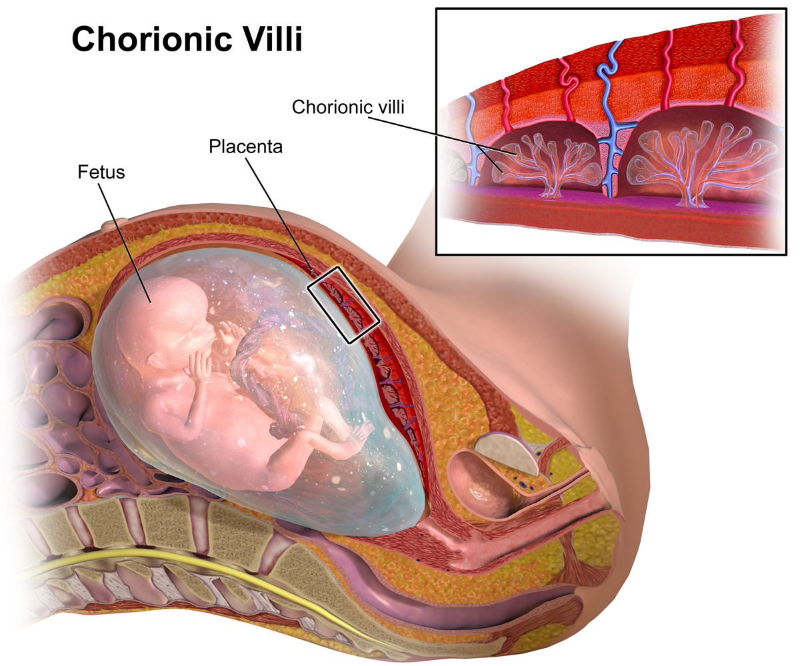

The Chorionic villi: Finger like projections that contains capillaries transporting oxygen and nutrients through the umbilical cord. Both the fetus and its mother’s blood **do not intermingle**, being **separated** from each other by the delicate walls of the villi. Through the blood vessels in the umbilical cord, the fetus receives all necessary **nutrition** and **oxygen**. Science and research has shown us that the blood of a mother and her unborn child **never mixes,** and if it does, the mother's blood would raise up an **immunology** protest. The mother will start making so many antibodies that she will not be able to carry her baby at all. A mother and her baby have **TWO distinct blood system.**

He is Almighty God and Perfect man

1 Peter 2:22

He committed no sin, and no deceit was found in his mouth. NIV

**Examined** 4 days – by religious – rulers – found not guilty – spotless lamb in Passover

Like the lamb – brought into house 4 days

The thing is, there is no once and for all sacrifice. Only Jesus can do it.

As **man** He can die for **man**. As **God**, with infinite value, He could die for **all** men.

The **superlative** value of Christ is more than sufficient to cover the sins of all men. In fact, it is overpaid!

Superlative value of the One – more than enough – pay for all sins

He didn’t come to give more laws, merely as a teacher or prophet. He came to be our Savior.

1 Pet 2:22

He committed **no sin**, and no deceit was found in his mouth. *NIV*

**Practical** application:

Heb 4:15-16

This High Priest of ours **understands** our weaknesses, for he faced all of the same testings we do, yet he did not sin.

16So let us come boldly to the throne of our gracious God. There we will **receive** his mercy, and we will find grace to help us when we need it most.

He works supernatural miracles

Matt 8:27 Winds obeyed Him

The men were amazed and asked, "What kind of man is this? Even the winds and the waves obey him!" *NIV*

Luke 7:22 Blind see, lame walk, deaf hear, poor hears good news …

Go and tell the things you have seen and heard: that the **blind** **see**, the **lame** **walk**, the lepers are cleansed, the **deaf** **hear**, the **dead** are **raised**, the **poor** have the **Good** **News** preached to them.

John 11:38-44 Lazarus raised

Lazarus was raised from death.

**Practical** **application** – wants to take you beyond the natural – business

Ask God sized prayers

He is the perfect sacrifice for our sins

1 Peter 3:18

For Christ also suffered once for sins, the righteous for the unrighteous, to bring you to God. He was put to death in the body but made alive in the Spirit. ESV

He rose from the dead

John 11:25

Jesus said to her, “I am the resurrection and the life. The one who believes in me will live, even though they die; NIV

1 Cor 15:5-8 **Appeared** to over **500** disciples at the **same** time

… and that he appeared to Peter, and then to the Twelve. 6After that, he appeared to more than five hundred of the brothers at the same time, most of whom are still living, though some have fallen asleep. 7Then he appeared to James, then to all the apostles, 8and last of all he appeared to me also, as to one abnormally born. *NIV*

He gives us new life

1 Corinthians 5:17

Therefore, if anyone is in Christ, the new creation has come: The old has gone, the new is here!

He is unique and has an astounding impact in history

Col 1:16-17

17He is before all things, and in him all things hold together. *NIV*

**Cultic** leaders can claim all kinds of thing

Jesus Christ

Holy Spirit

Mother of God

Can they **put together 300 prophecies**

Precisely predicting - birth, life and ministry, buried and resurrection

– **how** – **when** - **why**

**300** over prophecies – **1500** years – different people

Chances

100 quadrillion

1 in 100,000,000,000,000,000.

– **Rolls** Royce - explosion in Bak Kut Tay store

**Cover** France with silver coin two feet

and mark one of them. Blindfolded man reach and pick up the coin

Chance of that – like prophecy being fulfilled

Mathematically impossible.

He didn’t come to give more laws, merely as a teacher or prophet. He came to be our Savior.

Center of History

20 centuries – come and gone – he still **center** of human history

– **history** is divided by BC or AD

**Anno Domini** – in the year of the Lord

Today – CE – Common era

Or **BCE**

Astounding impacts

Transform an **empires** inside out eg Roman empire

**Life** transformed

**Slavery** abolished

**Women’s** rights elevated

Out of **100** great universities

- Many Harvard, Yale, Princeton, Columbia, and Oxford, Cambridge

Many famous **scientist** are staunch believers

Galileo **Galilei** (1564–1642):

Italian astronomer, physicist, engineer, mathematician

Spearhead science and renaissance.

Johannes **Kepler** (1571–1630)

Kepler's laws of planetary motion.

Louis **Pasteur** (1822–1895):

Microbiologist - **vaccination**

Michael **Faraday**

electromagnetic theory - establishing electrolysis.

Robert **Boyle**

Defined elements, compounds

Discovered the first gas law – Boyle’s Law.

Gregor **Mendel** 1822 – 1884.

A Catholic priest - founded the science of **genetics** - mathematical rules of **heredity** - identified **recessive** and dominant genes.

Isaac Newton 1643 to 1727

More time on Bible **study** than math and physics.

**Creative** bone and marrow

Discovered law of **gravity** – motion – invented **calculus** - first reflecting **telescope** – sunlight made of all the colors of the **rainbow**.

John **Fleming** 1849 – 1945.

A devout Christian who preached about the **Resurrection**

Founded the **electronic** age with his invention of the **vacuum** tube - **electric** motors and **generators**.

With Jesus, it is FINISHED!

**All faiths** teach – do good and you get to go to heaven or have a better life

**With Christ, it is finished**

John 19:30

When he had received the drink, Jesus said, "It is finished." With that, he bowed his head and gave up his spirit. *NIV*

The word, finished, means **paid** in full.

The word is used in the ancient papyrus documents to denote someone’s bill has been **paid in full**

Many people are ready to accept Jesus as merely a great moral teacher. Is this a possible claim?

A man who says the sort of things Jesus claims and promises is either a **liar** and a **lunatic** or is **really** what he claims to be - God!

There can only be three alternatives: …

His claims were false and he knew his claims were false.

If this was the case, then, he told a deliberate lie. So he was a liar and an impostor.

His claims were false and he did not know his claims were false.

Then, he was sincerely mistaken - so he must be a lunatic.

His claims were true and he is, indeed, the true God.

So you either accept him or reject him.

Someone who lived, **taught**, **impacted, transformed** lives and **resurrected** as Jesus did, can such a person be a **lunatic**? Can he be a **liar**?

A lunatic could never have given such profound teaching and performed such miracles or brought such impacts and transformation of lives.

A liar would never have sacrificed his life, nor would he have had the power to rise again.

It would take more than a Jesus to invent a Jesus. He is the Almighty God in human form.

* 1. Article II

A Man Without Equal

Here is a man who was born in an obscure village, the child of a peasant woman. He worked in a carpenter shop until he was 30, and then for three years he was an itinerant preacher. He never wrote a book. He never held an office. He never traveled two hundred miles from the place where he was born.

One day, he went through the mockery of an unfair trial. He was declared innocent but was crucified. His followers ran away. One of them denied him. He was nailed upon a cross between two thieves.

Nineteen long centuries have come and gone and today he is the centerpiece of the human race and the leader of the column of progress. Our daily events are dated before or after he was born (BC or AD).

He never wrote a book, and yet more books have been written about him than anyone on earth. He never wrote a song and yet he has furnished the theme for more songs than all the songwriters combined.

Without an army, he conquered more millions than Alexander, Caesar and Napoleon combined. Without a formal education, he spoke such words of life as were never spoken before or since and produced effects which lie beyond the reach of orators or poets.

All the armies that ever marched, all the parliaments that ever sat and all the kings that ever reigned, put together, have not affected the life of man upon this earth as powerfully as that one man - JESUS. *James Allan Francis (1864–1928)*