 | SEPTEMBER 2025
 | AMAZING GRACE  CONNECTIONS  Faith > Family > Community

Grace Lutheran Church of Lily Lake
5N600 Hanson Rd, St. Charles, IL 60175
Pastor David Mercurio

Worship every Sunday
At 9:30 am with Communion
.
- September 7 – Rally Sunday, Sunday School & Coffee Hour
with a short congregational meeting following worship to approve the 2024 audit.
- September 14 – Worship
- September 21 – Worship and Sunday School
- September 28 – Worship

Rally Sunday is the beginning of the new Sunday School Year and serves as a celebration of Christian Education and fellowship for the entire congregation. It is a time to rally together, renew energy for spiritual activities and welcome everyone back after the summer break.


MEMORIAL SERVICE FOR
PASTOR ARNE WALKER

In memory of our own Pastor Walker, there will be a memorial service at Grace on Saturday, September 20th.
10 am Visitation
11 am Service
12 pm Luncheon
Pastor Walker served at Grace Lutheran from 1966 to 1986
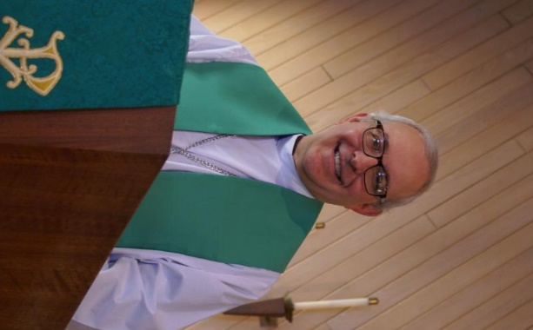
FROM PASTOR DAVID, SEPTEMBER 2025

Every person must answer four existential questions: Where did I come from?
Why am I here? What am I supposed to do? What happens when I die? Broadly
speaking, how you answer those questions puts you in one of two camps.

Camp A
Billions of years ago, a primordial soup came about on earth, itself the result of a big bang. That soup, through a random process of chaos, evolved into single cell amoebas, which in turn became fish, then mammals, then apes, then humans. I am here to be kind and supportive to my fellow human beings without irresponsibly damaging the environment. I shall work hard, obey the law,
accumulate a large 401k, advance in my career, raise a family, and retire early,enjoying life as best I can along the way. After I am gone, I shall return to the dust and be no more.
Such a world view gives us the following headlines:
- Pregnancy robots’ could give birth to human children in revolutionary breakthrough — and a game-changer for infertile couples (NY Times; 8/17/25)
- Committee reviewing euthanasia in Canada finds some deaths driven by homelessness fears, isolation (AP; 10/18/24)
- UK free speech crackdown sees up to 30 people a day arrested for petty offenses such as retweets and cartoons (NY Post; 8/19/25)

Camp B
I came about through God’s master plan set in motion from before time began. (I praise you because I am fearfully and wonderfully made. Psalm 139). During my short time here, I have one purpose-to honor and obey my Creator. (“Praise be to the Lord, the God of Israel, because he has come to his people and redeemed them. Luke 1). While I am here, I have certain responsibilities to fulfill, not as a burden, but in thankfulness for all that has been given to me. I am to love the Lord my God with all my heart, soul, mind, and strength, and I am to love my neighbor as myself. (Therefore, my dear brothers and sisters, stand firm. Let nothing move you. Always give yourselves fully to the work of the Lord, because you know that your labor in the Lord is not in vain.
( I Corinthians 15). And after my time on earth is over, I have a blessed assurance that I will be reunited with the Father, Son, and Holy Spirit from which I came. (Then the angel showed me the
river of the water of life, as clear as crystal, flowing from the throne of God and of the Lamb down the middle of the great street of the city. On each side of the river stood the tree of life, bearing twelve crops of fruit, yielding its fruit every month. And the leaves of the tree are for the healing of the nations. No longer will there be any curse. The throne of God and of the Lamb will be in the city, and his servants will serve him. They will see his face, and his name will be on their foreheads. There will be no more night. They will not need the light of a lamp or the light of the sun, for the Lord God will give them light. And they will reign for ever and ever. Revelation 22).

I have yet to figure out what is attractive about Camp A when Camp B has been freely given to us. More importantly, I am thankful for the invitation.
AMEN

Recently, Nobel Prize winner Geoffrey Hinton, considered the godfather of
AI (Artificial Intelligence), has been making the media rounds, sounding a clarion call to humanity regarding the dangers of his invention. I think most of us have heard the term AI enough times to at least be somewhat familiar with what it is, a computer .

Pastor’s Hours: Mondays, Wednesdays and Fridays plus Sundays and as needed and by appointment when requested.

VISION TEAM REPORT
At their August meeting the Vision Team:
- Approved minutes and treasurer’s reports
- Noted the visits pastors has been making
- VT is in process of updating our membership list
- CD of $36,750 has been renewed for 12 months
- Janice Muncie’s daughter’s wedding will be at Grace on Oct. 18th. VT approved throwing of bird seed
- Erosion control has been completed on the east side of the building
- Ongoing maintenance issues: tree trimming, resurfacing of parking lots, repair of masonry on west side of buildling, purchase of new lawn mower, sanctuary carpeting wronkles, parsonage resolution
See minutes located on the gathering room table for more information.

If you have any questions or concerns, please contact a Vision Team member: Pastor David, Dallas Peters, Tricia Painter, Lee Strom, Nancy Schnaitman, and Cathy Lindquist.


SPECIAL THANKS to all who have shared their time and talents with Grace , including but not limited to:
- All who helped with the Elburn Days church float and parade especially Cathy Whiteside, Janice Muncie and Karen Patterson – too many more to name including all ages. See picture at the end of the newsletter.
- Special thanks to Linda Smykowski for coordinating the installation of our new air conditioning unit that cools the Grace Room and some office areas.
- All the clothing sorters coordinated by Cathy Whiteside.
- All who have assisted with ushering during worship over the summer.


REBECCA CIRCLE

Circle will meet on Tuesday, September 16th at 1 pm in Fellowship Hall. Hostesses are Vicki Linden and Jan Meyer.

The Circle will be sending cards and gift cards to our college students this fall. Please give addresses to either Twyla Strom or Kathy Hooey by the September Circle meeting.

FINANCIAL MATTERS – SEPTEMBER 2025
Summer months are coming to an end, school sessions have begun. Your continued
donations are a blessing to Grace and allow a variety of ministries to continue at Grace and help us serve our community.
- Our 11-month CD matured and Vision Team voted to reinvest the $36,750 into a 12-month CD @ 4%.
- Drainage + erosion repairs on the east end of church, along with some mulch installation was completed ($3,640). Funds from the Capital Improvement savings were used, and the present balance is $3,371. The Building Maintenance and Vision Teams review building and safety needs, outside of the regular maintenance services and any emergency repairs. If you wish to donate to this specific fund, please notate “Capital Improvement Fund” (which was f/k/a Building Maintenance Fund), so your donation is designated accordingly.
- A brief Congregational Meeting will be held on Sunday, September 7, at the conclusion of the worship service, to Accept the 2024 Audit Report.

Brief recap of July financials:
2025 2024
July 2025 Year-to-Date Year-to-Date
INCOME $ 12,085 $ 181,489 $ 114,219
EXPENSES $ 18,321 $ 138,843 $ 102,737
NET +/- $ -6,236 $ 42,646 $ 11,482

I pray for continued blessings upon our Grace family in the month of August ~ Blessings, Tricia Painter, Treasure


Line dancing & Games
S’mores by the fire pit
Hot dogs, pulled pork
Side dishes & drinks
Desserts
Saturday, September 27
4 – 7 pm (food served until 6:30 pm)
A free will offering will be taken to be shared with
the Elburn Food Pantry

Join us for the fun. Community is invited!!!


PRE School Program
This Photo by Unknown Author is licensed under CC BY-ND
Pre-School program – open house on September 3rd from 9-11 am. The school year resumes in September still on Mondays and Wednesdays. Registration is open for the 2025-2026 school year. Please tell anyone you know with a 3 to 5 year-old child to check out our website at graceoflilylake.org/PDO. You can also contact Janice Muncie directly at 630-854-1066.

FALL RUMMAGE SALE
OCTOBER 3 & 4

We are preparing for the Autumn Rummage Sale on Oct. 3 (9am-4pm) and Oct.4 (9am-2pm) - please mark your calendars. We kindly ask that you hold your donations until the end of September (Oktoberfest is Sept. 27) as we cannot clutter up entryways, doorways, walkways, etc. If you have items that can be stored in the garage (nothing with cloth or fabric please), stored in critter proof containers - please contact Linda Smykowski to coordinate drop-off (708-309-3444). If you have a clothing donation, please contact Cathy Whiteside (630-605-1096) - **she collects clothing year-round &amp; please contact Cathy if you can help throughout the year also**
Also, when considering your donations, our gentle reminder to please ask yourself,
“would I purchase this?, does it work/operational?, are the cords or all pieces
intact?, doesn’t smell like smoke and free of pet hair?, it is (fairly) clean, etc.” -
if not, please understand if we say “no thank you” & “we don’t have the volunteer
time to go through it all.” As a reminder, we cannot accept TV cabinets, older TVs,
and large furniture pieces. Thank you for your understanding and cooperation.
SEPT/OCT - Donation Drop-Off Times:
Mon, Sept. 29: 6-7pm
Tues, Sept. 30: various times - pls watch weekly announcements
Wed, Oct. 1: 10am - 6pm; volunteers needed for sale set-up in pavilion, garage,
Fellowship Hall
Thurs, Oct. 2: 10am-6pm (**last donations will be accepted until 3pm); volunteers
needed for sale set-up throughout the day
Friday, Oct. 3: volunteers needed all day of sale (9am-4pm)
Saturday, Oct. 4: volunteers needed all day of sale (9am-2pm) & sale clean-up -
2pm until ??
Any further questions, please contact me. Gratefully, Tricia Painter 708-624-
0400 (leave message or text)


HABITAT FOR HUMANITY - POTTAWATOMIE
Grace Lutheran is a partnership church. Nancy Corbige, our representative to Habitat for Humanity, reports that they have started building a new house in St. Charles, north of Rte 64 and that volunteers are needed. Times you may volunteer include, Wednesday, Friday or Saturday from 8:30 am to 4 pm.

If you can volunteer a day or more, please send your name and email address to Nancy at ncorbige@gmail.com. She will keep us updated on the progress of the build. Volunteers do a variety of jobs, including providing lunches, doing clean up, painting and construction work.


ROAD RUNNERS 2025 TRIP

Dear Grace Roadrunners,

Spring Greetings! Plans are coming together for our 2025 Roadrunner trip –“Let’s Travel to Iowa.” The trip leaves Monday, September 22 and returns Saturday 27. We decided to concentrate on the NE corner of the state -Decorah, Dyersville, Mason City and Dubuque. We found some interesting stops in some of the smaller towns in this area too. We’ll go to the Field of Dreams, National Mississippi Museum and Aquarium, Vesterheim- the National Norwegian-America Museum, Bily Clocks Museum and Music Man Square.
This trip will cost $1030 - $1130 per person based on double occupancy. If you desire a single room, add $340. A deposit of $500 due June 26th holds your place with the balance due August 1st . Checks should be made out to Grace Lutheran Church of Lily Lake with Grace Roadrunners written on the memo line.
The first 40 registrations are guaranteed a spot on the coach, and then a waiting list will be started. Please mail your registration sheet and check to: Suzanne Girsch, 370 Delnor Glen Dr., St. Charles, IL 60174. The $500 deposit will be refundable before July 31st . Refunds after the final payment is due will be based on what we are able to be compensated for. Contact Suzanne Girsch at sgirsch1012@gmail.com or 630-888-7254 if you have questions.
Blessings this Spring, Roadrunner Planning Committee:
Suzanne Girsch, Karen North, Dawn Root and Sharon Sabin


LINE DANCING BEGINS AGAIN ON SEPT. 11
And continues this fall on Thursdays
from 6-7 pm in Fellowship Hall
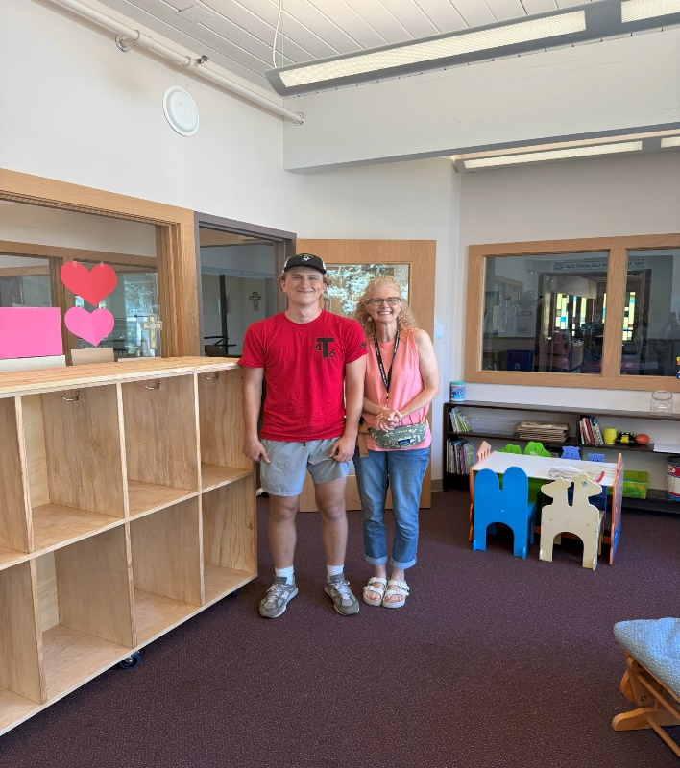
EAGLE SCOUT PROJECT FOR GRACE
You may have noticed the new furniture in the nursery room off of the Narthex. We have been blessed with another Eagle Scout project for Grace Lutheran. This one was created by Ethan Srocki. He is with Troop 46 that meets at Grace. He is also a relative of one of our preschool families. He came to us back in May asking if he could create anything for our preschool. After meeting with him, he decided he wanted to take on THREE projects! He began with drawing out the plans, working on the budget, buying all of the materials, and building cubbies, a wagon and a Lego table! All are beautiful and will be truly loved by Grace preschoolers! We can't thank him enough for his generosity and creativity! Please stop by the nursery and Grace room to see his projects.
Janice Muncie, Preschool Director

NOISY OFFERING
Every Sunday we collect a “noisy offering” when you wish to empty your change purse or pockets. We are currently collecting for maintenance items. Thank you.

MISCELLANOUS INFORMATION
- SPECIAL TECH NEED: Are you familiar with IT / computer technology / streaming ?? We are asking for several people to become familiar with or learn the technology that we use to record our church services with. Seeking several people so we will be able to spread out the weekly tasks, so your assistance is not necessary every week ~ please consider ~ and contact Pastor or Tricia Painter
- If you can knit or crochet, we need you to help make more prayer shawls as we are running low. We have the yarn so please contact Helen Gruber if you can help. If you know of someone needing a PRAYER SHAWL, please let Twyla Strom know.
- The Finance Team is looking for volunteers to sign up as counters (counting our weekly offerings after worship). Please see Linda Smykowski or Tricia Painter for further details.

SPECIAL MINISTRY INFORMATION
Bridge to Life Group’s Jesus Closet (homeless in Elgin): Items needed are backpacks, blankets, gym shoes, t-shirts, jeans, coats and socks. Please mark donated items to the attention of Cathy Whiteside (630/605-1096). Thank you for all the donations.
Clothing and miscellaneous items for those in need in Chicago are being collected by Cathy Whiteside (630/605-1096) to be given to Pastor Anna-Kari Johnson for distribution in Chicago. Thank you to all who have donated in the past.
CONTACTS:
For emergencies, please contact the church office at 630-365-6751. For prayer requests or other needs please call Kathy Hooey at 630-341-2293 or leave a message at the church office at 630-365-6751. Messages are checked daily at noon & 5 pm.

Information for the October newsletter will be due by September 25th– please send items to Marty Bradley at masbradley50@gmail.com. Thank you

Elburn Days Parade
We had a great turnout for the Elburn Days Parade again this year! We had over 25 people walking alongside or riding on the float. Such a great representation of Grace Lutheran Church! There is no cost to participate in the parade, but donations are accepted by the Elburn Lions Club who matches all donations received and passes it along to the Elburn food pantry. Cathy Whiteside collected $126 from members participating on the float that day! Thank you to everyone who made this event possible: Cathy Whiteside for hosting the float at her house and working with Karen Patterson and Janice Muncie to organize the event, the Barton’s for the use of their truck and trailer and to Missy for driving the truck, the Anderson’s for donating the bales of hay for the float, to everyone who donated candy, and to all of the members of Grace who came out to decorate the float, ride on the float and to give out candy to the many children watching the parade!



