 | OCTOBER 2025
 | AMAZING GRACE  CONNECTIONS  Faith > Family > Community

Grace Lutheran Church of Lily Lake
5N600 Hanson Rd, St. Charles, IL 60175
Pastor David Mercurio

Worship every Sunday
At 9:30 am with Communion
- October 5 – Worship and Sunday School
- October 12 – Worship and Coffee Hour
- October 19 – Worship and Sunday School (special music)
- October 26 – Worship

VISION TEAM REPORT
If you have any questions or concerns, please contact a Vision Team member
At their September meeting the Vision Team:
- Approved minutes and treasurer’s reports
- Former Chicago bishop, Wayne Miller, was appointed interim Bishop of the Chicago Synod.
- There are now 11 children enrolled in our Pre-school.
- Microsoft is abandoning support of windows 10 after October 14th.
- Monies from the Kirk Hooey memorial fund will be given to the Rebecca Circle.
- Pastor will be working remotely October 6-8.
- Grace will pay for background checks for volunteers for the preschool.
- Margaret Swanson’s son, Jeff wanted to name an area in Fellowship Hall for her – Margaret’s Corner and havve a plaque be placed there (the corner where Margaret sat selling jewelry at every rummage sale. Grace has received $1200 of memorial money in her name. It was approved to create “Margaret’s Corner.”
- It was decided that members who go above and beyond for Grace will be recognized at the Annual Meeting.
- Giving has increased since the practice of using pledge cards has stopped.
- Ongoing maintenance issues: tree trimming, resurfacing of parking lots, repair of masonry on west side of buildling, purchase of new lawn mower, sanctuary carpeting wronkles, parsonage resolution.
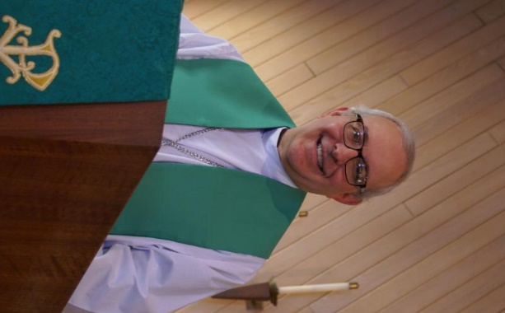
FROM PASTOR DAVID, OCTOBER 2025

Last month I took my family to the Sandwich Fair. Being a city boy, I had never been to a county fair before. I would describe it as a huge carnival with an
expansive side of animals for show. But we had a blast. (Thank you, Kurt, for the recommendation). Late in the day, as my wife and son were occupied with a
coloring book, I decided to engage in one of my favorite past times: people
watching. And as I gazed at the throngs of people walking by, two thoughts came to mind.

First, I thought of all the people I have met in my life who were raised on a farm (but when I met them, they were in some endeavor not related to farming). What struck me about them is the fact that they were all very successful in their profession, which totally debunks the “country bumpkin” stereotype. I wondered what the cause of their excellence might be. As I looked around at the fair, it
dawned on me. Growing up on a farm entails hard work and discipline; there’s no lying around on the couch playing video games. You also have to learn to work with others as many chores cannot be done alone. And you have to figure out how to solve problems, whether opening a stuck gate, or tearing down and rebuilding a complicated piece of machinery. And all these skills are transferable
throughout life, which I believe contribute to one’s success.

Then I thought of something else. If you’ve followed the news at all these past few years, you would recall many doom and gloom stories that humanity is fading. Birth rates have plummeted around the globe to the point where many countries, including the U.S., are below their replacement levels, signaling the eventual extinction of the human race. But wait. If that is true, why am I seeing at
this fair all these young mothers and parents pushing strollers with two, three, even four kids in tow? And I don’t mean a few; I mean hundreds of young families. There was no dearth of new life here. So, these two observations caused me to pause and ask, “Why is God apparently blessing rural America in ways that other parts of the country do not experience?” Could it be that these folks, who work so hard with very little recognition or compensation, carry out a most critical function, feeding us? Could it be that rural America has a much higher percentage church attendance rate than urban and suburban areas? Could it be that rural America has not fallen into
the hateful, backbiting vitriol that blankets many cities and suburbs today? I suppose it could be any or all of them. What I do know is that we had a wonderful time at the fair.
God bless America!
AMEN

Pastor’s Hours: Mondays, Wednesdays and Fridays plus Sundays and as needed and by appointment when requested.


SPECIAL THANKS to all who have shared their time and talents with Grace , including but not limited to:
- Everyone who helped with the Oktoberfest, especially organizers, Linda S. and Andra W.
- All who assisted with Pastor Walker’s memorial service and luncheon at Grace. What a wonderful turnout.
- All who are in the process of putting together our fall rummage sale, especially Tricia, Cathy and Linda!!! And all who are donating items to sell.

REBECCA CIRCLE

Circle will meet on Tuesday, October 21st at 1 pm in Fellowship Hall. Hostesses are Kay Kinsel and Nancy Corbige.

FINANCIAL MATTERS – SEPTEMBER 2025

Welcome to 4th qtr. of our church year. We note that our summer months fall a little short of our monthly goals, while also noting we are ahead of our proposed 2025 budget, due in part to several large charitable memorial donations bestowed upon Grace. With your faithful giving of your time, talents and tithes, Grace continues to keep our church functioning, ministries growing and supporting our community.
- My thank you to Pastor for his assistance in balance sheet and memorial account
updates
- My thank you to George Theros who secured a new computer desktop system in
the church office, with files transferred from old computer, etc.
- Thank you for all who attended our Congregational meeting on Sept. 7, as a
quorum was present to Accept the 2024 Audit Report.
- Our freewill offering of $811 collected at the Oktoberfest (Sept.27) was split with the
Elburn Food Pantry and Grace’s Capital Improvement Fund.

Brief recap of the August financials:
2025 2024
August 2025 Year-to-Date Year-to-Date
Income: $ 13,173 $ 194,663 $ 127,059
Expenses: $ 15,925 $ 154,769 $ 116,322
NET +/- $ - 2,752 $ 39,894 $ 10,737

I pray for continued blessings upon our Grace family in the last quarter of 2025. Blessings, Tricia Painter, Treasure


This Photo by Unknown Author is licensed under CC BY-ND
GRACE PRE School Program
The pre school year resumed in September on Mondays and Wednesdays. Registration is open for the 2025-2026 school year. Please tell anyone you know with a 3 to 5 year-old child to check out our website at graceoflilylake.org/PDO. You can also contact Janice Muncie directly at 630-854-1066.

FALL RUMMAGE SALE
OCTOBER 3 & 4

We are preparing for the Autumn Rummage Sale on Oct. 3 (9am-4pm) and Oct.4 (9am-2pm) - please mark your calendars. We kindly ask that you hold your donations until the end of September (Oktoberfest is Sept. 27) as we cannot clutter up entryways, doorways, walkways, etc. If you have items that can be stored in the garage (nothing with cloth or fabric please), stored in critter proof containers - please contact Linda Smykowski to coordinate drop-off (708-309-3444). If you have a clothing donation, please contact Cathy Whiteside (630-605-1096) - **she collects clothing year-round &amp; please contact Cathy if you can help throughout the year also**
Also, when considering your donations, our gentle reminder to please ask yourself,
“would I purchase this?, does it work/operational?, are the cords or all pieces
intact?, doesn’t smell like smoke and free of pet hair?, it is (fairly) clean, etc.” -
if not, please understand if we say “no thank you” & “we don’t have the volunteer
time to go through it all.” As a reminder, we cannot accept TV cabinets, older TVs,
and large furniture pieces. Thank you for your understanding and cooperation.
SEPT/OCT - Donation Drop-Off Times:
Mon, Sept. 29: 6-7pm
Tues, Sept. 30: various times - pls watch weekly announcements
Wed, Oct. 1: 10am - 6pm; volunteers needed for sale set-up in pavilion, garage,
Fellowship Hall
Thurs, Oct. 2: 10am-6pm (**last donations will be accepted until 3pm); volunteers
needed for sale set-up throughout the day
Friday, Oct. 3: volunteers needed all day of sale (9am-4pm)
Saturday, Oct. 4: volunteers needed all day of sale (9am-2pm) & sale clean-up -
2pm until ??
Any further questions, please contact me. Gratefully, Tricia Painter 708-624-
0400 (leave message or text)


HABITAT FOR HUMANITY - POTTAWATOMIE
Grace Lutheran is a partnership church. Nancy Corbige, our representative to Habitat for Humanity, reports that they have started building a new house in St. Charles, north of Rte 64 and that volunteers are needed. Times you may volunteer include, Wednesday, Friday or Saturday from 8:30 am to 4 pm.

If you can volunteer a day or more, please send your name and email address to Nancy at ncorbige@gmail.com. She will keep us updated on the progress of the build. Volunteers do a variety of jobs, including providing lunches, doing clean up, painting and construction work.

ROAD RUNNERS 2025 TRIP

Dear Grace Roadrunners,

Our travel in Iowa:
The Grace Roadrunners were ‘On the Road Again’ traveling to NE Iowa September 22nd-26th. Their first stop was Laura Ingalls Park and Museum in Burr Oak. The family lived and worked in Master Hotel. In Decorah, IA. they went to the Vesterheim National Norwegian American Museum and Folk Art School. Adjacent to the museum is Heritage Park with buildings that depict the story of immigration and life in Norway in 1800s and then life in America. The Northeast Iowa Dairy and Agriculture Foundation in Calmar had dairy cows being milked by a robot and cows can choose their own schedule for when to be milked. In Nashua, they stopped at The Little Brown Church in the Vale where they learned the history of the church. They sang the hymn by the same name which was written before the church was even built. Over 74,000 weddings have been held there.

Next up was a visit to the World’s Smallest Church that seats eight people. Have you discovered the Bily Clocks Museum in Spillville, IA? Two brothers, Frank and Joseph, were farmers and carpenters. Their wooden clocks are masterpieces that were bequeathed to the town of Spillville with the agreement that they never be sold or moved. In Dubuque, Roadrunners explored the National Mississippi River Museum and Aquarium before boarding the American Lady for a lunch cruise down the Mississippi. Lastly, they went to the Field of Dreams in Dyersville and had a tour of the home and an interview with a ghost player. The group was able to stop at three Freedom Rocks during the week. There are a total of 99 Freedom Rocks in Iowa, one in every county. They were created and designed by Ray “Bubba” Sorenson to honor veterans. He now wants to create Freedom Rocks in every state. There is one in Shiloh, IL!

On Sunday, October 19th, the Roadrunners and those that would like to be a Roadrunner, will have a potluck at Grace at church at noon. We’ll vote on where to go next year for another fun adventure, September 21st – 25th/26th, 2026.

(Submitted by Suzanne Girsch)
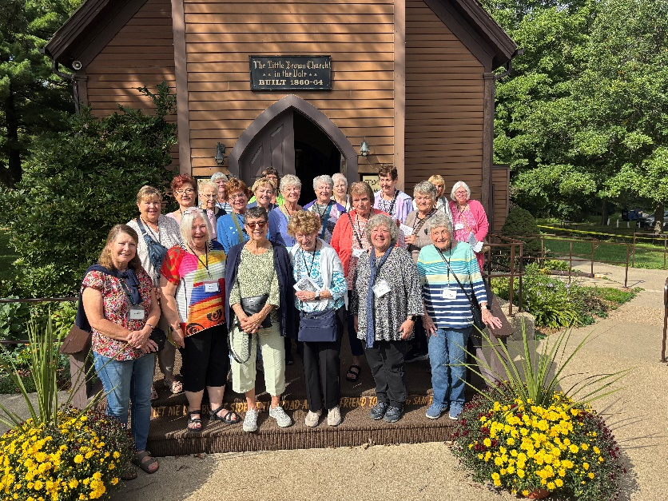

LINE DANCING continues everyThursday
from 6-7 pm in Fellowship Hall. Come enjoy the fun and maybe lose a few pounds.

NOISY OFFERING
Every Sunday we collect a “noisy offering” when you wish to empty your change purse or pockets. We are currently collecting for maintenance items. Thank you.

MISCELLANOUS INFORMATION
- SPECIAL TECH NEED: Are you familiar with IT / computer technology / streaming ?? We are asking for several people to become familiar with or learn the technology that we use to record our church services with. Seeking several people so we will be able to spread out the weekly tasks, so your assistance is not necessary every week ~ please consider ~ and contact Pastor or Tricia Painter
- If you can knit or crochet, we need you to help make more prayer shawls as we are running low. We have the yarn so please contact Helen Gruber if you can help. If you know of someone needing a PRAYER SHAWL, please let Twyla Strom know.
- The Finance Team is looking for volunteers to sign up as counters (counting our weekly offerings after worship). Please see Linda Smykowski or Tricia Painter for further details.

SPECIAL MINISTRY INFORMATION
Bridge to Life Group’s Jesus Closet (homeless in Elgin): Items needed are backpacks, blankets, gym shoes, t-shirts, jeans, coats and socks. Please mark donated items to the attention of Cathy Whiteside (630/605-1096). Thank you for all the donations.
Clothing and miscellaneous items for those in need in Chicago are being collected by Cathy Whiteside (630/605-1096) to be given to Pastor Anna-Kari Johnson for distribution in Chicago. Thank you to all who have donated in the past.

CONTACTS:
For emergencies, please contact the church office at 630-365-6751. For prayer requests or other needs please call Kathy Hooey at 630-341-2293 or leave a message at the church office at 630-365-6751. Messages are checked daily at noon & 5 pm.

Information for the November newsletter will be due by October 25th– please send items to Marty Bradley at masbradley50@gmail.com. Thank you

