Uh Oh Topher
God Sends Elijah Food


BIG IDEA: God takes care of me.
BIBLE BASIS: 1 Kings 17:1-16
KEY VERSE: “Turn all your worries over to him. He cares about you.” 1 Peter 5:7 (NIrV)

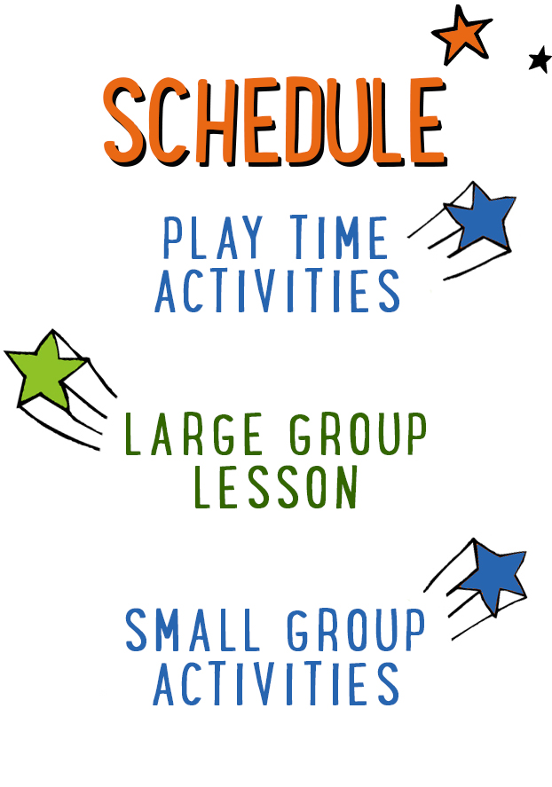
15–20 minutes
20–25 minutes
25–35 minutes

Scripture marked “NIV” is taken from the Holy Bible, NEW INTERNATIONAL VERSION®. Copyright © 1973, 1978, 1984 Biblica. All rights reserved throughout the world. Used by permission of Biblica. Scripture marked “NIrV” is taken from the Holy Bible, New International Reader’s Version ™, Copyright ©1995, 1996, 1998 by International Bible Society. Used by permission of Zondervan Publishing House. All rights reserved. All scripture references are taken from NIrV unless otherwise stated.

User Agreement:
The GO! curriculum by Go Tell It, LLC is intended for download and print by subscribing entities only. It may not be transferred electronically to or duplicated by other non-subscribing entities. If the GO! curriculum is cost prohibitive for your organization, please contact us about assistance. We are awesomely generous! All use must be in accordance with the Terms of Use agreement as described on the website www.gocurriculum.com.
LEADER DEVOTIONAL

A few years ago, life had taken a sudden turn. Overnight, what felt like a secure future became a cloud of uncertainty. I remember standing in my kitchen, staring into my coffee mug like it had answers, saying, “God, what now?” Bills were coming. Our kids were young. And that familiar voice of fear kept ringing louder than my faith.

It is in those moments we need to remember the story of Elijah, a widow, and God’s surprising provision. First, God sent Elijah to a stream during a drought and fed him with bread and meat carried by ravens. Then, when the stream dried up, God sent him to a widow who, by all earthly measures, had nothing left — just a handful of flour and a little oil. But she obeyed God’s word and gave what she had. And somehow, miraculously, that tiny jar of flour and oil never ran out.

The same God who took care of Elijah — through birds and a widow in crisis — is the God who takes care of us. He may not always show up the way we expect, but He always shows up. He is never late, and He is never limited by what we see.

In seasons of lack, in moments of anxiety, we have a choice: fix our eyes on the empty jar or trust the One who fills it. As 1 Peter 5:7 reminds us, “Turn all your worries over to him. He cares about you.” Not some worries. Not just the “spiritual” ones. All of them.

So what feels empty in your life today? What area feels like it's running out?

Bring it to Him. Every fear. Every need. Every burden. He cares for you. And He will provide — sometimes through unexpected means, but always with unwavering love.

Mindy Rausch
GO! Contributor

LARGE GROUP SKILL BUILDING

Five Steps to Becoming a Master of Group Management

There’s a fine line between being a Large Group teacher and a zookeeper. If you make a few untimely missteps, it can start to feel like you’re losing control of the room and slipping into the wild kingdom. Don’t fret, though! We’ve all been there! And fortunately, there are a few things you can do to prevent your kids’ wild side from breaking out.

Get some help: Hopefully you’ve got some dynamic adult helpers in the room who are willing and able to help you. They can be your first line of defense. Talk to them ahead of time and ask them to sit among the kids (as opposed to the back of the room). Encourage them to intervene any time they see distracting behavior.

Separate the fire and gas: Some kids just make for explosive combinations. If there are two (or more) kids seated together that historically have trouble being around one another, don’t be afraid to separate them from the beginning.

Involve the kids: If you’re too much of a “talking head,” kids can start to zone out and get fidgety — especially preschoolers! Be sure to involve the kids in as much of the lesson as you can. Bonus points if you can get the kids moving physically. Fortunately, the GO! lessons are chock full of these kinds of interactive opportunities!

Don’t get stale: Fidgety kids can also be an indication that it’s time to move on to something different. If you’re overly verbose and spend too much time on the same thing, you can start to lose the room. Again, the GO! lessons are written with this in mind, so the more you can stick to the script, the better!

Put your body and voice into it: Often, when a communicator is beginning to lose the attention of the entire room, the first response is to call for quiet and “eyes up here.” There’s a better way, though. By changing what you do with your body and voice, you can regain the kids’ attention in a way that doesn’t interrupt the flow of the lesson. For example, if you’re standing, try sitting or kneeling near the kids for a moment. Resist the urge to talk over the kids. Instead, begin speaking in a quiet voice, just above a whisper. This body/voice combination can do wonders with regaining attention.

UNIT DESCRIPTION
That mischievous little gopher has done it again! Topher the Gopher has burrowed his way into the preschool room while we weren’t looking. He got his paws on the story pictures from the true Bible story and hid them around the room. But the story must go on! It’s up to the kids to find the hidden pictures so the story can be told. During the silly search, kids will learn that God takes care of them and His way is the best way.

SET-UP INSTRUCTIONS
- Print the “Uh-oh, Oh Topher” story pictures on 8½” x 11” cardstock paper. Hide the pictures around the room in locations that are at least partially visible from where the children will be seated. You can make some of the pictures a little harder to find than others.
- Create a “Super Duper Bible Box” and place your storytelling Bible inside. This box will be used every week. See the Resource Folder for details on how to make the “Super Duper Bible Box.”
- If using the non-video options for the Topher segments of the lesson, print the Topher’s Storytime Rules signs and Topher’s Big Idea signs on 8½” x 11” cardstock paper and place in the story time area. See “Getting Started” in the Resource Folder for the printable signs and for more instructions on how to perform the non-video options.
- Note: Any media repeated throughout the unit, such as the Topher videos and the title slide, is located in the Lesson 1 Resource Folder only.

WELCOME AND MUSIC

Music: Play one or two upbeat worship songs

BIG IDEA AND BIBLE VERSE

Large Group Leader: Hello, everybody! I’m so glad you’re here today, because I REALLY need your help. Who’s good at finding things? (Children respond.) I hope so, because something is missing and I think I know who took it. I’ll give you a hint: he’s a furry little rascal with two big front teeth! Before we hunt for our missing items, I want to tell you something about our Bible story.

Say: Today’s true Bible story is going to teach us that God takes care of me. That’s our Big Idea for the day. Let’s say it together. (Repeat Big Idea with children.) God takes care of me. It’s true: God takes care of me. In fact, that’s what our memory verse from the Bible tells us. Let me teach it to you.

“God’s way (walk in place)
is perfect (two thumbs up).
The LORD’S word (cup hands around mouth like you’re calling out)
doesn’t have any flaws (brush hands off).
Psalm 18:30 (extend hands like you’re holding a book).

Say: Let’s do that together. (Repeat memory verse with children two or three times.)

STORY TIME RULES

Say: Wow — nice job! I think you are ready for the Bible story. Before we get started, though, I think we should go over our three story time rules.

Video: Play “Topher the Gopher Story Time Rules” video

(Note: Play the “Topher the Gopher Story Time Rules” video or use the Story Time Rules script found in the Resource Folder.)

UH OH TOPHER INTRO

Say: Like I said earlier, I could really use your help finding something, or should I say “someone.” I’m looking for Topher the Gopher. I know that silly little gopher is hiding around here somewhere. Stay seated, but look around the room. If you see where he’s hiding, point to him and say, “Uh oh, Topher!” (Allow children time to look for Topher. If they have trouble finding him, give them clues. Once Topher is found, remove him from his hiding spot.)

Say: This is Topher the Gopher. He’s a silly little gopher who does silly little things. This morning, he did something super silly. He took the story pictures from our Bible story and hid them around the room. If we don’t find those pictures, we’re going to have trouble telling the story. So what do you think? Should we look for the story pictures together? (Children respond.)

Say: Great! In just a little bit, I’ll tell you what picture to look for. Whenever it’s time to look for a picture, stay seated and look from where you’re sitting. If you see what we’re looking for, point to it and say, “Uh oh, Topher.” Then I’ll go get it.

Say: If you’re ready to find the pictures and hear today’s true Bible story, give me two big thumbs up. (Children give thumbs up.) Great! First, let’s get our Bible out of the Super Duper Bible Box. Then we can look for the missing story pictures. (Move to the Bible Box.) I need your help getting the Bible out, though. We need to say our special Bible words together. Repeat these special words after me: It’s true, it’s true, the Bible is true!

Slide: Show the “God Sends Elijah Food” slide

BIG BIBLE STORY — GOD SENDS ELIJAH FOOD

(Note: Ahead of time, hide the story pictures around the room in locations that are at least partially visible from where the children will be seated. You can make some of the pictures a little harder to find than others.)

Say: I think it’s time to find our first missing picture. Does anyone see the picture of a sun? (Allow children time to look for the picture. Give clues if needed. Once found, remove the picture from its hiding place and hold it up for children to see.) In the Bible, in the Book of 1 Kings, the sun was shining bright and hot! (Look one direction.) There was no rain over there. (Look other direction.) There was no rain over there. (Look in a circle.) There was no rain anywhere. In fact, (hold up three fingers) it didn’t rain for three years. And because it didn’t rain, there was no water to drink or to grow food. Let’s rub our tummies and use our hungry voice to say, “I’m really hungry!” (Perform with children.)

Say: Let’s see if we can find the next picture. Does anyone see the picture of a black bird? (Children look for picture. Hold it up once it’s found.) There was a man named Elijah who loved God very much. Let’s give ourselves a big hug. (Hug yourself.) God told Elijah where to find a small stream of water. Then he told Elijah, “I will send ravens to bring you food.” A raven is a black bird just like this (refer to picture). Every day, Elijah drank water from the stream and the ravens brought him bread and meat. Let’s flap our arms like we’re a raven bringing Elijah bread and meat. (Perform with children.)

Say: I think we need to find another picture. Does anyone see the picture of a glass of water? (Children look for picture. Hold it up once it’s found.) After a while, the stream dried up and there was no more water for Elijah to drink, so God told Him to go find a widow. A widow is a woman whose husband has died. Elijah asked the widow, “Would you bring me some water to drink? I’m thirsty.” Let’s pretend to be drinking a refreshing glass of water. (Pretend with children.)

Say: Let’s see if we can find another picture. Does anyone see the picture of a loaf of bread? (Children look for picture. Hold it up once it’s found.) As the widow went to get the water, Elijah called out, “Please bring me a piece of bread too.” (Look sad.) “I’m sorry,” the widow said, “I don’t have any bread. All I have is a little bit of flour and oil. I’ll use the flour and oil to make one last meal for my son and me, but then we’ll go hungry.” Can you show me what you look like when you’re really hungry? (Pretend with children.)

Say: Let’s find one more picture of a brown jar and a brown jug. (Children look for picture. Hold it up once it’s found.) Elijah said, “Don’t be afraid. Make me a small loaf of bread. Then make some for yourself too. God will keep filling your jar of flour and jug of oil every day until it rains again.” And that’s what God did — every day, He filled the jar full of flour and He filled the jug full of oil so the widow could make as much bread as she needed. It was a miracle — something only God can do!

MUSIC AND CLOSING

(Encourage the children to stand up. Lead them in a worship song of your choice. Following the song, use the rhyme from earlier to help the children sit down again.)

Music: Play one worship song

Say: In our Bible story for today, how did God give Elijah food? (Take answer. Hold up raven picture if necessary.) You’re right — the ravens brought Elijah food. And how did God give the widow food? (Take answers. Hold up jar and jug picture if necessary.) Right again — He filled up her jar with flour, and He filled up her jug with oil. God took care of Elijah and the widow, and He takes care of us too!

Say: We might not have ravens that bring us food (hold up raven picture in one hand), and we might not have jars of flour that fill up every day (hold up jar picture in other hand), but God still gives us food. He sends the rain that waters the plants. He helps the farmers who grow all the food. And then there’s one more thing He does, but I need another picture to show you what it is. Can you find the picture of a mommy and daddy? (Children look for picture. Hold it up once it’s found.) God gives us mommies and daddies who buy us food from the grocery store. That’s why it’s good to say a prayer before you eat. You can tell God, “Thank you, God, for giving me food!” On the count of three, let’s shout that to God. (Count to three and shout with children.)

Say: Elijah and the widow didn’t have to worry about finding food, and neither do we. That’s because God takes care of us.

Say: Hey — that’s our Big Idea for today! I think we should tell it to our parents when we see them. Maybe we should practice first. (Appear to be thinking.) Hmm…who could we practice telling? I know! We could tell our friend, Topher the Gopher. Let’s see if we can find him.

TOPHER’S BIG IDEA

Video: Play “Topher’s Big Idea Video 1”

(Whisper.) Uh-oh. It looks like Topher is asleep. I think we should wake him up. When he wakes up, we can all tell him that God takes care of us. On the count of three, let’s all yell, “Topher the Gopher, wake up, wake up!” (Count to three and yell with kids. Then play “Topher’s Big Idea Video 2” or hold up card #2.)

Topher: Hey, what’s the Big Idea?

Children and Large Group Leader: God takes care of us. (Repeat the Big Idea several times. When finished, play “Topher’s Big Idea Video 3” or hold up card #3.)

Topher: Wow! That is a Big Idea! Thanks for telling me! Goodbye, kids. (Encourage kids to wave goodbye to Topher as he disappears back into his hole.)

Large Group Leader: Let’s say a prayer together and thank God for taking care of us. (Encourage kids to repeat the following prayer after you.)

Dear God,
You are such a wonderful God.
Thank You for taking care of us.
You give us food to eat.
And best of all
You give us Jesus.
Amen.

