 |  |  | Notes  _____________________________________________________________________________________________________________________________________________________________________________________________________________________________________________________________________________________________________________________________________________________________________________________________________________________________________________________________________________________________________________________________________________________________________________________________________________________________________________________________________________________________________________________________________________________________________________________________________________________________________________________________________________________________________________________________________________________________________________________________________________________________________________________________________________________________________________________________________________________________________________________________________________________________________________________________________________________________________________________________________________________________________________________________________________________________________________________________________________________________________________________________________________________________________________________________________________________________________________________________________________________________________________________________________________________________________________________ |  |  | 
  
  Each month, the Divine Bulletin features a member for the spotlight. For the month of April, that member is DeAnna Smith! DeAnna is an active member of our women’s ministry and kitchen volunteer staff. Her sweet nature is welcoming, and her worship and testimony is real! Thank you all for your dedication to the ministry and congratulations!
  The Divine Bulletin
    - Divine Destiny Family Worship Center
  Vol 6 Issue 5
  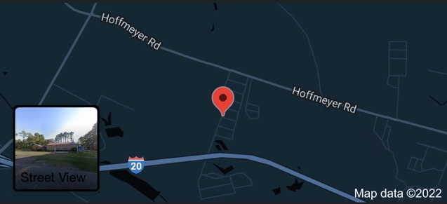
  3824 Oak Drive Florence, SC 29501
  11

 | 
  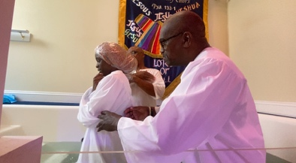
  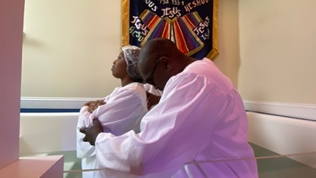
  Upcoming May Events
  The women’s ministry enjoyed a fun ladies’ night! They enjoyed games, music, and good food. The fellowship was awesome ladies! We were also proud to baptize 2 of our members, as well as open our pool for other guests for Baptism Sunday.
  This month we are also excited for our Media Team Bake Sale! The media team will be selling freshly bakes treats on Sunday, May 19th. All proceeds will go towards production and technical supplies to enhance the worship experience. Please make sure you support!
  Mark your calendars for an all-inclusive bowling day! The women will be traveling to Stars and Stripes in Myrtle Beach, SC for fun fellowship at the lanes. Please see Elder Hill for your ticket!
  
  
  Stay tuned for more upcoming events!
  1st Sunday– Pastoral Sunday
  2nd Sunday– Building Fund
  3rd Sunday – Youth Sunday
  4th Sunday– Missions Sunday
  5th Sunday– Friends & Family Day
  May Birthdays
  Happy Birthday to all May
  Birthdays from DDFWC!
  
  Upcoming Events
  May:
  3rd- Ladies Night
  4th- Baptism Sunday
  11th- Mother’s Day
  18th- Media Team Bake Sale
  31st- Women’s Bowling Day
  June:
  
  22nd- How Tasty Is your grill competition
  Monthly Encouragement
  If He dresses the lilies with beauty and splendor, how much more would He clothe you?
  Worship with us at DDFWC!
  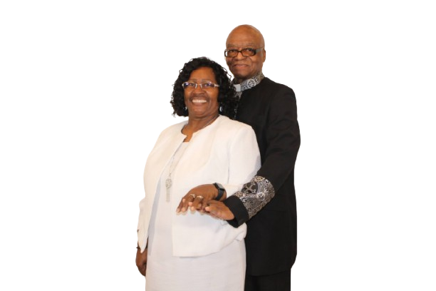
  Where you don’t mind the drive when the church is alive!
  Let’s Keep In Touch!
  3824 Oak Drive Florence, SC 29501
  Facebook: Divine Destiny Family Worship Center
  Instagram: @divinedestinyfwc
  Twitter: @ddfwcministry
  TikTok: @DDFWC.TV

