

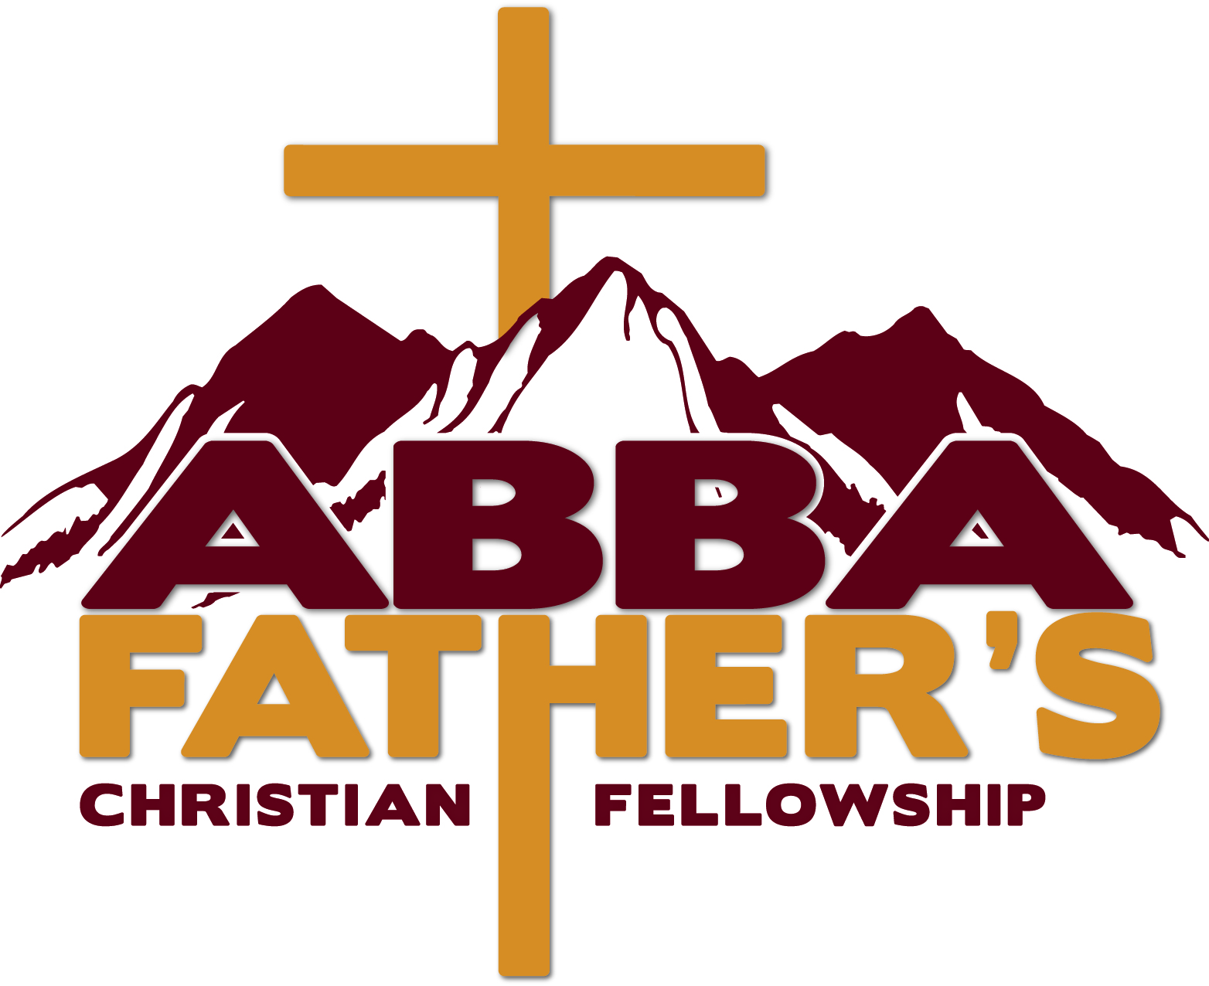

**January 2024**

**21 DAY CORPORATE FAST**

**Fasting & Prayer Journal**

*O God, You are my God; early will I seek you: my soul thirsts for You, my flesh longs for You in a dry and thirsty land, where there is no water—Psalm 63:1*

**Pastor’s Rony & Cynthia Harden, Sr.**

**227 W. Rezanof St.**

**Kodiak, AK 99615**

**January 2024 Fasting Guidelines**

Congratulations,

You have made a commitment to participate in the AFCFC Daniel Fast. The Daniel Fast, which is a partial fast; meaning that we will eliminate some common things from our daily diet but will have generous options available to you. We will limit our eating habits to fruits and vegetables that are pure and simple.

The Daniel fast is a great model to follow and is one of the most common types of fasts. It proves to be extremely effective for spiritual focus, discipline and purification for the body and soul. In the book of Daniel, we find that Daniel fasted two different times (**Daniel 1** and **10**). **Daniel 1** states that he ate vegetables and water, and in **Daniel 10**, he ate no rich or choice foods, including meat or wine.

The Lord Jesus Christ emphasizes in several portions of scripture that fasting is an exercise for each person in the church to participate in from time to time. Jesus didn’t say **if** you fast, but **when** you fast! (**Matthew 6:16-18** & **9:14-15**).

This ***21-day*** fast will begin and end at **6:00 am** on Monday, ***January 1, 2024***,and we will continue until Sunday, ***January 21*** at **5:00 pm** after your own private prayer time. Over the next ***21*** days, we will come together as a church family to seek God and prepare yourselves for what He has in store for us this year!

As you participate in this fast, you will begin to discover and experience God in a new way. Your relationship with the Lord will grow and your vision, clarity and focus will sharpen. We are excited to see what God will do in you and through you, as well as our corporate body.

Please note, if you happen to fail, don’t be discouraged or feel condemned. Get back on track and keep going – remember, His mercies are new every morning. He will give you grace and strength to keep moving, so don’t quit!

Additionally, we will be praying corporately on ***Sundays*** at **10:30 am** prior to morning worship and ***Wednesday*** at **6:00 pm** prior to bible study. We will pray each day, ***Monday*** through ***Sunday*** prior to our **5:00 pm** evening meal.

I encourage you to take the time to read through this packet as we believe the Lord will bless the plans and establish them for His Glory and Honor.

We look forward to God meeting us together as we journey to another level in Him. Please don’t forget to visit: <https://ultimatedanielfast.com/ultimate-daniel-fast-food-guidelines/> for additional Daniel Fast resources.

Yours in service to Christ,

Pastors Rony & Cynthia Harden, Sr.

**Prayer and Fasting 101:**

Fasting without prayer is a diet and does not manifest any supernatural benefits. We must not only fast, but we must also pray!

**Why Pray?**

Prayer is two-way communication with God. Prayer is not just you talking to God but also you listening to God to hear what He has to say. During these next ***twenty- one*** days, we encourage you to really pour your heart out to the Lord and listen for what He has to say.

Our primary goal in prayer should be to know Jesus more and experience Him; not just tell Him all about our troubles. When you pray, pour your heart before God, surrender totally to Him, and tell Him your desire to glorify Him in and through your life. Focus on who He is and His character, love, goodness, and greatness.

We must communicate with God DAILY. Set aside some time every day to spend with Him. **If you don’t plan to pray, you won’t.**  Find some worship music to listen to as you set the atmosphere for you entering the presence of the Lord.

**Jeremiah 33:3 NIV, *“Call to me and I will answer you and tell you great and unsearchable things you do not know.”***

**Why Fast?**

The purpose of fasting is to strengthen you spiritually, mentally, and physically. The goal is to help cleanse your temple of destructive and negative forces that interfere with your relationship with God. By incorporating fasting as a part of your Christian walk and seeking God through prayer, you will grow closer to the Lord and mature in the faith like never before.

The goal of fasting is to increase your ability to deny the flesh when needed. During your time of fasting, be diligent in your study and mediation of God’s Word. **Our primary focus and objective are to focus our attention on seeking God’s direction for our lives.**

Through fasting and prayer, the Holy Spirit can transform your life.

**Preparing to Fast.**

**Isaiah 58:3-6 NIV*, “Why have we fasted,’ they say, ‘and you have not seen it? Why have we humbled ourselves, and you have not noticed?’ “Yet on the day of your fasting, you do as you please and exploit all your workers. Your fasting ends in quarreling and strife, and in striking each other with wicked fists. You cannot fast as you do today and expect your voice to be heard on high. Is this the kind of fast I have chosen, only a day for people to humble themselves? Is it only for bowing one’s head like a reed and for lying in sackcloth and ashes? Is that what you call a fast, a day acceptable to the Lord? “Is not this the kind of fasting I have chosen: to loose the chains of injustice and untie the cords of the yoke, to set the oppressed free and break every yoke?”***

Before you begin a fast, it is important that you prepare yourself to fast. Although fasting is primarily a spiritual discipline, it begins in the physical realm. You should not fast without specific physical preparation. Here are some steps that you should take to ensure your fast is effective.

Before the fast begins, prepare your body by eating smaller meals. Avoid high fat and sugary foods. Eat raw fruits and vegetables two days prior to starting the fast. Depending upon the type of fast you choose, you may even need to gather a few recipes for meal preparation.

Remember when Jesus went on His 40-day fast? He went by Himself out into the wilderness.

Consequently, you too may need to modify your daily habits or routines. Many people can fast and function fine without much fatigue; bless God if this is you. However, if not, exercise wisdom during this ***21-day*** period and adjust as necessary.

Throughout your fast, you may feel somewhat weaker than normal; especially during the first few days. In fact, you may feel very tired, irritable, or fatigued. To maintain your health and morale, it would be a good idea to lighten your workload and cut down on strenuous exercise. Here are some steps you should take to ensure your fast is effective.

**Step One: Why are you Fasting?**

What is the purpose of your fast? What are you expecting God to do during this fast? Is it for spiritual direction? Healing? Discipline? Ask the Holy Spirit to lead you as you determine your personal reason for fasting.

We are all at different places in our walk with God, so start where **you** are! We should not fast to impress others or to prove our spirituality. We fast to draw nearer to God.

“Moreover, when we fast, be not, as the hypocrites, of a sad countenance: For they disfigure their

faces that they may appear unto men to fast. Verily I say unto you, they have their reward.”

(**Matthew 6:16**).

**Step 2: Make Your Commitment**

Make your commitment to the Lord after giving consideration and thought to a few key areas

such as:

* Corporately, we are encouraging our members to do the Daniel Fast together; however, if

you have any condition that prohibits you from being a part of the Daniel Fast, there are

other options. Choose something from your daily routine (i.e., specific foods or beverages, television, technology, etc.) and fast in that manner for the next ***21***days. Parents consider this option for your children. Remember, the details are not as important as the attitude from which you participate.

* What changes will you need to make to your daily schedule? I.E., a modification to your

exercise routines, sporting events, etc. When fasting, your energy levels will be different,

so, you may need to adjust your schedule during the fast.

* How much time do I need to devote to prayer and study of God’s Word? Set a start and

end time for prayer, reading, meditating, and studying the Word.

**Step 3: Prepare Yourself Spiritually**

Spiritual preparation is essential for a successful fast. The very foundation of fasting and prayer is repentance. Unconfessed sin can hinder your prayers. Begin to prepare yourself spiritually by meditating on the following in your heart:

* Remember that God is your Father. He loves you and is for you.
* Confess every sin that the Holy Spirit brings to your remembrance and accept God’s

forgiveness (**1 John 1:9**).

* Seek forgiveness from all whom you have offended, and forgive all who have hurt you

(**Mark 11:25**, **Luke 11:4**, **Luke 17: 3-4**).

* Ask God to fill you with His Holy Spirit according to His Word in **Ephesians 5:18** and

His promise in **John 5:14-15**.

* Surrender your life fully to Jesus Christ as your Lord and Master; refuse to blend in with

the world (**Romans 12:1-2**).

* Mediate on the Word of God particularly concerning the character of God, His love,

sovereignty, power, wisdom, faithfulness, grace, and compassion (**Psalms 48:9-10**, **Psalms 103:1-8**, **Psalms 103:11-13**).

* Begin your time of fasting and prayer with an expectant heart (**Hebrews 11:6**).
* Be prepared for spiritual opposition, the enemy will come to attack and test your

commitment (**Galatians 5:16-17**).

**What to eat on the Daniel Fast?**

One of the great things about the Daniel Fast is that you are not limited to any specific amount of

food, only the kind of foods you can eat.

*\*Water in the excess of 10 or more cups per day will help reduce fatigue and withdrawals and*

*help you maintain hydration.*

**Foods to Eat:**

* **Whole Grains:** Brown Rice, Oats, Barley
* **Legumes:** Dried Beans, Pinto Beans, Split Peas, Lentils, Black Eyed Peas
* **Fruit:** Apples, Apricots, Bananas, Blackberries, Blueberries, Cantaloupe, Cherries,

Cranberries, Figs, Grapefruit, Grapes, Guava, Honeydew Melon, Kiwi, Lemons, Limes,

Mangoes, Nectarines, Papayas, Peaches, Pears, Pineapples, Plums, Prunes, Raisins,

Raspberries, Strawberries, Tangelos, Tangerines, Watermelon

* **Vegetables:** Artichokes, Asparagus, Beets, Broccoli, Brussels, Sprouts, Cabbage, Carrots, Cauliflower, Celery, Chili Peppers, Corn, Cucumbers, Eggplant, Kale, Greens, Lettuce, Mushrooms, Okra, Onions, Potatoes, Spinach, Squash, Sweet Potatoes, Tomatoes, Yams, Zucchini
* Seeds, Nuts, Sprouts
* **Liquids:** Water, Unsweetened Soymilk, Herbal Tea, Natural Fruit Juice (no added sugar)

If you have young children or students, you may want to consider adding turkey, chicken or fish

to the approved list of foods.

**Foods to Avoid:**

* Meat, Poultry, Fish
* White Rice, Fried Foods
* Carbonated Beverages
* Foods containing preservatives or additives
* Refined sugar or sugar substitutes
* White flour
* Margarine, shortening, high fat products
* All breads
* Dairy (milk, butter, cheese, yogurt, etc.)
* Junk foods
* Sweets

**Fasting While Nursing or Pregnant**

If you are pregnant or nursing but would like to participate in the ***21***day fast, here are some options you may want to consider. First, obtain the approval of your physician. Then consider the following:

* A modified Daniel Fast including whole grain, legumes, whey protein, calcium and other

iron supplements

* Fasting sweets and desserts
* Fasting red meat
* Fasting certain pleasurable activities (television shows, movies, social media, video

games, etc.)

You can still participate in the fast without causing harm or injury to yourself or your baby; as

your priority is the health and development of your baby.

**Ending your Fast**

The way you end your fast is extremely important to your physical and spiritual well-being.

When the fast is over, gradually resume your previous diet. A greasy cheeseburger for example

would not be the best food selection. Your digestive track has slowed down tremendously and

heavy, fatty, sugary foods will cause nausea, pain, and overall discomfort.

Here are some tips to help end the fast properly:

* Break an extended water fast with fruit such as watermelon.
* While continuing to drink fruit or vegetable juices, add the following:
* ***First day:*** Raw salad
* ***Second day:*** Baked or broiled potato, no butter or seasoning
* ***Third day:*** Steamed vegetables

**An important ingredient – Studying God’s Word.**

It is important that we spend time studying God’s Word. The Bible is the inspired Word of God.

It is important to mediate, memorize and apply the Word on an everyday basis.

Why study God’s Word?

* Because the Word when spoken has the power to run the enemy away (**Matthew 4:1-11**).
* Because the Word when applied will keep us from sin (**Psalms 119:11**).
* Because the Word when practiced will guide and instruct us in the ways of God (**Psalms**

**119:105**).

* Because the Word when received in our hearts will help us develop knowledge and

understanding of God’s character (**Timothy 2:15**).

* Because the Word when obeyed will disciple us in the Lord’s principles, so we begin to

look more and more like Jesus (**2 Timothy 3:16-17**).

* Because the Word when meditated upon will cause us to prosper and have good success

(**Joshua 1:18**)

**Ultimate Daniel Fast Prayer Points**

The focus of the Daniel Fast is prayer. While it’s natural to be concerned about the food list, your priority on the fast should always be calling out to God on behalf of your own needs and the needs of others.

I suggest investing in a journal or a notebook so you can write down specific requests, how God answers them, and what the Lord does in your life on your 21-day journey. Also, take advantage of the following list of prayer points–one for each day of the fast–to make your prayer time more effective. (You can also use this guide throughout the year, not only when you’re doing the Daniel Fast.)

Finally, incorporate the daily verses in your prayers by praying them aloud. For example, on Day 1, you might say: “Lord, I pray you’ll remove the blinders from the eyes of unbelievers that Satan has put on their spiritual eyes. Enable them to understand the glorious light of the gospel. May they believe that Jesus is your Son, who came and died for their sins, and that he is also God.” As you speak God’s truth with faith and confidence, you’ll be declaring supernatural power over people and circumstances, which will bring about changed hearts for eternity.

**Day 1 -** Pray for unbelievers to repent and be saved.

“Satan, who is the god of this world, has blinded the minds of those who don’t believe. They are unable to see the glorious light of the Good News. They don’t understand this message about the glory of Christ, who is the exact likeness of God” (**2 Corinthians 4:4** NLT).

**Day 2 -** Pray for revival and a great awakening in the world.

“If my people, who are called by my name, will humble themselves and pray and seek my face and turn from their wicked ways, then I will hear from heaven, and I will forgive their sin and will heal their land” (**2 Chronicles 7:14**).

**Day 3 -** Pray for Christians who are enduring persecution.

“Though I walk in the midst of trouble, you preserve my life. You stretch out your hand against the anger of my foes; with your right hand you save me” (**Psalm 138:7**).

**Day 4 -** Pray for families to be strengthened in the Lord.

“Be strong in the Lord and in the strength of His might. Put on the full armor of God, so that you will be able to stand firm against the schemes of the devil” (**Ephesians 6:10-11**).

**Day 5 -** Pray for a family member or a friend who is sick.

“Lord, help!” they cried in their trouble, and he saved them from their distress. He sent out his word and healed them, snatching them from the door of death” (**Psalm 107:19-20** NLT).

**Day 6 -** Pray for a couple who is struggling in their marriage.

“Make allowance for each other’s faults and forgive anyone who offends you. Remember, the Lord forgave you, so you must forgive others. Above all, clothe yourselves with love, which binds us all together in perfect harmony” (**Colossians 3:13-14** NLT).

**Day 7 -** Pray for unity in churches and in the body of Christ.

“I appeal to you, dear brothers, and sisters, by the authority of our Lord Jesus Christ, to live in harmony with each other. Let there be no divisions in the church. Rather, be of one mind, united in thought and purpose” (**1 Corinthians 1:10** NLT).

**Day 8 -** Pray for your pastor and for your church leadership.

“If you need wisdom, ask our generous God, and he will give it to you. He will not rebuke you for asking. But when you ask him, be sure that your faith is in God alone. Do not waver, for a person with divided loyalty is as unsettled as a wave of the sea that is blown and tossed by the wind” (**James 1:5-6** NLT).

**Day 9 -** Pray for a ministry in your church or community.

“Whatever you do, work at it with all your heart, as working for the Lord, not for human masters, since you know that you will receive an inheritance from the Lord as a reward. It is the Lord Christ you are serving” (**Colossians 3:23-24**).

**Day 10 -** Pray for a neighbor.

“I keep asking that the God of our Lord Jesus Christ, the glorious Father, may give you the Spirit of wisdom and revelation, so that you may know him better” (**Ephesians 1:17**).

**Day 11 -** Pray for a missionary.

“Surely the righteous will never be shaken; they will be remembered forever. They will have no fear of bad news; their hearts are steadfast, trusting in the Lord” (**Psalm 112:6 -7**).

**Day 12 -** Pray for a widow/widower.

“The Lord is close to the brokenhearted and saves those who are crushed in spirit” (**Psalm 34:18**).

**Day 13 -** Pray for the people in your country to turn to God.

“All the ends of the earth will remember and turn to the Lord, and all the families of the nations will bow down before him, for dominion belongs to the Lord and he rules over the nations” (**Psalm 22:27-28**).

**Day 14 -** Pray for the governmental leaders in your country.

“It is the Lord your God you must follow, and him you must revere. Keep his commands and obey him; serve him and hold fast to him” (**Deuteronomy 13:4**).

**Day 15 -** Pray for the sanctity of life to be upheld and celebrated.

“You made all the delicate, inner parts of my body and knit me together in my mother’s womb. Thank you for making me so wonderfully complex! Your workmanship is marvelous—how well I know it.” (**Psalm 139:13-15** NLT).

**Day 16 -** Pray for an unsaved family member or friend.

“If you declare with your mouth, ‘Jesus is Lord,’ and believe in your heart that God raised him from the dead, you will be saved. For it is with your heart that you believe and are justified, and it is with your mouth that you profess your faith and are saved” (**Romans 10:9-10**).

**Day 17 -** Pray for someone who is battling depression.

“For the Lord your God is living among you. He is a mighty savior. He will take delight in you with gladness. With his love, he will calm all your fears. He will rejoice over you with joyful songs” (**Zephaniah 3:17** NLT).

**Day 18 -** Pray for the people in your city/community.

“Dear friends, let us continue to love one another, for love comes from God. Anyone who loves is a child of God and knows God. But anyone who does not love does not know God, for God is love” (**1 John 4:7-8** NLT).

**Day 19 -** Pray for your heart to be obedient to the Lord.

“If you look carefully into the perfect law that sets you free, and if you do what it says and don’t forget what you heard, then God will bless you for doing it” (**James 1:25** NLT).

**Day 20 -** Pray for a deeper commitment to prayer.

“Rejoice evermore. Pray without ceasing. In every thing give thanks: for this is the will of God in Christ Jesus concerning you.” (**1** **Thessalonians 5:16-18**).

**Day 21 -** Pray for boldness to share the gospel with others.

“For I am not ashamed of this Good News about Christ. It is the power of God at work, saving everyone who believes—the Jew first and also the Gentile.” (**Romans 1:16** NLT).

**Abba Father’s Christian Fellowship Church - 2024 Prayer Targets**

 Pray for Abba Father’s ability to reach souls for the Kingdom of God.

 Pray for Salvation of Lost Souls Bind the spirit of bondage and loose the spirit of adoption in the hearts of the lost

 Pray for the Mission Field and the Persecuted Church

 Pray the Lord will send workers, teachers, and the releasing of the 5-fold ministry into AFCFC

 Pray for the addition of those that have passion to operate in the ministry of helps

 Pray for the boldness to be Ambassadors for Christ and to work in God’s Vineyard.

 Pray for revival to take place our homes, schools, and workplaces

 Pray to Bind the spirit of poverty and loose God’s prosperity – Pray God will meet all the needs of the Saint

 Pray for Abba Father’s Leadership, Congregation and becoming a part of United Pentecostal Church International

 Pray for Deliverance within Leadership

 Pray for Greater discernment and obedience to Walk in God’s Will and Instructions

 Pray for Spiritual Growth Congregational Members

 Pray for Church Growth, numerically

 Pray for Building Fund Project – Church Finances (**Philippians 4:6**)

 Pray for Breaking Strongholds (Allow the Lord to minister through you concerning all areas that keep people in sin)

 Pray for the deliverance from Addictions

 Pray for the deliverance from Poverty (Mentality & Physically)

 Pray deliverance from Condemnation, Denial, Shame

 Pray for deliverance from Evil, Uncleanness

 Pray for deliverance from Fear, Worry, Anxiety, Unforgiveness, uncertainties of Life and Family (**1 Peter 5:7**)

 Pray for deliverance from False Religion, Methodologies, Heresies

 Pray for deliverance from Doubt & Unbelief

 Pray for those who have suffered (bereavement) loss.

 Pray they will receive the Lord’s grace, peace, healing, and comfort

 Pray for those that are convalescing and need healing in their bodies from COVID-19 and all other sickness and disease

* Pray for our Nation, President, Congress, governmental leader on all levels of government- revival, deliverance, restoration, effective communication, cooperation, and love, one to another.

**MY 21 DAY FASTING COMMITMENT**

I commit to participate in our church corporate wide fast from Monday, **January 1, 2024** – Sunday, **January 21, 2024** (fast will end on Sunday during **5 pm** prayer).

My purpose for fasting is: ________________________________________________________

_____________________________________________________________________________

Specific things I am praying and believing God for during this fast:

_____________________________________________________________________________

_____________________________________________________________________________

_____________________________________________________________________________

Also remember to journal each day the scriptures you read and any revelation the Lord spoke to your heart during your study and meditation time.

MY SUCCESS PLAN:

1. I will find an accountability partner, someone who will encourage me when the temptation to quit arises. **Note: This person should agree with your desire to compete the fast and a spiritually mature person who can encourage you with the word. Ecclesiastes 4:12, “A threefold cord is not quickly broken.”**
2. My accountability partner for this fast is: __________________________________
3. I will set aside time every morning from _____am to ______am to praise God, read my Word and spend time in prayer.
4. I will set aside time every evening from _____pm to _____pm to praise God, read my Word and spend time in prayer.
5. I will Not allow the enemy to accuse me or shame me should I fall short. I am determined to use this time to draw closer to the Lord.

“So, we fasted and petitioned our God about this, and he answered our prayers.” (**Ezra 8:23**).

I believe that God is the only one to answer my prayer and that fasting will draw me closer to Him. Therefore, God being my strength and grace being freely given to me daily, I commit myself to the above fast.

Signed: ____________________________________ Date: _______________________