Kentuck Baptist Church

Weekly Schedule – Fall 2025

September 3 Registration / Welcome Back

10 Crazy Socks

17 Bring-A-Friend

24 Obstacle Course

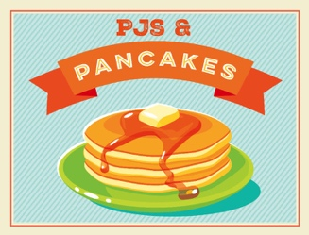

October 1 AWANA

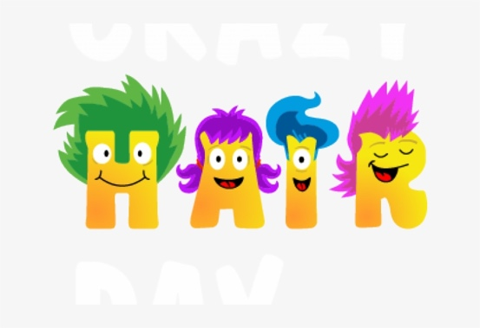 8 Double Bucks

15 Mystery Store

22 Crazy Hair

29 PJs and Pancakes

November 5 AWANA

12 Operation Christmas Child Shoebox Packing Party

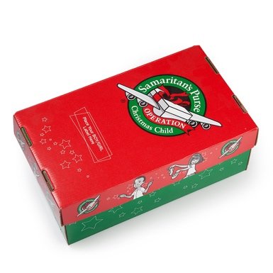 19 Give Thanks, Double Bucks

26 Happy Thanksgiving! NO AWANA

December 3 Dress Like Christmas

10 Christmas Store

17 Merry Christmas! NO AWANA

24 Merry Christmas and Happy New Year! NO AWANA

31 Happy New Year! NO AWANA

Looking Ahead …

January 7 Welcome Back

14 Backwards Night