
  - D Group Sermon Series
“Live with Courage”
Sermon Series: Following God in a Culture that Doesn’t
#6 Daniel 6 10.12.25
New Testament Church of Christ

 | HOOK – Getting Started (Engage the Group)  Purpose: Help your group connect emotionally and personally with the theme before diving into the text.  - When you hear “Daniel and the Lions’ Den,” what stands out most — courage, faith, danger, or deliverance? Why?  - Think about a time you faced pressure to hide or compromise your faith. What made that situation difficult?  - In today’s world, what “lions” do Christians face — personally or culturally? (Examples: fear of rejection, workplace pressure, ridicule, etc.)  - Why do you think courage is often misunderstood as the absence of fear rather than the presence of faith?  LOOK – Exploring the Passage (Daniel 6)  Purpose: Examine what Scripture says and uncover timeless truths.  Read Daniel 6:1–28 together.  An Excellent Spirit (vv. 1–3)  - Verse 3 says Daniel had “an excellent spirit.” (ESV) What does that mean in practical terms?  - What would an “excellent spirit” look like in your daily interactions, especially in a skeptical culture?  - What would an “excellent spirit” look like in your daily interactions, especially in a skeptical culture?
  BIG IDEA: To live courageously in a culture that opposes God, we must develop an excellent spirit, maintain godly character, and demonstrate faith that trusts publicly and steadfastly — just as Daniel did in the lions’ den.
  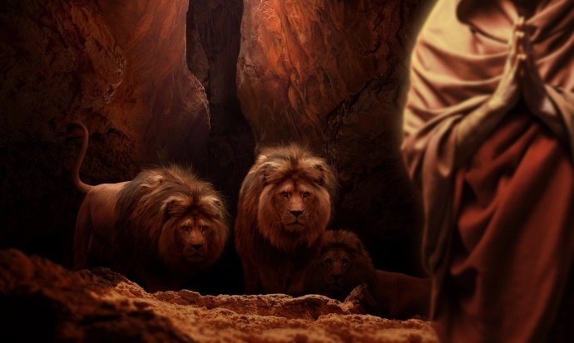
  Key Points of the Sermon:
  _________________________________________________________________________________________
  - A courageous life requires Respect
  - A courageous life requires Character.
  - A courageous life requires Trust

  - D Group Sermon Series
“Live with Courage”
Sermon Series: Following God in a Culture that Doesn’t
#6 Daniel 6 10.12.25
New Testament Church of Christ

LOOK – Exploring the Passage (Daniel 6) cont.
Purpose: Examine what Scripture says and uncover timeless truths.
- How might the Fruit of the Spirit (Gal. 5:22-23) shape how others see your courage and faith?

Godly Character (vv. 4–10)
- The administrators tried to find fault with Daniel, but couldn’t. What habits or convictions do you see in him that kept his integrity intact?
- How does Daniel’s consistency challenge our approach to small compromises?
- Why is character an essential foundation for courage?

Faith that Trusts (vv. 10–23)
- In verse 10, Daniel prays “just as he had done before.” How does that statement capture the strength of his faith?
- Daniel could have hidden his prayers. Why didn’t he? What does this teach us about public vs. private faith?
- What does verse 23 (“He had trusted in his God”) reveal about the relationship between faith and fear?
- How does Daniel’s deliverance point us to Jesus, who delivers us from the ultimate “den” of death?

TOOK – Living It Out (Apply the Truth)
Purpose: Move from understanding to action and transformation.
- Which of Daniel’s qualities — excellent spirit, character, or faith — do you need to grow in most right now?
- What practices can help you develop courage before you ever face a “lion’s den” moment?
- How can our group help one another live with courage in a culture that often rejects biblical values?
- What specific “lion” are you asking God to help you face this week with faith instead of fear?
Memory Verse:
“He had trusted in his God.” — Daniel 6:23
Prayer Focus:
Pray for one another to live with courage — to display excellence, integrity, and faith that points others to Christ even when the cost is high.
D Group Sermon Series
“Live with Courage”
Sermon Series: Following God in a Culture that Doesn’t
#6 Daniel 6 10.12.25
New Testament Church of Christ

Resources
Type | Title / Link | What It Helps With

Video | Courage in the Lion’s Den (Ben Stuart) https://youtu.be/GtFNsUpgDsw?si=k7dJME39y3wOqdud | How to respond when civil authority conflicts with faith

Video | Safe in the Lion’s Den – Daniel 6:15-28 https://youtu.be/85zKhcXclQA?si=KRkM6es_EmYztvZb | Visual storytelling of the dramatic deliverance

Video | *Lessons from the Lions’ Den  https://youtu.be/85zKhcXclQA?si=V0ILao2kXw2Ap4Wy | Daniel 6*

Article | Daniel and Courage (Insight for Living) Daniel and Courage | Insight for Living Canada | Explores how Daniel’s courage was rooted in God’s provision and protection

Article | Walking by Faith: Daniel – Courage to Stand in a Culture That Doesn’t Walking by Faith: Daniel – Courage to Stand in a Culture That Doesn’t | Emphasizes Daniel’s lifelong faith, not just his moment in the den

