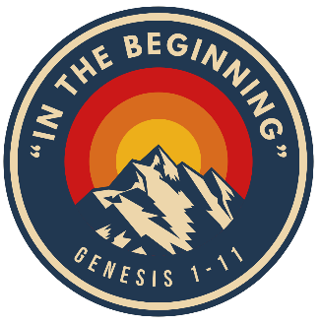
The Distinction of Mankind
1. People were made separate from the rest of creation
- Animals, then humans (Genesis 1:25-26)
- A zoomed in view (Genesis 2:7-23)
- A specific place prepared (Genesis 2:8)
- Adam was tasked with naming the animals (Genesis 2:20)
2. We were formed, not created (Genesis 2:7)
- The animals were God’s last “Let there be” (Genesis 1:24)
- Made in God’s image (Genesis 1:26)
- Given the “breath of life” (Genesis 2:7)
3. God-given purpose and responsibilities
- Dominion (Genesis 1:26)
- Work/Keep (Genesis 2:15)
- Relationship (Genesis 2:24, chapter 3)
What does this mean to us?
- We were made separate from the rest of creation. (Psalm 139:14)
- God made mankind with the ability to have a relationship with Him.
Description of God:
Fully self-existent, all-powerful
Desires a relationship with mankind
Ordered and purposeful in what He does
Has a specific plan and purpose for us

