]]
Merry Christmas!
When God Changes Your Plans

Luke 2:1-7 Pastor Mel Svendsen
December 14, 2025

Bottom Line:
Mary and Joseph had plans—plans for a wedding, plans for a quiet life together in Nazareth. But those plans were upended by God’s calling on their lives and His plans to save the world….and through it all, God was wonderfully at work!

1. God may, at times, redirect our plans to fulfill His
greater purposes. Luke 2:1-3
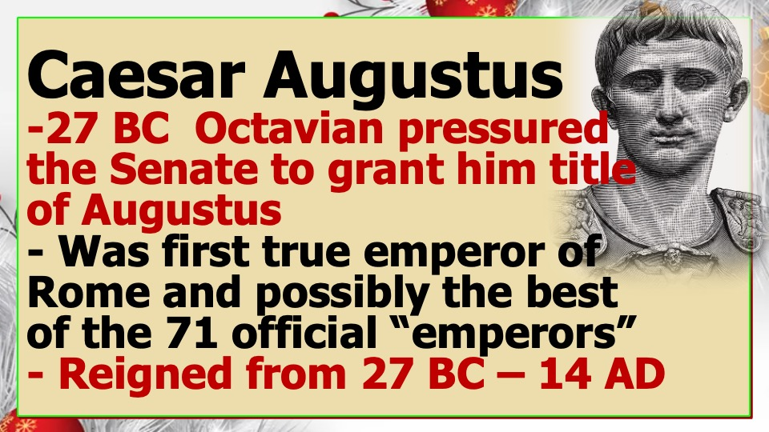

- Joseph and Mary did not choose Bethlehem.
- They did not choose the timing.
- They did not choose a manger.
- But God directed their path in fulfillment of Micah 5:2, the ancient prophecy that pointed to the coming of the Messiah who would change the world and be born in the midst of Mary and Joseph’s “changed plans”.
- Ephesians 1:11; Romans 8:28; 2 Cor. 5:7
- Trust in the Lord and discover how life’s frustrations can become wonderful God-opportunities!
2. God may, at times, use unlikely “actors” to
accomplish His purposes. Luke 2:4-5;
Acts 17:24-27

- God’s sovereignty is awesome, even over unbelieving rulers!

B. God uses wordly events to move people where
they need to be!

Examples:
- Proverbs 21:1 — “The king’s heart is in the hand of the Lord…”
- Romans 13:1 — “There is no authority except from God.”
- John 19:11 — Jesus told Pilate, “You would have no power over Me unless it had been given you from above.”

3. God may, at times, produce awesome outcomes
out of difficult/ “mysterious” /unexpected
circumstances. Luke 2:6-7; Isaiah 55:8-9;
Deuteronomy 29 :29

Examples:
- 2 Corinthians 8:9 — “Though He was rich, for your sake He became poor.”
- Philippians 2:6-8 — Christ “emptied Himself… taking the form of a servant.”
- 1 Corinthians 1:27-29 — God chooses the weak and foolish things to shame the strong.

