The Book of 1 Peter
The Truth About Trials

1 Peter 1:6-9 Pastor Mel Svendsen
October 12, 2025
Bottom Line:
God works in our lives through difficult trials to accomplish His purposes and bring us to a mature faith.

1. Trials are temporary but also are powerful
tools for growth! 1 Peter 1:6

Trials:
Hardships which God either permits or in our lives to accomplish His purposes if we respond in godly obedience!

Purpose of Trials
A stress test, pushing us up to and beyond our perceived limits, so that we will recognize our weaknesses and grow in our dependence upon God, trusting Him for help in the times of trouble!

Important Growth Step:
We might not always understand why trials are necessary, but we can trust Who deems them so. God tailors every trial for His purposes—to humble us,
to drive us from idols, to strengthen us for service, or to conform us to Christ.

2. Faith refined is faith proven and strengthened
1 Peter 1:7

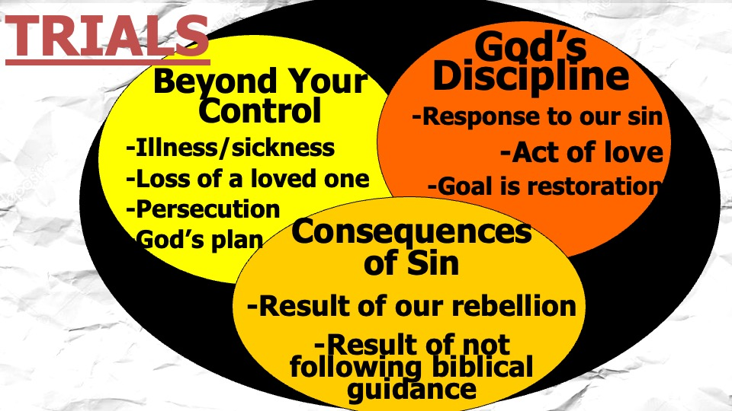

Test:
A process used for evaluation or diagnosis with a goal of improvement

“Yes, we can handle the truth about trials!”:
(James 1:2-4)
- Trials are to be expected.
- Joy is to be our response.
- God’s plan is to be trusted

Joy:
The state of inner well-being and satisfaction that comes from knowing and serving a sovereign God.

3. Your love for Jesus and faith in Him will sustain
you! 1 Peter 1:8-9

Peter concludes with the ultimate outcome:
“the salvation of your souls.”
Trials are not the end of the story. Salvation is.
The testing of faith is moving us toward that final day when we will see Christ face to face and receive our awesome inheritance!

