The Book of 1 Peter
Great Purpose…Great Promises

1 Peter 1:1-5. Pastor Mel Svendsen
September 7, 2025
Bottom Line:
Our identity as God’s people gives us “living hope” in Christ which entails a great purpose for today and amazing promises for tomorrow and beyond!!

Rejoice today because…
1. God’s sovereignty in our salvation is awesome!
1 Peter 1:1-2

1 Peter 1:1-2
Peter, an apostle of Jesus Christ, To those who are elect exiles of the Dispersion in Pontus, Galatia, Cappadocia, Asia, and
Bithynia, ² according to the foreknowledge of God the Father, in
the sanctification of the Spirit, for obedience to Jesus Christ and for sprinkling with his blood:

-The sovereignty of our God in salvation is beyond our full
comprehension…Scripture refers to the “mystery”…


-The debate to try to understand God’s sovereignty in salvation
has been “raging” for centuries…
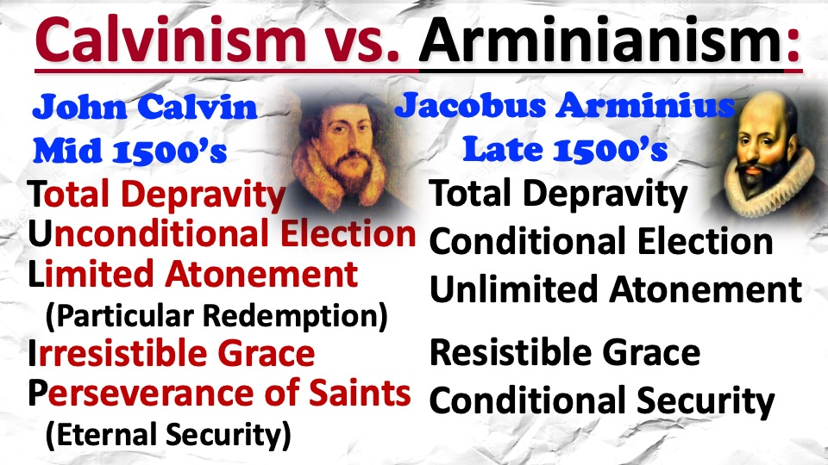

Rejoice today because…
2. Jesus’ resurrection is the key to our “living
hope”! 1 Peter 1:3-4

The Nature of our inheritance…
- Imperishable: Unlike earthly goods, it cannot decay. v. 4

- Undefiled: It is pure, untouched by sin or corruption. v. 4

- Unfading: It will not lose its beauty or glory. v.4

Rejoice today because…
3. Our security in Christ is absolutely immoveable
and unshakeable! 1 Peter 1:4-5

The security of our inheritance…
A. No fear: Don’t worry about losing your
Salvation if you are truly in Christ!
It is God’s power, not your performance, that guards you.

B. No pride: No boasting:, your salvation is
obtained and sustained through Jesus.

