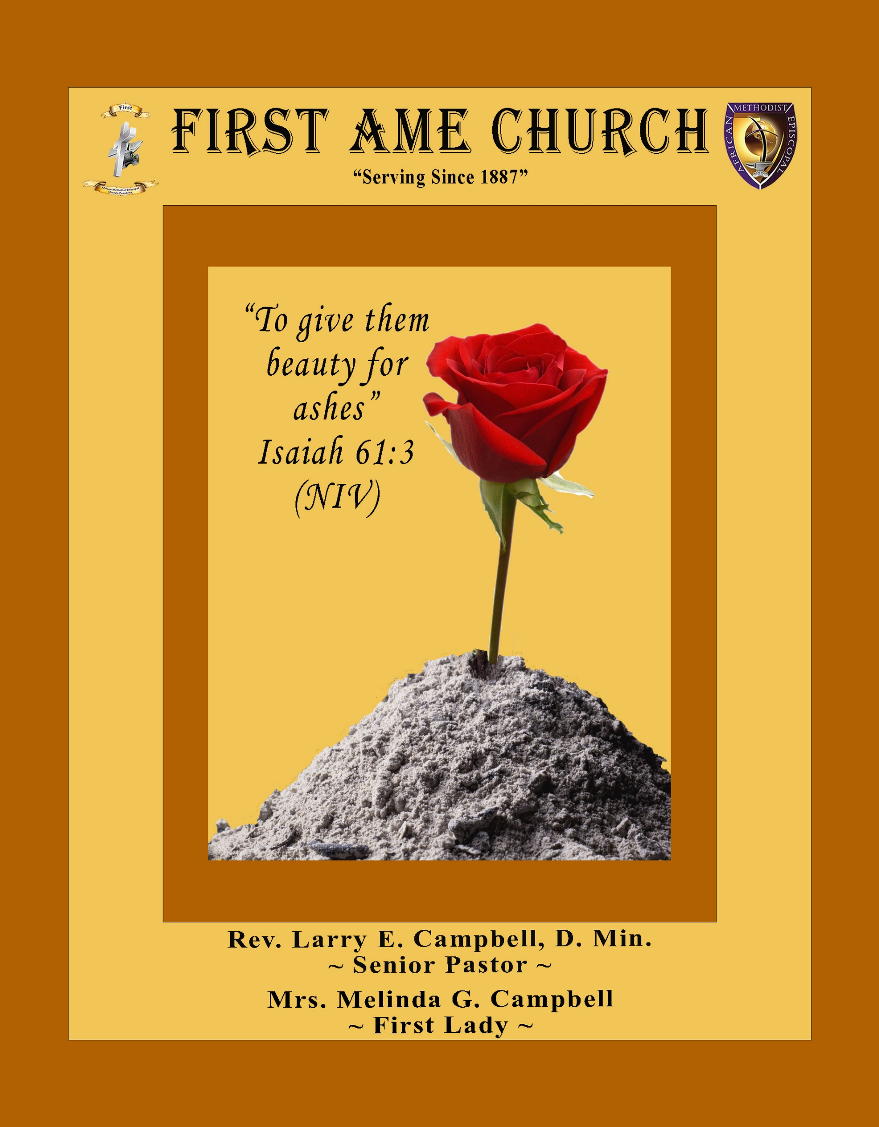

**Sunday, September 14, 2025 | 9:30 a.m.**

**Rt. Rev. Francine A. Brookins, Esq, Presiding Bishop**

**Rev. Miriam J. Burnett, MD, MPH, Supervisor of Missions**

**Rev. Roosevelt Lindsey, Jr. Presiding Elder**

**The Rev. Dr. Larry E. Campbell ~ Pastor/Minister**

**Mobile: (951) 587-1894 ~ Email: larrycampbell@famepasadena.org**

**Our First Lady: Mrs. Melinda G. Campbell**

The Reverend Dr. Jennifer Oliver ~ Itinerant Elder -

The Reverend Dr. Nikia Smith-Robert ~ Itinerant Elder (Affiliated)

The Reverend Lois Woodard ~ Itinerant Elder Superannuated (Retired)

The Reverend Rochelle Wright Moore ~ Itinerant Deacon

The Reverend Deborah West-Jones ~ Local Elder

The Reverend Philis J. Griffin, MDiv ~ Local Elder

Dr. Phyllis Beech ~ Evangelist

**The Reverend Van E. White ~ Executive Assistant/ Youth Coordinator**

**Church Administrative Assistant: Ms. Letha Rhymes**

**Church Office Hours:**

Tue, Wed 9:00am - 5:00pm, Thurs 9:00am - 3:00pm & 4:00pm - 7:30pm, Fri 9:00am -3:00pm.

Closed for Lunch Daily: 12:00pm - 1:00pm.

**Music Ministry**

Dr. Timothy Davis, Minister of Music

Bro. Jimmy Watlington, Percussionist ~ Bro. Carlos Caldwell, Organist

Bro. Darien Dorsey, Keyboardist

Sis. Karen Law, Women’s Chorus Director ~ Sis. Tonia Graham, Children’s Choir Director

Bro. J. Renard Washington, New Generation’s Choir

**FREE WI-FI service is available on the FAME Campus by accessing FAME 1700**

**Password: 6267980503**

**-3-**

**~ Order of Worship Experience ~**

**Warning: This order of worship is subject to change without warning or prior notice --- everything is governed by the Sovereignty of the Holy Spirit.**

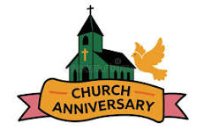 **CELEBRATING 138 YEARS IN GOD’S SERVICE**

**THEME: FAITH THAT CAN’T BE BURNED**

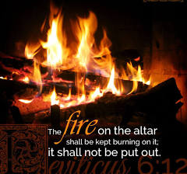

**+++ The Altar Call +++**

Praise & Worship

Doxology: “Praise God From Whom All Blessings Flow”

**The Call to Worship Sis. Alison Moses**

**Leader:** I was glad when they said unto me, let us go into the house of the Lord, our feet shall stand within Thy gates O Jerusalem! **(Psalm 122:1)**

**People:** For a day in Thy courts is better than a thousand. I had rather be a doorkeeper in the house of my God than to dwell in the tents of wickedness. **(Psalm 84:10)**

**Leader:** Because of the house ofthe Lord our God, I will seek Thy good.

**(Psalm 122:9)**

**People:** Those that be planted in the house of the Lord, shall flourish in the courts of our God. **(Psalm 92:13)**

**Leader:** Blessed are they that dwell in Thy house. Lord, I have loved Thy habitation, the place where Thy honor dwelleth. **(Psalm 26:8)**

**People:** For the Lord is in His holy temple; let all the earth keep silence before Him.

**(Habakkuk 2:20).**

**Leader:** Let the words of my mouth and the meditation of my heart, be acceptable in Thy sight, O Lord my strength and my redeemer. **(Psalm 19:14)**

**Unison:**  O Sing unto the Lord a new song, for He has done marvelous things. Make a

joyful noise unto the Lord, all the earth, sing His praises. **(Psalm 98:1, 4)**

**-4-**

**The Hymn of Praise A .M.E. Hymnal #54**

**A Mighty Fortress Is Our God**

**Words: Martin Luther, 1423-1546**

**1** A mighty fortress is our God, a bulwark never failing;  
Our helper he, amid the flood Of mortal ills prevailing.  
For still our ancient foe Doth seek to work us woe;  
His craft and power are great,

And armed with cruel hate,  
On earth is not his equal.

**2** Did we in our own strength confide, Our striving would be losing,  
Were not the right Man on our side, The Man of God's own choosing:  
Dost ask who that may be? Christ Jesus, it is He;  
Lord Sabaoth. His name, from age to age the same;  
And he must win the battle.

**3** And though this world, with devils filled, Should threaten to undo us,  
We will not fear, for God has willed His truth to triumph through us:  
The prince of darkness grim, We tremble not for him;  
His rage we can endure, For lo, his doom is sure;  
One little word shall fell him.

**4** That Word above all earthly powers, No thanks to them, abideth;  
The Spirit and the gifts are ours Through him who with us sideth:  
Let goods and kindred go, This mortal life also;  
The body they may kill: God's truth abideth still;  
His kingdom is forever. Amen.

**The Invocation Bro. Ken McPheeters**

**Ministry of Music The Praise Team**

**-5-**

**Scripture Lesson Sis. Anna Lou Parker**

**(Please Stand for the Reading of God’s Words)**

**Hebrews 11:1-3 (New International Version)**

Now faith is confidence in what we hope for and assurance about what we do not see. **2** This is what the ancients were commended for. **3** By faith we understand that the universe was formed at God’s command, so that what is seen was not made out of what was visible.

**Hebrews 12: 1-3, 28-29 (New Internation Version)**

**1**Therefore, since we are surrounded by such a great cloud of witnesses, let us throw off everything that hinders and the sin that so easily entangles. And let us run with perseverance the race marked out for us, **2** fixing our eyes on Jesus, the pioneer and perfecter of faith. For the joy set before Him He endured the cross scorning its shame, and sat down at the right hand of the throne of God. **3** Consider Him who endured such opposition from sinners, so that you will not grow weary and lose heart.

**28** Therefore, since we are receiving a kingdom that cannot be shaken, let us be thankful, and so worship God acceptably with reverence and awe, **29** for our God is a consuming fire.

**-6-**

**Historical Presentations** **Dr. Brian K. Venerable**

**Sister Allene Washington**

**Musical Selection**  ***(For Every Mountain)* Sis. Natalya Jones & Praise Team**

**Abbreviated Announcements/Visitor’s Welcome**



**Wedding**

**90 Plus Birthday Celebrations**

**Edna Lofton celebrated her 92nd birthday on September 2nd**

**Elois Blizzard will celebrate her 94th birthday on September 24th**

**Birthdays Recognized for the Month**

***“The best Birthday wish that you can get for the day is that you may live each moment of your life to the very fullest, without any regrets.”*** **Anonymous**

**Congregational *(Sing along)* Hymn AME Hymnal #364**

***My Hope is Built***

**-7-**

**The Offertory *(Tithes ~ Gifts ~ Benevolent Offerings)*  Bro. Zack De Johnette, Steward**

**The following Electronic GIVING Platforms are credible methods to GIVE to FAME:**

**#1. GIVELIFY** - Mobile Giving App available on the App Store. It’s easy to set up, just follow the guidelines.

**#2. Cash App: $FirstAMEPASADENA**

**#3. Mail in your Tithes & Offering - If you would like to mail your tithes and offering by check or money order, please send it to: First AME Church, 1700 N. Raymond Avenue, Pasadena, CA 91103.**

**#4. Drop off your Tithes & Offering - During business hours in the basket outside of the office.**

**Choral Response: *“All things come of Thee, O Lord; and of Thine own have we given Thee. Amen.”***

***Children’s Church Dismissal***

**Introduction of Guest Preacher Sis. Gwendolyn Brown**

**Sermonic Selection** **The Praise Team**

**Proclamation of The Word Rev. Latisha Stewart-Smith**

**Pastor – First A.M.E. Church, Val Verde, CA**

**The Invitation (Public/Private) Pastor**

**How to Join First A.M.E. Church of Pasadena**

**PROFESSION OF FAITH.** If you have never been a member of any church, you may join by professing Jesus Christ as your personal Lord and Savior.

**RENEWAL OF VOWS.** If you have been a member of a church at one time, but have been in active, you may join by renewing your faith in Jesus Christ as Lord and Savior.

**TRANSFER.** If you are a member of another African Methodist Episcopal Church and you are in good standing, you may join by requesting that your membership be transferred to the First African Methodist Episcopal Church of Pasadena.

**AFFILIATE MEMBER.** Sometimes an individual has reasons for keeping /his/her membership in another church but would like to be an active member of First African Methodist Episcopal Church, too. This is possible as an affiliate member. **__________________________________________________________________________________________**

**The Doxology**

**The Benediction**

**-8-**

**Scripture of the Day**

**Faith that can’t be Burned. *“When you pass through the fire, you will not be burned; the flames will not set you ablaze"* Isaiah 43:2**

**Quote of the Day**

***“To one who has faith, no explanation is necessary. To one without faith, no explanation is possible.”* Thomas Aquinas**

**Thought of the Week**

In the story of Shadrach, Meshach, and Abednego, we see three young men who were pushed to the limit. They were captives in Babylon, a foreign land with a foreign king who demanded their allegiance. When they refused to bow to King Nebuchadnezzar's golden statue, they were given a terrifying ultimatum: worship the idol or be thrown into a blazing furnace.

Their response wasn't a panicked prayer for rescue, but a powerful declaration of trust. They stated their confidence that God was able to save them, but they didn't stop there. They went on to say, "But even if he does not," their commitment would not waver. Their faith was not conditioned on their circumstances. It wasn't built on the expectation of a specific outcome, but on the unshakeable character of God himself.

We all face our own "fiery furnaces"—situations that test our resolve and threaten to consume us. It could be a devastating health diagnosis, a financial crisis, or immense personal pressure. In those moments, it's easy to focus on the fire and our desire to escape it. But the faith that cannot be burned is revealed when we stand firm, trusting God's goodness regardless of the outcome.

The three men were thrown into the fire, but they were not consumed. In fact, they were set free within the flames, and a fourth person—the Son of God—joined them there. Not a hair was singed, and they did not even smell of smoke. Their fiery ordeal didn't destroy them; it freed them and served as a powerful testimony to God's power.

Today, remember that your faith is not rooted in comfort but in Christ. He is with you in the fire, and no matter how intense the heat, your faith is safe in his hands.

**Humor of the Week**

Jonah and the whale

One day, a teacher was talking to her first grade class about whales when a little girl had a question.

Little Girl: “Do whales swallow people?”

Teacher: “No, even though they are much bigger than a person, they have throat pleats that filter their food of krill and plankton.

Little Girl: “But Mrs. Thurston says Jonah was swallowed by a whale.”

Teacher getting angry: “Blue whales cannot swallow people.”

Little Girl: “Well, when I get to heaven I’ll just ask Jonah if he was really swallowed by a whale.”

Teacher, still red with anger: “What if Jonah went to hell?”

Girl: “Well, then you can ask him.”

**HOME DAILY BIBLE READINGS**

**September 15, 2025 – September 21, 2025 (Week 52, Eternal Life)**

Monday Day 358 2 Peter 1-3, Ecclesiastes 5

Tuesday Day 359 1 John 1-5, Ecclesiastes 6

Wednesday Day 360 2 John, 3 John, Jude, Ecclesiastes 7

Thursday Day 361 Revelation 1-5, Ecclesiastes 8

Friday Day 362 Revelation 6-8, Ecclesiastes 9

Saturday Day 363 Revelation 9-14, Ecclesiastes 10

Sunday Day 364 Revelation 15-18, Ecclesiastes 11

Day 365 Revelation 19-22, Ecclesiastes 12

**-9-**

**ANNOUNCEMENTS**

**BEREAVEMENT NOTICE:** It is with heavy hearts that we announce the passing of **Bro. Larry Walton,** a beloved member of the FAME Church Family. Larry is the treasured Son of Sister Jessie Smith.  Please keep Sister Jessie and the entire Family in your prayers during this difficult season of bereavement.

**Beloved FAME Church Family,**

**Today, we gather not only to celebrate 138 years of our church’s faithful service in the Pasadena and Altadena community but also to honor the strength we’ve shown in the face of the Eaton Canyon wildfires. These flames may have tried to consume our surroundings, but they can never touch our spirit or the faith that unites us.**

**As I reflect on Isaiah 43:2*—“When you walk through fire, you shall not be burned”*—I am reminded that we are never alone. God walks with us through every trial. Our history is rich with stories of resilience and hope, woven together by generations who have strengthened our community with love.**

**Though we faced challenges, we also have each other. Let us support one another in healing and together turn our grief into hope. Our mission remains steadfast: to uplift those in need and proclaim the love of Christ.**

**As we celebrate today, let us carry this enduring faith forward—a flame that cannot be extinguished. Together, as a church family, we will shine God’s light even brighter.**

**Proudly serving as your pastor,**

**Rev. Dr. Larry E. Campbell**

**Baptismal Sunday**

**The Sacrament of Baptism will be held on Sunday, September 21, 2025. All Baptismal Candidates must attend a virtual Baptism class on Wednesday, September 17, 2025 at 6:00 p.m.**

**Join Zoom Meeting**

[**https://us**](https://us)**02web.zoom.us/j/82924063785?pwd=cSbgvkGq9fJVsam2Mb44Nxi2CnZtso.1**

**Meeting ID: 829 2406 3785 | Passcode: 518877**

**FIRST A.M.E. CHURCH — *“Feed My Sheep”* FOOD PANTRY**

**OPEN EVERY SECOND AND FOURTH FRIDAY**

**9:00 A.M. — 11:00 A.M.**

**Please consider making a financial donation in support of our Food Pantry**

**-10-**

**ANNOUNCEMENTS (Continued)**

**CHURCH CONFERENCE**

**Annual State of the Church**

Pastor Campbell will present the **FAME Church Family** with an official “State of the Church” Address at **7:00** **p.m. on Thursday, September 18, 2025**. The presence of the entire church membership is requested to be in attendance.

**Join Zoom Meeting**

[**https://us**](https://us)**02web.zoom.us/j/83805216493?pwd=P06tWYxk7Ds86Sy71ZdqHXzD27RVqn.1**

**Meeting ID: 838 0521 6493 | Passcode: 905424**

**One tap mobile:**

**+16699006833,,83805216493#,,,,*905424# US (San Jose)**

**+16694449171,,83805216493#,,,,*905424# US**

**\*\*\* Each Ministry President or designated representative will present the Top FIVE Significant Accomplishments of this Annual Conference Year. \*\*\***

**Budget Submission**

**All Auxiliary and Organization Presidents must submit their 2025-2026 draft budgets to Sis. Kischchen Hazelton Venerable by Friday, September 19, 2025.**

**-11-**

**101st SESSION OF THE SOUTHERN CALIFORNIA ANNUAL CONFERENCE**

**Wednesday – September 24**

7:15 -8:00 a.m. Login for Virtual Participation

8:00 a.m. – 12:00 Noon Women’s Missionary Society Convention

8:00 a.m. – 12:00 Noon Women in Ministry Convention

Bishop ’s prescheduled appointments

12:00 Noon – 1:30 p.m. Lunch Break

2:00 p.m. – 5:00 p.m. WMS Convention / WIM Convention

Board of Examiners

Bishop ’s prescheduled appointments

7:00 p.m. 9:00 p.m. WMS Night in White

**Thursday – September 25th**

7:15 -8:00 a.m. Login for Virtual Participation

8:00 a.m. – 8:45 a.m. Prayer & Hymn Sing

9:00 a.m. – 11:45 a.m. Business Session

Call to Order

Roll Call

Conference Organization

Finance Committee (Elect)

Trustees (Elect)

Judiciary Committee (Elect)

Ministerial Efficiency Committee (Appoint)

Presiding Elder’s Summaries

Board of Examiners

Pastor’s Reports

12:00 Noon – 1:00 p.m. Hour of Power – WIM in Charge

1:00 p.m. – 2:30 p.m. Lunch Break

2:30 p.m. – 5:00 p.m. Business Session

5:00 p.m. – 7:00 p.m. Dinner/Recess

7:00 p.m. Opening Worship Service

**Friday – September 26th**

7:00 -8:00 a.m. Login for Virtual Participation

8:00 a.m. – 8:45 a.m. Prayer & Hymn Sing

9:00 a.m. – 11:30 a.m. Business Session

12:00 Noon – 1:00 p.m. Hour of Power

1:00 p.m. – 2:30 p.m. Lunch

2:30 p.m. – 5:00 p.m. Business Session/Literary Reports

5:00 p.m. – 7:00 p.m. Dinner/Recess

7:00 p.m. (Lay in Charge)

**Saturday – September 27th**

7:15 -8:00 a.m. Login for Virtual Participation

8:00 a.m. – 8:45 a.m. Church School

9:00 a.m. – 10:00 a.m. Closing Business Session

10:00 a.m. Ordination Service / Holy Communion

**Sunday September 28TH**

3:00 p.m. Closing Service

**-12-**

**Prayer Request(s)**

**Please notify the Church Office of Sick & Shut-in additions, deletions, or status/address changes.**

**Bishop Francine A. Brookins, Esq. Supervisor Miriam Burnett, MD**

**Presiding Elder Roosevelt & Dr. Kaye Lindsey Rev. Dr. Larry & Melinda Campbell**

Richard Craig Hazel Clark Erica Woodard Jason Shirley Joshua Shirley Julian Shirley Ayanna Terry Aloura Clarke Gwendolyn Flowers Andrea Anderson Ocilda Files Danielle Clark Yolanda Oliver Brittany Shepherd Rev. Charles Brooks Doris Bailey Kimberly Woods Cynithia Grace Zechariah Robinson Diane Jordan Teresa Thompson Raymond Morrison Glen Scott Victoria Moore Christopher McCarthy Cheryl Jamerson Wilma Haynes Jewell Malloy Calle Burns Noel Johnson Vanessa Robinson Charles Ludd, Sr. Rev. Rochelle Moore Richelle Niara Vogel Catherine Graham Brittney Petty

Taylor Family Alford Family Spurill Family Deborah Burton Nettie McChristen Mary Glizer

Lorene Butler Stella Pulliam Jacquelyn Walker Donita Towler Vern Bo

**The Eaton Canyon Fire Victims**

**College Students**

**Let’s continue to support and pray for our beloved College Students**

Isaiah Crowell Alecia Davis Ahmad Harris Jade Williams Chase Johnson Jordan Patterson

Tyler Johnson Richard Jones Tyrikk Lawson Makia Rose Talbert Isaiah Ringo Grant Blizzard Elyse Sharp Kylee Sharp Zion Otano Elise Tervalon Grace Jones Journy Rogers Kimberly Robinson Donovan Williams Jasmine Collins Brandon Bates Gabriel Blizzard

**Sick and Shut-Ins**

|  |
| --- |
| **Bettina Ayers**  Pasadena Meadows Nursing Home, 150 Bellefontaine St., Pas., CA 91105 |
| **Bobby Thomas** 1052 E. Morada Place, Altadena, CA 91001 |
| **Carrie Wynne** Senior Living Heritage, 161 N. Hemet St., Hemet, CA 92545 |
| **Doris Curd** 11619 Woodcock Avenue, San Fernando, CA 91340 |
| **Edmund Riddle** Active Care Mission Bay, 2440 Grand Avenue, San Diego, CA 92109 |
| **Eleanor Towler** 975 E. Union Street, Unit #417, Pasadena, CA 91106 |
| **Elois Blizzard** P. O. Box 3646, So. Pasadena, CA 91031 |
| **Emily Cormier-Ross** 2549 La Fiesta Avenue, Altadena, CA 91001 |
| **Ernestine English** 26 W. Fair Oaks Drive, Pasadena, CA 91103 |
| **Frederick Smith** 1055 N. Vignes St., Los Angeles, CA 90012 |
| **Fred & Francis Caple** 5549 Hamill Ave, San Diego, CA 92120 |
| **Gloria Cubit Clay** 11745 Pierce St., Lake View Terrace, CA 91342 |
| **Hugh Hamberry** 2518 N. Marengo Avenue, Altadena, CA 91001 |
| **Josephine Brown** 15607 Saddleback Rd, Riverside, CA 92506 |
| **Jessie Smith** 7980 Mayten Avenue, Apt 3050 Rancho Cucamonga, CA 91730-8113 |
| **Linnie G. Nollie** 2250 E. New York Drive, Altadena, CA 91001 |
| **Malika G. Hendry** P. O. Box 94082, Pasadena, CA 91109 |
| **Mildred Lewis** C/O Hazel Rohr, 884 W. Jane Court, Upland, CA 91786 |
| **Norma Burnett** 618 Fairview Avenue, Unit #228, Arcadia, CA 91007 |
| **Opal Hampton** 1030 Chevron Court, Pasadena, CA 91103 |
| **Paul Ratliff** 1015 E. Athens St. Altadena, CA 91001 |
| **Ruthie Hopkins** 1155 Via Verde , San Dimas, CA 91773 |
| **Virlyn Grant** 15122 Orange Ave., Paramount, CA 90723 |
| **Wanda Nelson** 3618 N. Fair Oaks Avenue, Altadena, CA 91001 |
| **William Hilliard** 313 E. Loma Alta Dr. Altadena, CA 91001 |
| **Zell L. Hill** 375 Barthe Drive, Pasadena, CA 91103 |

**-13-**

**Sermon Notations**

**Scripture: _____________________________________________________________**

**Subject: _______________________________________________________________**

**Points of the Message: ___________________________________________________**

**_______________________________________________________________________**

**_______________________________________________________________________**

**_______________________________________________________________________**

**_______________________________________________________________________**

**_______________________________________________________________________**

**_______________________________________________________________________**

**Main Ideas of the Sermon: ________________________________________________**

**_______________________________________________________________________**

**_______________________________________________________________________**

**_______________________________________________________________________**

**_______________________________________________________________________**

**_______________________________________________________________________**

**Illustrations I want to remember: _________________________________________**

**_______________________________________________________________________**

**_______________________________________________________________________**

**_______________________________________________________________________**

**_______________________________________________________________________**

**_______________________________________________________________________**

**_______________________________________________________________________**

**What should I do as a result of this Sermon?** ________________________________

_____________________________________________________

_____________________________________________________

_____________________________________________________

_____________________________________________________

**-14-**

