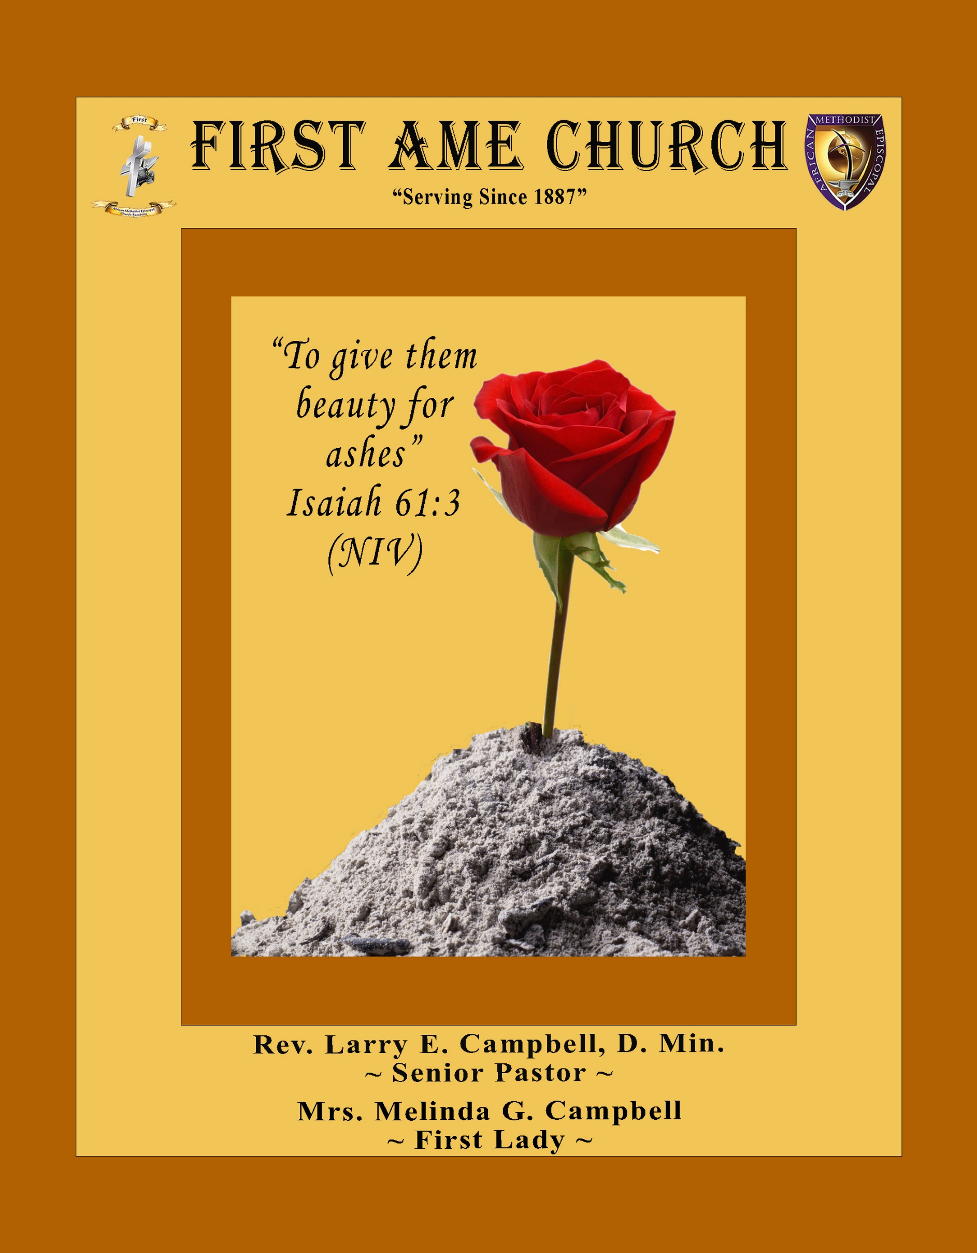

**Sunday, October 19, 2025 | 9:30 a.m.**

**Rt. Rev. Francine A. Brookins, Esq, Presiding Bishop**

**Rev. Miriam Burnett, MD, MPH, Supervisor of Missions**

**Rev. Roosevelt Lindsey, Jr. Presiding Elder**

**The Rev. Dr. Larry E. Campbell ~ Pastor/Minister**

**Mobile: (951) 587-1894 ~ Email: larrycampbell@famepasadena.org**

**Our First Lady: Mrs. Melinda G. Campbell**

The Reverend Dr. Jennifer Oliver ~ Itinerant Elder -

The Reverend Dr. Nikia Smith-Robert ~ Itinerant Elder (Affiliated)

The Reverend Lois Woodard ~ Itinerant Elder Superannuated (Retired)

The Reverend Rochelle Wright Moore ~ Itinerant Deacon

The Reverend Deborah West-Jones ~ Local Elder

The Reverend Philis J. Griffin, MDiv ~ Local Elder

Dr. Phyllis Beech ~ Evangelist

**The Reverend Van E. White ~ Executive Assistant/ Youth Coordinator**

**Community Resource Center Director ~ Ms. Kischchen Hazelton Venerable**

**Church Administrative Assistant: Ms. Letha Rhymes**

**Church Office Hours:**

Tue, Wed 9:00am - 5:00pm, Thurs 9:00am - 3:00pm & 4:00pm - 7:30pm, Fri 9:00am -3:00pm.

Closed for Lunch Daily: 12:00pm - 1:00pm.

**Music Ministry**

Dr. Timothy Davis, Minister of Music

Bro. Jimmy Watlington, Percussionist ~ Bro. Carlos Caldwell, Organist

Bro. Darien Dorsey, Keyboardist

Sis. Karen Law, Women’s Chorus Director ~ Sis. Tonia Graham, Children’s Choir Director

Bro. J. Renard Washington, New Generation’s Choir

**FREE WI-FI service is available on the FAME Campus by accessing FAME 1700**

**Password: 6267980503**

**-3-**

**~ Order of Worship Experience ~**

**Warning: This order of worship is subject to change without warning or prior notice --- everything is governed by the Sovereignty of the Holy Spirit**

**Children & Youth Sunday**

~ Altar Call ~

Praise & Worship

Doxology: “Praise God From Whom All Blessings Flow”

**The Call to Worship Princess Sidney Sims**

**Leader:** I was glad when they said unto me, let us go into the house of the Lord, our feet shall stand within Thy gates O Jerusalem! **(Psalm 122:1)**

**People:** For a day in Thy courts is better than a thousand. I had rather be a doorkeeper in the house of my God than to dwell in the tents of wickedness. **(Psalm 84:10)**

**Leader:** Because of the house ofthe Lord our God, I will seek Thy good.

**(Psalm 122:9)**

**People:** Those that be planted in the house of the Lord, shall flourish in the courts of our God. **(Psalm 92:13)**

**Leader:** Blessed are they that dwell in Thy house. Lord, I have loved Thy habitation, the place where Thy honor dwelleth. **(Psalm 26:8)**

**People:** For the Lord is in His holy temple; let all the earth keep silence before Him.

**(Habakkuk 2:20)**

**Leader:** Let the words of my mouth and the meditation of my heart, be acceptable in Thy sight, O Lord my strength and my redeemer. **(Psalm 19:14)**

**Unison:**  O Sing unto the Lord a new song, for He has done marvelous things. Make a

joyful noise unto the Lord, all the earth, sing His praises. **(Psalm 98:1, 4)**

**-4-**

**The Congregational Song of Praise Every Praise**

**(Repeat Verse 3 times)**

Every praise is to our God.   
Every word of worship with one accord  
Every praise every praise is to our God.  
Sing hallelujah to our God  
Glory hallelujah is due our God  
Every praise every praise is to our God.

**(Repeat Chorus 3 times)**

God my Savior   
God my Healer  
God my Deliverer  
Yes He is, yes He is

Yes He is, yes He is, yes He is, yes He is  
Yes He is, yes He is, yes He is, yes He is

**(Repeat Verse 2 times)**

Every praise is to our God.   
Every word of worship with one accord  
Every praise, every praise, every praise, every praise  
Every praise, every praise, every praise, every praise  
Every praise, every praise, every praise, every praise  
All of my worship, every praise,  
Every praise, every praise  
When you see me dancing, every praise  
Every praise, every praise  
When you see me shoutin', every praise  
Every praise, every praise, every praise, every praise  
Every praise, every praise, to our God  
Is to our God

**The Invocation Masters Dominque & Timothy De Johnette**

**Musical Selections The Combined Children & Youth Choir**

**-5-**

**(Please Stand for the Reading of God’s Words)**

**Old Testament Princess Heaven Gaddis**

**Numbers 13:1-3; -20 (New International Version) — Exploring Canaan**

**13** The Lord said to Moses, **2**“Send some men to explore the land of Canaan, which I am giving to the Israelites. From each ancestral tribe send one of its leaders.” **3**So at the Lord’s command Moses sent them out from the Desert of Paran. All of them were leaders of the Israelites.

**17**When Moses sent them to explore Canaan, he said, “Go up through the Negev and on into the hill country. **18**See what the land is like and whether the people who live there are strong or weak, few or many. **19**What kind of land do they live in? Is it good or bad? What kind of towns do they live in? Are they unwalled or fortified? **20**How is the soil? Is it fertile or poor? Are there trees in it or not? Do your best to bring back some of the fruit of the land.” (It was the season for the first ripe grapes.)

**New Testament Princess Scholar Jeffery**

**James 3:1-10 (New Century Version) — Controlling the Things We Say**

**Leader: 3** My brothers and sisters, not many of you should become teachers, because you

know that we who teach will be judged more strictly.

**People: 2We all make many mistakes. If people never said anything wrong, they**

**would be perfect and able to control their entire selves, too.**

**Leader:** 3When we put bits into the mouths of horses to make them obey us, we can control

their whole bodies.

**People: 4Also a ship is very big, and it is pushed by strong winds. But a very small**

**rudder controls that big ship, making it go wherever the pilot wants.**

**Leader: 5**It is the same with the tongue. It is a small part of the body, but it brags about

great things.

**People: A big forest fire can be started with only a little flame. 6And the tongue is like**

**a fire. It is a whole world of evil among the parts of our bodies. The tongue**

**spreads its evil through the whole body. The tongue is set on fire by hell, and**

**it starts a fire that influences all of life.**

**Leader: 7**People can tame every kind of wild animal, bird, reptile, and fish, and they have

tamed them, 8but no one can tame the tongue. It is wild and evil and full of deadly

poison.

**ALL: 9We use our tongues to praise our Lord and Father, but then we curse people,**

**whom God made like himself. 10Praises and curses come from the same**

**mouth! My brothers and sisters, this should not happen.**

**-6-**

**The Summary of the Decalogue Princess Savannah Sim**

|  |
| --- |
| **LEADER: From all that dwell below the skies…** |
| **SUNG:** From all that dwell below the skies, Let the Creator’s praise arise; Let the  Redeemer’s Name be sung, through every land, by every tongue. |
| **LEADER**: Hear what Christ our Savior saith, Thou shalt love the Lord thy God with all thy  heart, with all thy soul, and with all thy mind. This is the first and great  commandment. And the second is like unto it: Thou shalt love thy neighbor  as thyself. On these two commandments hang all the law and the prophets. |
| **SUNG:** Glory be to the Father, and to the Son, and to the Holy Ghost; as it was in  the beginning, is now, and ever shall be, world without end. **A~Men** |

**Abbreviated Announcements/Visitor’s Welcome**

**K-FAME Radio**



**-7-**

**Congregational *(Sing along)* Hymn AME Hymnal #323**

***What A Friend We Have In Jesus***

**The Offertory *(Tithes ~ Gifts ~ Benevolent Offerings)*  Bro. Todd Skinner, Steward**

**The following Electronic GIVING Platforms are credible methods to GIVE to FAME:**

**#1. GIVELIFY** - Mobile Giving App available on the App Store. It’s easy to set up, just follow the guidelines.

**#2. Cash App: $FirstAMEPASADENA**

**#3. Mail in your Tithes & Offering - If you would like to mail your tithes and offering by check or money order, please send it to: First AME Church, 1700 N. Raymond Avenue, Pasadena, CA 91103.**

**#4. Drop off your Tithes & Offering - During business hours in the basket outside of the office.**

**Choral Response: *“All things come of Thee, O Lord; and of Thine own have we given Thee. Amen.”***

**Children’s Church Dismissal**

**Sermonic Selection** **The Praise Team**

**Proclamation of The Word Pastor Larry E. Campbell**

**The Invitation (Public/Private)**

**How to Join First A.M.E. Church of Pasadena**

**PROFESSION OF FAITH.** If you have never been a member of any church, you may join by professing Jesus Christ as your personal Lord and Savior.

**RENEWAL OF VOWS.** If you have been a member of a church at one time, but have been in active, you may join by renewing your faith in Jesus Christ as Lord and Savior.

**TRANSFER.** If you are a member of another African Methodist Episcopal Church and you are in good standing, you may join by requesting that your membership be transferred to the First African Methodist Episcopal Church of Pasadena.

**AFFILIATE MEMBER.** Sometimes an individual has reasons for keeping /his/her membership in another church but would like to be an active member of First African Methodist Episcopal Church, too. This is possible as an affiliate member.

**______________________________________________________________________________________**

**The Doxology**

**The Benediction**

**-8-**

**Scripture of the Day**

**Tongue Trouble.** ***“Whoever keeps his mouth and his tongue keeps himself out of trouble".* Proverbs 21:23**

**Quote of the Day**

***"The tongue has no bones, but it is strong enough to break a heart.”* An African Proverb**

**Thought of the Week**

**The Power of the Tongue**

**Proverbs 18:21 (ESV) *-- Death and life are in the power of the tongue, and those who love it will eat its fruits.***

“Sticks and stones may break my bones, but words will never hurt me.” This statement has been repeated for ages by parents to children who got their feelings hurt by someone’s mean words. The problem with the statement is that it’s simply not true. Words do hurt us. In fact, careless words spoken to us can stay with us for a lifetime.

This reality shouldn’t surprise us at all. The Bible teaches us that our words carry massive significance in our lives. Our passage today is one such example. The proverb says, “Death and life are in the power of the tongue, and those who love it will eat its fruits.” That is a big statement. “Death and life” are in the power of the tongue? We either give life or take life with our words. This is obviously a metaphorical statement, but it is absolutely true. We can either build up with our words or tear down with them.

Can you remember hurtful words spoken to you in your life? Think about the impact those words had on you. Maybe it was something about your appearance, or your social status. Those things stay with us. Likewise, the encouraging words and affirmations we receive do too. 

As Christians, we need to remember the effect our words have on ourself and other people. We should be those who give life with our words. We want to season them with grace, truth, and love. The last thing we should ever do is tear others down with our words. There are many temptations around us to tear others down, whether behind their back or to their face. But we are accountable to the Lord for our words. May we use our words today to honor the Lord and love our neighbor. Let’s repent of every ungodly word we speak about ourself and others.

**Humor of the Week**

**Mrs. Smartt was fumbling in her purse for her offering when a large television remote fell out and clattered into the aisle.**

**The curious usher bent over to retrieve it for her and whispered, “Do you always carry your TV remote to church?”**

**“No,” she replied, “but my husband refused to come with me this morning, and I figured this was the most evil thing I could do to him legally.”**

**HOME DAILY BIBLE READINGS**

**October 20, 2025 – October 26, 2025 (Week 5, Deuteronomy)**

Monday Day 29 Exodus 32-34, Psalm 17

Tuesday Day 30 Exodus 35-37, Psalm 18:1-5

Wednesday Day 31 Exodus 38-40, Psalm 18:6-13

Thursday Day 32 Leviticus 1-4, Psalm 18:14-19

Friday Day 33 Leviticus 5-7, Psalm 18:20-29

Saturday Day 34 Leviticus 8-10, Psalm 18:30-39

Sunday Day 35 Leviticus 11-13, Psalm 18:40-50

**-9-**

**ANNOUNCEMENTS**

**AME Voter’s Count Down**

**16 Days To Go**

**Use Your Voice by Voting!**

**Tell the Good News … Your VOTE Matters!**

**November 4, 2025 is Elections Day!**

**TELL EVERYBODY YOU MEET!**

**Voters Public Service Announcement**

***This is a public service announcement for every voter who has moved, since the last election, or voters who were forced to move because of the Eaton and Palisades Fires:***

**Be sure to re-register to vote so the California Secretary of State knows where to mail your ballot. Voters are required to register when any of the following happens: (1) when you move, (2) change your name, or (3) want to change your political party.**

**Changing your address with the post office DOES NOT automatically change your address with the Secretary of State. So, to register or to be sure you’re registered with your new mailing address, simply go to their website at www.registertovote.ca.gov. On this website you can register, confirm your registration, and find out for sure if you’re registered to receive your ballot at your current mailing address. The deadline to register for the upcoming November 4, 2025, election is October 20, 2025.**

**NOTE: You can still vote even if you miss this deadline. You can go to any Vote Center/Polling Place after they open, register there, receive a ballot, and vote there. You’ll just have to go there in person. Going online is simply easier and more convenient. Make sure your voice is heard by casting your ballot! To register to vote online:** [**www.registertovote.ca.gov**](http://www.registertovote.ca.gov)

**To have a registration form mailed to you call: 800-345-8683**

**90+ Ministry Holiday Bazaar Fundraiser**

**The annual 90+ Ministry Holiday Catalog Bazaar is here! Let us make your Christmas shopping easy this year with Afrocentric cards and gifts by Shades of Color and African American Expressions.**

**Orders may be placed by contacting one of the following team members October 12, 2025 through October 26, 2025: Lateefah Doxey, Robin Ford, Ann Hall-Jones, Karyn Hawthorne, Beverly Price, or Brenda Sharp. We will have a sales table set up outside after church service on October 12, October 19 and October 26. Catalogs and order forms are also available in the church office.**

**Proceeds from this fundraiser will help ensure our ability to continue bringing smiles and encouragement to our cherished 90+ FAME members.**

**Thank you in advance for your support.**

**The 90+ Ministry Team**

**FIRST A.M.E. CHURCH — *“Feed My Sheep”* FOOD PANTRY**

**OPEN EVERY SECOND AND FOURTH FRIDAY**

**9:00 A.M. — 11:00 A.M.**

**Please consider making a financial donation in support of our Food Pantry**

**-10-**

**ANNOUNCEMENTS (Continued)**

**Auxiliaries/Organizations Budget Reconciliation Virtual Meeting**

**Time: Oct 21, 2025 07:00 PM Pacific Time (US and Canada)**

**Join Zoom Meeting**

**https://us02web.zoom.us/j/89648698559?pwd=paQ4klgeawVKO6J17wRwE6ulgzOuto.1**

**Meeting ID: 896 4869 8559**

**Passcode: 652184**

**---**

**One tap mobile**

**+16699006833,,89648698559#,,,,*652184# US (San Jose)**

**+16694449171,,89648698559#,,,,*652184# US**

**-11-**

**ANNOUNCEMENTS (Continued)**

**~SAVE The DATE~**

**November 9, 2025 | 9:30 a.m. Worship Service**

**Pastor and First Lady Appreciation Day**

**Los Angeles South/ Las Vegas District Planning Meeting**

**Saturday, November 15, 2025 | 10:00 a.m.**

**Host Church: Brookins-Kirkland Community A.M.E. Church**

**3719 W. Slauson Ave**

**Los Angeles, CA 90043.**



**October is Breast Cancer Awareness Month. It is the most common cancer among African American Women. If you are 40 years or older, it is important to get a mammogram and breast exam every year. Early detection is the best preventive measure against breast cancer.**

**-12-**

**Prayer Request(s)**

**Please notify the Church Office of Sick & Shut-in additions, deletions, or status/address changes.**

**Bishop Francine A. Brookins, Esq. Supervisor Miriam Burnett, MD**

**Presiding Elder Roosevelt & Dr. Kaye Lindsey Rev. Dr. Larry & Melinda Campbell**

Richard Craig Hazel Clark Erica Woodard Jason Shirley Joshua Shirley Julian Shirley Ayanna Terry Aloura Clarke Gwendolyn Flowers Andrea Anderson Ocilda Files Danielle Clark Donita Towler Brittany Shepherd Rev. Charles Brooks Doris Bailey Kimberly Woods Cynithia Grace Zechariah Robinson Diane Jordan Teresa Thompson Raymond Morrison Glen Scott Victoria Moore

Christopher McCarthy Cheryl Jamerson Wilma Haynes Jewell Malloy Calle Burns Noel Johnson Vanessa Robinson Charles Ludd, Sr. Rev. Rochelle Moore Richelle Niara Bogle Catherine Graham Brittney Petty Taylor Family Alford Family The Spurill Family Deborah Burton Nettie McChristen Mary Glizer Lorene Butler Stella Pulliam Jacquelyn Walker Vern Bo Selene Cox

**The Eaton Canyon Fire Victims**

**College Students**

**Let’s continue to support and pray for our beloved College Students**

Isaiah Crowell Alecia Davis Ahmad Harris Jade Williams Chase Johnson Grant Blizzard

Tyler Johnson Richard Jones Tyrikk Lawson Makia Rose Talbert Isaiah Ringo Journey Rogers Elyse Sharp Kylee Sharp Zion Otano Elise Tervalon Grace Jones Jordan Patterson Kimberly Robinson Donovan Williams Jasmine Collins Brandon Bates Gabriel Blizzard

**Sick and Shut-Ins**

|  |
| --- |
| **Bettina Ayers**  Pasadena Meadows Nursing Home, 150 Bellefontaine St., Pas., CA 91105 |
| **Bobby Thomas** 1052 E. Morada Place, Altadena, CA 91001 |
| **Carrie Wynne** Senior Living Heritage, 161 N. Hemet St., Hemet, CA 92545 |
| **Doris Curd** 11619 Woodcock Avenue, San Fernando, CA 91340 |
| **Edmund Riddle** Active Care Mission Bay, 2440 Grand Avenue, San Diego, CA 92109 |
| **Eleanor Towler** 975 E. Union Street, Unit #417, Pasadena, CA 91106 |
| **Elois Blizzard** P. O. Box 3646, So. Pasadena, CA 91031 |
| **Emily Cormier-Ross** 2549 La Fiesta Avenue, Altadena, CA 91001 |
| **Ernestine English** 26 W. Fair Oaks Drive, Pasadena, CA 91103 |
| **Frederick Smith** 1055 N. Vignes St., Los Angeles, CA 90012 |
| **Fred & Francis Caple** 5549 Hamill Ave, San Diego, CA 92120 |
| **Gloria Cubit Clay** 11745 Pierce St., Lake View Terrace, CA 91342 |
| **Hugh Hamberry** 2518 N. Marengo Avenue, Altadena, CA 91001 |
| **Josephine Brown** 15607 Saddleback Rd, Riverside, CA 92506 |
| **Jessie Smith** 7980 Mayten Avenue, Apt 3050 Rancho Cucamonga, CA 91730-8113 |
| **Linnie G. Nollie** 2250 E. New York Drive, Altadena, CA 91001 |
| **Malika G. Hendry** P. O. Box 94082, Pasadena, CA 91109 |
| **Mildred Lewis** C/O Hazel Rohr, 884 W. Jane Court, Upland, CA 91786 |
| **Norma Burnett** 618 Fairview Avenue, Unit #228, Arcadia, CA 91007 |
| **Opal Hampton** 1030 Chevron Court, Pasadena, CA 91103 |
| **Paul Ratliff** 1015 E. Athens St. Altadena, CA 91001 |
| **Ruthie Hopkins** 1155 Via Verde , San Dimas, CA 91773 |
| **Virlyn Grant** 15122 Orange Ave., Paramount, CA 90723 |
| **Wanda Nelson** 3618 N. Fair Oaks Avenue, Altadena, CA 91001 |
| **William Hilliard** 313 E. Loma Alta Dr. Altadena, CA 91001 |
| **Zell L. Hill** 375 Barthe Drive, Pasadena, CA 91103 |

**-13-**

**Sermon Notations**

**Scripture: _____________________________________________________________**

**Subject: _______________________________________________________________**

**Points of the Message: ___________________________________________________**

**_______________________________________________________________________**

**_______________________________________________________________________**

**_______________________________________________________________________**

**_______________________________________________________________________**

**_______________________________________________________________________**

**_______________________________________________________________________**

**Main Ideas of the Sermon: ________________________________________________**

**_______________________________________________________________________**

**_______________________________________________________________________**

**_______________________________________________________________________**

**_______________________________________________________________________**

**_______________________________________________________________________**

**Illustrations I want to remember: _________________________________________**

**_______________________________________________________________________**

**_______________________________________________________________________**

**_______________________________________________________________________**

**_______________________________________________________________________**

**_______________________________________________________________________**

**_______________________________________________________________________**

**What should I do as a result of this Sermon?** ________________________________

_____________________________________________________

_____________________________________________________

_____________________________________________________

_____________________________________________________

**-14-**

