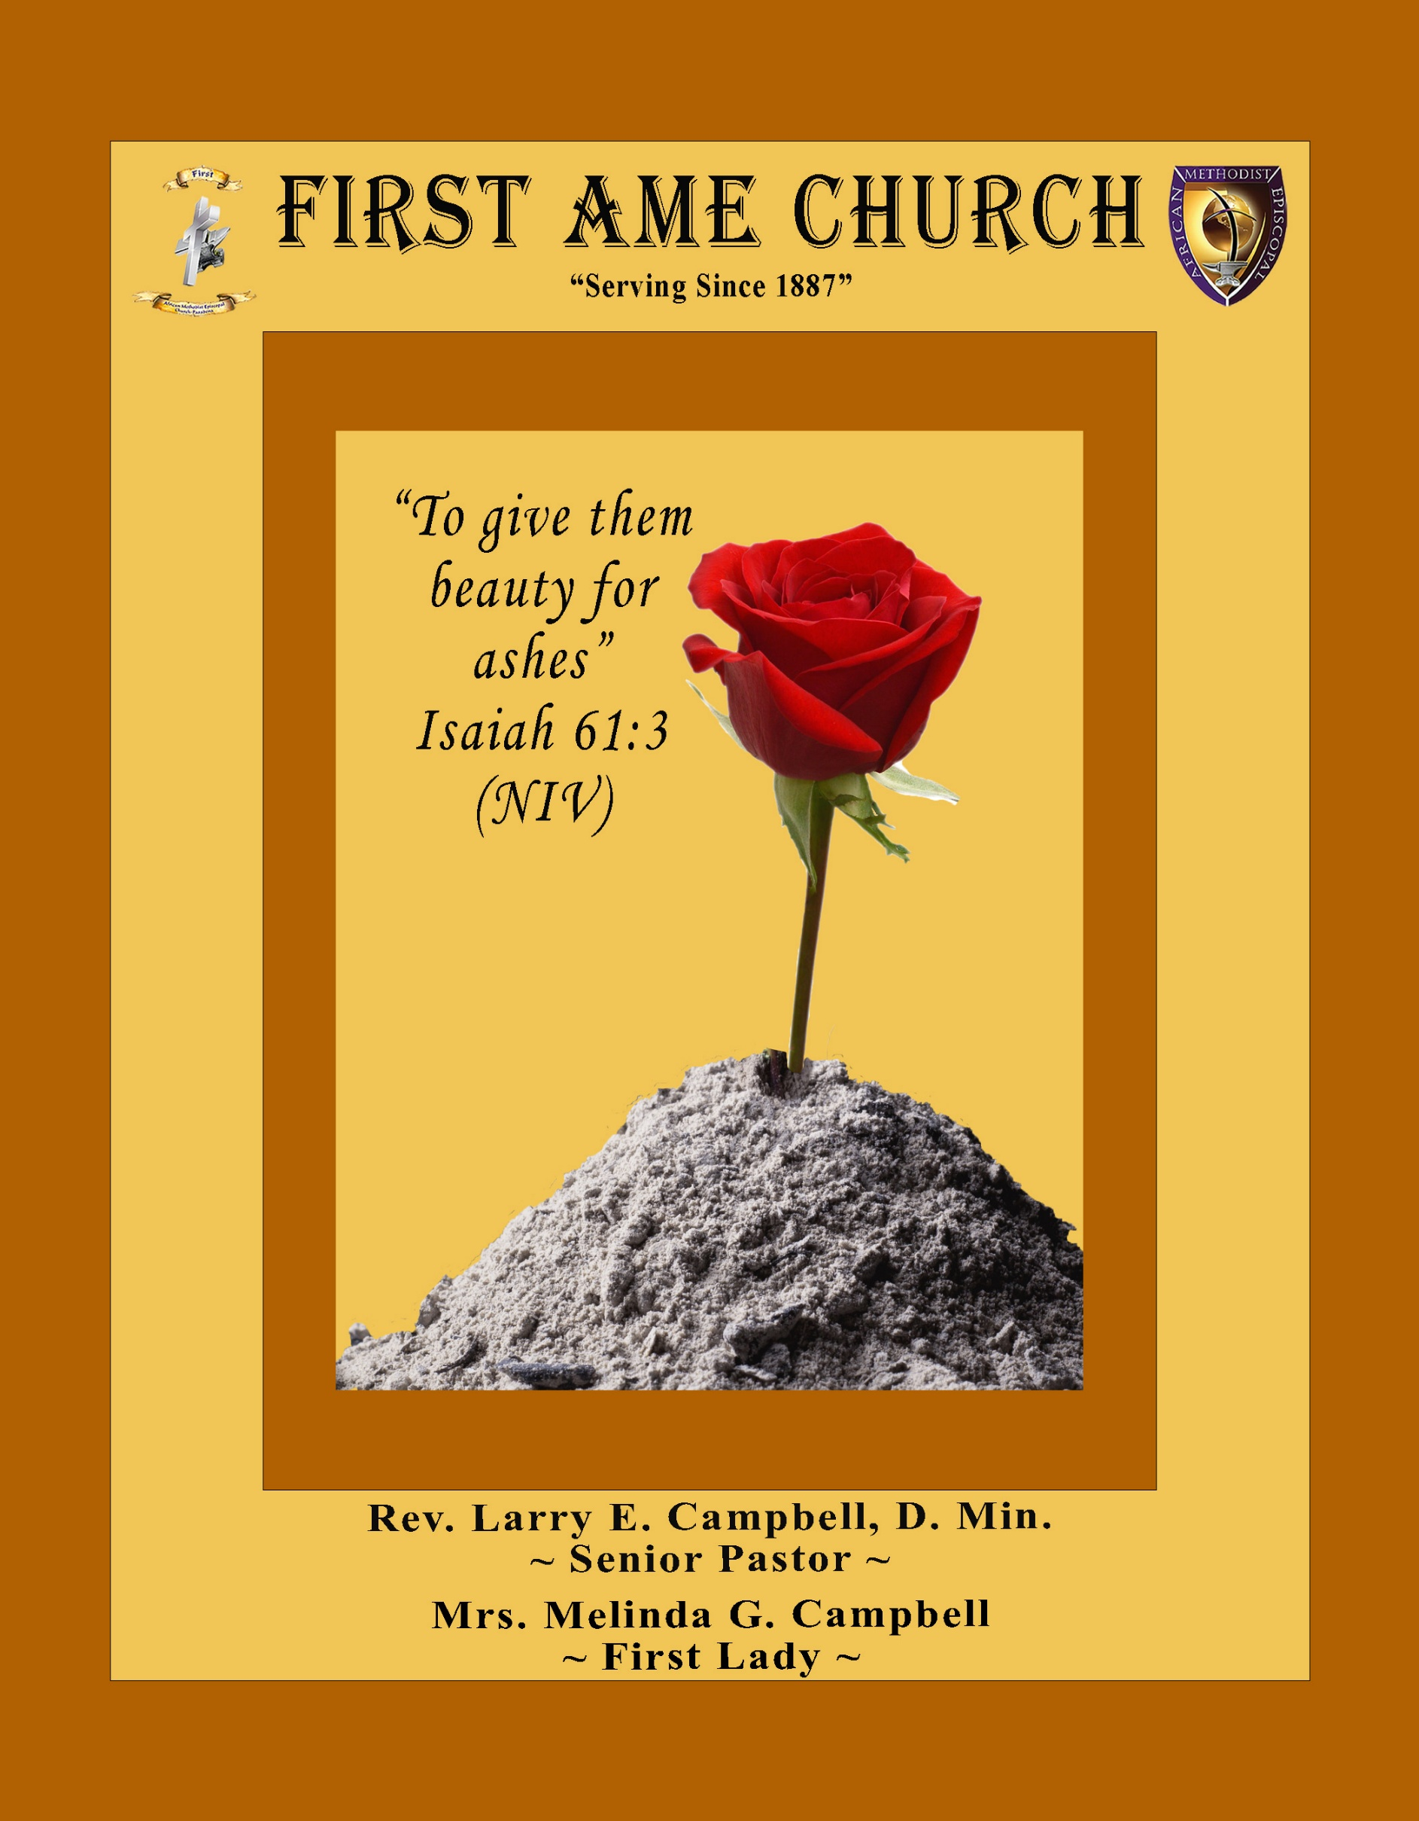
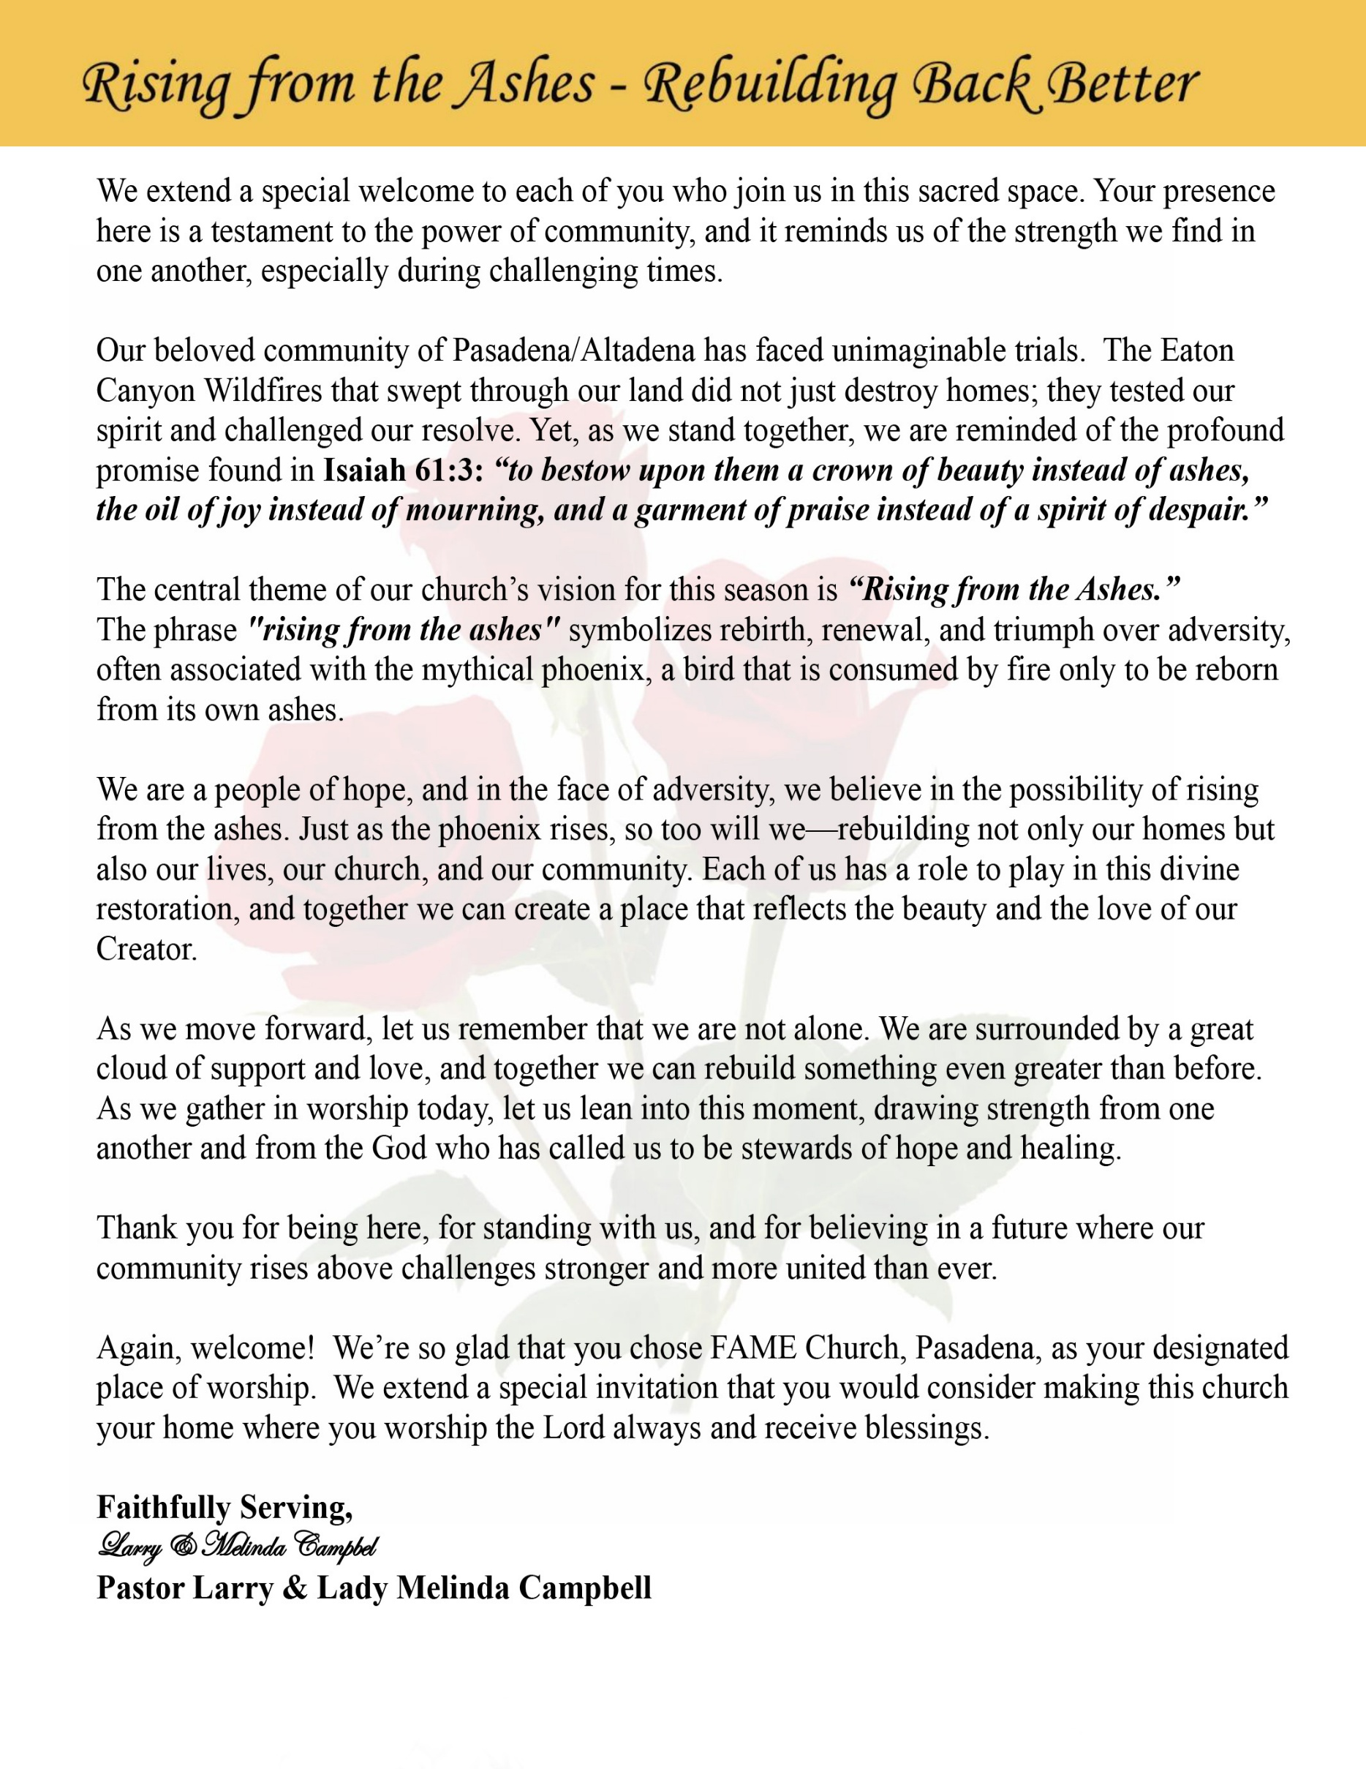

Sunday, November 9, 2025 | 9:30 a.m.

Rt. Rev. Francine A. Brookins, Esq, Presiding Bishop
Rev. Miriam Burnett, MD, MPH, Supervisor of Missions
Rev. Roosevelt Lindsey, Jr. Presiding Elder

The Rev. Dr. Larry E. Campbell ~ Pastor/Minister

Mobile: (951) 587-1894 ~ Email: larrycampbell@famepasadena.org

Our First Lady: Mrs. Melinda G. Campbell

The Reverend Dr. Jennifer Oliver ~ Itinerant Elder -
The Reverend Dr. Nikia Smith-Robert ~ Itinerant Elder (Affiliated)
The Reverend Lois Woodard ~ Itinerant Elder Superannuated (Retired)
The Reverend Rochelle Wright Moore ~ Itinerant Deacon
The Reverend Deborah West-Jones ~ Local Elder
The Reverend Philis J. Griffin, MDiv ~ Local Elder
Dr. Phyllis Beech ~ Evangelist

The Reverend Van E. White ~ Executive Assistant/ Youth Coordinator
Community Resource Center Director ~ Ms. Kischchen Hazelton Venerable
Church Administrative Assistant: Ms. Letha Rhymes

Church Office Hours:
Tue, Wed 9:00am - 5:00pm, Thurs 9:00am - 3:00pm & 4:00pm - 7:30pm, Fri 9:00am -3:00pm.
Closed for Lunch Daily: 12:00pm - 1:00pm.

Music Ministry
Dr. Timothy Davis, Minister of Music
Bro. Jimmy Watlington, Percussionist ~ Bro. Carlos Caldwell, Organist
Bro. Darien Dorsey, Keyboardist
Sis. Karen Law, Women’s Chorus Director ~ Sis. Tonia Graham, Children’s Choir Director
Bro. J. Renard Washington, New Generation’s Choir

FREE WI-FI service is available on the FAME Campus by accessing FAME 1700
Password: 6267980503

-3-

~ Order of Worship Experience ~

Warning: This order of worship is subject to change without warning or prior notice --- everything is governed by the Sovereignty of the Holy Spirit



+The Altar Call +

Greeters & Processional Sis. Maryetta Babalola & Sis. Darlene Anderson, Stewards

Doxology: “Praise God From Whom All Blessings Flow”

The Call to Worship Bro. Todd Skinner, Steward

Leader: I was glad when they said unto me, let us go into the house of the Lord, our feet shall stand within Thy gates O Jerusalem! (Psalm 122:1)

People: For a day in Thy courts is better than a thousand. I had rather be a doorkeeper in the house of my God than to dwell in the tents of wickedness. (Psalm 84:10)

Leader: Because of the house of the Lord our God, I will seek Thy good.
(Psalm 122:9)

People: Those that be planted in the house of the Lord, shall flourish in the courts of our God. (Psalm 92:13)

Leader: Blessed are they that dwell in Thy house. Lord, I have loved Thy habitation, the place where Thy honor dwelleth. (Psalm 26:8)

People: For the Lord is in His holy temple; let all the earth keep silence before Him.
(Habakkuk 2:20).

Leader: Let the words of my mouth and the meditation of my heart, be acceptable in Thy sight, O Lord my strength and my redeemer. (Psalm 19:14)

Unison: O Sing unto the Lord a new song, for He has done marvelous things. Make a
joyful noise unto the Lord, all the earth, sing His praises. (Psalm 98:1, 4)

-4-

The Hymn of Praise A.M.E. Hymnal #520

Come, We That Love the Lord
(We’re Marching to Zion)

1. Come, we that love the Lord,
and let our joys be known.
Join in a song with sweet accord, Join in a song with sweet accord
And thus surround the throne,
And thus surround the throne.
Refrain:
We're marching to Zion, We're marching to Zion,
Beautiful, beautiful Zion;
We're marching upward to Zion,
The beautiful city of God.

2. Let those refuse to sing
Who never knew our God;
But children of the heav'nly King, But children of the heav'nly King
May speak their joys abroad,
May speak their joys abroad.
(Refrain)

3. The hill of Zion yields
a thousand sacred sweets
Before we reach the heav'nly fields, Before we reach the heav'nly fields,
Or walk the golden streets,
Or walk the golden streets.
(Refrain)

4. Then let our songs abound,
And ev'ry tear be dry;
We're marching through Emmanuel's ground, We're marching through Emmanuel's ground,
to fairer worlds on high,
to fairer worlds on high.
(Refrain)

The Invocation Bro. Ray Bolton, Steward

Ministry of Music The Praise Team

-5-

Responsive Scripture Lesson Sis. Linda P. Wright, Steward
(Please Stand for the Reading of God’s Words)
Ephesians 6:10-13 (New International Version) —Standing Strong
¹⁰ Finally, be strong in the Lord and in his mighty power. ¹¹ Put on the full armor of God, so that you can take your stand against the devil’s schemes. ¹² For our struggle is not against flesh and blood, but against the rulers, against the authorities, against the powers of this dark world and against the spiritual forces of evil in the heavenly realms. ¹³ Therefore put on the full armor of God, so that when the day of evil comes, you may be able to stand your ground, and after you have done everything, to stand.

Pastoral Appreciation Litany —“Still Standing, Still Serving, Still Strong”
Sis. Barbra McPheeters & Lynnette Burke, Stewards
Leader: Today we give thanks for our Pastor — 11 years of pastoral leadership at FAME Pasadena, and 25 years of dedicated pastoral service in the African Methodist Episcopal Church.
People: We thank God that our Pastor is Still Standing, Still Serving, and Still Strong!
Leader: Through trials and triumphs, through seasons of change and challenge, God has sustained His servant.
People: “The Lord is my strength and my shield; my heart trusts in Him, and He helps me.” (Psalm 28:7)
Leader: When the world was shaken by the COVID-19 pandemic, our Pastor led with courage — keeping us connected, comforted, and covered in prayer.
People: He reminded us that faith conquers fear and God’s presence never fails.
Leader: When the Eaton Canyon Fire tested our community, our Pastor and First Lady stood strong — serving the hurting and declaring that we may be burned down, but not burned out!
People: Their steady hands and strong hearts showed us that hope survives the flames.
Leader: We thank God for First Lady Melinda — a woman of grace and prayer, whose love and support strengthen this ministry.
People: She serves with compassion and stands faithfully beside God’s servant.
Leader: Pastor, you have fought the good fight, kept the faith, and stood firm in the armor of God.
[Continued on page 7]

-6-

Pastoral Litany Continued]

People: And having done all to stand, you are Still Standing!
Leader: You continue to serve with vision and power.
People: You are Still Serving!
Leader: You lead with endurance, grace, and faith.
People: You are Still Strong!
Leader: FAME Pasadena, let us give God praise for our Pastor and First Lady — faithful examples of perseverance and purpose.
All Together: To God be the glory — for our leaders are Still Standing, Still Serving, Still Strong!

Abbreviated Announcements/Visitor’s Welcome

Anniversaries & Birthday’s Sis. Joann Forte’-Wormely, Trustee Pro-Tem
Wedding

90 Plus Birthday Celebrations

Emmell Beech will celebrate his 93rd birthday on November 17th.

Harley Wyatt will celebrate her 91st birthday on November 24th.

Linnie Nollie will celebrate her 92nd birthday on November29th.

Birthdays Recognized for the Month


“The best Birthday wish that you can get for the day is that you may live each moment of your life to the very fullest, without any regrets.” Anonymous

-7-

Special Presentations/Video Sis. Juanita West-Tillman, Steward

Special Congregational Hymn (Sing along)
A Special tribute to our Military Veterans
#572 Mine Eyes Have Seen the Glory

The Offertory (Tithes ~ Gifts ~ Benevolent Offerings) Bro. Bill Matlock, Steward
Bro. Zach De Johnette, Steward

The following Electronic GIVING Platforms are creditable methods to GIVE to FAME:

#1. GIVELIFY - Mobile Giving App available on the App Store. It’s easy to set up, just follow the guidelines.

#2. Cash App: $FirstAMEPASADENA

#3. Mail in your Tithes & Offering - If you would like to mail your tithes and offering by check or money order, please send it to: First AME Church, 1700 N. Raymond Avenue, Pasadena, CA 91103.

#4. Drop off your Tithes & Offering - During business hours in the basket outside of the office.

Choral Response: “All things come of Thee, O Lord; and of Thine own have we given Thee. Amen.”

Children’s Church Dismissal

Introduction of Guest Preacher Sis. Kischchen A Hazelton Venerable, Steward

Sermonic Selection The Praise Team

The Preached Word Rev. Dr. Ralph E. Williamson
Pastor — Christ Our Redeemer A.M.E. Church, Irvine, CA

The Invitation (Public/Private)

Pastor & FirstLady Remarks

The Doxology

The Benediction

-8-

Scripture of the Day
Still Standing, Still Serving, Still Strong. “Therefore, my dear brothers and sisters, stand firm. Let nothing move you. Always give yourselves fully to the work of the Lord, because you know that your labor in the Lord is not in vain.” 1 Corinthians 15:58

Quote of the Day
“Still standing is a testimony. Still serving is a calling. Still strong is a declaration that God is not finished with us yet.” Rev Dr. Larry E. Campbell
Thought of the Week
There are moments in life when standing is an act of victory. Not running, not fighting—just standing.
Standing after the storm. Standing after the loss. Standing after the battle you didn’t think you’d survive.
Many of us can look back over our lives and say, “I’ve been through some things — but I’m still here.” That’s not pride talking; that’s testimony. We’re still standing, not because we were the strongest, but because God’s grace held us upright when life tried to knock us down.
But standing isn’t enough. God calls us to keep serving — to keep showing up, giving, loving, and leading, even when it would be easier to sit down.
Serving reminds the world that our faith is still alive, that our strength doesn’t come from medals, muscles, or memories — it comes from the Spirit of God within us.
And through it all, we remain strong. Not the kind of strength that boasts, but the kind that believes:
“I can do all things through Christ who strengthens me.” (Philippians 4:13)
That’s the strength that carried soldiers through war, families through loss, and believers through every trial and tribulation. It’s the quiet, enduring strength that whispers, “By His grace — I’m still standing.”
Today, take a moment to thank God:
For the times He kept you standing when you wanted to fall.
For the privilege of serving even when tired.
For the inner strength that only His Spirit can provide.
Let your life today be living proof that God’s grace still works, His calling still matters, and His power still holds you up.

Humor of the Week
A teacher was giving a lesson on the Old Testament and asked one of her students, “Tommy, who knocked down the walls of Jericho?”
Tommy answered, “Well, it wasn’t me.”
Worried about this lack of Bible knowledge, the teacher called Tommy’s mother.
His mother said, “Look, my son’s a good kid. If he says he didn’t knock the wall down, he didn’t knock the wall down.”
More worried, the teacher called Tommy’s father. He listened to her story and said, “Well, look, I don’t want any trouble. Just tell me how much this wall costs, and I’ll take care of it.”

HOME DAILY BIBLE READINGS
November 10, 2025 – November 16, 2025 (Week 8, Ruth)
Monday Day 50 Numbers 23-25, Psalm 25:1-3
Tuesday Day 51 Numbers 26-27, Psalm 25:4-11
Wednesday Day 52 Numbers 28-30, Psalm 25:19
Thursday Day 53 Numbers 31-32, Psalm 25:20-22
Friday Day 54 Numbers 33-34, Psalm 26:1-3
Saturday Day 55 Numbers 35-36, Psalm 26:4-7
Sunday Day 56 Deuteronomy 1-4, Psalm 26:8-12

-9-

ANNOUNCEMENTS

Pastor’s Veteran’s Message
“Serving with Honor — Standing in Faith”
Today, we pause to honor the men and women who put on the uniform of these United States and said, “Here am I—send me.” As someone who proudly served 29 years in the United States Marine Corps, I can tell you — there’s no greater privilege than to serve your country and your God with the same heart of devotion.

To my fellow Veterans in the house — Army, Navy, Air Force, Marines, Coast Guard, Space Force — I salute you! You’ve stood the watch in peace and in conflict, you’ve sacrificed time with family, and you’ve carried the weight of freedom on your shoulders.

But here’s the good news, Church: the same discipline, courage, and faith that carried us through the battlefield are the same virtues that carry us through life’s battles today. We may have hung up our uniforms, but the mission continues — to serve God, to strengthen our community, and to stand as examples of perseverance and purpose.
So today, we don’t just say “thank you for your service.” We say, “thank you for still standing, still serving, and still strong — in faith, in love, and in spirit.”

May God bless every Veteran, every family that stood behind them, and may we continue to be soldiers of the cross — faithful to the end.
Semper Fi, and God bless America!
Pastor Larry E. Campbell

20/20 (14.0) Kick Off Initiative! Sunday, November 9, 2025
The 20/20 initiative is a Church-wide fundraising project managed by the Stewards. This project was established to assist with our Annual Connectional Budget. Financial gifts donated through the 20/20 initiative are added to our collected conference claims and assist greatly in meeting the first and second half of our Connectional Budgetary obligations. The Steward Board is requesting 150 participants for the conference year 2025-2026. The first half of our budget is due in February 2026. In addition to the 18 officers and we are asking STARTING TODAY 132 people to give 20 dollars per week for 20 weeks in addition to your regular tithes, gifts and offerings. Please mark your envelopes 20/20 and allocate $20.00. Our goal is to raise $60,000. Again, this will satisfy all budgetary needs on the conference level without utilizing any operational funds. Please see or contact any Steward to participate; we are looking forward to your commitment.

-10-

ANNOUNCEMENTS (Continued)

Los Angeles South/ Las Vegas District Planning Meeting
Saturday, November 15, 2025 | 10:00 a.m.
Host Church: Brookins-Kirkland Community A.M.E. Church
3719 W. Slauson Ave, Los Angeles, CA 90043

Official Board Meeting
Budget Finalization/Approval Meeting
Tuesday, November 18, 2025 | 7:00 p.m.

FIRST A.M.E. CHURCH — “Feed My Sheep” FOOD PANTRY
OPEN EVERY SECOND AND FOURTH FRIDAY | 9:00 A.M. — 11:00 A.M.
Please consider making a financial donation in support of our Food Pantry

AFRICAN METHODIST EPISCOPAL CHURCH
FIFTH EPISCOPAL DISTRICT
SOUTHERN CALIFORNIA ANNUAL CONFERENCE
LAY ORGANIZATION
WINTER WONDERLAND
LAY AWARDS & SILENT AUCTION
SATURDAY, DECEMBER 13, 2025
11:00 AM - 2:00 PM
Carson Event Center

Tickets $80.00
No tickets will be sold at the door.
Final date to purchase tickets Friday, December 5, 2025
For more information, email scclayorganization5@gmail.com

Church Conference
Pastoral Planning Meeting
Wednesday, December 10, 2025 | 7:00 p.m.
(Trustee Board and Annual Conference Delegates elections will be conducted)

Annual Church Christmas Party
Immediately after Worship Service
Sunday, December 14, 2025
Thelma Blake Fellowship Hall

Mark Your Calendars
Annual Christmas Cantata
Sunday, December 21, 2025 | 4:00 p.m.

-11-

ANNOUNCEMENTS (Continued)

National Homeless Youth Awareness Month

November was first declared as National Homeless Youth Awareness Month in 2007. Since then, November has been a time to acknowledge those children and families experiencing homelessness. As many as 2.5 million youth experience homelessness per year. Along with losing their home, community, friends, and routines as well as their sense of stability and safety, many homeless youth are also victims of trauma. While trying to survive on the streets, youth are exposed to countless dangers, with an increased likelihood of substance abuse, early parenthood, impulsivity, depression, posttraumatic stress disorder, and a vulnerability to being trafficked.

National Homeless Youth Awareness Month serves as an important reminder of the challenges faced by homeless youth across the country. To raise awareness and foster positive change, it is vital to implement viable solutions that can make a difference.

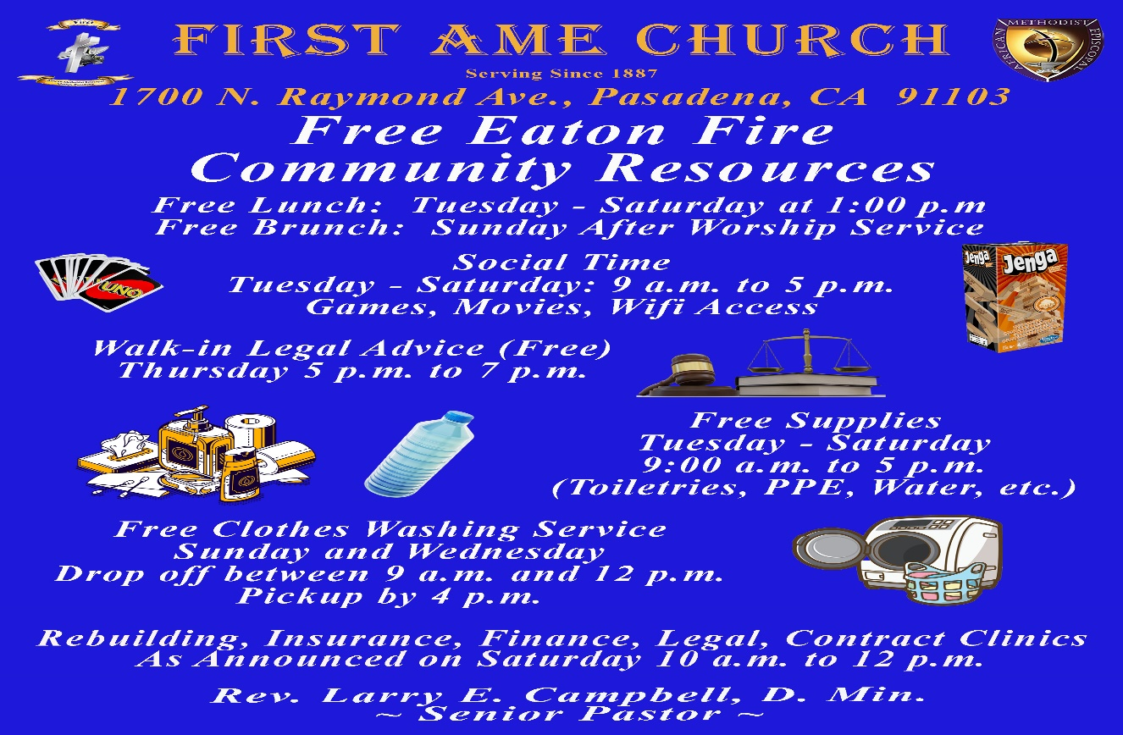

-12-

Prayer Request(s)
Please notify the Church Office of Sick & Shut-in additions, deletions, or status/address changes.

Bishop Francine A. Brookins, Esq. Supervisor Miriam Burnett, MD
Presiding Elder Roosevelt & Dr. Kaye Lindsey Rev. Dr. Larry & Melinda Campbell
Richard Craig Hazel Clark Erica Woodard Jason Shirley Joshua Shirley Julian Shirley Ayanna Terry Aloura Clarke Gwendolyn Flowers Andrea Anderson Ocilda Files Danielle Clark Donita Towler Brittany Shepherd Rev. Charles Brooks Doris Bailey Kimberly Woods Cynithia Grace Zechariah Robinson Diane Jordan Teresa Thompson Raymond Morrison Glen Scott Victoria Moore
Christopher McCarthy Cheryl Jamerson Wilma Haynes Jewell Malloy Calle Burns Noel Johnson Vanessa Robinson Charles Ludd, Sr. Rev. Rochelle Moore Richelle Niara Bogle Brittney Petty Taylor Family Alford Family The Spurill Family Deborah Burton Nettie McChristen Mary Glizer Lorene Butler Stella Pulliam Jacquelyn Walker Selene Cox Colette Blizzard Carita Smith Joyce Johnson
The Eaton Canyon Fire Victims

College Students

Let’s continue to support and pray for our beloved College Students

Isaiah Crowell Alecia Davis Ahmad Harris Jade Williams Chase Johnson Grant Blizzard

Tyler Johnson Richard Jones Tyrikk Lawson Makia Rose Talbert Isaiah Ringo Journey Rogers Elyse Sharp Kylee Sharp Zion Otano Elise Tervalon Grace Jones Jordan Patterson Kimberly Robinson Donovan Williams Jasmine Collins Brandon Bates Gabriel Blizzard

Sick and Shut-Ins
Bettina Ayers Pasadena Meadows Nursing Home, 150 Bellefontaine St., Pas., CA 91105
Bobby Thomas 1052 E. Morada Place, Altadena, CA 91001
Carrie Wynne Senior Living Heritage, 161 N. Hemet St., Hemet, CA 92545
Doris Curd 11619 Woodcock Avenue, San Fernando, CA 91340
Edmund Riddle Active Care Mission Bay, 2440 Grand Avenue, San Diego, CA 92109
Eleanor Towler 975 E. Union Street, Unit #417, Pasadena, CA 91106
Elois Blizzard P. O. Box 3646, So. Pasadena, CA 91031
Emily Cormier-Ross 2549 La Fiesta Avenue, Altadena, CA 91001
Ernestine English 26 W. Fair Oaks Drive, Pasadena, CA 91103
Frederick Smith 1055 N. Vignes St., Los Angeles, CA 90012
Fred & Francis Caple 5549 Hamill Ave, San Diego, CA 92120
Gloria Cubit Clay 11745 Pierce St., Lake View Terrace, CA 91342
Hugh Hamberry 2518 N. Marengo Avenue, Altadena, CA 91001
Josephine Brown 15607 Saddleback Rd, Riverside, CA 92506
Jessie Smith 7980 Mayten Avenue, Apt 3050 Rancho Cucamonga, CA 91730-8113
Linnie G. Nollie 2250 E. New York Drive, Altadena, CA 91001
Malika G. Hendry P. O. Box 94082, Pasadena, CA 91109
Mildred Lewis C/O Hazel Rohr, 884 W. Jane Court, Upland, CA 91786
Norma Burnett 618 Fairview Avenue, Unit #228, Arcadia, CA 91007
Opal Hampton 1030 Chevron Court, Pasadena, CA 91103
Paul Ratliff 1015 E. Athens St. Altadena, CA 91001
Ruthie Hopkins 1155 Via Verde , San Dimas, CA 91773
Virlyn Grant 15122 Orange Ave., Paramount, CA 90723
Wanda Nelson 3618 N. Fair Oaks Avenue, Altadena, CA 91001
William Hilliard 313 E. Loma Alta Dr. Altadena, CA 91001
Zell L. Hill 375 Barthe Drive, Pasadena, CA 91103

-13-

Sermon Notations

Scripture: _____________________________________________________________

Subject: _______________________________________________________________

Points of the Message: ___________________________________________________
_______________________________________________________________________
_______________________________________________________________________
_______________________________________________________________________
_______________________________________________________________________
_______________________________________________________________________
_______________________________________________________________________

Main Ideas of the Sermon: ________________________________________________
_______________________________________________________________________
_______________________________________________________________________
_______________________________________________________________________
_______________________________________________________________________
_______________________________________________________________________

Illustrations I want to remember: _________________________________________
_______________________________________________________________________
_______________________________________________________________________
_______________________________________________________________________
_______________________________________________________________________
_______________________________________________________________________
_______________________________________________________________________

What should I do as a result of this Sermon? ________________________________

_____________________________________________________
_____________________________________________________
_____________________________________________________
_____________________________________________________

-14-

