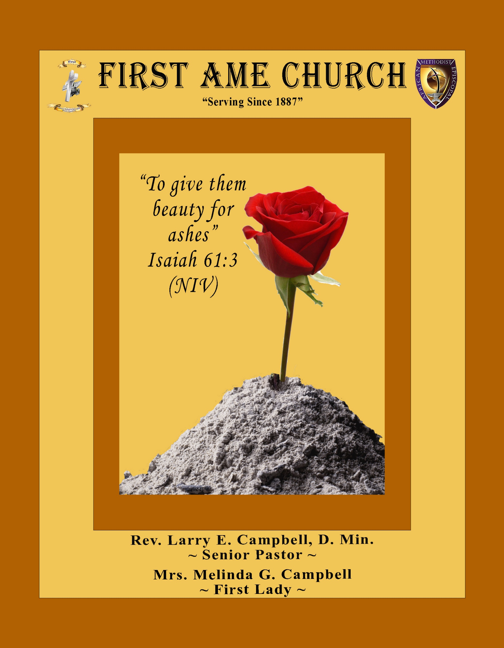
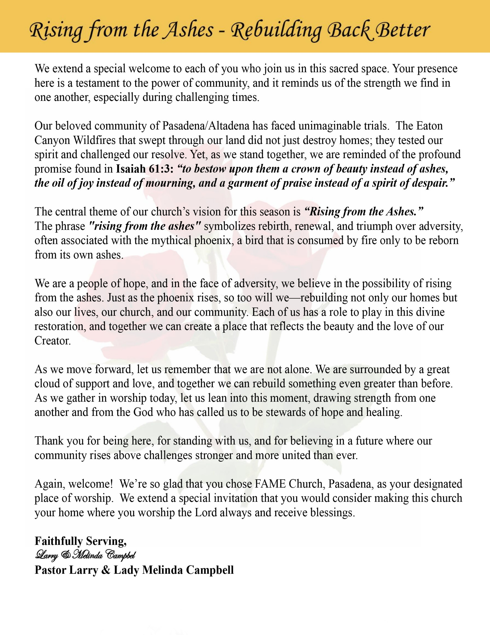

Sunday, November 2, 2025 | 9:30 a.m.

Rt. Rev. Francine A. Brookins, Esq., Presiding Bishop
Rev. Miriam Burnett, MD, MPH, Supervisor of Missions
Rev. Roosevelt Lindsey, Jr. Presiding Elder
The Rev. Dr. Larry E. Campbell ~ Senior Pastor ~ Minister
Mobile: (951) 587-1894 ~ Email: larrycampbell@famepasadena.org

Our First Lady: Mrs. Melinda G. Campbell

The Reverend Dr. Jennifer Oliver ~ Itinerant Elder -
The Reverend Dr. Nikia Smith-Robert ~ Itinerant Elder (Affiliated)
The Reverend Lois Woodard ~ Itinerant Elder Superannuated (Retired)
The Reverend Rochelle Wright Moore ~ Itinerant Deacon
The Reverend Deborah West-Jones ~ Local Elder
The Reverend Philis J. Griffin, MDiv ~ Local Elder
Dr. Phyllis Beech ~ Evangelist
The Reverend Van E. White ~ Executive Assistant
Community Resource Center Director ~ Ms. Kischchen Hazelton Venerable
Church Administrative Assistant: Ms. Letha Rhymes

Church Office Hours:
Tue, Wed 9:00am - 5:00pm, Thurs 9:00am - 3:00pm & 4:00pm - 7:30pm, Fri 9:00am -3:00pm.
Closed for Lunch Daily: 12:00pm - 1:00pm.

Music Ministry
Dr. Timothy Davis, Minister of Music
Bro. Jimmy Watlington, Percussionist ~ Bro. Carlos Caldwell, Organist
Bro. Darien Dorsey, Keyboardist
Sis. Karen Law, Women’s Chorus Director ~ Sis. Tonia Graham, Children’s Choir Director
Bro. J. Renard Washington, New Generation’s Choir

FREE WI-FI service is available on the FAME Campus by accessing FAME 1700
Password: 6267980503

-3-

~ Order of Worship Experience ~

Warning: This order of worship is subject to change without warning or prior notice --- everything is governed by the Sovereignty of the Holy Spirit



~ Altar Call ~
Praise & Worship

Doxology: “Praise God From Whom All Blessings Flow”

The Call to Worship Pastor Larry E. Campbell

Leader: I was glad when they said unto me, let us go into the house of the Lord, our feet shall stand within Thy gates O Jerusalem! (Psalm 122:1)

People: For a day in Thy courts is better than a thousand. I had rather be a doorkeeper in the house of my God than to dwell in the tents of wickedness. (Psalm 84:10)

Leader: Because of the house of the Lord our God, I will seek Thy good.
(Psalm 122:9)

People: Those that be planted in the house of the Lord, shall flourish in the courts of our God. (Psalm 92:13)

Leader: Blessed are they that dwell in Thy house. Lord, I have loved Thy habitation, the place where Thy honor dwelleth. (Psalm 26:8)

People: For the Lord is in His holy temple; let all the earth keep silence before Him.
(Habakkuk 2:20).

Leader: Let the words of my mouth and the meditation of my heart, be acceptable in Thy sight, O Lord my strength and my redeemer. (Psalm 19:14)

Unison: O Sing unto the Lord a new song, for He has done marvelous things. Make a
joyful noise unto the Lord, all the earth, sing His praises. (Psalm 98:1, 4)

-4-

The Hymn of Praise A.M.E. Hymnal #139

Alas! And Did My Savior Bleed
(At the Cross)

Words: Isaac Watts, 1674-1748
Tune: Ralph E. Hudson, 1843-1901

1 Alas! and did my Savior bleed,
and did my Sovereign die!
Would he devote that sacred head
for sinners such as I?

Refrain
At the cross, at the cross where
I first saw the light,
And the burden of my heart rolled away,
It was there by faith I received my sight,
And now I am happy all the day!

2 Was it for crimes that I have done,
he groaned upon the tree?
Amazing pity! Grace unknown!
And love beyond degree!
Refrain

3 Well might the sun in darkness hide,
and shut its glories in,
when God, the mighty maker, died
for his own creature's sin.
Refrain

4 But drops of tears can ne'er repay
the debt of love I owe.
Here, Lord, I give myself away;
'tis all that I can do.
Refrain

The Invocation The Rev. Deborah West-Jones

Ministry of Music The Mass Choir

-5-

Scripture Lesson
(Please Stand for the Reading of God’s Words)

(Responsive Reading)
Romans 7:14-25 (New Revised Standard Version) — The Inner Conflict
Leader: ¹⁴ For we know that the law is spiritual, but I am of the flesh, sold into slavery
under sin.

People: ¹⁵ I do not understand my own actions. For I do not do what I want, but I do
the very thing I hate. ¹⁶ Now if I do what I do not want, I agree that the law is
good. ¹⁷ But in fact it is no longer I who do it but sin that dwells within me.

Leader: ¹⁸ For I know that the good does not dwell within me, that is, in my flesh. For the
desire to do the good lies close at hand, but not the ability.

People: ¹⁹ For I do not do the good I want, but the evil I do not want is what I
do. ²⁰ Now if I do what I do not want, it is no longer I who do it but sin that
dwells within me.

Leader: ²¹ So I find it to be a law that, when I want to do what is good, evil lies close at
hand.

People: ²² For I delight in the law of God in my inmost self, ²³ but I see in my
members another law at war with the law of my mind, making me captive to
the law of sin that dwells in my members.

Leader: ²⁴ Wretched person that I am! Who will rescue me from this body of
death? ²⁵ Thanks be to God through Jesus Christ our Lord!

ALL: So then, with my mind I am enslaved to the law of God, but with my flesh I
am enslaved to the law of sin.

Minister: What do you believe?

People: I believe in God the Father Almighty, Maker of heaven and earth, and in Jesus
Christ His only son our Lord who was conceived by the Holy Spirit, born of the Virgin Mary, suffered under Pontius Pilate, was crucified, dead and buried. The third day he
arose from the dead; he ascended into heaven and sitteth at the right hand of God the
Father Almighty; from thence he shall come to judge the quick and the dead. I believe in the Holy Spirit, the Church Universal, the communion of saints, the forgiveness of sins, the resurrection of the body and the life everlasting. Amen.

-6-

THE PRELUDE TO THE DECALOGUE

“From all that dwell below the skies, Let the Creator’s praise arise;
Let the Redeemer’s name be sung. Through every land, by every tongue.”

THE DECALOGUE (An Affirmation of God’s Law)

Minister: Let us express our commitment to keep God’s Law

People: God of our salvation, only You are God.
We will make no idols.
We will not invoke with malice your name, O God.
We will remember the Sabbath Day and keep it holy.
We will honor our father and our mother.
We will not commit murder.
We will not commit adultery.
We will not steal.
We will not be a false witness.
We will not covet anything that belongs to our neighbor.
Minister: Jesus said: “You shall love the Lord your God with all your heart, and with all your soul and with all your mind. This is the great and first commandment.”

ALL: Jesus also challenged us to love justly with a second commandment which is like
the first. We shall love our neighbor as ourselves! On these commandments
depend all the law and the prophets.

THE GLORIA PATRI
Glory be to the Father, and to the Son, and to the Holy Ghost.
As it was in the beginning, is now and ever shall be, world without end. Amen Amen!!

Abbreviated Announcements/ Visitor’s Welcome

Pastoral Remarks

-7-

The Offertory (Tithes ~ Gifts ~ Benevolent Offerings) Sis. Mable Davis, Steward

In order to satisfy the steady increase of inflation, we are asking each member to consider increasing your Tithe, Offerings & Gifts.

The following Electronic GIVING Platforms are creditable methods to GIVE to FAME:

#1. GIVELIFY - Mobile Giving App available on the App Store. It’s easy to set up, just follow the guidelines.

#2. Cash App: $FirstAMEPASADENA

#3. Mail in your Tithes & Offering - If you would like to mail your tithes and offering by check or money order, please send it to: First AME Church, 1700 N. Raymond Avenue, Pasadena, CA 91103.

#4. Drop off your Tithes & Offering - During business hours in the basket outside of the office.

Choral Response: “All things come of Thee, O Lord; and of Thine own have we given Thee. Amen.”

Sermonic Selection The Mass Choir

Proclamation of The Word: Pastor Larry E. Campbell

The Invitation (Public/Private)

How to Join First A.M.E. Church of Pasadena
PROFESSION OF FAITH. If you have never been a member of any church, you may join by professing Jesus Christ as your personal Lord and Savior.

RENEWAL OF VOWS. If you have been a member of a church at one time, but have been in active, you may join by renewing your faith in Jesus Christ as Lord and Savior.

TRANSFER. If you are a member of another African Methodist Episcopal Church and you are in good standing, you may join by requesting that your membership be transferred to the First African Methodist Episcopal Church of Pasadena.

AFFILIATE MEMBER. Sometimes an individual has reasons for keeping /his/her membership in another church but would like to be an active member of First African Methodist Episcopal Church, too. This is possible as an affiliate member.

-8-

The Sacrament of the Lord’s Supper or Holy Communion

THE SOLICITATION

You that do truly and earnestly repent of your sins, and are in love and charity with your neighbor, and intend to lead a new life, following the commandments of God, and walking from henceforth in His holy ways, draw near with faith and take this holy sacrament to your comfort; and make your humble confession to Almighty God.

THE GENERAL CONFESSION

Minister: Let us humbly confess our sins unto Almighty God.

Minister and People:

Almighty God, Father of our Lord Jesus Christ, Maker of all things, Judge of all men, we acknowledge and bewail our manifold sins and wickedness which we from time to time most grievously have committed by thought, word, and deed against Your divine Majesty, provoking most justly Your wrath and indignation against us. We do earnestly repent and are heartily sorry for these our misdoings; the remembrance of them is grievous unto us. Have mercy upon us, have mercy upon us, most merciful Father for Your Son our Lord Jesus Christ’s sake; forgive us all that is past, and grant that we may ever hereafter serve and please You in newness of life, to the honor and glory of Your name through Jesus Christ our Lord.

Amen. (Choral). (You may be seated).

THE PRAYER OF PARDON

Almighty God, our Heavenly Father, who of Your great mercy has promised forgiveness of sins to all them that with hearty repentance and true faith turn unto You, have mercy upon us; pardon and deliver us from all our sins; confirm and strengthen us in all goodness; and bring us to everlasting life through Jesus Christ, our Lord.

Choral Response: Amen.

THE PRAYER OF CONSECRATION

Minister: Almighty God, our Heavenly Father, who for your tender mercy did give your only Son, Jesus Christ, to suffer death on the cross for our redemption, who made thereby his own oblation of himself, once offered; a full, perfect and sufficient sacrifice, oblation, and satisfaction for the sins of the whole world; and did institute and in his holy gospel command us to continue a perpetual memory of that, his precious death, until his coming again.

Hear us, O merciful Father, we most humbly beseech you, and grant that receiving these your creatures of bread and wine, according to your Son, our Savior Jesus Christ’s holy institution, in remembrance of his death and passion, may be partakers of his most blessed body and blood: who in the same night that He was betrayed took bread and when He had given thanks, He broke it, and gave it to His disciples, and saying, “Take, eat: This is My body which is given for you. This do in remembrance of Me.” Likewise, after the supper, He took the cup; and when He had given thanks, He gave it to them and said, “Drink this, all of you; for this is My blood of the New Testament, which is shed for you and many for the remission of sins. Do this, as often as you drink it, in remembrance of Me.”

THE LORD’S PRAYER (ALL)

THE ELEMENTS SHARED

-9-

ANNOUNCEMENTS

AME Voter’s Count Down
2 Days to Go
Use Your Voice by Voting!
Tell the Good News … Your VOTE Matters!
November 4, 2025 is Elections Day!
TELL EVERYBODY YOU MEET!

Men's Ministry - BIBLE STUDY
Time: Wednesday, November 5, 2025 | 6:00 p.m.
Meeting ID: 894 7536 6487
Passcode: 465177
One tap mobile: +16699006833,,89475366487#,,,,*465177# US (San Jose)

Women's Ministry - BIBLE STUDY
Time: Wednesday, November 5, 2025 | 6:00 p.m.
Meeting ID: 857 0061 9461; Passcode: 933892
One tap mobile +16699006833,,85700619461#,,,,,,0#,,933892# US (San Jose)

First Family Appreciation Service
Please join us in the sanctuary on
Sunday, November 9, 2025 | at 9:30 a.m. for Worship Service.
We are celebrating 11 years of FAME Pasadena Pastoral Leadership
&
25 Years of Dedicated Pastoral Service!
“Still Standing, Still Serving, Still Strong!”
“Having done all, Stand.” Ephesians 6:13

For your consideration: On behalf of the Steward Board, we are suggesting an offering of $100.

Los Angeles South/ Las Vegas District Planning Meeting
Saturday, November 15, 2025 | 10:00 a.m.
Host Church: Brookins-Kirkland Community A.M.E. Church
3719 W. Slauson Ave, Los Angeles, CA 90043.

-10-

ANNOUNCEMENTS (Continued)

Official Board Meeting
Budget Finalization/Approval Meeting
Tuesday, November 18, 2025 | 7:00 p.m.

Church Conference
Pastoral Planning Meeting
Thursday, November 20, 2025 | 7:00 p.m.
(Trustee Board and Annual Conference Delegates elections will be conducted)

FIRST A.M.E. CHURCH — “Feed My Sheep” FOOD PANTRY
OPEN EVERY SECOND AND FOURTH FRIDAY | 9:00 A.M. — 11:00 A.M.
Please consider making a financial donation in support of our Food Pantry

Annual Church Christmas Party
Immediately after Worship Service
Sunday, December 14, 2025
Thelma Blake Fellowship Hall

Mark Your Calendars
Annual Christmas Cantata
Sunday, December 21, 2025 | 4:00 p.m.

AFRICAN METHODIST EPISCOPAL CHURCH
FIFTH EPISCOPAL DISTRICT
SOUTHERN CALIFORNIA ANNUAL CONFERENCE
LAY ORGANIZATION
WINTER WONDERLAND
LAY AWARDS & SILENT AUCTION
SATURDAY, DECEMBER 13, 2025
11:00 AM - 2:00 PM
Carson Event Center

Tickets $80.00
No tickets will be sold at the door.
Final date to purchase tickets Friday, December 5, 2025
For more information, email scclayorganization5@gmail.com

-11-

Scripture of the Day
Inner Conflict. “For the desires of the flesh are against the Spirit, and the desires of the Spirit are against the flesh, for these are opposed to each other, to keep you from doing the things you want to do.” Galatians 5:17

Quote of the Day
“The battleline between good and evil runs through the heart of every man."
Alexander Solzhenitsyn
Thought of the Week
A young man met an old man and asked him: Do you remember me? The old man replied, “No, I don’t.”
Then the young man said, “I was one of your students.”
The old man asked: — Oh really? What do you do now?
The young man answered: I became a teacher.
— That’s great! Just like me? — said the old man.
— Yes. I became a teacher because you inspired me to be one.
The old man was curious and asked what moment inspired him.
The young man told this story:
— One day, one of my friends brought a beautiful new watch to school. I wanted it, so I stole it from his pocket. After a while, my friend noticed his watch was missing and told you about it.
You stopped the class and said: “Someone’s watch was stolen during the lesson. Whoever took it, please return it. — But I didn’t return it. I was too ashamed.
Then you closed the classroom door and told all of us to stand up. You said you would check everyone’s pockets until the watch was found. But you also told us to close our eyes while you searched.
So, we did.
You went through everyone’s pockets, one by one. When you reached mine, you found the watch and took it. But you didn’t stop. You kept checking the others’ pockets too.
Then you said: — Open your eyes. I found the watch.
You never said anything to me. You didn’t punish me, and you never told anyone it was me. That day was the most embarrassing moment of my life. But it was also the day I was saved from going down the wrong path. You didn’t lecture me, but your actions spoke louder than words. That day, I understood what it means to be a real teacher. And that’s why I became one.
Do you remember that day, teacher?
The old man replied: — I remember the situation and searching for the watch, but I don’t remember you — because I also had my eyes closed.
This is what true teaching is: If correcting someone means embarrassing them, then you don’t truly know how to teach. ❣️
HOME DAILY BIBLE READINGS
November 3, 2025 – November 16, 2025 (Week 7, Judges)
Monday Day 43 Numbers 5-7, Psalm 22:6-10
Tuesday Day 44 Numbers 8-10, Psalm 22:11-18
Wednesday Day 45 Numbers 11-13, Psalm 22:19-24
Thursday Day 46 Numbers 14-15, Psalm 22:25-31
Friday Day 47 Numbers 16-17, Psalm 23
Saturday Day 48 Numbers 18-20, Psalm 24:1-4
Sunday Day 49 Numbers 21-22, Psalm 24:5-10

-12-

Prayer Request(s)
Please notify the Church Office of Sick & Shut-in additions, deletions, or status/address changes.

Bishop Francine A. Brookins, Esq. Supervisor Miriam Burnett, MD
Presiding Elder Roosevelt & Dr. Kaye Lindsey Rev. Dr. Larry & Melinda Campbell
Richard Craig Hazel Clark Erica Woodard Jason Shirley Joshua Shirley Julian Shirley Ayanna Terry Aloura Clarke Gwendolyn Flowers Andrea Anderson Ocilda Files Danielle Clark Yolanda Oliver Brittany Shepherd Rev. Charles Brooks Doris Bailey Kimberly Woods Cynithia Grace Zechariah Robinson Diane Jordan Teresa Thompson Raymond Morrison Glen Scott Victoria Moore Christopher McCarthy Cheryl Jamerson Wilma Haynes Jewell Malloy Calle Burns Noel Johnson Vanessa Robinson Charles Ludd, Sr. Rev. Rochelle Moore Richelle Niara Bogle Catherine Graham Brittney Petty
Taylor Family Alford Family Spurill Family Deborah Burton Nettie McChristen Mary Glizer
Lorene Butler Stella Pulliam Jacquelyn Walker Karin Robinson Smith Vern Bo Selene Cox
The Eaton Canyon Fire Victims

College Students

Let’s continue to support and pray for our beloved College Students

Isaiah Crowell Alecia Davis Ahmad Harris Jade Williams Chase Johnson Grant Blizzard

Tyler Johnson Richard Jones Tyrikk Lawson Makia Rose Talbert Isaiah Ringo Journey Rogers Elyse Sharp Kylee Sharp Zion Otano Elise Tervalon Grace Jones Jordan Patterson Kimberly Robinson Donovan Williams Jasmine Collins Brandon Bates Gabriel Blizzard

Sick and Shut-Ins
Bettina Ayers Pasadena Meadows Nursing Home, 150 Bellefontaine St., Pas., CA 91105
Bobby Thomas 1052 E. Morada Place, Altadena, CA 91001
Carrie Wynne Senior Living Heritage, 161 N. Hemet St., Hemet, CA 92545
Doris Curd 11619 Woodcock Avenue, San Fernando, CA 91340
Edmund Riddle Active Care Mission Bay, 2440 Grand Avenue, San Diego, CA 92109
Eleanor Towler 975 E. Union Street, Unit #417, Pasadena, CA 91106
Elois Blizzard P. O. Box 3646, So. Pasadena, CA 91031
Emily Cormier-Ross 2549 La Fiesta Avenue, Altadena, CA 91001
Ernestine English 26 W. Fair Oaks Drive, Pasadena, CA 91103
Frederick Smith 1055 N. Vignes St., Los Angeles, CA 90012
Fred & Francis Caple 5549 Hamill Ave, San Diego, CA 92120
Gloria Cubit Clay 11745 Pierce St., Lake View Terrace, CA 91342
Hugh Hamberry 2518 N. Marengo Avenue, Altadena, CA 91001
Josephine Brown 15607 Saddleback Rd, Riverside, CA 92506
Jessie Smith 7980 Mayten Avenue, Apt 3050 Rancho Cucamonga, CA 91730-8113
Linnie G. Nollie 2250 E. New York Drive, Altadena, CA 91001
Malika G. Hendry P. O. Box 94082, Pasadena, CA 91109
Mildred Lewis C/O Hazel Rohr, 884 W. Jane Court, Upland, CA 91786
Norma Burnett 618 Fairview Avenue, Unit #228, Arcadia, CA 91007
Opal Hampton 1030 Chevron Court, Pasadena, CA 91103
Paul Ratliff 1015 E. Athens St. Altadena, CA 91001
Ruthie Hopkins 1155 Via Verde , San Dimas, CA 91773
Virlyn Grant 15122 Orange Ave., Paramount, CA 90723
Wanda Nelson 3618 N. Fair Oaks Avenue, Altadena, CA 91001
William Hilliard 313 E. Loma Alta Dr. Altadena, CA 91001
Zell L. Hill 375 Barthe Drive, Pasadena, CA 91103

-13-

Sermon Notations

Scripture: _____________________________________________________________

Subject: _______________________________________________________________

Points of the Message: ___________________________________________________
_______________________________________________________________________
_______________________________________________________________________
_______________________________________________________________________
_______________________________________________________________________
_______________________________________________________________________
_______________________________________________________________________

Main Ideas of the Sermon: ________________________________________________
_______________________________________________________________________
_______________________________________________________________________
_______________________________________________________________________
_______________________________________________________________________
_______________________________________________________________________

Illustrations I want to remember: _________________________________________
_______________________________________________________________________
_______________________________________________________________________
_______________________________________________________________________
_______________________________________________________________________
_______________________________________________________________________
_______________________________________________________________________

What should I do as a result of this Sermon? ________________________________

_____________________________________________________
_____________________________________________________
_____________________________________________________
_____________________________________________________

-14-

