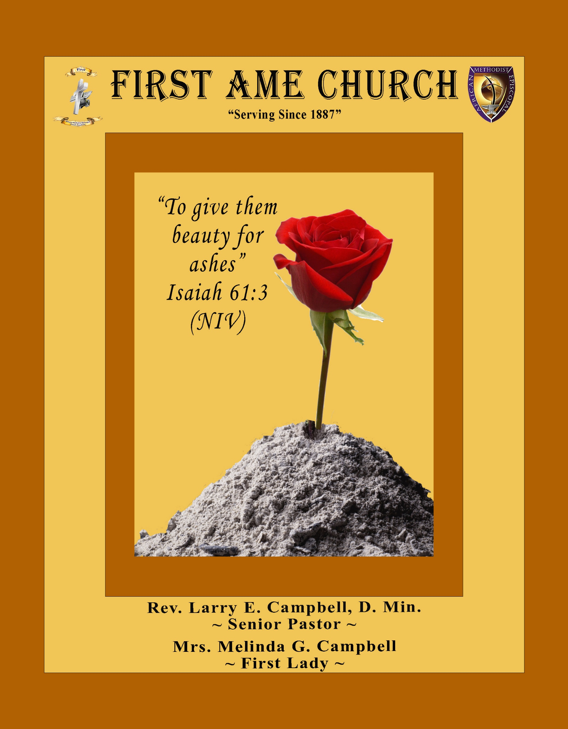
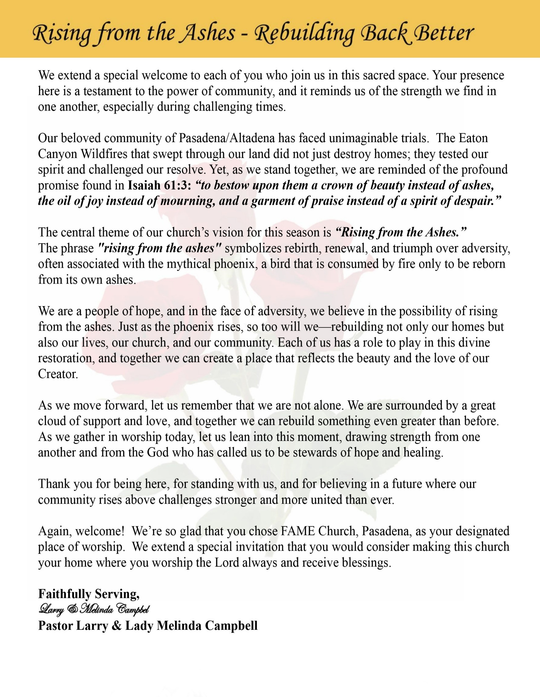

Sunday, November 16, 2025 | 9:30 a.m.

Rt. Rev. Francine A. Brookins, Esq, Presiding Bishop
Rev. Miriam Burnett, MD, MPH, Supervisor of Missions
Rev. Roosevelt Lindsey, Jr. Presiding Elder

The Rev. Dr. Larry E. Campbell ~ Pastor/Minister

Mobile: (951) 587-1894 ~ Email: larrycampbell@famepasadena.org

Our First Lady: Mrs. Melinda G. Campbell

The Reverend Dr. Jennifer Oliver ~ Itinerant Elder -
The Reverend Dr. Nikia Smith-Robert ~ Itinerant Elder (Affiliated)
The Reverend Lois Woodard ~ Itinerant Elder Superannuated (Retired)
The Reverend Rochelle Wright Moore ~ Itinerant Deacon
The Reverend Deborah West-Jones ~ Local Elder
The Reverend Philis J. Griffin, MDiv ~ Local Elder
Dr. Phyllis Beech ~ Evangelist

The Reverend Van E. White ~ Executive Assistant/ Youth Coordinator
Community Resource Center Director ~ Ms. Kischchen Hazelton Venerable
Church Administrative Assistant: Ms. Letha Rhymes

Church Office Hours:
Tue, Wed 9:00am - 5:00pm, Thurs 9:00am - 3:00pm & 4:00pm - 7:30pm, Fri 9:00am -3:00pm.
Closed for Lunch Daily: 12:00pm - 1:00pm.

Music Ministry
Dr. Timothy Davis, Minister of Music
Bro. Jimmy Watlington, Percussionist ~ Bro. Carlos Caldwell, Organist
Bro. Darien Dorsey, Keyboardist
Sis. Karen Law, Women’s Chorus Director ~ Sis. Tonia Graham, Children’s Choir Director
Bro. J. Renard Washington, New Generation’s Choir

FREE WI-FI service is available on the FAME Campus by accessing FAME 1700
Password: 6267980503

-3-

~ Order of Worship Experience ~

Warning: This order of worship is subject to change without warning or prior notice --- everything is governed by the Sovereignty of the Holy Spirit

+The Altar Call +

Praise & Worship

Doxology: “Praise God From Whom All Blessings Flow”

The Call to Worship Bro. LaWayne Williams

Leader: I was glad when they said unto me, let us go into the house of the Lord, our feet shall stand within Thy gates O Jerusalem! (Psalm 122:1)

People: For a day in Thy courts is better than a thousand. I had rather be a doorkeeper in the house of my God than to dwell in the tents of wickedness. (Psalm 84:10)

Leader: Because of the house of the Lord our God, I will seek Thy good.
(Psalm 122:9)

People: Those that be planted in the house of the Lord, shall flourish in the courts of our God. (Psalm 92:13)

Leader: Blessed are they that dwell in Thy house. Lord, I have loved Thy habitation, the place where Thy honor dwelleth. (Psalm 26:8)

People: For the Lord is in His holy temple; let all the earth keep silence before Him.
(Habakkuk 2:20).

Leader: Let the words of my mouth and the meditation of my heart, be acceptable in Thy sight, O Lord my strength and my redeemer. (Psalm 19:14)

Unison: O Sing unto the Lord a new song, for He has done marvelous things. Make a
joyful noise unto the Lord, all the earth, sing His praises. (Psalm 98:1, 4)

-4-

The Congregational Praise Song
In the Sanctuary
Song by The Kurt Carr Singers
We lift our hands in the sanctuary; We lift our hands to give You the glory
We lift our hands to give You the praise; And we will praise You for the rest of our days
Yes, we will praise You for the rest of our days
We clap our hands in the sanctuary; We clap our hands to give you the glory
We clap our hands to give you the praise; And we will praise you for the rest of our days
Yes, we will praise you for the rest of our days
We sing our song in the sanctuary; We sing our song to give You the glory
We sing our song to give You the praise; And we will praise You for the rest of our days
Yes, we will praise You for the rest of our days
Jesus, we give You the praise; Emmanuel, we lift up Your name
Heavenly Father, coming Messiah
And we will praise You for the rest of our days;
Yes, we will praise You for the rest of our days
Hallelujah in the sanctuary
Hallelujah we give You the glory
Hallelujah we give You the praise
And we will praise You for the rest of our days
Yes, we will praise You for the rest of our days
Jesus, we give You the praise; Emmanuel, we lift up Your name
Heavenly Father, coming Messiah
And we will praise You for the rest of our days;
Yes, we will praise You for the rest of our days

The Invocation Sis. Ashley Williams

Ministry of Music The Praise Team

-5-

Responsive Scripture Lesson Sis. Alexandria Smith

(Please Stand for the Reading of God’s Words)
Genesis 18:1-15 (New International Version) — The Three Visitors
Leader: 18 The Lord appeared to Abraham near the great trees of Mamre while he was
sitting at the entrance to his tent in the heat of the day. ² Abraham looked up and
saw three men standing nearby. When he saw them, he hurried from the entrance
of his tent to meet them and bowed low to the ground.

People: ³ He said, “If I have found favor in your eyes, my lord, do not pass your
servant by. ⁴ Let a little water be brought, and then you may all wash your
feet and rest under this tree. ⁵ Let me get you something to eat, so you can be
refreshed and then go on your way—now that you have come to your
servant.” “Very well,” they answered, “do as you say.”

Leader: ⁶ So Abraham hurried into the tent to Sarah. “Quick,” he said, “get three measures of the finest flour and knead it and bake some bread.”

People: ⁷ Then he ran to the herd and selected a choice, tender calf and gave it to a servant, who hurried to prepare it. ⁸ He then brought some curds and milk and the calf that had been prepared, and set these before them. While they ate, he stood near them under a tree.

Leader: ⁹ “Where is your wife Sarah?” they asked him. “There, in the tent,” he said.
¹⁰ Then one of them said, “I will surely return to you about this time next year, and Sarah your wife will have a son.”

People: Now Sarah was listening at the entrance to the tent, which was behind him. ¹¹ Abraham and Sarah were already very old, and Sarah was past the age of childbearing. ¹² So Sarah laughed to herself as she thought, “After I am worn out and my lord is old, will I now have this pleasure?”

Leader: ¹³ Then the Lord said to Abraham, “Why did Sarah laugh and say, ‘Will I really have a child, now that I am old?’ ¹⁴ Is anything too hard for the Lord? I will return to you at the appointed time next year, and Sarah will have a son.”

Unison: ¹⁵ Sarah was afraid, so she lied and said, “I did not laugh.” But he said, “Yes, you did laugh.”

-6-

The Summary of the Decalogue Sis. Jessica Ludd, Esq.

LEADER: From all that dwell below the skies…
SUNG: From all that dwell below the skies, Let the Creator’s praise arise; Let the
Redeemer’s Name be sung, through every land, by every tongue.
LEADER: Hear what Christ our Savior saith, Thou shalt love the Lord thy God with all thy
heart, with all thy soul, and with all thy mind. This is the first and great
commandment. And the second is like unto it: Thou shalt love thy neighbor
as thyself. On these two commandments hang all the law and the prophets.
SUNG: Glory be to the Father, and to the Son, and to the Holy Ghost; as it was in
the beginning, is now, and ever shall be, world without end. A~Men

Abbreviated Announcements/Visitor’s Welcome

K-FAME Radio Broadcast



Special Congregational Hymn (Sing along)
#381 There’s Not a Friend

-7-

The Offertory (Tithes ~ Gifts ~ Benevolent Offerings) Sis. Darlene Anderson, Steward

The following Electronic GIVING Platforms are creditable methods to GIVE to FAME:

#1. GIVELIFY - Mobile Giving App available on the App Store. It’s easy to set up, just follow the guidelines.

#2. Cash App: $FirstAMEPASADENA

#3. Mail in your Tithes & Offering - If you would like to mail your tithes and offering by check or money order, please send it to: First AME Church, 1700 N. Raymond Avenue, Pasadena, CA 91103.

#4. Drop off your Tithes & Offering - During business hours in the basket outside of the office.

Choral Response: “All things come of Thee, O Lord; and of Thine own have we given Thee. Amen.”

Children’s Church Dismissal

Sermonic Selection The Praise Team

The Preached Word Pastor Larry E. Campbell

The Invitation (Public/Private)

How to Join First A.M.E. Church of Pasadena
PROFESSION OF FAITH. If you have never been a member of any church, you may join by professing Jesus Christ as your personal Lord and Savior.

RENEWAL OF VOWS. If you have been a member of a church at one time, but have been in active, you may join by renewing your faith in Jesus Christ as Lord and Savior.

TRANSFER. If you are a member of another African Methodist Episcopal Church and you are in good standing, you may join by requesting that your membership be transferred to the First African Methodist Episcopal Church of Pasadena.

AFFILIATE MEMBER. Sometimes an individual has reasons for keeping /his/her membership in another church but would like to be an active member of First African Methodist Episcopal Church, too. This is possible as an affiliate member. __________________________________________________________________________________________

The Doxology

The Benediction

-8-

Scripture of the Day
God’s Timing. “Therefore, my dear brothers and sisters, stand firm. Let nothing move you. Always give yourselves fully to the work of the Lord, because you know that your labor in the Lord is not in vain.” 1 Corinthians 15:58

Quote of the Day
“Anything other than God’s plan carried out in God’s way and in God’s timing amounts to self-reliance.” Charles Spurgeon

Thought of the Week
Scripture: “He has made everything beautiful in its time.” — Ecclesiastes 3:11 (NIV)
God’s timing is never late, though it often feels that way to us. We live in a world that prizes speed—instant results, quick fixes, and overnight success. But God operates on divine timing, not human schedules. When we rush ahead of Him, we often end up frustrated and weary. When we wait on Him, we find peace in knowing He’s working things out behind the scenes.
Every delay in your life may be divine preparation. Joseph spent years in prison before stepping into his purpose. David waited long after being anointed before he wore the crown. Even Jesus waited until the “fullness of time” to reveal Himself as the Savior. God’s timing may test your patience, but it will never fail your purpose.
Reflection:
Sometimes God’s “not yet” is not a denial but a divine delay — a sign that He’s aligning things perfectly for your good and His glory.

Humor of the Week
A young pastor was sitting in a restaurant eating lunch. He opened a letter he’d just received that morning from his mom. As he opened it a twenty-dollar bill fell out. He thought to himself, Thanks, Mom, I sure needed that right now. As he finished his meal, he noticed a beggar outside on the sidewalk leaning against the light post. Thinking that the poor man could probably use the twenty dollars more than he, he crossed out the names on the envelope and wrote across the top in large letters, PERSEVERE!
So as not to make a scene, he put the envelope under his arm and dropped it as he walked past the man. The man picked it up and read the message and smiled. The next day, as the pastor enjoyed his meal, the same man tapped him on the shoulder and handed him a big wad of bills. Surprised, the young pastor asked him what that was for.
The man replied, “This is your half of the winnings. Persevere came in first in the fourth race at the track yesterday and paid thirty to one.”

HOME DAILY BIBLE READINGS
November 17, 2025 – November 23, 2025 (Week 9, 1 Samuel)
Monday Day 57 Deuteronomy 5-7, Psalm 27:1-3
Tuesday Day 58 Deuteronomy 8-10, Psalm 27:4-6
Wednesday Day 59 Deuteronomy 11-13, Psalm 27:7-12
Thursday Day 60 Deuteronomy 14-16, Psalm 27:13-14
Friday Day 61 Deuteronomy 17-20, Psalm 28
Saturday Day 62 Deuteronomy 21-23, Psalm 29
Sunday Day 63 Deuteronomy 24-27, Psalm 30

-9-

ANNOUNCEMENTS

A Heartfelt Thanksgiving from the Pastor and First Lady

Beloved FAME Family,
We extend our heartfelt thanks for the wonderful First Family Appreciation Service last Sunday. Your enormous expressions of love, the delicious luncheon, the joyful fellowship, and your generous financial gifts deeply touched our hearts.

We are truly grateful to serve such a loving and faithful congregation. Through every season — joys and challenges alike — God’s grace has kept us. Because of your prayers, encouragement, and partnership in ministry, we are still standing, still serving, and still strong.
From the bottom of our hearts, thank you for your love, faithfulness, and continued support. Together, let us keep pressing forward — trusting God, serving with joy, and standing strong in His power.
With love and appreciation,
Rev. Dr. Larry E. & First Lady Melinda W. Campbell
Proud to Serve the FAME Pasadena Family

Tis The Season ~ Children’s Christmas Program
Christmas is about 1 ½ months away. Casting and rehearsals for the Children/Youth Christmas program have started during Children’s Church. There are roles for ages ranging from talking toddlers to college students. We will have all types of roles, and we also want our young musicians (singers, praise dancers, pianists, etc.) to showcase their gifts!

If your child would like to participate, but can’t make it to Children’s Church, please contact Mrs. Monique Sims at (626) 319-8489 or Thesimsteam1@gmail.com.

The Children’s Christmas Program is scheduled for Sunday, December 21, 2025.
Thank you!

20/20 (14.0) Kick Off Initiative! Sunday, November 9, 2025
The 20/20 initiative is a Church-wide fundraising project managed by the Stewards. This project was established to assist with our Annual Connectional Budget. Financial gifts donated through the 20/20 initiative are added to our collected conference claims and assist greatly in meeting the first and second half of our Connectional Budgetary obligations. The Steward Board is requesting 150 participants for the conference year 2025-2026. The first half of our budget is due in February 2026. In addition to the 18 officers and we are asking STARTING TODAY 132 people to give 20 dollars per week for 20 weeks in addition to your regular tithes, gifts and offerings. Please mark your envelopes 20/20 and allocate $20.00. Our goal is to raise $60,000. Again, this will satisfy all budgetary needs on the conference level without utilizing any operational funds. Please see or contact any Steward to participate; we are looking forward to your commitment.

-10-

ANNOUNCEMENTS (Continued)

FIRST A.M.E. CHURCH — “Feed My Sheep” FOOD PANTRY
OPEN EVERY SECOND AND FOURTH FRIDAY | 9:00 A.M. — 11:00 A.M.
Please consider making a financial donation in support of our Food Pantry

Steward Board Meeting
Tuesday, December 9, 2025 | 7:00 p.m.

AFRICAN METHODIST EPISCOPAL CHURCH
FIFTH EPISCOPAL DISTRICT
SOUTHERN CALIFORNIA ANNUAL CONFERENCE
LAY ORGANIZATION
WINTER WONDERLAND
LAY AWARDS & SILENT AUCTION
SATURDAY, DECEMBER 13, 2025
11:00 AM - 2:00 PM
Carson Event Center

Tickets $80.00
No tickets will be sold at the door.
Final date to purchase tickets Friday, December 5, 2025
For more information, email scclayorganization5@gmail.com

Official Board Meeting
Budget Finalization/Approval Meeting
Thursday, December 4, 2025 | 7:00 p.m.

Church Conference
Pastoral Planning Meeting
Wednesday, December 10, 2025 | 7:00 p.m.
(Trustee Board and Annual Conference Delegates elections will be conducted)

Annual Church Christmas Party
Immediately after Worship Service
Sunday, December 14, 2025
Thelma Blake Fellowship Hall

Trustee Board Meeting
Tuesday, December 16, 2025 | 5:30 p.m.

-11-

ANNOUNCEMENTS (Continued)

Mark Your Calendars
Annual Christmas Cantata
Sunday, December 21, 2025 | 4:00 p.m.

National Homeless Youth Awareness Month

November was first declared as National Homeless Youth Awareness Month in 2007. Since then, November has been a time to acknowledge those children and families experiencing homelessness. As many as 2.5 million youth experience homelessness per year. Along with losing their home, community, friends, and routines as well as their sense of stability and safety, many homeless youth are also victims of trauma. While trying to survive on the streets, youth are exposed to countless dangers, with an increased likelihood of substance abuse, early parenthood, impulsivity, depression, posttraumatic stress disorder, and a vulnerability to being trafficked.

National Homeless Youth Awareness Month serves as an important reminder of the challenges faced by homeless youth across the country. To raise awareness and foster positive change, it is vital to implement viable solutions that can make a difference.

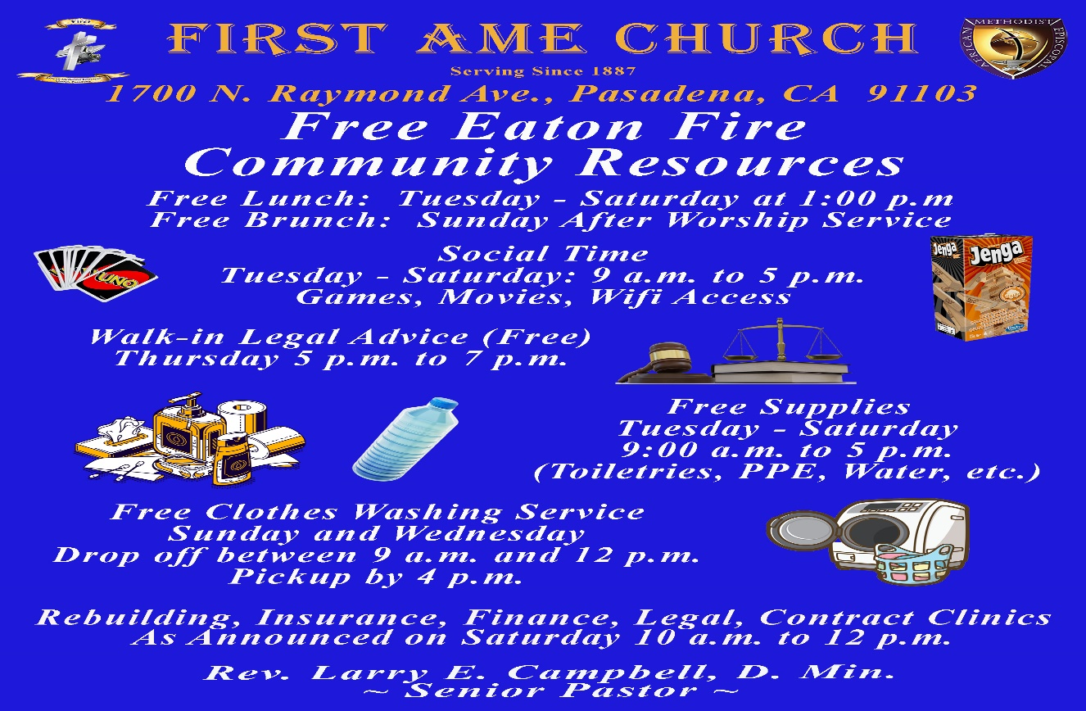

-12-

Prayer Request(s)
Please notify the Church Office of Sick & Shut-in additions, deletions, or status/address changes.

Bishop Francine A. Brookins, Esq. Supervisor Miriam Burnett, MD
Presiding Elder Roosevelt & Dr. Kaye Lindsey Rev. Dr. Larry & Melinda Campbell
Richard Craig Hazel Clark Erica Woodard Jason Shirley Joshua Shirley Julian Shirley Ayanna Terry Aloura Clarke Gwendolyn Flowers Andrea Anderson Ocilda Files Danielle Clark Donita Towler Brittany Shepherd Rev. Charles Brooks Doris Bailey Kimberly Woods Cynithia Grace Zechariah Robinson Diane Jordan Teresa Thompson Raymond Morrison Glen Scott Victoria Moore
Christopher McCarthy Cheryl Jamerson Wilma Haynes Jewell Malloy Calle Burns Noel Johnson Vanessa Robinson Charles Ludd, Sr. Rev. Rochelle Moore Richelle Niara Bogle Brittney Petty Taylor Family Alford Family The Spurill Family Deborah Burton Nettie McChristen Mary Glizer Lorene Butler Stella Pulliam Jacquelyn Walker Selene Cox Colette Blizzard Carita Smith Joyce Johnson
The Eaton Canyon Fire Victims Cheryl Jameson

College Students

Let’s continue to support and pray for our beloved College Students

Isaiah Crowell Alecia Davis Ahmad Harris Jade Williams Chase Johnson Grant Blizzard

Tyler Johnson Richard Jones Tyrikk Lawson Makia Rose Talbert Isaiah Ringo Journey Rogers Elyse Sharp Kylee Sharp Zion Otano Elise Tervalon Grace Jones Jordan Patterson Kimberly Robinson Donovan Williams Jasmine Collins Brandon Bates Gabriel Blizzard

Sick and Shut-Ins
Bettina Ayers Pasadena Meadows Nursing Home, 150 Bellefontaine St., Pas., CA 91105
Bobby Thomas 1052 E. Morada Place, Altadena, CA 91001
Carrie Wynne Senior Living Heritage, 161 N. Hemet St., Hemet, CA 92545
Doris Curd 11619 Woodcock Avenue, San Fernando, CA 91340
Edmund Riddle Active Care Mission Bay, 2440 Grand Avenue, San Diego, CA 92109
Eleanor Towler 975 E. Union Street, Unit #417, Pasadena, CA 91106
Elois Blizzard P. O. Box 3646, So. Pasadena, CA 91031
Emily Cormier-Ross 2549 La Fiesta Avenue, Altadena, CA 91001
Ernestine English 26 W. Fair Oaks Drive, Pasadena, CA 91103
Frederick Smith 1055 N. Vignes St., Los Angeles, CA 90012
Fred & Francis Caple 5549 Hamill Ave, San Diego, CA 92120
Gloria Cubit Clay 11745 Pierce St., Lake View Terrace, CA 91342
Hugh Hamberry 2518 N. Marengo Avenue, Altadena, CA 91001
Josephine Brown 15607 Saddleback Rd, Riverside, CA 92506
Jessie Smith 7980 Mayten Avenue, Apt 3050 Rancho Cucamonga, CA 91730-8113
Linnie G. Nollie 2250 E. New York Drive, Altadena, CA 91001
Malika G. Hendry P. O. Box 94082, Pasadena, CA 91109
Mildred Lewis C/O Hazel Rohr, 884 W. Jane Court, Upland, CA 91786
Norma Burnett 618 Fairview Avenue, Unit #228, Arcadia, CA 91007
Opal Hampton 1030 Chevron Court, Pasadena, CA 91103
Paul Ratliff 1015 E. Athens St. Altadena, CA 91001
Ruthie Hopkins 1155 Via Verde , San Dimas, CA 91773
Virlyn Grant 15122 Orange Ave., Paramount, CA 90723
Wanda Nelson 3618 N. Fair Oaks Avenue, Altadena, CA 91001
William Hilliard 313 E. Loma Alta Dr. Altadena, CA 91001
Zell L. Hill 375 Barthe Drive, Pasadena, CA 91103

-13-

Sermon Notations

Scripture: _____________________________________________________________

Subject: _______________________________________________________________

Points of the Message: ___________________________________________________
_______________________________________________________________________
_______________________________________________________________________
_______________________________________________________________________
_______________________________________________________________________
_______________________________________________________________________
_______________________________________________________________________

Main Ideas of the Sermon: ________________________________________________
_______________________________________________________________________
_______________________________________________________________________
_______________________________________________________________________
_______________________________________________________________________
_______________________________________________________________________

Illustrations I want to remember: _________________________________________
_______________________________________________________________________
_______________________________________________________________________
_______________________________________________________________________
_______________________________________________________________________
_______________________________________________________________________
_______________________________________________________________________

What should I do as a result of this Sermon? ________________________________

_____________________________________________________
_____________________________________________________
_____________________________________________________
_____________________________________________________

-14-

