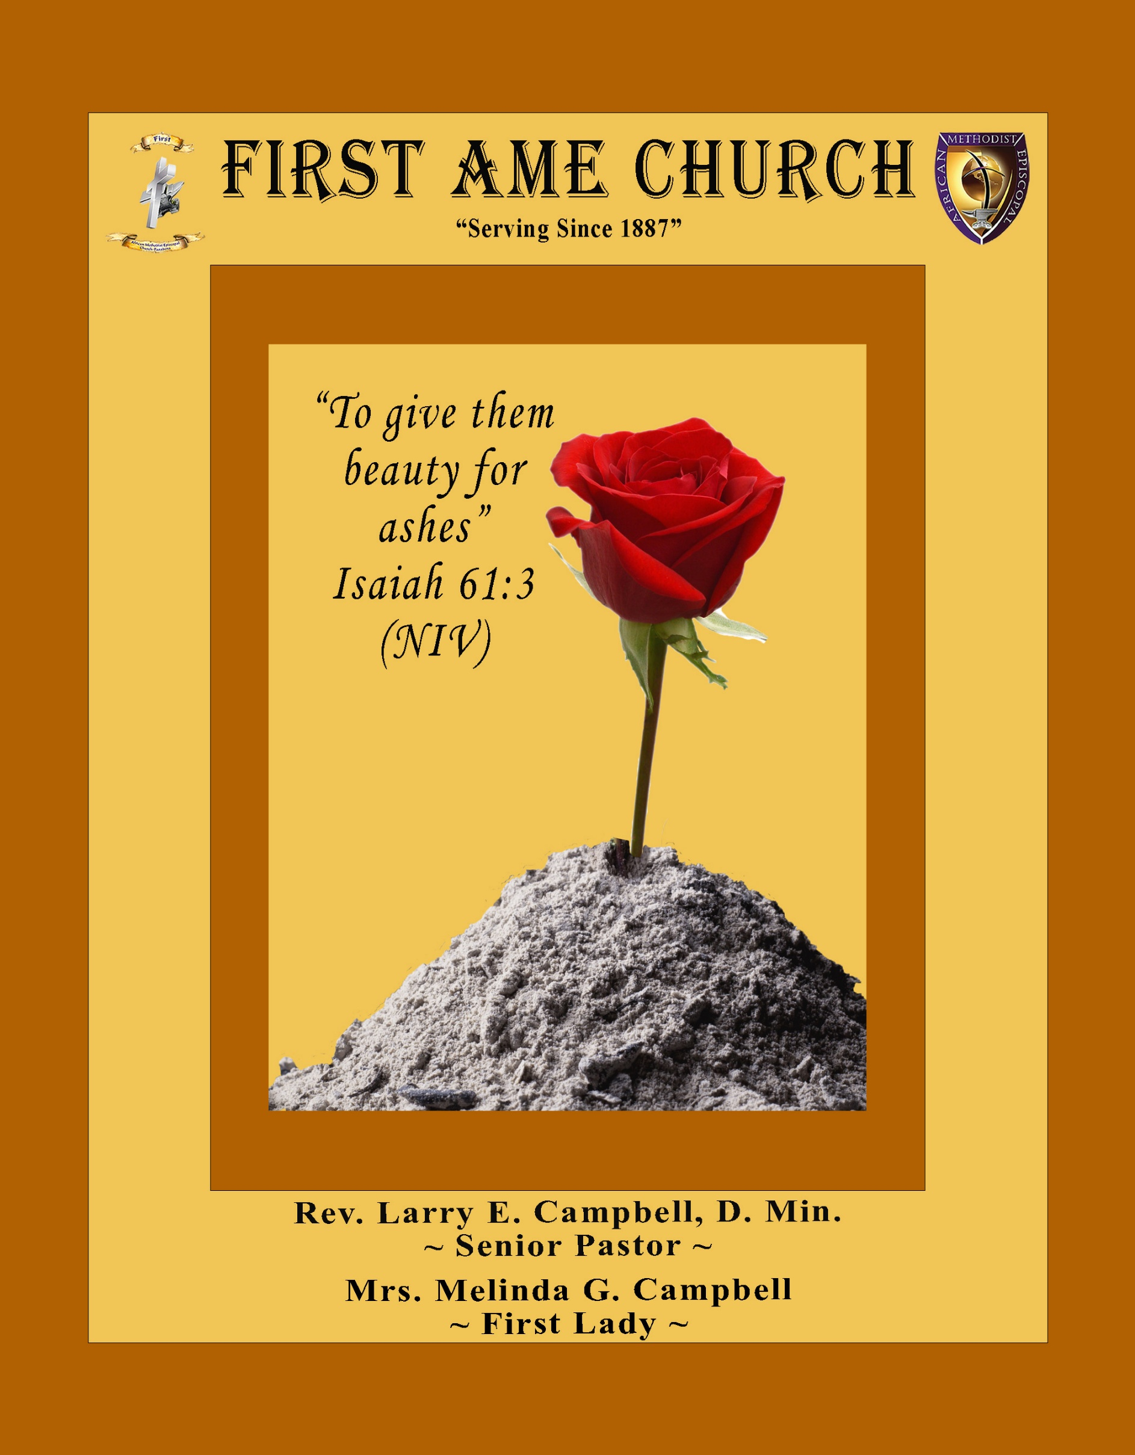
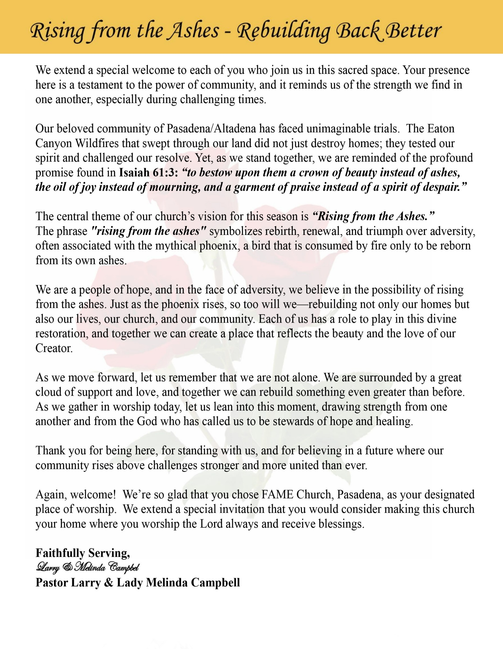

Sunday, January 4, 2026 | 9:30 a.m.

Rt. Rev. Francine A. Brookins, Esq., Presiding Bishop
Rev. Miriam Burnett, MD, MPH, Supervisor of Missions
Rev. Roosevelt Lindsey, Jr. Presiding Elder

The Rev. Dr. Larry E. Campbell ~ Senior Pastor ~ Minister

Mobile: (951) 587-1894 ~ Email: larrycampbell@famepasadena.org

Our First Lady: Mrs. Melinda G. Campbell

The Reverend Dr. Jennifer Oliver ~ Itinerant Elder -
The Reverend Dr. Nikia Smith-Robert ~ Itinerant Elder (Affiliated)
The Reverend Lois Woodard ~ Itinerant Elder Superannuated (Retired)
The Reverend Rochelle Wright Moore ~ Itinerant Deacon
The Reverend Deborah West-Jones ~ Local Elder
The Reverend Philis J. Griffin, MDiv ~ Local Elder
Dr. Phyllis Beech ~ Evangelist

Community Resource Center Director ~ Ms. Kischchen Hazelton Venerable
Church Administrative Assistant: Ms. Letha Rhymes

Church Office Hours:
Tue - Wed 9:00 am - 5:00 pm, & Fri 9:00 am -3:00 pm.
Closed for Lunch Daily: 12:00 pm - 1:00 pm.

Music Ministry
Dr. Timothy Davis, Minister of Music
Bro. Jimmy Watlington, Percussionist ~ Bro. Carlos Caldwell, Organist
Bro. Darien Dorsey, Keyboardist
Sis. Karen Law, Women’s Chorus Director ~ Sis. Tonia Graham, Children’s Choir Director
Bro. J. Renard Washington, New Generation’s Choir

FREE WI-FI service is available on the FAME Campus by accessing FAME 1700
Password: 6267980503

-3-

~ Order of Worship Experience ~



Holy Communion Sunday

+++ The Altar Call +++
Praise & Worship

Doxology: “Praise God From Whom All Blessings Flow”

The Call to Worship Pastor Larry E. Campbell

Leader: I was glad when they said unto me, let us go into the house of the Lord, our feet shall stand within Thy gates O Jerusalem! (Psalm 122:1)

People: For a day in Thy courts is better than a thousand. I had rather be a doorkeeper in the house of my God than to dwell in the tents of wickedness. (Psalm 84:10)

Leader: Because of the house of the Lord our God, I will seek Thy good.
(Psalm 122:9)

People: Those that be planted in the house of the Lord, shall flourish in the courts of our God. (Psalm 92:13)

Leader: Blessed are they that dwell in Thy house. Lord, I have loved Thy habitation, the place where Thy honor dwelleth. (Psalm 26:8)

People: For the Lord is in His holy temple; let all the earth keep silence before Him.
(Habakkuk 2:20).

Leader: Let the words of my mouth and the meditation of my heart, be acceptable in Thy sight, O Lord my strength and my redeemer. (Psalm 19:14)

Unison: O Sing unto the Lord a new song, for He has done marvelous things. Make a
joyful noise unto the Lord, all the earth, sing His praises. (Psalm 98:1, 4)

-4-

The Hymn of Praise A.M.E. Hymnal #304
And Are We Yet Alive
Words and Tune: Charles Wesley, 1707-1788

And are we yet alive, And see each other’s face?
Glory and praise to Jesus give For His redeeming grace.

Preserved by power divine, To full salvation here,
Again in Jesus’ praise we join, And in His sight appear.

What troubles have we seen, What conflicts have we passed,
Fightings without and fears within, Since we assembled last.

But out of all the Lord - Hath brought us by His love;
And still He doth His help afford, And hides our life above.

Then let us make our boast - Of His redeeming power,
Which saves us to the uttermost. Till we can sin no more.

Let us take up the cross - Till we the crown obtain;
And gladly reckon all things loss, So we may Jesus gain.

The Invocation Evangelist Dr. Phyllis Beech

Ministry of Music The Mass Choir

Scripture Lesson Rev. Deborah West-Jones
(Please Stand for the Reading of God’s Words)
Genesis 12:1-9 (New International Version) — The Call of Abram
12 The Lord had said to Abram, “Go from your country, your people and your father’s household to the land I will show you. ² “I will make you into a great nation, and I will bless you; I will make your name great, and you will be a blessing. ³ I will bless those who bless you, and whoever curses you I will curse; and all peoples on earth will be blessed through you.” ⁴ So Abram went, as the Lord had told him; and Lot went with him. Abram was seventy-five years old when he set out from Harran. ⁵ He took his wife Sarai, his nephew Lot, all the possessions they had accumulated and the people they had acquired in Harran, and they set out for the land of Canaan, and they arrived there. ⁶ Abram traveled through the land as far as the site of the great tree of Moreh at Shechem. At that time the Canaanites were in the land. ⁷ The Lord appeared to Abram and said, “To your offspring I will give this land.” So he built an altar there to the Lord, who had appeared to him. ⁸ From there he went on toward the hills east of Bethel and pitched his tent, with Bethel on the west and Ai on the east. There he built an altar to the Lord and called on the name of the Lord. ⁹ Then Abram set out and continued toward the Negev.

-5-

The AFFIRMATION OF FAITH (The Apostle Creed) The Rev. Rochelle Wright- Moore

Minister: What do you believe?

People: I believe in God the Father Almighty, Maker of heaven and earth, and in Jesus
Christ His only son our Lord who was conceived by the Holy Spirit, born of the Virgin Mary, suffered under Pontius Pilate, was crucified, dead and buried. The third day he arose from the dead; he ascended into heaven and sitteth at the right hand of God the Father Almighty; from thence he shall come to judge the quick and the dead. I believe in the Holy Spirit, the Church Universal, the communion of saints, the forgiveness of sins, the resurrection of the body and the life
everlasting. Amen.

THE PRELUDE TO THE DECALOGUE

“From all that dwell below the skies, Let the Creator’s praise arise;
Let the Redeemer’s name be sung. Through every land, by every tongue.”

THE DECALOGUE (An Affirmation of God’s Law)

Minister: Let us express our commitment to keep God’s Law

People: God of our salvation, only You are God.
We will make no idols.
We will not invoke with malice your name, O God.
We will remember the Sabbath Day and keep it holy.
We will honor our father and our mother.
We will not commit murder.
We will not commit adultery.
We will not steal.
We will not be a false witness.
We will not covet anything that belongs to our neighbor.
Minister: Jesus said: “You shall love the Lord your God with all your heart, and with all your soul and with all your mind. This is the great and first commandment.”

ALL: Jesus also challenged us to love justly with a second commandment
which is like the first. We shall love our neighbor as ourselves! On these
commandments depend all the law and the prophets.

-6-

THE GLORIA PATRI
Glory be to the Father, and to the Son, and to the Holy Ghost.
As it was in the beginning, is now and ever shall be, world without end. Amen Amen!!

Abbreviated Announcements/Visitor’s Welcome



New Year’s Litany of Tithes, Gifts, and First Fruits Pastor Larry E. Campbell

Leader: As we stand at the doorway of a new year, we acknowledge that every good
and perfect gift comes from the Lord.

People: We thank You, O God, for bringing us into this new season of life.

Leader: Before we ask You for blessings, we pause to honor You with our first fruits.

People: We give You the first and the best, not what is left over.

Leader: Your Word declares that the earth is the Lord’s and the fullness thereof.

People: All that we have belongs to You, O God.

Leader: In gratitude for Your protection through dangers seen and unseen, for provision in times of uncertainty, and for grace that sustained us day by day—

People: We return to You a portion of what You have entrusted to us.

-7-

New Year’s Litany of Tithes, Gifts, and First Fruits -- (Continued)

Leader: We bring our tithes as an act of obedience.

People: We bring our offerings as an expression of thanksgiving.

Leader: We present our first fruits as a declaration of faith in what You will yet do.

People: By faith, we trust You for provision in this new year.

Leader: Teach us to give cheerfully, faithfully, and sacrificially.

People: Remove fear from our giving and replace it with faith.

Leader: May our giving open doors of ministry, bless our community, and advance Your kingdom on earth.

People: Use what we give to bring hope, healing, and transformation.

Leader: As we sow into this new year—

People: We believe You will bring a harvest in due season.

All Together: We dedicate our tithes, gifts, and first fruits to You, O Lord. May they
honor Your name and glorify Your purpose. Amen.

The Offertory (Tithes ~ Gifts ~ Benevolent Offerings)

The following Electronic GIVING Platforms are creditable methods to GIVE to FAME:

#1. GIVELIFY - Mobile Giving App available on the App Store. It’s easy to set up, just follow the guidelines.

#2. Cash App: $FirstAMEPASADENA

#3. Mail in your Tithes & Offering - If you would like to mail your tithes and offering by check or money order, please send it to: First AME Church, 1700 N. Raymond Avenue, Pasadena, CA 91103.

#4. Drop off your Tithes & Offering - During business hours in the basket outside of the office.

Choral Response: “All things come of Thee, O Lord; and of Thine own have we given Thee. Amen.”

Sermonic Selection The Mass Choir
Proclamation of The Word: Pastor Larry E. Campbell
The Invitation (Public/Private)

-8-

The Sacrament of the Lord’s Supper or Holy Communion

THE SOLICITATION

You that do truly and earnestly repent of your sins, and are in love and charity with your neighbor, and intend to lead a new life, following the commandments of God, and walking from henceforth in His holy ways, draw near with faith and take this holy sacrament to your comfort; and make your humble confession to Almighty God.

THE GENERAL CONFESSION

Minister: Let us humbly confess our sins unto Almighty God.

Minister and People:

Almighty God, Father of our Lord Jesus Christ, Maker of all things, Judge of all men, we acknowledge and bewail our manifold sins and wickedness which we from time to time most grievously have committed by thought, word, and deed against Your divine Majesty, provoking most justly Your wrath and indignation against us. We do earnestly repent and are heartily sorry for these our misdoings; the remembrance of them is grievous unto us. Have mercy upon us, have mercy upon us, most merciful Father for Your Son our Lord Jesus Christ’s sake; forgive us all that is past, and grant that we may ever hereafter serve and please You in newness of life, to the honor and glory of Your name through Jesus Christ our Lord.

Amen. (Choral). (You may be seated).

THE PRAYER OF PARDON

Almighty God, our Heavenly Father, who of Your great mercy has promised forgiveness of sins to all them that with hearty repentance and true faith turn unto You, have mercy upon us; pardon and deliver us from all our sins; confirm and strengthen us in all goodness; and bring us to everlasting life through Jesus Christ, our Lord.

Choral Response: Amen.

THE PRAYER OF CONSECRATION

Minister: Almighty God, our Heavenly Father, who for your tender mercy did give your only Son, Jesus Christ, to suffer death on the cross for our redemption, who made thereby his own oblation of himself, once offered; a full, perfect and sufficient sacrifice, oblation, and satisfaction for the sins of the whole world; and did institute and in his holy gospel command us to continue a perpetual memory of that, his precious death, until his coming again.

Hear us, O merciful Father, we most humbly beseech you, and grant that receiving these your creatures of bread and wine, according to your Son, our Savior Jesus Christ’s holy institution, in remembrance of his death and passion, may be partakers of his most blessed body and blood: who in the same night that He was betrayed took bread and when He had given thanks, He broke it, and gave it to His disciples, and saying, “Take, eat: This is My body which is given for you. This do in remembrance of Me.” Likewise, after the supper, He took the cup; and when He had given thanks, He gave it to them and said, “Drink this, all of you; for this is My blood of the New Testament, which is shed for you and many for the remission of sins. Do this, as often as you drink it, in remembrance of Me.”

THE LORD’S PRAYER (ALL)

THE ELEMENTS SHARED

-9-

ANNOUNCEMENTS

Beloved FAME Family, 

As we step into 2026, we do so with gratitude for where God has brought us and faith for where He is leading us. The past year has shaped us, stretched us, and strengthened us—but it does not define us. God declares, “See, I am doing a new thing!” (Isaiah 43:19). A new year calls us to embrace God’s new work with courage, trust, and obedience. Like Abraham who moved by faith, Ruth who chose a new future, and Joshua who led into a new season, we move forward believing that God is already ahead of us. In 2026, let us release what was, trust God with what is, and step boldly into what will be. The same God who kept us is the God who will carry us forward.
Happy New Year, FAME Church.
Pastor Larry & First Lady Melinda Campbell

20/20 (14.0)
The 20/20 initiative is a Church-wide fundraising project managed by the Stewards. This project was established to assist with our Annual Connectional Budget. Financial gifts donated through the 20/20 initiative are added to our collected conference claims and assist greatly in meeting the first and second half of our Connectional Budgetary obligations. The Steward Board is requesting 150 participants for the conference year 2025-2026. The first half of our budget is due in February 2026. In addition to the 18 officers and we are asking 132 people to give 20 dollars per week for 20 weeks in addition to your regular tithes, gifts and offerings. Please mark your envelopes 20/20 and allocate $20.00. Our goal is to raise $60,000. Again, this will satisfy all budgetary needs on the conference level without utilizing any operational funds. Please see or contact any Steward to participate; we are looking forward to your commitment.

Men's Ministry - BIBLE STUDY
Time: Tuesday, January 6, 2026 | 6:00 p.m.
Meeting ID: 894 7536 6487 | Passcode: 465177
One tap mobile: +16699006833,,89475366487#,,,,*465177# US (San Jose)

Women's Ministry - BIBLE STUDY
Time: Tuesday, January 6, 2026 | 6:00 p.m.
Meeting ID: 857 0061 9461; Passcode: 933892
One tap mobile +16699006833,,85700619461#,,,,,,0#,,933892# US (San Jose)

Virtual Steward Board Meeting on Thursday, January 8, 2026 | 7:00 p.m.

Special Sons of Allen Ministry – Men’s Breakfast
“Iron Sharpens Iron” (Proverbs 27:17)
All men of First AME Church, Pasadena are earnestly requested to attend a Special Sons of Allen Ministry Men’s Breakfast as we gather for fellowship, encouragement, and vision.
Saturday, January 10, 2026 | 9:00 a.m. – 11:00 a.m.| Location: [Church Fellowship Hall]
This gathering is being convened at the request of our Pastor, who is calling every man of FAME Pasadena to come together to plan and organize the Men’s Ministry for the Conference Year. As Scripture reminds us, “Iron sharpens iron, and one man sharpens another” (Proverbs 27:17). Together, we will strengthen one another through prayer, dialogue, and shared purpose. Come ready to be sharpened, encouraged, and equipped as we build a Men’s Ministry that is strong in faith, unified in brotherhood, and committed to service. Your presence strengthens the whole body. Breakfast will be served.

-10-
-

ANNOUNCEMENTS (Continued)

Children’s Praise Dance Ministry
Parents, get ready! A Children's Praise Dance Ministry is launching, and your children are invited to join the fun! Practice will begin on Saturday, January 10th, from 10:00 a.m. to 12:00 p.m. This joyful ministry is a wonderful way for children to praise God through movement, music, and creativity. Let’s dance, praise, and have fun together! For more information or to sign up, please contact:
Mariah Carter at idancewithangelsdaily@gmail.com

Senior Ministry In-Person Gathering
Tuesday, January 13, 2026| 11:30 a.m.
Church Fellowship Hall

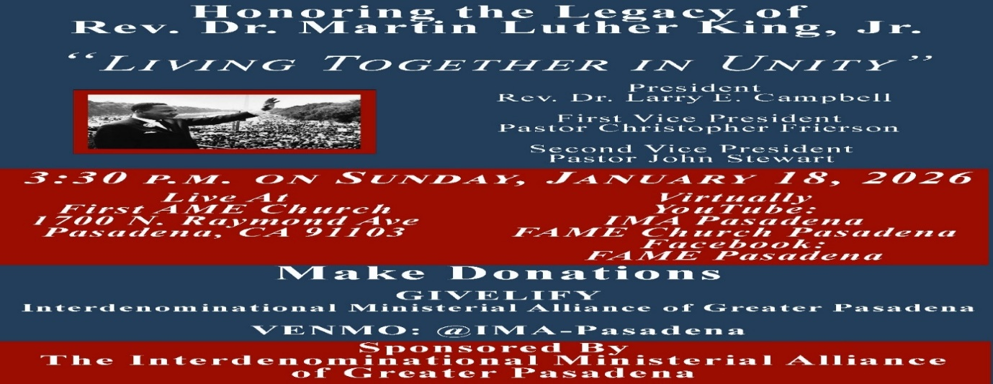

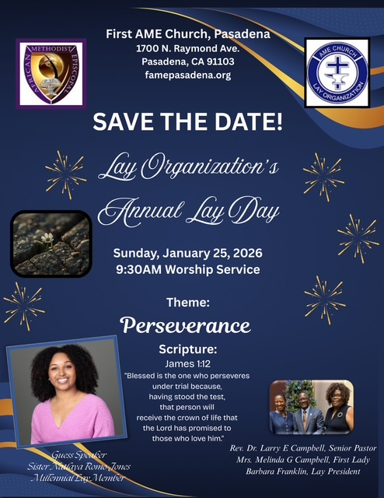

-11-

Scripture of the Day
Time for Change. “Forget the former things; do not dwell on the past. ¹⁹ See, I am doing a new thing! Now it springs up; do you not perceive it? I am making a way in the wilderness and streams in the wasteland.” Isaiah 43:18-19

Quote of the Day
"If you change the way you look at things, the things you look at change."
— Wayne Dyer

Thought of the Week
"See, I am doing a new thing! Now it springs up; do you not perceive it? I am making a way in the desert and streams in the wasteland" (Isaiah 43:19)
Change is one of the most difficult things for people to face; however, change is inevitable. In fact, Mark Twain once said, "The only person who likes change is a wet baby." One reason people don't like change is because they get comfortable with where they are in life. They get used to their friends, job or the place they live. And even if it's not perfect, they accept it simply because it's familiar. However, when we are not willing to change, we get stuck in life holding on to what God did in the past instead of growing and moving forward into what God wants to do in the future.
Therefore, you are encouraged to be open to the new things God has in store for you. Always remember that just because God has blessed you where you are doesn't mean you can just sit back and settle there. God wants to do something new in you and through you. He wants to see you grow, prosper and flourish. Get ready and keep your heart focused on Him. Embrace change and see the blessing God has in store for you!

Humor of the Week
An elderly lady was at the store and accidentally locked her keys in the car. She had a coat hanger and was trying and trying, but she couldn't get it unlocked. She finally prayed and asked God to help her.
About that time, this real rough looking guy pulled up on a motorcycle. He was dressed in leather, tattoos, wearing a skull cap. In 15 seconds, he had the car unlocked.
She gave him a hug and said "Lord, thank you for sending me this nice man." He said "Lady, I'm not a nice man. I just got out of prison for auto theft." She hugged him again and said "Lord, thank you. You even sent me a professional."

HOME DAILY BIBLE READINGS
January 5, 2026 – January 11, 2026 (Week 16, Isaiah)
Monday Day 106 2 Kings 18-19, Psalm 44:1-8
Tuesday Day 107 2 Kings 20-22, Psalm 44:9-16
Wednesday Day 108 2 Kings 23-25, Psalm 44:17-22
Thursday Day 109 1 Chronicles 1-2, Psalm 44:23-26
Friday Day 110 1 Chronicles 3-5, Psalm 45:1-4
Saturday Day 111 1 Chronicles 6, Psalm 45:5-12
Sunday Day 112 1 Chronicles 7-8, Psalm 45:13-17

-12-

Prayer Request(s)
Please notify the Church Office of Sick & Shut-in additions, deletions, or status/address changes.

Bishop Francine A. Brookins, Esq. Supervisor Miriam Burnett, MD
Presiding Elder Roosevelt & Dr. Kaye Lindsey Rev. Dr. Larry & Melinda Campbell
Richard Craig Hazel Clark Erica Woodard Jason Shirley Joshua Shirley Julian Shirley Ayanna Terry Cheryl Jamerson Gwendolyn Flowers Andrea Anderson Ocilda Files Danielle Clark Donita Towler Rev. Charles Brooks Doris Bailey Kimberly Woods Cynithia Grace Zechariah Robinson Diane Jordan Christopher McCarthy Wilma Haynes Jewell Malloy Calle Burns Noel Johnson Brittney Petty Taylor Family Deborah Burton Nettie McChristen Jacquelyn Walker Selene Cox
Rev. Rochelle Moore Lorene Butler Stella Pulliam Colette Blizzard Carita Smith Joyce Johnson The Eaton Canyon Fire Victims The Caple Family Cheryl Jameson Barbara McPheeter

College Students

Let’s continue to support and pray for our beloved College Students

Isaiah Crowell Alecia Davis Jade Williams Chase Johnson Grant Blizzard

Tyler Johnson Richard Jones Tyrikk Lawson Makia Rose Talbert Isaiah Ringo Journey Rogers Elyse Sharp Kylee Sharp Zion Otano Elise Tervalon Grace Jones Jordan Patterson Kimberly Robinson Donovan Williams Jasmine Collins Brandon Bates Gabriel Blizzard

Sick and Shut-Ins
Andrew Oliver 1405 N. Roosevelt Avenue. Pasadena, CA 91104
Bettina Ayers Pasadena Meadows Nursing Home, 150 Bellefontaine St., Pas., CA 91105
Bobby Thomas 1052 E. Morada Place, Altadena, CA 91001
Carrie Wynne Senior Living Heritage, 161 N. Hemet St., Hemet, CA 92545
Doris Curd 11619 Woodcock Avenue, San Fernando, CA 91340
Edmund Riddle Active Care Mission Bay, 2440 Grand Avenue, San Diego, CA 92109
Eleanor Towler 975 E. Union Street, Unit #417, Pasadena, CA 91106
Elois Blizzard P. O. Box 3646, So. Pasadena, CA 91031
Emily Cormier-Ross 2549 La Fiesta Avenue, Altadena, CA 91001
Ernestine English 26 W. Fair Oaks Drive, Pasadena, CA 91103
Frederick Smith 1055 N. Vignes St., Los Angeles, CA 90012
Fred Caple 51 North 15th Street Haledon, NJ 07508
Gloria Cubit Clay 11745 Pierce St., Lake View Terrace, CA 91342
Hugh Hamberry 19225 Chole Rd., Apple Valley, CA 92307
Jackie Johnson 641 W. Mariposa, Altadena, CA 91101
Josephine Brown 15607 Saddleback Rd, Riverside, CA 92506
Jessie Smith 7980 Mayten Avenue, Apt 3050 Rancho Cucamonga, CA 91730-8113
Linnie G. Nollie 2250 E. New York Drive, Altadena, CA 91001
Malika G. Hendry P. O. Box 94082, Pasadena, CA 91109
Mildred Lewis C/O Hazel Rohr, 884 W. Jane Court, Upland, CA 91786
Norma Burnett 618 Fairview Avenue, Unit #228, Arcadia, CA 91007
Opal Hampton 1030 Chevron Court, Pasadena, CA 91103
Paul Ratliff P.O. Box 40407 Pasadena, CA 91114
Ruthie Hopkins 1155 Via Verde , San Dimas, CA 91773
Virlyn Grant 15122 Orange Ave., Paramount, CA 90723
Wanda Nelson 3618 N. Fair Oaks Avenue, Altadena, CA 91001
William Hilliard 7504 Wynstone Pl., Fontana, CA 92336
Zell L. Hill 375 Barthe Drive, Pasadena, CA 91103

-13-

Sermon Notations

Scripture: _____________________________________________________________

Subject: _______________________________________________________________

Points of the Message: ___________________________________________________
_______________________________________________________________________
_______________________________________________________________________
_______________________________________________________________________
_______________________________________________________________________
_______________________________________________________________________
_______________________________________________________________________

Main Ideas of the Sermon: ________________________________________________
_______________________________________________________________________
_______________________________________________________________________
_______________________________________________________________________
_______________________________________________________________________
_______________________________________________________________________

Illustrations I want to remember: _________________________________________
_______________________________________________________________________
_______________________________________________________________________
_______________________________________________________________________
_______________________________________________________________________
_______________________________________________________________________
_______________________________________________________________________

What should I do as a result of this Sermon? ________________________________

_____________________________________________________
_____________________________________________________
_____________________________________________________
_____________________________________________________

-14-

