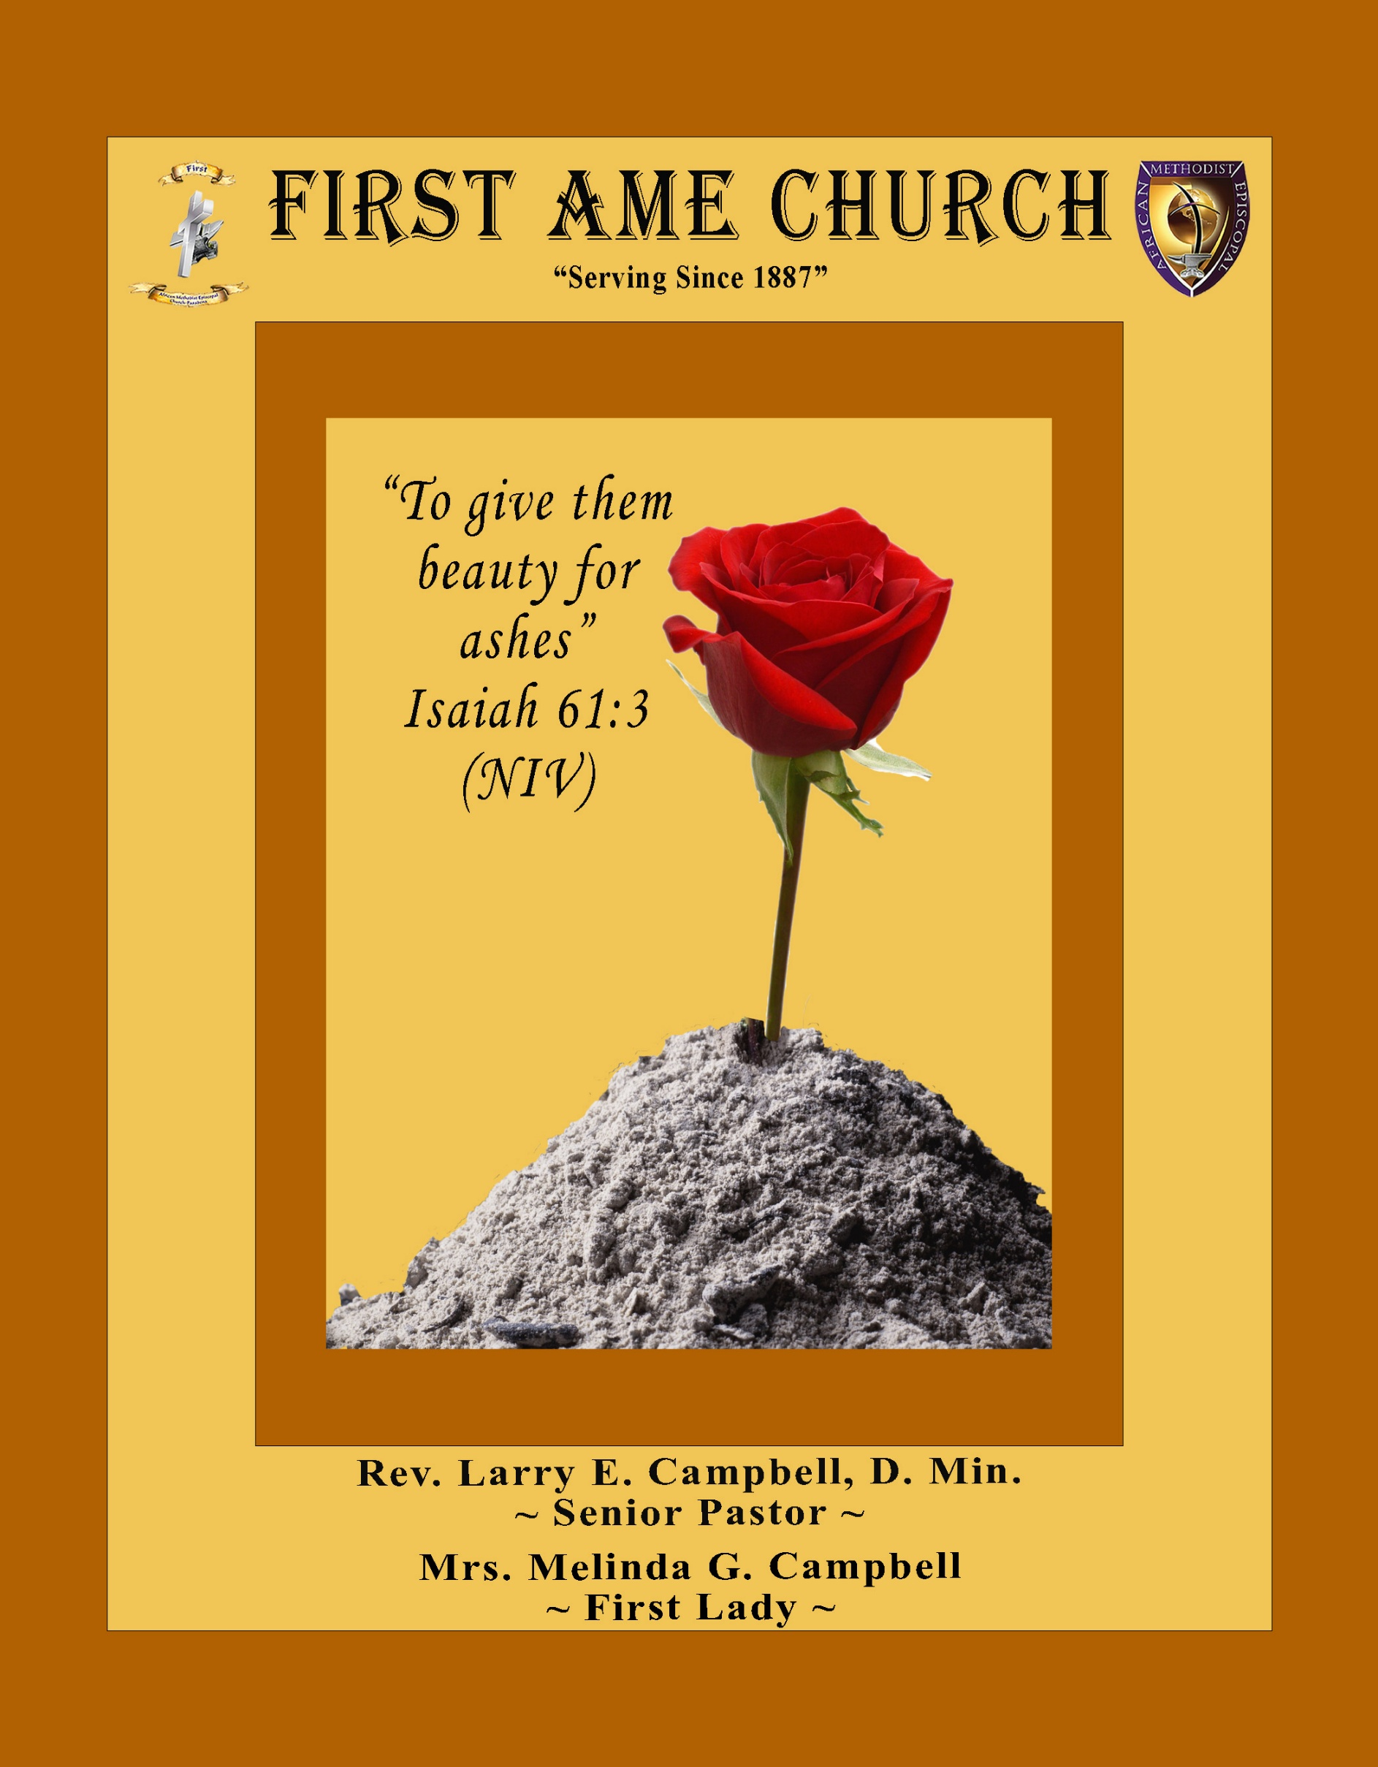
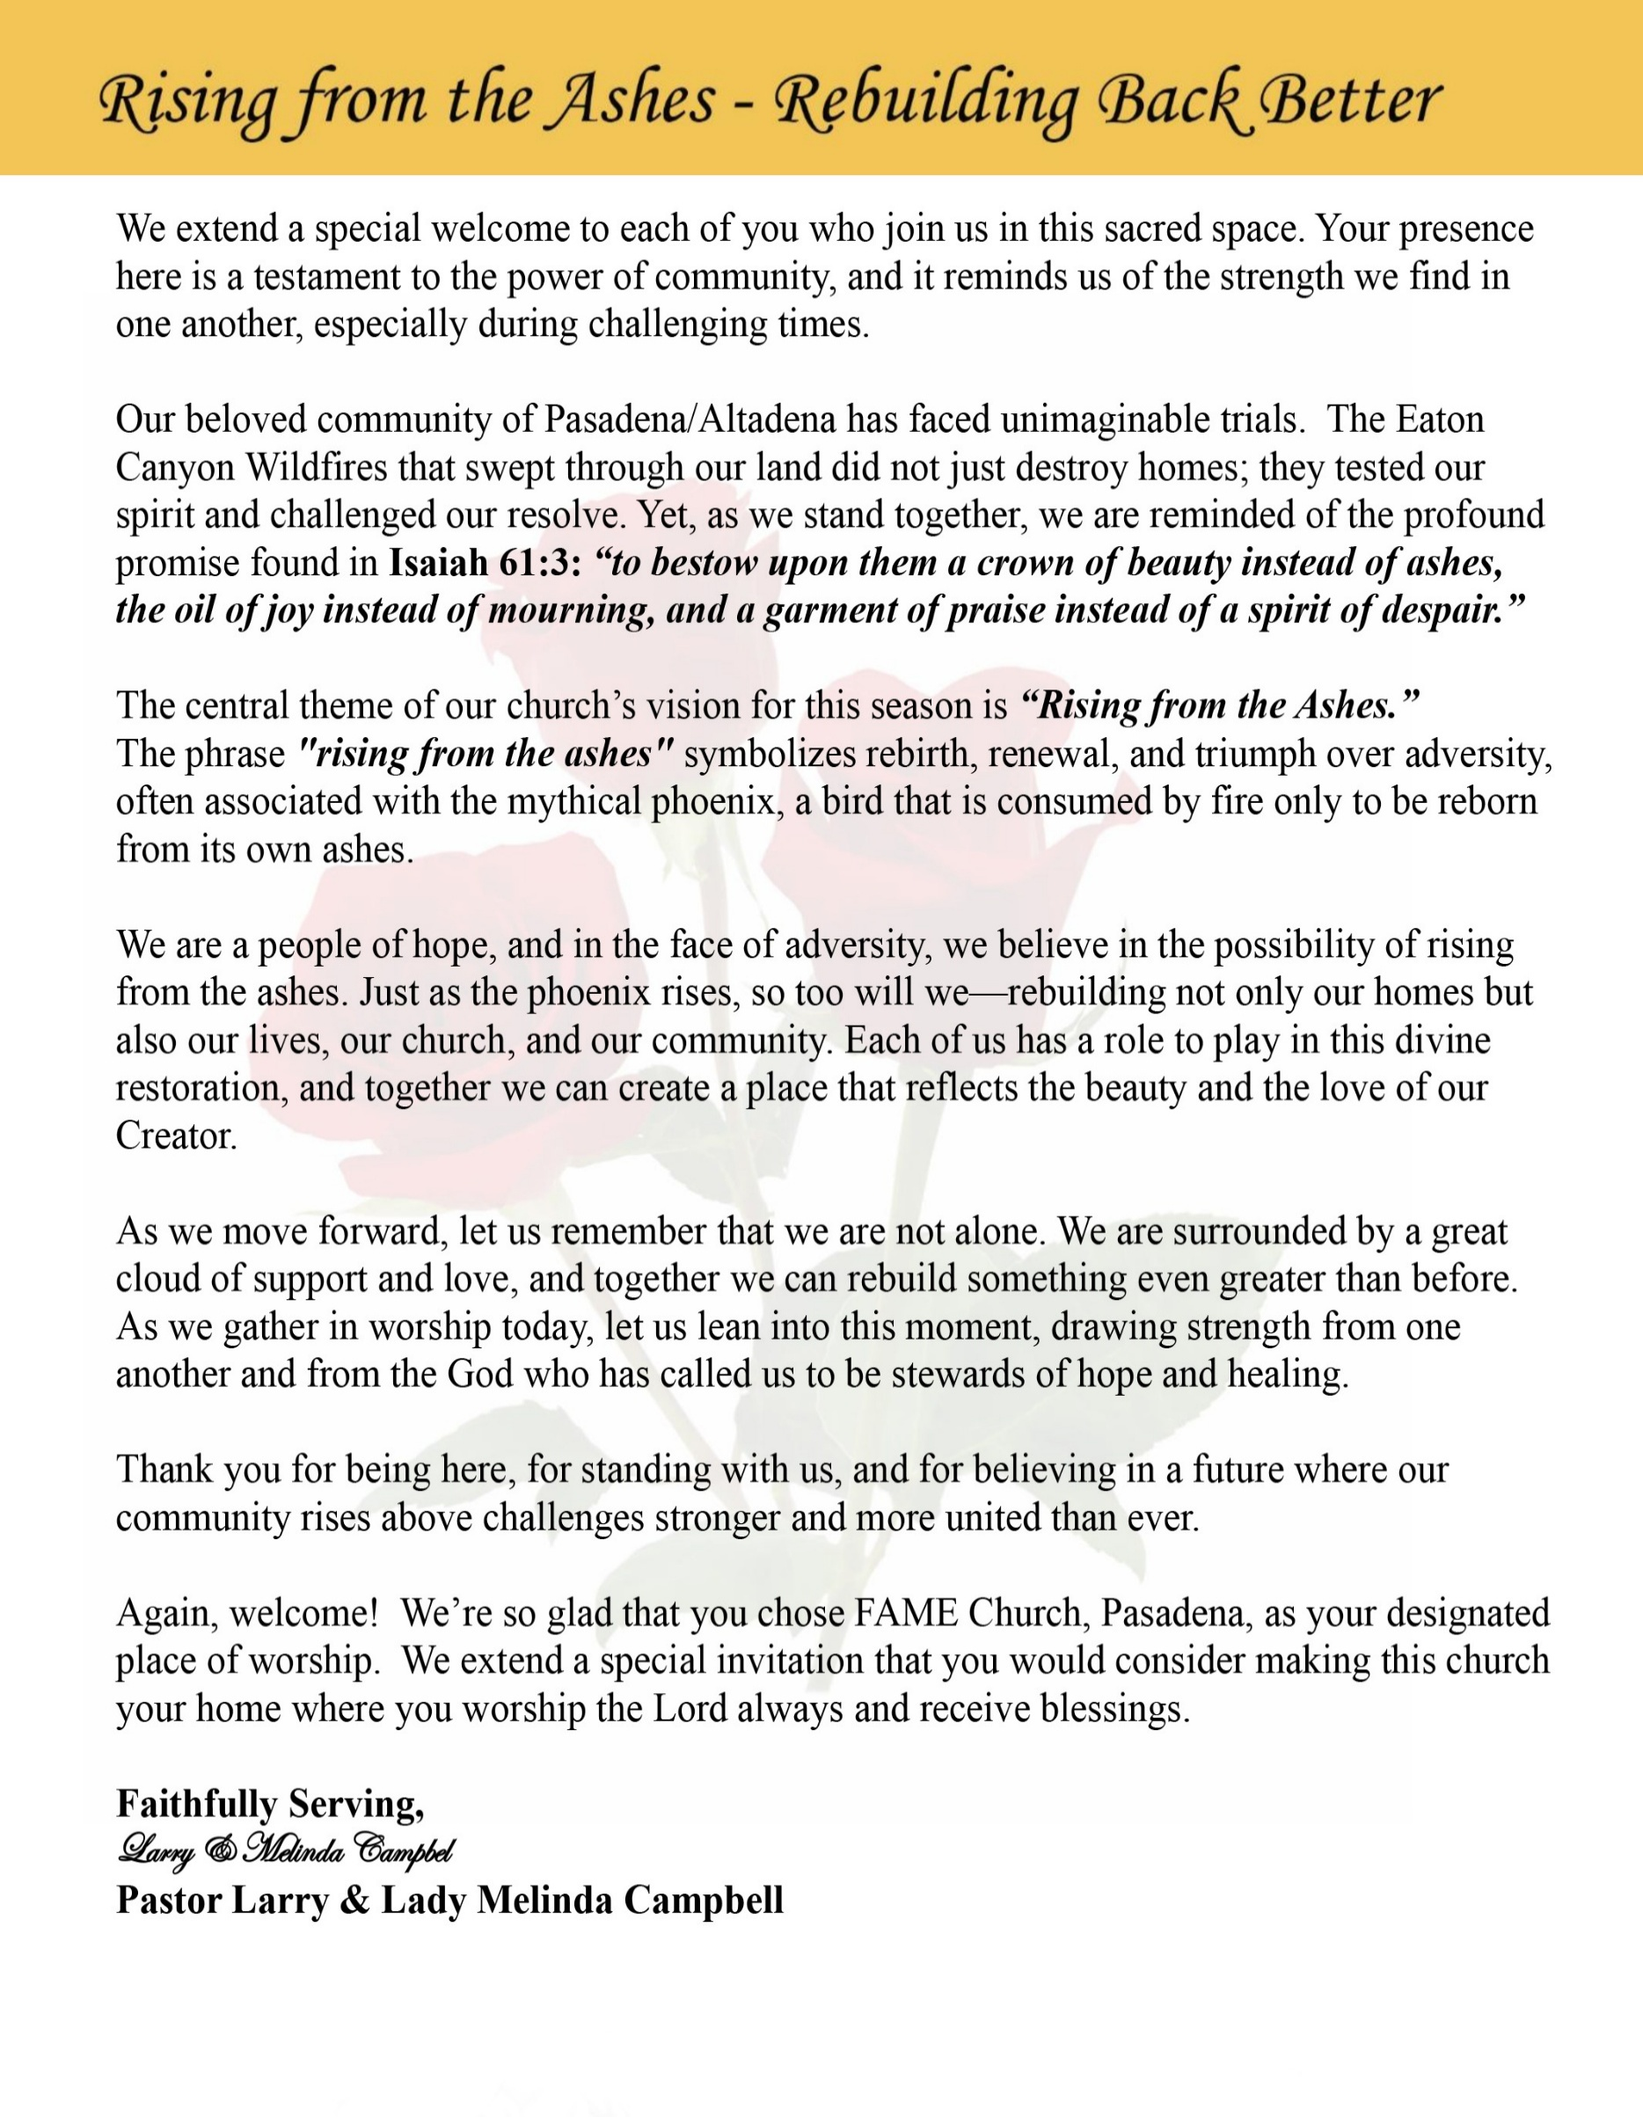

Sunday, January 18, 2026 | 9:30 a.m.

Rt. Rev. Francine A. Brookins, Esq., Presiding Bishop
Rev. Miriam Burnett, MD, MPH, Supervisor of Missions
Rev. Roosevelt Lindsey, Jr. Presiding Elder

The Rev. Dr. Larry E. Campbell ~ Senior Pastor ~ Minister

Mobile: (951) 587-1894 ~ Email: larrycampbell@famepasadena.org

Our First Lady: Mrs. Melinda G. Campbell

The Reverend Dr. Jennifer Oliver ~ Itinerant Elder -
The Reverend Dr. Nikia Smith-Robert ~ Itinerant Elder (Affiliated)
The Reverend Lois Woodard ~ Itinerant Elder Superannuated (Retired)
The Reverend Rochelle Wright Moore ~ Itinerant Deacon
The Reverend Deborah West-Jones ~ Local Elder
The Reverend Philis J. Griffin, MDiv ~ Local Elder
Dr. Phyllis Beech ~ Evangelist

Community Resource Center Director ~ Ms. Kischchen Hazelton Venerable
Church Administrative Assistant: Ms. Letha Rhymes

Church Office Hours:
Tue - Wed 9:00 am - 5:00 pm, & Fri 9:00 am -3:00 pm.
Closed for Lunch Daily: 12:00 pm - 1:00 pm.

Music Ministry
Dr. Timothy Davis, Minister of Music
Bro. Jimmy Watlington, Percussionist ~ Bro. Carlos Caldwell, Organist
Bro. Darien Dorsey, Keyboardist
Sis. Karen Law, Women’s Chorus Director ~ Sis. Tonia Graham, Children’s Choir Director
Bro. J. Renard Washington, New Generation’s Choir

FREE WI-FI service is available on the FAME Campus by accessing FAME 1700
Password: 6267980503

-3-

~ Order of Worship Experience ~

Warning: This order of worship is subject to change without warning or prior notice --- everything is governed by the Sovereignty of the Holy Spirit

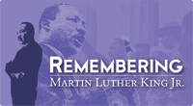

+The Altar Call +

Doxology: “Praise God From Whom All Blessings Flow”

The Call to Worship Judge Tara L. Newman

Leader: I was glad when they said unto me, let us go into the house of the Lord, our feet shall stand within Thy gates O Jerusalem! (Psalm 122:1)

People: For a day in Thy courts is better than a thousand. I had rather be a doorkeeper in the house of my God than to dwell in the tents of wickedness. (Psalm 84:10)

Leader: Because of the house of the Lord our God, I will seek Thy good.
(Psalm 122:9)

People: Those that be planted in the house of the Lord, shall flourish in the courts of our God. (Psalm 92:13)

Leader: Blessed are they that dwell in Thy house. Lord, I have loved Thy habitation, the place where Thy honor dwelleth. (Psalm 26:8)

People: For the Lord is in His holy temple; let all the earth keep silence before Him.
(Habakkuk 2:20).

Leader: Let the words of my mouth and the meditation of my heart, be acceptable in Thy sight, O Lord my strength and my redeemer. (Psalm 19:14)

Unison: O Sing unto the Lord a new song, for He has done marvelous things. Make a
joyful noise unto the Lord, all the earth, sing His praises. (Psalm 98:1, 4)

-4-

The Hymn of Praise A.M.E. Hymnal #571

Lift Every Voice and Sing
(James Weldon Johnson, 1871-1938)

Lift every voice and sing, Till earth and heaven ring,
Ring with the harmonies of liberty;
Let our rejoicing rise High as the listening skies,
Let it resound loud as the rolling sea,
Sing a song full of the faith that the dark past had taught us,
Sing a song full of the hope that the present has brought us;
Facing the rising sun Of our new day begun,
Let us march on till victory is won.

Stony the road we trod, Bitter the chastening rod,
Felt in the days when hope unborn had died;
Yet with a steady beat, Have not our weary feet
Come to the place for which our fathers sighed?
We have come over a way that with tears has been watered,
We have come, treading our path through the blood of the slaughtered;
Out from the gloomy past, Till now we stand at last
Where the white gleam of our bright star is cast.

God of our weary years, God of our silent tears,
Thou who hast brought us thus far on the way;
Thou who hast by Thy might, Led us into the light,
Keep us forever in the path, we pray.
Lest our feet stray from the places, our God, where we met Thee,
Lest our hearts, drunk with the wine of the world, we forget Thee;
Shadowed beneath Thy hand, May we forever stand,
True to our God, True to our native land.

The Invocation Bro. Zack Jackson

Musical Selections The Combined Children & Youth Choir

-5-

**A Scriptural Litany Honoring the Life and Legacy of Dr. Martin Luther King Jr.**
~Bro. LaWayne Williams~
Leader: Today we remember a servant of God who dared to dream in the language of Scripture,
who preached justice, walked in love, and labored for peace.

People: “The Lord requires of us to do justice, to love mercy, and to walk humbly with our
God.” (Micah 6:8)

Leader: We remember Dr. Martin Luther King Jr., called by God to speak truth to power and hope
to the broken.

People: “The Spirit of the Lord is upon me, because He has anointed me to bring good news to
the poor.” (Luke 4:18)

Leader: He believed that faith without works is incomplete, and that love must be active,
courageous, and redemptive.

People: “Let us love, not in word or speech, but in truth and action.” (1 John 3:18)

Leader: Dr. King marched, preached, prayed, and suffered, believing that injustice anywhere
threatens justice everywhere.

People: “Let justice roll down like waters, and righteousness like an ever-flowing stream.”
(Amos 5:24)

Leader: When hatred rose, he chose love. When violence tempted, he clung to nonviolence. When
Despair pressed in; he stood on hope.

People: “Do not be overcome by evil but overcome evil with good.” (Romans 12:21)

Leader: He trusted that God’s truth, though delayed, is never denied, and that the moral arc of the
The universe bends toward justice.

People: “Weeping may endure for a night, but joy comes in the morning.” (Psalm 30:5)

Leader: Dr. King dreamed of a beloved community, where all of God’s children are seen, valued,
and free.

People: “There is neither Jew nor Greek… for you are all one in Christ Jesus.”
(Galatians 3:28)

Leader: Today, we do not only remember his words—we recommit ourselves to his witness.

People: “Here am I; send me.” (Isaiah 6:8)

Leader: May we carry forward the work he began, until justice, peace, and love reign in every
community.

ALL: “Now faith, hope, and love abide, these three; and the greatest of these is love.”
(1 Corinthians 13:13) Amen.

-6-

The Summary of the Decalogue Bro. Hasan Doxey
LEADER: From all that dwell below the skies…
SUNG: From all that dwell below the skies, Let the Creator’s praise arise; Let the
Redeemer’s Name be sung, through every land, by every tongue.
LEADER: Hear what Christ our Savior saith, Thou shalt love the Lord thy God with all thy
heart, with all thy soul, and with all thy mind. This is the first and great
commandment. And the second is like unto it: Thou shalt love thy neighbor
as thyself. On these two commandments hang all the law and the prophets.
SUNG: Glory be to the Father, and to the Son, and to the Holy Ghost; as it was in
the beginning, is now, and ever shall be, world without end. A~Men

Abbreviated Announcements/Visitor’s Welcome

K-FAME Radio Broadcast



-7-

Special Congregational Hymn (Sing along)
#283 I am Thine, O Lord

The Offertory (Tithes ~ Gifts ~ Benevolent Offerings) Sis. Maryetta Babalola, Steward

The following Electronic GIVING Platforms are creditable methods to GIVE to FAME:

#1. GIVELIFY - Mobile Giving App available on the App Store. It’s easy to set up, just follow the guidelines.

#2. Cash App: $FirstAMEPASADENA

#3. Mail in your Tithes & Offering - If you would like to mail your tithes and offering by check or money order, please send it to: First AME Church, 1700 N. Raymond Avenue, Pasadena, CA 91103.

#4. Drop off your Tithes & Offering - During business hours in the basket outside of the office.

Choral Response: “All things come of Thee, O Lord; and of Thine own have we given Thee. Amen.”

Children’s Church Dismissal

Sermonic Selection The Praise Team

Proclamation of The Word Pastor Larry E. Campbell

The Invitation (Public/Private)

How to Join First A.M.E. Church of Pasadena
PROFESSION OF FAITH. If you have never been a member of any church, you may join by professing Jesus Christ as your personal Lord and Savior.

RENEWAL OF VOWS. If you have been a member of a church at one time, but have been in active, you may join by renewing your faith in Jesus Christ as Lord and Savior.

TRANSFER. If you are a member of another African Methodist Episcopal Church and you are in good standing, you may join by requesting that your membership be transferred to the First African Methodist Episcopal Church of Pasadena.

AFFILIATE MEMBER. Sometimes an individual has reasons for keeping /his/her membership in another church but would like to be an active member of First African Methodist Episcopal Church, too. This is possible as an affiliate member. __________________________________________________________________________________________

The Doxology

The Benediction

-8-

Scripture of the Day
Dreams & Visions. “Then He said, “Hear now My words: If there is a prophet among you, I, the Lord, make Myself known to him in a vision; I speak to him in a dream.” Number 12:6

Quote of the Day
“Not everything that is faced can be changed, but nothing can be changed until it is faced.” James Baldwin

Thought of the Week
Dreaming Forward
“Hold fast to dreams, for if dreams die, life is a broken-winged bird that cannot fly.”
— Langston Hughes
God has always moved our people forward through dreams. When the night was long and the road uncertain, God placed vision in our spirits to keep us going. Dreams became prayers, and visions became roadmaps toward freedom, dignity, and purpose.
To dream is to trust God beyond what you see right now. Vision reminds us that today’s struggle does not cancel tomorrow’s promise. Even when progress feels slow, God is still at work—quietly shaping outcomes we cannot yet measure.
Our history proves that dreaming works. From freedom songs to marches, from classrooms to pulpits, vision has carried us through. And the same God who sustained our ancestors is still calling us to dream forward—not backward, not in fear, but in faith.
Do not let disappointment silence your vision. Guard your dreams carefully. What God has placed in you is meant to lift not only you, but generations to come.

Humor of the Week
An elderly man had a serious hearing problem for many years. He went to the doctor and was fitted with this state of the art, high-tech hearing aide, to where he could hear 100%.
He went back a month later for a checkup. The doctor said "Wow, your hearing is perfect. Your family must be so excited that you can hear again."
He said "No, I haven't told my family yet. I just sit around and listen to the different conversations, and I've changed my will 3 times."

HOME DAILY BIBLE READINGS
January 19, 2026 – January 25, 2026 (Week 18, Jeremiah)
Monday Day 120 2 Chronicles 1-5, Psalm 49:12-20
Tuesday Day 121 2 Chronicles 6-8, Psalm 50:1-6
Wednesday Day 122 2 Chronicles 9-12, Psalm 50:7-13
Thursday Day 123 2 Chronicles 13-17, Psalm 50:14-21
Friday Day 124 2 Chronicles 18-20, Psalm 50:22-23
Saturday Day 125 2 Chronicles 21-24, Psalm 51:1-6
Sunday Day 126 2 Chronicles 25-27, Psalm 51:7-12

-9-

ANNOUNCEMENTS

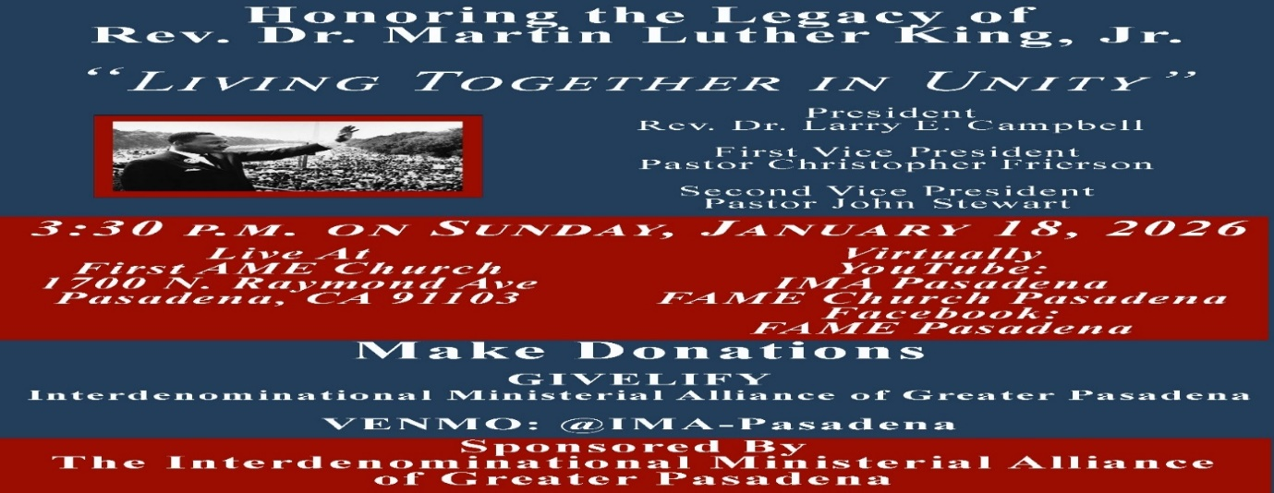

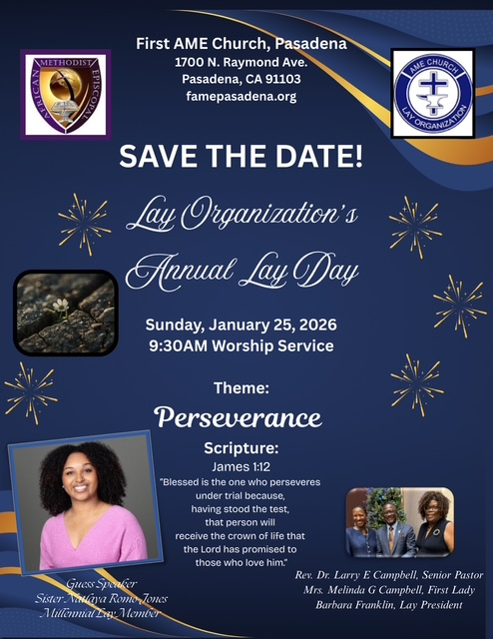

-10-
-

ANNOUNCEMENTS (Continued)

20/20 (14.0)
The 20/20 initiative is a Church-wide fundraising project managed by the Stewards. This project was established to assist with our Annual Connectional Budget. Financial gifts donated through the 20/20 initiative are added to our collected conference claims and assist greatly in meeting the first and second half of our Connectional Budgetary obligations. The Steward Board is requesting 150 participants for the conference year 2025-2026. The first half of our budget is due in February 2026. In addition to the 18 officers and we are asking 132 people to give 20 dollars per week for 20 weeks in addition to your regular tithes, gifts and offerings. Please mark your envelopes 20/20 and allocate $20.00. Our goal is to raise $60,000. Again, this will satisfy all budgetary needs on the conference level without utilizing any operational funds. Please see or contact any Steward to participate; we are looking forward to your commitment.

Everyone is encouraged to join our weekly Christian Education Sessions

VIRTUAL ADULT CHURCH SCHOOL
Sunday Mornings at 8:00 a.m.
http://us02web.zoom.us/j/844840183?pwd-sm0w1yvmvhOvC13175urZ2vr7M3EtU.1

HYBRID PASTOR’S WEEKLY BIBLE STUDY
Wednesdays at 11:00 a.m.
https://us02web.zoom.us/j/84484840183?pwd=sm0w1yvmvhOvC13l75urZ2vr7M3EtU.1
Meeting ID: 844 8484 0183 | Passcode: 357260

WEEKLY TELECONFERENCE PRAYERS SESSIONS
Wednesdays at 5:30 a.m. and 6:00 p.m.
Conference Call Number: (530_ 881-1212
Access Code: 234575160#

FIRST A.M.E. CHURCH — “Feed My Sheep” FOOD PANTRY
OPEN EVERY SECOND AND FOURTH FRIDAY
9:00 A.M. — 11:00 A.M.
Please consider making a financial donation in support of our Food Pantry

-11-

ANNOUNCEMENTS (Continued)

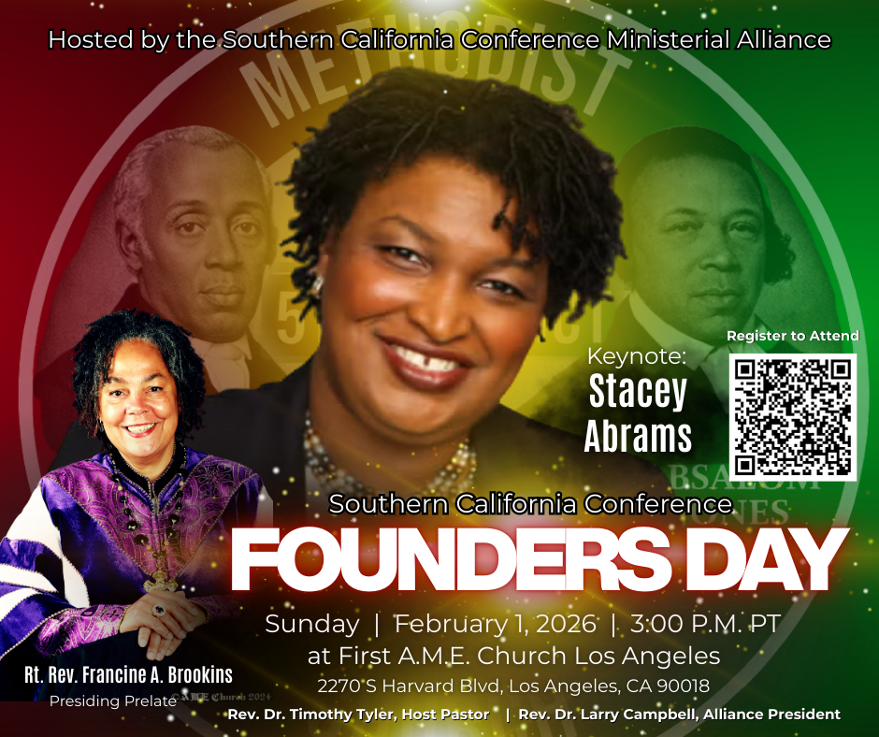

2025 FINANCIAL CONTRIBUTION STATEMENT
Financial Contribution Statements will be prepared upon request and ready for disbursement on Sunday, January 25, 2026. Please complete the information below and place it in the offering basket or leave it in the church office.

Last Name: _______________________ First Name: ____________________________

Address:___________________________________________________________________

Day Phone: ___________________________ Evening Phone: ______________________

-12-

Prayer Request(s)
Please notify the Church Office of Sick & Shut-in additions, deletions, or status/address changes.

Bishop Francine A. Brookins, Esq. Supervisor Miriam Burnett, MD
Presiding Elder Roosevelt & Dr. Kaye Lindsey Rev. Dr. Larry & Melinda Campbell
Richard Craig Hazel Clark Erica Woodard Jason Shirley Joshua Shirley Julian Shirley Ayanna Terry Cheryl Jamerson Gwendolyn Flowers Andrea Anderson Ocilda Files Danielle Clark Donita Towler Rev. Charles Brooks Doris Bailey Kimberly Woods Cynithia Grace Zechariah Robinson Diane Jordan Christopher McCarthy Wilma Haynes Jewell Malloy Calle Burns Noel Johnson Brittney Petty Taylor Family Deborah Burton Nettie McChristen Jacquelyn Walker Carita Smith
Rev. Rochelle Moore Lorene Butler Stella Pulliam Cheryl Jameson The Caple Family Joyce Johnson
The Eaton Canyon Fire Victims Selene Cox Barbra McPheeter Colette Blizzard

College Students

Let’s continue to support and pray for our beloved College Students

Isaiah Crowell Alecia Davis Jade Williams Chase Johnson Grant Blizzard

Tyler Johnson Richard Jones Tyrikk Lawson Makia Rose Talbert Isaiah Ringo Journey Rogers Elyse Sharp Kylee Sharp Zion Otano Elise Tervalon Grace Jones Jordan Patterson Kimberly Robinson Donovan Williams Jasmine Collins Brandon Bates Gabriel Blizzard

Sick and Shut-Ins
Andrew Oliver 1405 N. Roosevelt Avenue. Pasadena, CA 91104
Bettina Ayers Pasadena Meadows Nursing Home, 150 Bellefontaine St., Pas., CA 91105
Bobby Thomas 1052 E. Morada Place, Altadena, CA 91001
Carrie Wynne Senior Living Heritage, 161 N. Hemet St., Hemet, CA 92545
Doris Curd 11619 Woodcock Avenue, San Fernando, CA 91340
Edmund Riddle Active Care Mission Bay, 2440 Grand Avenue, San Diego, CA 92109
Eleanor Towler 975 E. Union Street, Unit #417, Pasadena, CA 91106
Elois Blizzard P. O. Box 3646, So. Pasadena, CA 91031
Emily Cormier-Ross 2549 La Fiesta Avenue, Altadena, CA 91001
Ernestine English 26 W. Fair Oaks Drive, Pasadena, CA 91103
Fred Caple 51 North 15th Street Haledon, NJ 07508
Frederick Smith 1055 N. Vignes St., Los Angeles, CA 90012
Gloria Cubit Clay 11745 Pierce St., Lake View Terrace, CA 91342
Hugh Hamberry 19225 Chole Rd., Apple Valley, CA 92307
Josephine Brown 15607 Saddleback Rd, Riverside, CA 92506
Jessie Smith 7980 Mayten Avenue, Apt 3050 Rancho Cucamonga, CA 91730-8113
Linnie G. Nollie 2250 E. New York Drive, Altadena, CA 91001
Malika G. Hendry P. O. Box 94082, Pasadena, CA 91109
Mildred Lewis C/O Hazel Rohr, 884 W. Jane Court, Upland, CA 91786
Norma Burnett 618 Fairview Avenue, Unit #228, Arcadia, CA 91007
Opal Hampton 1030 Chevron Court, Pasadena, CA 91103
Paul Ratliff P.O. Box 40407 Pasadena, CA 91114
Ruthie Hopkins 1155 Via Verde , San Dimas, CA 91773
Virlyn Grant 15122 Orange Ave., Paramount, CA 90723
Wanda Nelson 3618 N. Fair Oaks Avenue, Altadena, CA 91001
William Hilliard 7504 Wynstone Pl., Fontana, CA 92336
Zell L. Hill 375 Barthe Drive, Pasadena, CA 91103

-13-

Sermon Notations

Scripture: _____________________________________________________________

Subject: _______________________________________________________________

Points of the Message: ___________________________________________________
_______________________________________________________________________
_______________________________________________________________________
_______________________________________________________________________
_______________________________________________________________________
_______________________________________________________________________
_______________________________________________________________________

Main Ideas of the Sermon: ________________________________________________
_______________________________________________________________________
_______________________________________________________________________
_______________________________________________________________________
_______________________________________________________________________
_______________________________________________________________________

Illustrations I want to remember: _________________________________________
_______________________________________________________________________
_______________________________________________________________________
_______________________________________________________________________
_______________________________________________________________________
_______________________________________________________________________
_______________________________________________________________________

What should I do as a result of this Sermon? ________________________________

_____________________________________________________
_____________________________________________________
_____________________________________________________
_____________________________________________________

-14-

