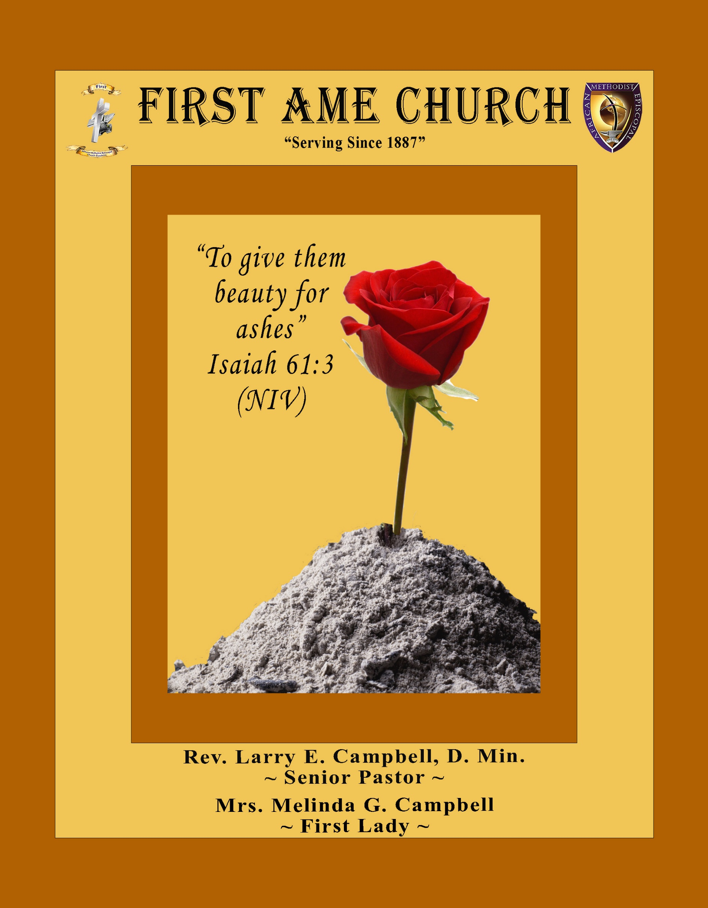
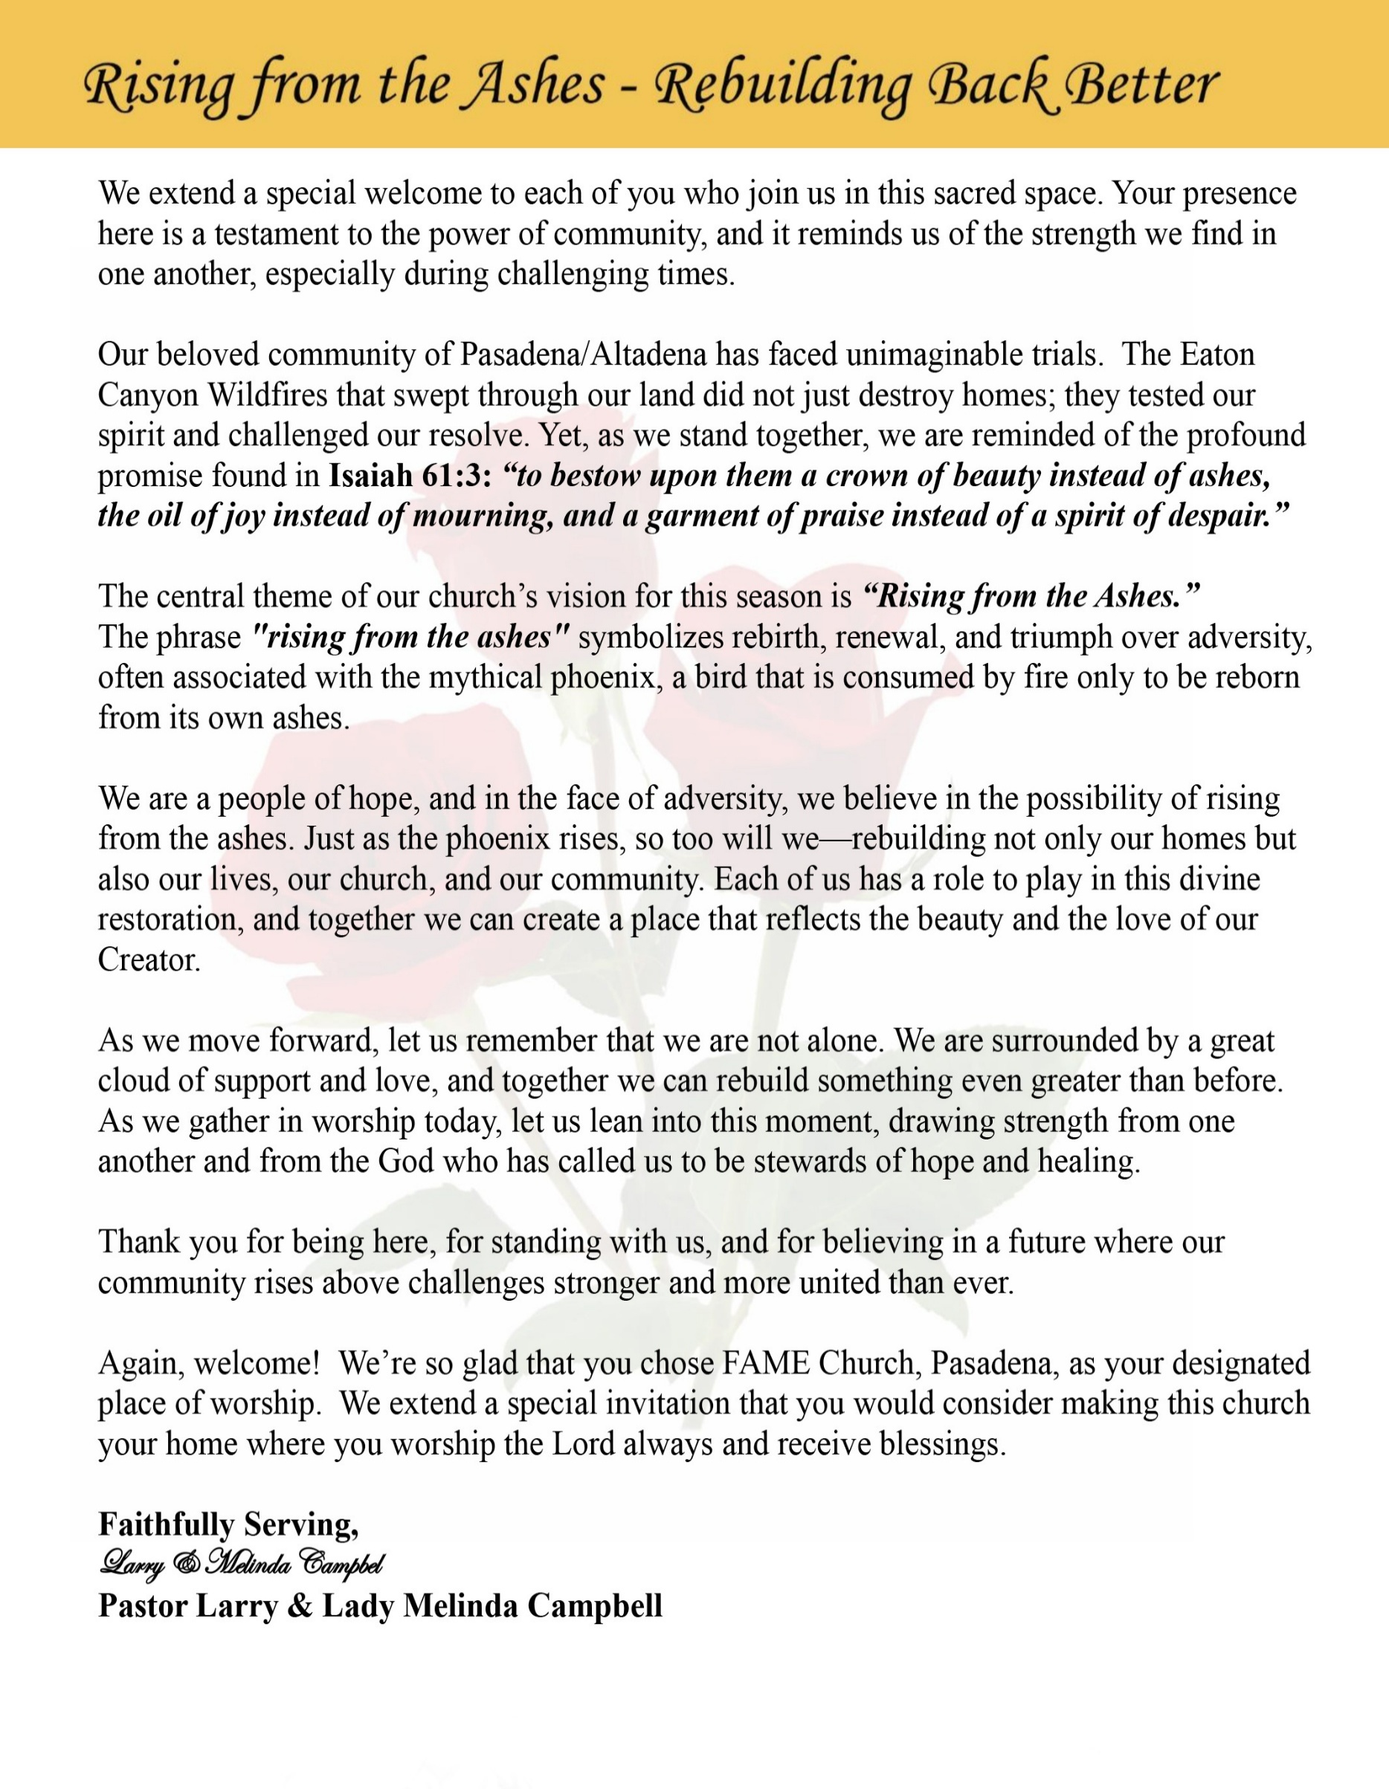

Sunday, January 11, 2026 | 9:30 a.m.

Rt. Rev. Francine A. Brookins, Esq., Presiding Bishop
Rev. Miriam Burnett, MD, MPH, Supervisor of Missions
Rev. Roosevelt Lindsey, Jr. Presiding Elder

The Rev. Dr. Larry E. Campbell ~ Senior Pastor ~ Minister

Mobile: (951) 587-1894 ~ Email: larrycampbell@famepasadena.org

Our First Lady: Mrs. Melinda G. Campbell

The Reverend Dr. Jennifer Oliver ~ Itinerant Elder -
The Reverend Dr. Nikia Smith-Robert ~ Itinerant Elder (Affiliated)
The Reverend Lois Woodard ~ Itinerant Elder Superannuated (Retired)
The Reverend Rochelle Wright Moore ~ Itinerant Deacon
The Reverend Deborah West-Jones ~ Local Elder
The Reverend Philis J. Griffin, MDiv ~ Local Elder
Dr. Phyllis Beech ~ Evangelist

Community Resource Center Director ~ Ms. Kischchen Hazelton Venerable
Church Administrative Assistant: Ms. Letha Rhymes

Church Office Hours:
Tue - Wed 9:00 am - 5:00 pm, & Fri 9:00 am -3:00 pm.
Closed for Lunch Daily: 12:00 pm - 1:00 pm.

Music Ministry
Dr. Timothy Davis, Minister of Music
Bro. Jimmy Watlington, Percussionist ~ Bro. Carlos Caldwell, Organist
Bro. Darien Dorsey, Keyboardist
Sis. Karen Law, Women’s Chorus Director ~ Sis. Tonia Graham, Children’s Choir Director
Bro. J. Renard Washington, New Generation’s Choir

FREE WI-FI service is available on the FAME Campus by accessing FAME 1700
Password: 6267980503

-3-

~ Order of Worship Experience ~

Warning: This order of worship is subject to change without warning or prior notice --- everything is governed by the Sovereignty of the Holy Spirit



+The Altar Call +

Doxology: “Praise God From Whom All Blessings Flow”

The Call to Worship Sis. Denise Altemus-Barden

Leader: I was glad when they said unto me, let us go into the house of the Lord, our feet shall stand within Thy gates O Jerusalem! (Psalm 122:1)

People: For a day in Thy courts is better than a thousand. I had rather be a doorkeeper in the house of my God than to dwell in the tents of wickedness. (Psalm 84:10)

Leader: Because of the house of the Lord our God, I will seek Thy good.
(Psalm 122:9)

People: Those that be planted in the house of the Lord, shall flourish in the courts of our God. (Psalm 92:13)

Leader: Blessed are they that dwell in Thy house. Lord, I have loved Thy habitation, the place where Thy honor dwelleth. (Psalm 26:8)

People: For the Lord is in His holy temple; let all the earth keep silence before Him.
(Habakkuk 2:20).

Leader: Let the words of my mouth and the meditation of my heart, be acceptable in Thy sight, O Lord my strength and my redeemer. (Psalm 19:14)

Unison: O Sing unto the Lord a new song, for He has done marvelous things. Make a
joyful noise unto the Lord, all the earth, sing His praises. (Psalm 98:1, 4)

-4-

The Hymn of Praise A.M.E. Hymnal #513

Time Is Filled with Swift Transition
(Hold to God’s Unchanging Hand)

1 Time is filled with swift transition,
naught of earth unmoved can stand;
Build your hopes on things eternal,
hold to God’s unchanging hand!

Refrain:
Hold to God’s unchanging hand!
Hold to God’s unchanging hand!
Build your hopes on things eternal,
hold to God’s unchanging hand!

2 Trust in Him who will not leave you,
whatsoever years may bring;
If by earthly friends forsaken,
still more closely to Him cling.
[Refrain]

3 Covet not this world’s vain riches
that so rapidly decay;
Seek to gain the heav’nly treasures,
they will never pass away!
[Refrain]

4 When your journey is completed,
if to God you have been true,
fair and bright the home in glory,
your enraptured soul will view!
[Refrain]

The Invocation Bro. Horace Wormely, AVT Technician

Ministry of Music The Praise Team

-5-

Memorial Candle-Lighting Litany of Hope
First Anniversary of the Eaton Canyon Fires
Pastor: On this sacred day of remembrance, we pause to honor what was lost and to give thanks
for what God has preserved. We light these candles not to relive the fire, but to proclaim
that the fire did not have the final word.

People: “The Lord is near to the brokenhearted and saves the crushed in spirit.” Psalm 34:18

Candle One – Remembrance of Loss -- (First candle is lit)

Pastor: We light this candle in memory of homes destroyed, memories consumed, and lives
forever changed.

People: We remember and we grieve. “Blessed are those who mourn, for they shall be
comforted.” — Matthew 5:4

(Moment of silence)

Candle Two – Tears and Trauma --(Second candle is lit)

Leader: We light this candle for tears shed— seen and unseen, public and private— for the pain
that still lingers one year later.

People: God has not ignored our sorrow. “You have kept count of my tossings; put my tears
in your bottle.” — Psalm 56:8

Candle Three – God’s Presence in the Fire -- (Third candle is lit)

Leader: We light this candle to testify that we were not abandoned.

People: God walked with us through the flames. “When you walk through fire, you shall not
be burned.” — Isaiah 43:2

Candle Four – Gratitude for Survival and Strength -- (Fourth candle is lit)

Leader: We light this candle in thanksgiving for lives spared, strength renewed, and
community that carried us when we could not carry ourselves.

People: God was our refuge and strength. “A very present help in trouble.” — Psalm 46:1

Candle Five – Hope and Restoration -- (Fifth candle is lit)

Leader: We light this candle as a declaration of hope— trusting that God is still rebuilding,
restoring, and renewing.

People: We are bound to hope. “Return to your stronghold, O prisoners of hope; today I
Declare that I will restore to you double.” — Zechariah 9:12
[Continued on page 7]

-6-

[Memorial Candle-Lighting Litany of Hope]

Closing Affirmation
Pastor: Though the fire burned fiercely—

People: Our faith still stands.

Pastor: Though loss touched our lives—

People: Hope still holds us.

Pastor: The light shines in the darkness— “And the darkness did not overcome it.”
— John 1:5

Final Declaration - (All Together)
We remember.
We grieve.
We give thanks.
We hope.
Our hope is built on nothing less
than Jesus’ blood and righteousness.
We are still here.
We are still standing.
Amen.

Abbreviated Announcements/Visitor’s Welcome



Wedding

90 Plus Birthday Celebrations

Ms. Zell Hill will celebrate her 100th birthday on January 31st.

-7-

Birthdays Recognized for the Month


“The best Birthday wish that you can get for the day is that you may live each moment of your life to the very fullest, without any regrets.” Anonymous

Special Congregational Hymn (Sing along)
#394 We Are Often Tossed and Driven

The Offertory (Tithes ~ Gifts ~ Benevolent Offerings) Sis. Lynnette Burke, Steward

The following Electronic GIVING Platforms are creditable methods to GIVE to FAME:

#1. GIVELIFY - Mobile Giving App available on the App Store. It’s easy to set up, just follow the guidelines.

#2. Cash App: $FirstAMEPASADENA

#3. Mail in your Tithes & Offering - If you would like to mail your tithes and offering by check or money order, please send it to: First AME Church, 1700 N. Raymond Avenue, Pasadena, CA 91103.

#4. Drop off your Tithes & Offering - During business hours in the basket outside of the office.

Choral Response: “All things come of Thee, O Lord; and of Thine own have we given Thee. Amen.”

Children’s Church Dismissal

Sermonic Selection The Praise Team

The Preached Word Pastor Larry E. Campbell

The Doxology

The Benediction

-8-

Scripture of the Day
Hope in the New Year. “Surely there is a future, and your hope will not be cut off.” Proverbs 23:18

Quote of the Day
“Hope has two beautiful daughters: anger at the way things are, and courage to see that they do not remain as they are.”.” St. Augustine

Thought of the Week
Hope in the New Year
A new year invites us to look ahead, but it does not ask us to forget what lies behind. We enter this season carrying memories—some joyful, some painful—but all of them remind us that God has brought us through. Hope is not denial of the past; it is confidence in God’s presence for the future.

As we step into this new year, we may not know what tomorrow holds, but we know who holds tomorrow. God’s faithfulness has sustained us through every season, and that same faithfulness will guide us forward. Even when circumstances feel uncertain, hope anchors our souls and keeps us steady.

Let this be a year marked by renewed trust, deeper faith, and courageous hope. May we move forward believing that God is still restoring, still renewing, and still making a way where we cannot yet see one. “Surely there is a future, and your hope will not be cut off.” — Proverbs 23:18

Humor of the Week
A woman walks into a pizza store and asks the owner:
“What’s your wi-fi password”?
The pizza shop owner looks at her and says: “You have to order pizza first”.
Frustrated, the woman says, “Oh, c’mon, you don’t have to be that stingy, what’s the wi-fi password?”
The pizza shop owner replies, “You have to order pizza first”.
The woman says angrily, “Ok, fine, give me a large pepperoni pizza!”
She takes out some cash and hands it over to the pizza shop owner.
The owner fulfills her requests and gives her a box of pizza, some change, and a receipt.
The woman says: “Now that I bought pizza, what's the wi-fi password?”
The owner says: “Like I’ve been saying, you have to order pizza first, that is the wi-fi password!”

HOME DAILY BIBLE READINGS
January 12, 2026 – January 18, 2025 (Week 17, Luke)
Monday Day 113 1 Chronicles 9-11, Psalm 46:1-7
Tuesday Day 114 1 Chronicles 12-14, Psalm 46:8-11
Wednesday Day 115 1 Chronicles 15-17, Psalm 47
Thursday Day 116 1 Chronicles 18-21, Psalm 48:1-7
Friday Day 117 1 Chronicles 22-24, Psalm 48:8-14
Saturday Day 118 1 Chronicles 25-27, Psalm 49:1-4
Sunday Day 119 1 Chronicles 28-29, Psalm 49:5-11

-9-

ANNOUNCEMENTS

20/20 (14.0)
The 20/20 initiative is a Church-wide fundraising project managed by the Stewards. This project was established to assist with our Annual Connectional Budget. Financial gifts donated through the 20/20 initiative are added to our collected conference claims and assist greatly in meeting the first and second half of our Connectional Budgetary obligations. The Steward Board is requesting 150 participants for the conference year 2025-2026. The first half of our budget is due in February 2026. In addition to the 18 officers and we are asking 132 people to give 20 dollars per week for 20 weeks in addition to your regular tithes, gifts and offerings. Please mark your envelopes 20/20 and allocate $20.00. Our goal is to raise $60,000. Again, this will satisfy all budgetary needs on the conference level without utilizing any operational funds. Please see or contact any Steward to participate; we are looking forward to your commitment.

Children’s Praise Dance Ministry
Parents, get ready! A Children's Praise Dance Ministry has launched! Again, all children are invited to join the fun! Additional practices are forthcoming and will be published soon. This joyful ministry is a wonderful way for children to praise God through movement, music, and creativity. Let’s dance, praise, and have fun together! For more information or to sign up, please contact:
Mariah Carter at idancewithangelsdaily@gmail.com
Senior Ministry In-Person Gathering
Tuesday, January 13, 2026 | 11:30 a.m.
Church Fellowship Hall

Everyone is encouraged to join our weekly Christian Education Sessions

VIRTUAL ADULT CHURCH SCHOOL
Sunday Mornings at 8:00 a.m.
http://us02web.zoom.us/j/844840183?pwd-sm0w1yvmvhOvC13175urZ2vr7M3EtU.1

HYBRID PASTOR’S WEEKLY BIBLE STUDY
Wednesdays at 11:00 a.m.
https://us02web.zoom.us/j/84484840183?pwd=sm0w1yvmvhOvC13l75urZ2vr7M3EtU.1
Meeting ID: 844 8484 0183 | Passcode: 357260

WEEKLY TELECONFERENCE PRAYERS SESSIONS
Wednesdays at 5:30 a.m. and 6:00 p.m.
Conference Call Number: (530_ 881-1212
Access Code: 234575160#

-10-
-

ANNOUNCEMENTS (Continued)

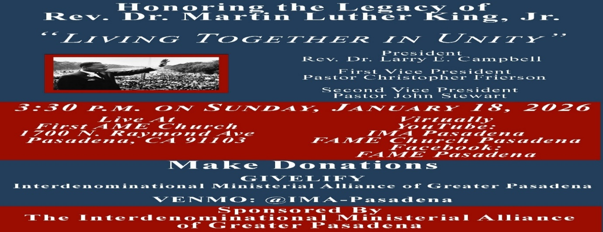

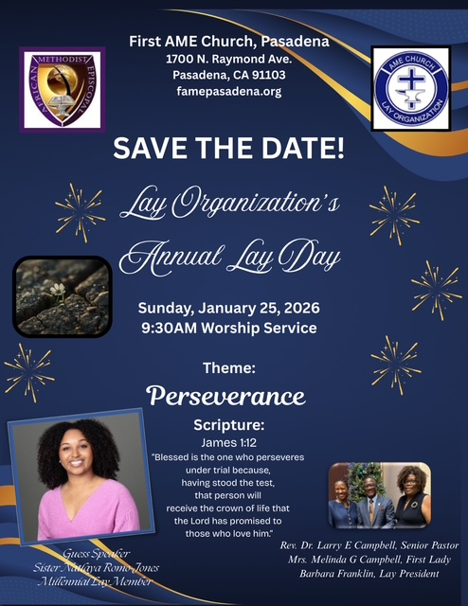

-11-

ANNOUNCEMENTS (Continued)

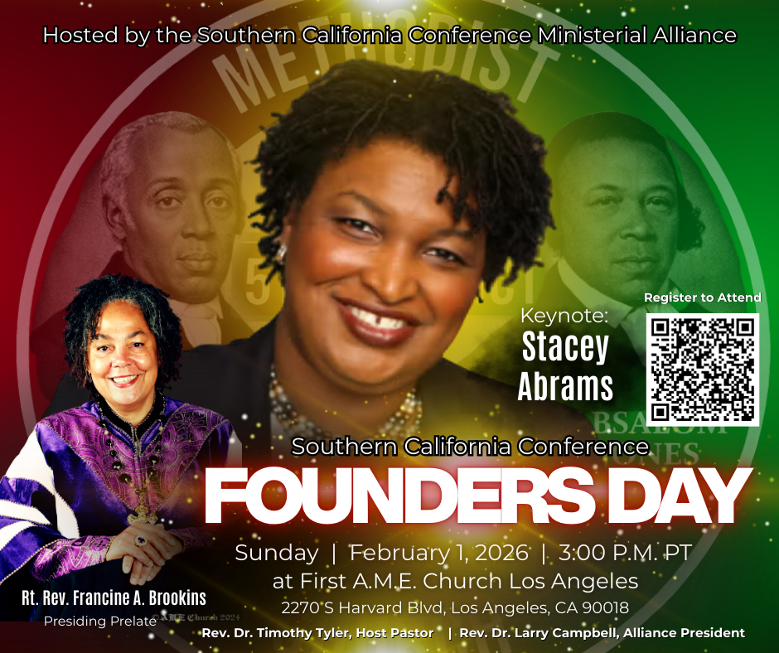

2025 FINANCIAL CONTRIBUTION STATEMENT
Financial Contribution Statements will be prepared upon request and ready for disbursement on Sunday, January 25, 2026. Please complete the information below and place it in the offering basket or leave it in the church office.

Last Name: _______________________ First Name: ____________________________

Address:___________________________________________________________________

Day Phone: ___________________________ Evening Phone: ______________________

-12-

Prayer Request(s)
Please notify the Church Office of Sick & Shut-in additions, deletions, or status/address changes.

Bishop Francine A. Brookins, Esq. Supervisor Miriam Burnett, MD
Presiding Elder Roosevelt & Dr. Kaye Lindsey Rev. Dr. Larry & Melinda Campbell
Richard Craig Hazel Clark Erica Woodard Jason Shirley Joshua Shirley Julian Shirley Ayanna Terry Cheryl Jamerson Gwendolyn Flowers Andrea Anderson Ocilda Files Danielle Clark Donita Towler Rev. Charles Brooks Doris Bailey Kimberly Woods Cynithia Grace Zechariah Robinson Diane Jordan Christopher McCarthy Wilma Haynes Jewell Malloy Calle Burns Noel Johnson Brittney Petty Taylor Family Deborah Burton Nettie McChristen Jacquelyn Walker Carita Smith
Rev. Rochelle Moore Lorene Butler Stella Pulliam Cheryl Jameson The Caple Family Joyce Johnson
The Eaton Canyon Fire Victims Selene Cox Barbara McPheeter Colette Blizzard

College Students

Let’s continue to support and pray for our beloved College Students

Isaiah Crowell Alecia Davis Jade Williams Chase Johnson Grant Blizzard

Tyler Johnson Richard Jones Tyrikk Lawson Makia Rose Talbert Isaiah Ringo Journey Rogers Elyse Sharp Kylee Sharp Zion Otano Elise Tervalon Grace Jones Jordan Patterson Kimberly Robinson Donovan Williams Jasmine Collins Brandon Bates Gabriel Blizzard

Sick and Shut-Ins
Andrew Oliver 1405 N. Roosevelt Avenue. Pasadena, CA 91104
Bettina Ayers Pasadena Meadows Nursing Home, 150 Bellefontaine St., Pas., CA 91105
Bobby Thomas 1052 E. Morada Place, Altadena, CA 91001
Carrie Wynne Senior Living Heritage, 161 N. Hemet St., Hemet, CA 92545
Doris Curd 11619 Woodcock Avenue, San Fernando, CA 91340
Edmund Riddle Active Care Mission Bay, 2440 Grand Avenue, San Diego, CA 92109
Eleanor Towler 975 E. Union Street, Unit #417, Pasadena, CA 91106
Elois Blizzard P. O. Box 3646, So. Pasadena, CA 91031
Emily Cormier-Ross 2549 La Fiesta Avenue, Altadena, CA 91001
Ernestine English 26 W. Fair Oaks Drive, Pasadena, CA 91103
Fred Caple 51 North 15th Street Haledon, NJ 07508
Frederick Smith 1055 N. Vignes St., Los Angeles, CA 90012
Gloria Cubit Clay 11745 Pierce St., Lake View Terrace, CA 91342
Hugh Hamberry 19225 Chole Rd., Apple Valley, CA 92307
Josephine Brown 15607 Saddleback Rd, Riverside, CA 92506
Jessie Smith 7980 Mayten Avenue, Apt 3050 Rancho Cucamonga, CA 91730-8113
Linnie G. Nollie 2250 E. New York Drive, Altadena, CA 91001
Malika G. Hendry P. O. Box 94082, Pasadena, CA 91109
Mildred Lewis C/O Hazel Rohr, 884 W. Jane Court, Upland, CA 91786
Norma Burnett 618 Fairview Avenue, Unit #228, Arcadia, CA 91007
Opal Hampton 1030 Chevron Court, Pasadena, CA 91103
Paul Ratliff P.O. Box 40407 Pasadena, CA 91114
Ruthie Hopkins 1155 Via Verde , San Dimas, CA 91773
Virlyn Grant 15122 Orange Ave., Paramount, CA 90723
Wanda Nelson 3618 N. Fair Oaks Avenue, Altadena, CA 91001
William Hilliard 7504 Wynstone Pl., Fontana, CA 92336
Zell L. Hill 375 Barthe Drive, Pasadena, CA 91103

-13-

Sermon Notations

Scripture: _____________________________________________________________

Subject: _______________________________________________________________

Points of the Message: ___________________________________________________
_______________________________________________________________________
_______________________________________________________________________
_______________________________________________________________________
_______________________________________________________________________
_______________________________________________________________________
_______________________________________________________________________

Main Ideas of the Sermon: ________________________________________________
_______________________________________________________________________
_______________________________________________________________________
_______________________________________________________________________
_______________________________________________________________________
_______________________________________________________________________

Illustrations I want to remember: _________________________________________
_______________________________________________________________________
_______________________________________________________________________
_______________________________________________________________________
_______________________________________________________________________
_______________________________________________________________________
_______________________________________________________________________

What should I do as a result of this Sermon? ________________________________

_____________________________________________________
_____________________________________________________
_____________________________________________________
_____________________________________________________

-14-

