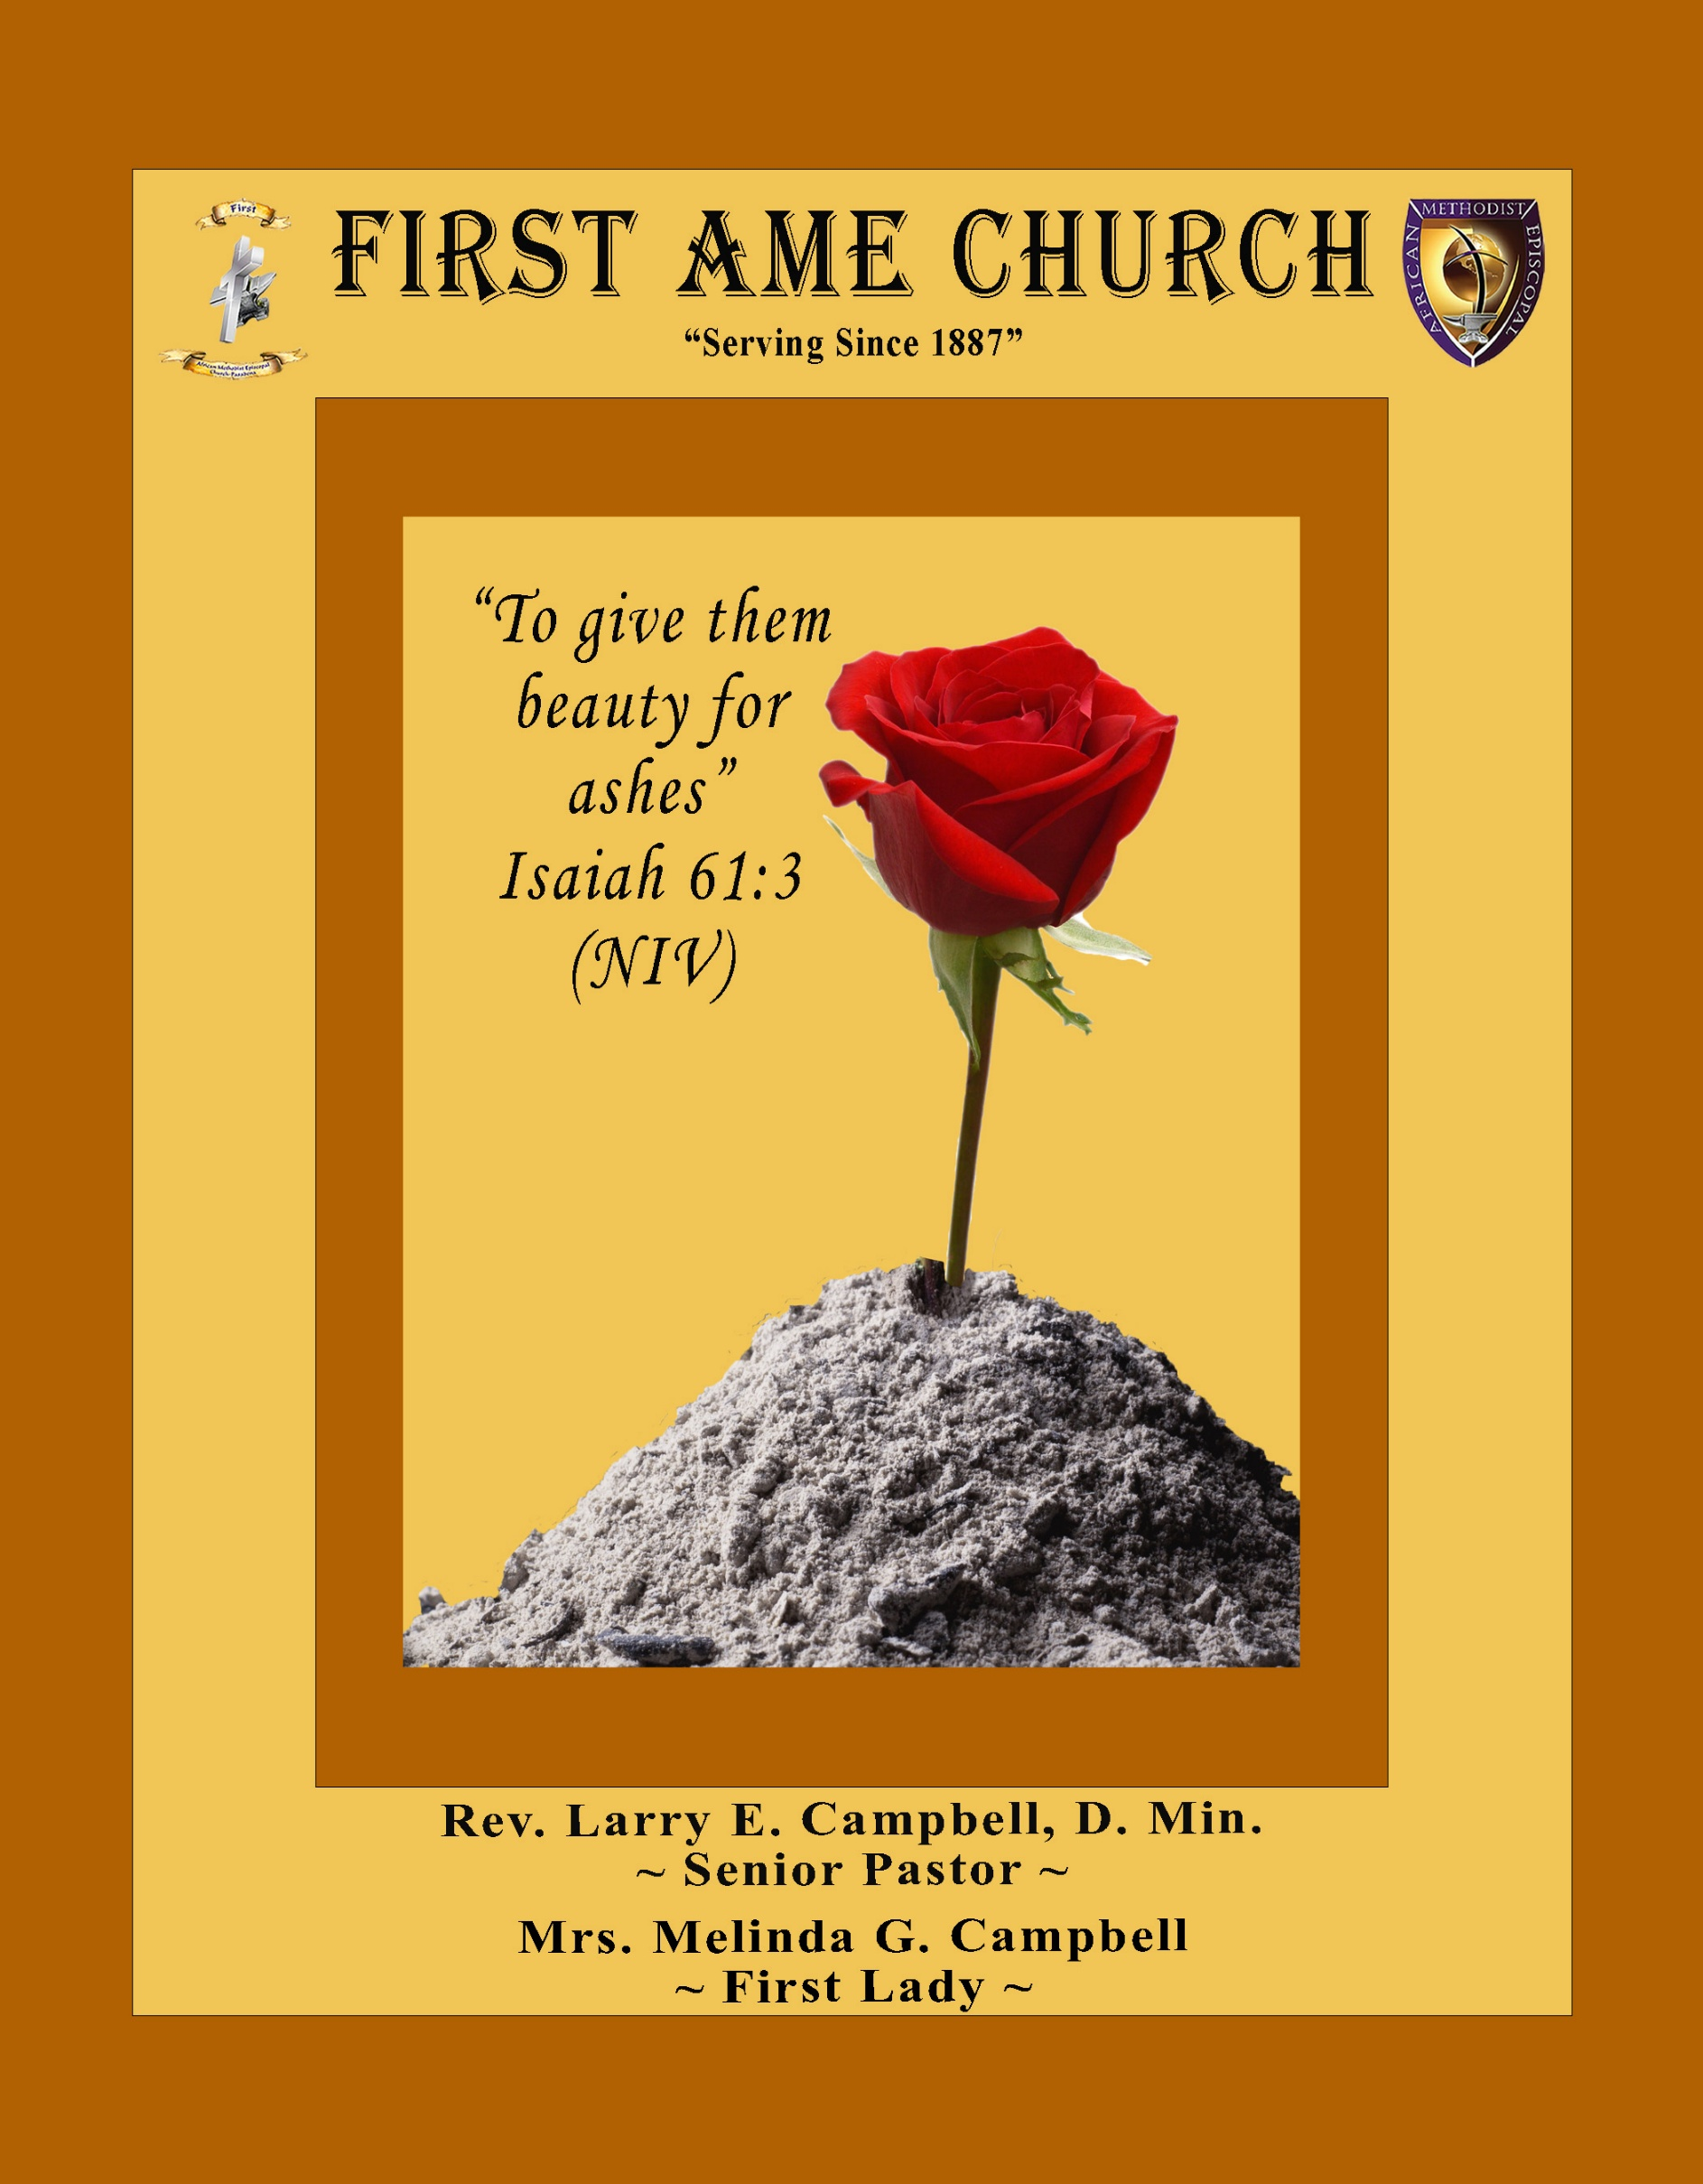
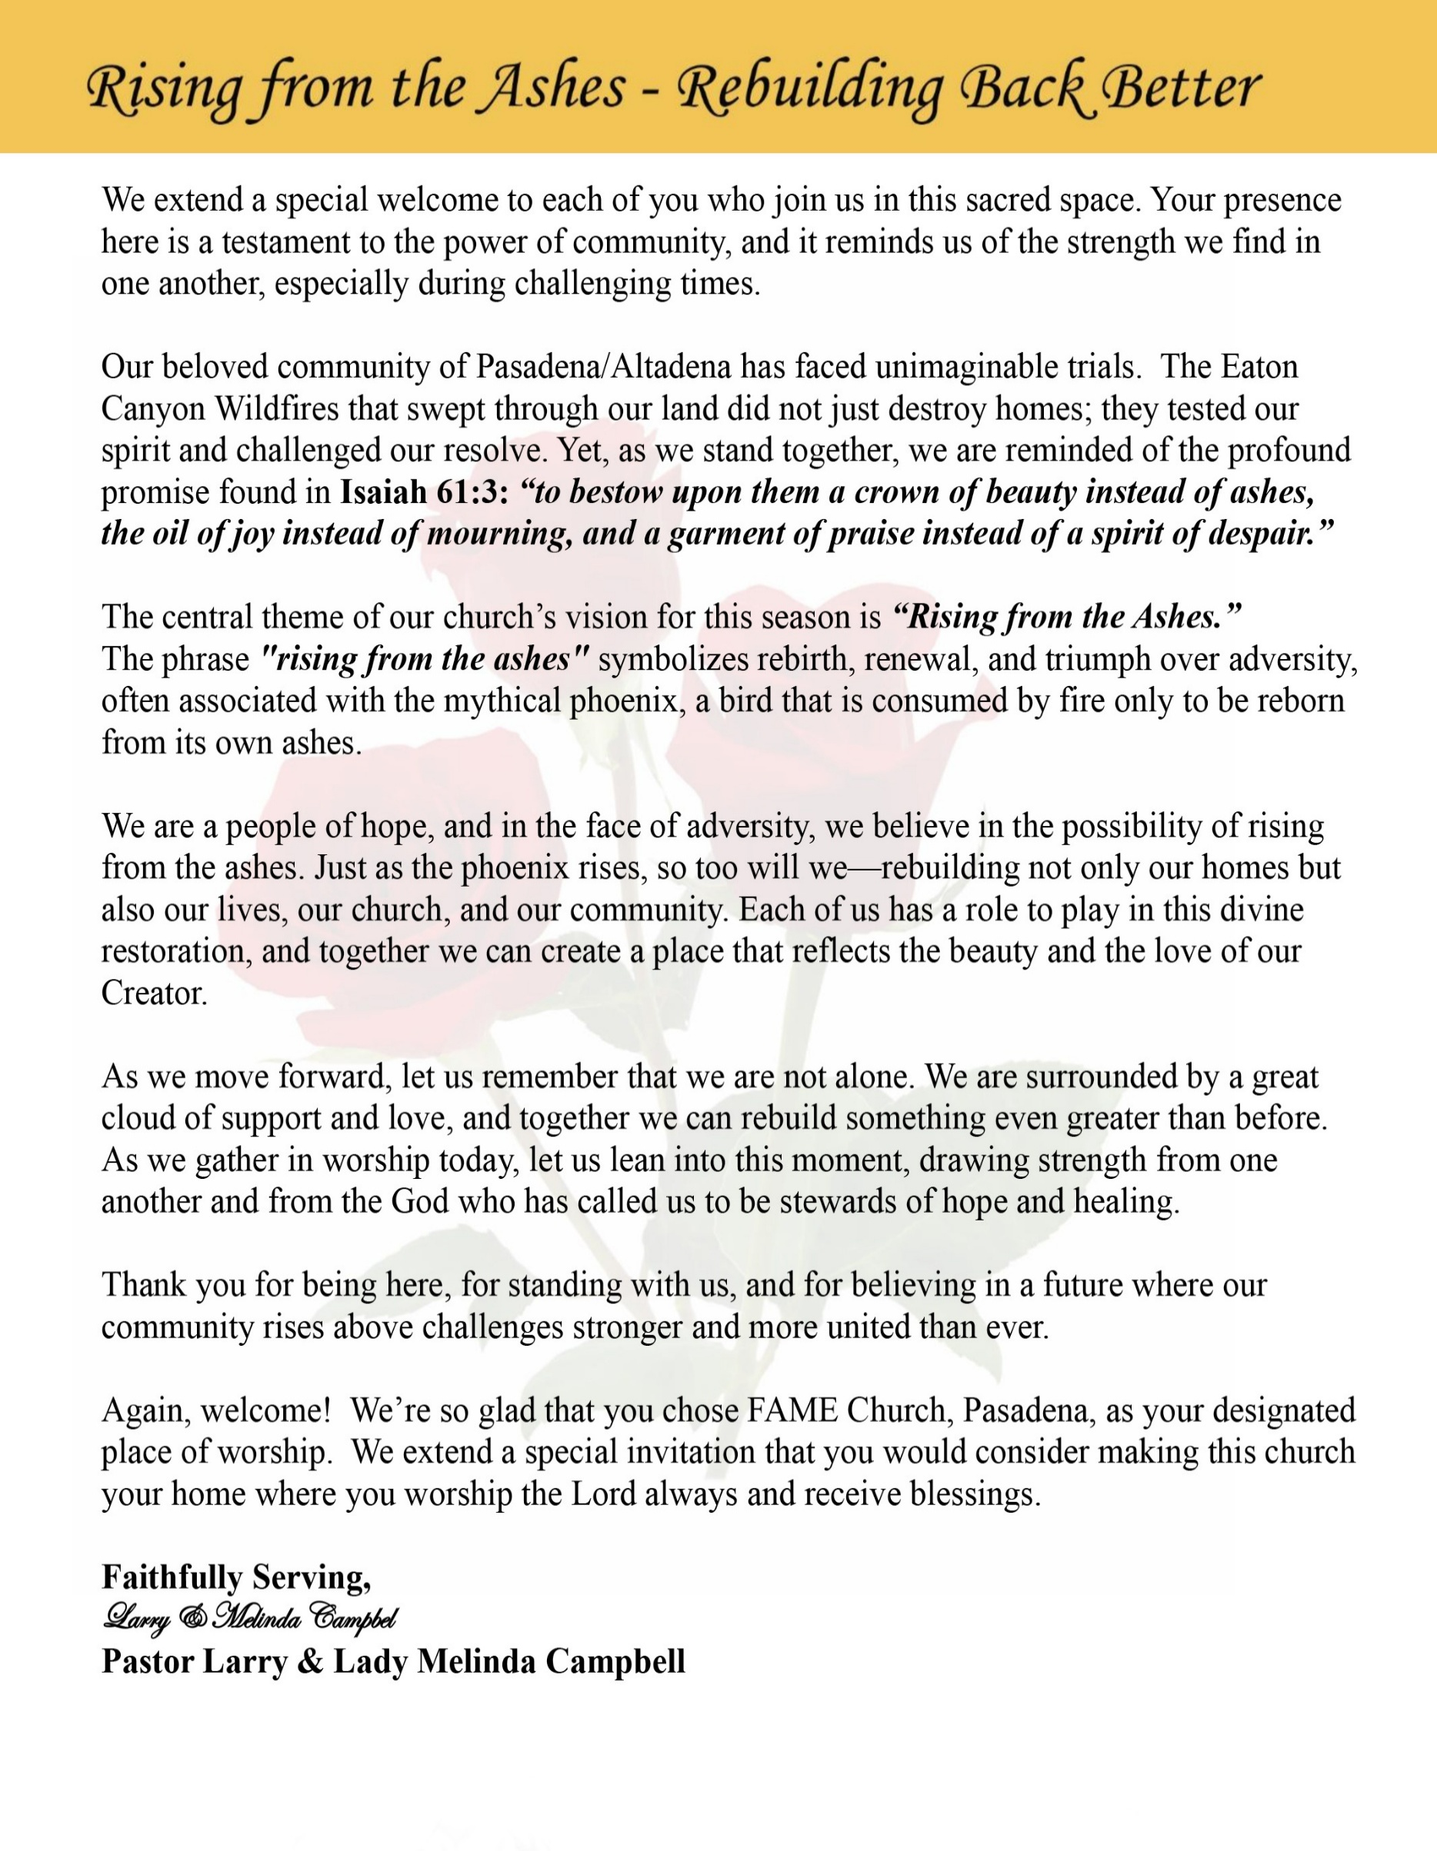

Sunday, December 7, 2025 | 9:30 a.m.

Rt. Rev. Francine A. Brookins, Esq., Presiding Bishop
Rev. Miriam Burnett, MD, MPH, Supervisor of Missions
Rev. Roosevelt Lindsey, Jr. Presiding Elder

The Rev. Dr. Larry E. Campbell ~ Senior Pastor ~ Minister

Mobile: (951) 587-1894 ~ Email: larrycampbell@famepasadena.org

Our First Lady: Mrs. Melinda G. Campbell

The Reverend Dr. Jennifer Oliver ~ Itinerant Elder -
The Reverend Dr. Nikia Smith-Robert ~ Itinerant Elder (Affiliated)
The Reverend Lois Woodard ~ Itinerant Elder Superannuated (Retired)
The Reverend Rochelle Wright Moore ~ Itinerant Deacon
The Reverend Deborah West-Jones ~ Local Elder
The Reverend Philis J. Griffin, MDiv ~ Local Elder
Dr. Phyllis Beech ~ Evangelist
The Reverend Van E. White ~ Executive Assistant
Community Resource Center Director ~ Ms. Kischchen Hazelton Venerable
Church Administrative Assistant: Ms. Letha Rhymes

Church Office Hours:
Tue, Wed 9:00am - 5:00pm, Thurs 9:00am - 3:00pm & 4:00pm - 7:30pm, Fri 9:00am -3:00pm.
Closed for Lunch Daily: 12:00pm - 1:00pm.

Music Ministry
Dr. Timothy Davis, Minister of Music
Bro. Jimmy Watlington, Percussionist ~ Bro. Carlos Caldwell, Organist
Bro. Darien Dorsey, Keyboardist
Sis. Karen Law, Women’s Chorus Director ~ Sis. Tonia Graham, Children’s Choir Director
Bro. J. Renard Washington, New Generation’s Choir

FREE WI-FI service is available on the FAME Campus by accessing FAME 1700
Password: 6267980503

-3-

~ Order of Worship Experience ~



&
Holy Communion Sunday

~ Altar Call ~
Praise & Worship
Doxology: “Praise God From Whom All Blessings Flow”

The Call to Worship Bro. Rodney D. and Sis. Donnetha Wallace

Leader: Today is the second Sunday of Advent. We open our hearts to Your peace.

People: Lord, in a world full of trouble, we seek Your peace.

Leader: When life feels chaotic and worries surround us, remind us that Your peace is
Deeper than our fear.

People: Calm our minds, O God. Soothe our spirits.

Leader: You have stilled storms before. You can calm us now.

People: Help us rest in Your presence. Help us share Your peace with others.

Leader: We join with God in becoming instruments of peace, in defending the cause
of the poor of the people, in giving deliverance to the needy, and to crush the
oppressive forces – within and without.

Light two purple candles.

ALL: We light a candle of peace, affirming that we, too, will not hurt or destroy
on God’s holy mountain. The God of peace be with us, and work in us.
Amen.

-4-

The Hymn of Praise A.M.E. Hymnal #112

Jesus, the Light of the World
(We’ll Walk in the Light)

Hark! The herald angels sing,
Jesus, the Light of the world;
Glory to the newborn King,
Jesus the Light of the world.

Refrain
We’ll walk in the light, beautiful light,
Come where the dewdrops of mercy are bright,
Shine all around us by day and by night,
Jesus, the Light of the world

Joyful, all ye nations, rise,
Jesus the Light of the world;
Join the triumph of the skies,
Jesus the Light of the world.

Refrain

Christ, by highest heaven adored,
Jesus the Light of the world;
Christ, the everlasting Lord!
Jesus, the Light of the world.

Refrain

Hail the heaven-born Price of Peace!
Jesus, the Light of the world;
Hail the Sun of Righteousness!
Jesus, the Light of the world.

Refrain

The Invocation The Reverend Dr. Nikia Smith-Robert

Ministry of Music The Mass Choir

-5-

Scripture Lesson The Reverend Rochelle Wright-Moore
(Please Stand for the Reading of God’s Words)

Mark 8:31-38 (New International Version) — Take Up Your Cross
³¹ He then began to teach them that the Son of Man must suffer many things and be rejected by the elders, the chief priests and the teachers of the law, and that he must be killed and after three days rise again. ³² He spoke plainly about this, and Peter took him aside and began to rebuke him.
³³ But when Jesus turned and looked at his disciples, he rebuked Peter. “Get behind me, Satan!” he said. “You do not have in mind the concerns of God, but merely human concerns.”
The Way of the Cross
³⁴ Then he called the crowd to him along with his disciples and said: “Whoever wants to be my disciple must deny themselves and take up their cross and follow me. ³⁵ For whoever wants to save their life will lose it, but whoever loses their life for me and for the gospel will save it. ³⁶ What good is it for someone to gain the whole world, yet forfeit their soul? ³⁷ Or what can anyone give in exchange for their soul? ³⁸ If anyone is ashamed of me and my words in this adulterous and sinful generation, the Son of Man will be ashamed of them when he comes in his Father’s glory with the holy angels.”

The AFFIRMATION OF FAITH (The Apostle Creed) Evangelist Phyllis Beech
Minister: What do you believe?

People: I believe in God the Father Almighty, Maker of heaven and earth, and in Jesus
Christ His only son our Lord who was conceived by the Holy Spirit, born of the Virgin Mary, suffered under Pontius Pilate, was crucified, dead and buried. The third day He arose from the dead; he ascended into heaven and sitteth at the right hand of God the Father Almighty; from thence he shall come to judge the quick and the dead. I believe in the Holy Spirit, the Church Universal, the communion of saints, the forgiveness of sins, the resurrection of the body and the life everlasting. Amen.

-6-

THE PRELUDE TO THE DECALOGUE The Reverend Deborah West-Jones

“From all that dwell below the skies, Let the Creator’s praise arise;
Let the Redeemer’s name be sung. Through every land, by every tongue.”

THE DECALOGUE (An Affirmation of God’s Law)

Minister: Let us express our commitment to keep God’s Law

People: God of our salvation, only You are God.
We will make no idols.
We will not invoke with malice your name, O God.
We will remember the Sabbath Day and keep it holy.
We will honor our father and our mother.
We will not commit murder.
We will not commit adultery.
We will not steal.
We will not be a false witness.
We will not covet anything that belongs to our neighbor.
Minister: Jesus said: “You shall love the Lord your God with all your heart, and with all your soul and with all your mind. This is the great and first commandment.”

ALL: Jesus also challenged us to love justly with a second commandment which is
like the first. We shall love our neighbor as ourselves! On these
commandments depend all the law and the prophets.

THE GLORIA PATRI
Glory be to the Father, and to the Son, and to the Holy Ghost.
As it was in the beginning, is now and ever shall be, world without end. Amen Amen!!

Abbreviated Announcements/Visitor’s Welcome

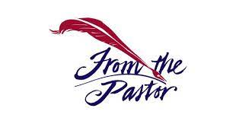

-7-

Tithing Litany – Second Sunday of Advent Kischchen Hazelton Venerable, Steward
Leader: This is the Second Sunday of Advent, the Sunday of Peace. As we prepare to
give, we rest in the peace only Christ can give.

People: We give today with peaceful hearts, trusting God’s care.

Leader: In a world filled with noise, stress, and uncertainty, God’s peace guards our minds
and calms our spirits.

People: The Lord is our peace. We give without fear or anxiety.

Leader: As Christ came to bring peace on earth, we give so His peace may flow through
this ministry, this community, and our homes.

People: Use our gifts, Lord, to spread Your peace.

Leader: When life feels shaken, God’s peace holds us steady. When resources feel thin,
God’s peace reminds us that He is our provider.

People: We trust in the God who supplies all our needs.

Leader: Let the peace of Christ rule in our hearts as we present our tithes and offerings.

People: We give in peace, with peace, and for peace.

Unison: Prince of Peace, bless these gifts. Let them build Your kingdom, heal Your
people, and strengthen this house. Amen.

The Offertory (Tithes ~ Gifts ~ Benevolent Offerings)

The following Electronic GIVING Platforms are creditable methods to GIVE to FAME:

#1. GIVELIFY - Mobile Giving App available on the App Store. It’s easy to set up, just follow the guidelines.

#2. Cash App: $FirstAMEPASADENA

#3. Mail in your Tithes & Offering - If you would like to mail your tithes and offering by check or money order, please send it to: First AME Church, 1700 N. Raymond Avenue, Pasadena, CA 91103.

#4. Drop off your Tithes & Offering - During business hours in the basket outside of the office.

Choral Response: “All things come of Thee, O Lord; and of Thine own have we given Thee. Amen.”

Sermonic Selection The Mass Choir

Proclamation of The Word: Pastor Larry E. Campbell

The Invitation (Public/Private)

-8-

The Sacrament of the Lord’s Supper or Holy Communion

THE SOLICITATION

You that do truly and earnestly repent of your sins, and are in love and charity with your neighbor, and intend to lead a new life, following the commandments of God, and walking from henceforth in His holy ways, draw near with faith and take this holy sacrament to your comfort; and make your humble confession to Almighty God.

THE GENERAL CONFESSION

Minister: Let us humbly confess our sins unto Almighty God.

Minister and People:

Almighty God, Father of our Lord Jesus Christ, Maker of all things, Judge of all men, we acknowledge and bewail our manifold sins and wickedness which we from time to time most grievously have committed by thought, word, and deed against Your divine Majesty, provoking most justly Your wrath and indignation against us. We do earnestly repent and are heartily sorry for these our misdoings; the remembrance of them is grievous unto us. Have mercy upon us, have mercy upon us, most merciful Father for Your Son our Lord Jesus Christ’s sake; forgive us all that is past, and grant that we may ever hereafter serve and please You in newness of life, to the honor and glory of Your name through Jesus Christ our Lord.

Amen. (Choral). (You may be seated).

THE PRAYER OF PARDON

Almighty God, our Heavenly Father, who of Your great mercy has promised forgiveness of sins to all them that with hearty repentance and true faith turn unto You, have mercy upon us; pardon and deliver us from all our sins; confirm and strengthen us in all goodness; and bring us to everlasting life through Jesus Christ, our Lord.

Choral Response: Amen.

THE PRAYER OF CONSECRATION

Minister: Almighty God, our Heavenly Father, who for your tender mercy did give your only Son, Jesus Christ, to suffer death on the cross for our redemption, who made thereby his own oblation of himself, once offered; a full, perfect and sufficient sacrifice, oblation, and satisfaction for the sins of the whole world; and did institute and in his holy gospel command us to continue a perpetual memory of that, his precious death, until his coming again.

Hear us, O merciful Father, we most humbly beseech you, and grant that receiving these your creatures of bread and wine, according to your Son, our Savior Jesus Christ’s holy institution, in remembrance of his death and passion, may be partakers of his most blessed body and blood: who in the same night that He was betrayed took bread and when He had given thanks, He broke it, and gave it to His disciples, and saying, “Take, eat: This is My body which is given for you. This do in remembrance of Me.” Likewise, after the supper, He took the cup; and when He had given thanks, He gave it to them and said, “Drink this, all of you; for this is My blood of the New Testament, which is shed for you and many for the remission of sins. Do this, as often as you drink it, in remembrance of Me.”

THE LORD’S PRAYER (ALL)

THE ELEMENTS SHARED

-9-

ANNOUNCEMENTS

BEREAVEMENT NOTIFICATION
It is with heavy hearts that we announce the passing of Sister Frances Caple, the beloved wife of Bro. Fred Caple, dear sister of Sis. Charlotte Searcy, and valued senior member of the FAME Church Family. Sister Caple passed away on Monday, November 17, 2025.
Sister Caple was a long-standing and respected part of our community, known for her dedication and service. Her legacy will be remembered fondly by all who knew her. A memorial service honoring her life will be held at FAME Pasadena on Saturday, December 20, 2025 | 11:00 a.m. Our prayers and condolences go out to the Caple Family during this difficult time.

Tis The Season ~ Children’s Christmas Program
Christmas is less than three weeks away. Casting and rehearsals for the Children/Youth Christmas program have started during Children’s Church. There are roles for ages ranging from talking toddlers to college students. We will have all types of roles, and we also want our young musicians (singers, praise dancers, pianists, etc.) to showcase their gifts!
If your child would like to participate, but can’t make it to Children’s Church, please contact Mrs. Monique Sims at (626) 319-8489 or Thesimsteam1@gmail.com.

The Children’s Christmas Program is scheduled for Sunday, December 21, 2025, and is a part of the Worship Service, starting at 9:30.

20/20 (14.0)
The 20/20 initiative is a Church-wide fundraising project managed by the Stewards. This project was established to assist with our Annual Connectional Budget. Financial gifts donated through the 20/20 initiative are added to our collected conference claims and assist greatly in meeting the first and second half of our Connectional Budgetary obligations. The Steward Board is requesting 150 participants for the conference year 2025-2026. The first half of our budget is due in February 2026. In addition to the 18 officers and we are asking STARTING TODAY 132 people to give 20 dollars per week for 20 weeks in addition to your regular tithes, gifts and offerings. Please mark your envelopes 20/20 and allocate $20.00. Our goal is to raise $60,000. Again, this will satisfy all budgetary needs on the conference level without utilizing any operational funds. Please see or contact any Steward to participate; we are looking forward to your commitment.

Steward Board Meeting
Tuesday, December 9, 2025 | 7:00 p.m.

Virtual Church Conference
(Pastor’s Planning Meeting)

Time: Dec 10, 2025 07:00 PM Pacific Time (US and Canada)
Join Zoom Meeting
https://us02web.zoom.us/j/83559112293?pwd=GdA2luoqrTFTUqRZjLdJnURaa563lz.1
Meeting ID: 835 5911 2293 | Passcode: 922824
One tap mobile: +16699006833,,83559112293#,,,,*922824# US (San Jose)

-10-

ANNOUNCEMENTS (Continued)

AFRICAN METHODIST EPISCOPAL CHURCH
FIFTH EPISCOPAL DISTRICT
SOUTHERN CALIFORNIA ANNUAL CONFERENCE
LAY ORGANIZATION
WINTER WONDERLAND
LAY AWARDS & SILENT AUCTION
SATURDAY, DECEMBER 13, 2025
Carson Event Center, 11:00 AM - 2:00 PM
Tickets $80.00
No tickets will be sold at the door. Final date to purchase tickets Friday, December 5, 2025
For more information, email scclayorganization5@gmail.com

Annual Church Christmas Party
Immediately after Worship Service
Sunday, December 14, 2025
Thelma Blake Fellowship Hall

Trustee Board Meeting
Tuesday, December 16, 2025 | 5:30 p.m.

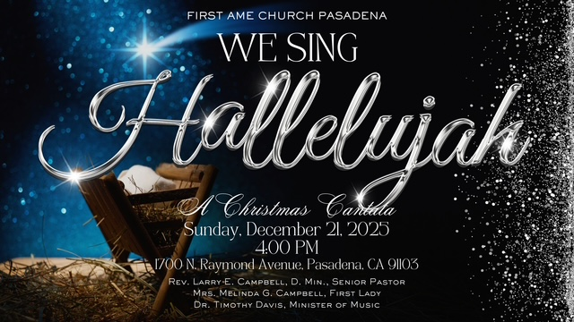

Mark Your Calendars
Annual Christmas Cantata
Sunday, December 21, 2025 | 4:00 p.m.

-11-

Scripture of the Day
The Cross. “Then Jesus told his disciples, “If anyone would come after me, let him deny himself and take up his cross and follow me.” Matthew 16:24

Quote of the Day
“Christians must lean on the Cross of Christ just as travelers lean on a staff when they begin a long journey” — St. Anthony of Padua;

Thought of the Week
“If anyone would come after Me, let him deny himself, take up his cross daily, and follow Me.” — Luke 9:23
Carrying your cross is not about suffering for suffering’s sake. It is about surrender—choosing God’s will over your own, even when it costs something. Jesus carried His cross out of love, and He invites us to follow Him with that same love, courage, and obedience.
Your cross may be a burden you didn’t choose, a season you didn’t plan, or a calling that stretches you beyond comfort. Yet Jesus says, “Take it up daily”—not as a punishment, but as a pathway to purpose. Every time you lift that cross, grace meets you. Strength rises in you. Christ walks with you.
The cross you carry today is shaping the crown you will wear tomorrow.
The weight you feel is producing the witness you will share.
And as you carry your cross, remember: you never carry it alone.

Humor of the Week
When a wealthy husband passed, he left $30,000 for an “elaborate funeral.”
After the service, a friend asked where all the money went. The widow explained:
“$6,500 for the funeral, $500 to the church, $500 for the wake… and the rest went toward the memorial stone.”
Her friend gasped, “The memorial stone cost $22,500?! My God, how big is it?”
The widow smiled and said,
“About four and a half carats.”

HOME DAILY BIBLE READINGS
December 8, 2025 – December 14, 2025 (Week 12, Nehemiah)
Monday Day 78 Judges 16-18, Psalm 35:7-10
Tuesday Day 79 Judges 19-21, Psalm 35:11-16
Wednesday Day 80 Ruth, Psalm 35:17-21
Thursday Day 81 1 Samuel 1-3, Psalm 35:22-28
Friday Day 82 1 Samuel 4-8, Psalm 36:1-4
Saturday Day 83 1 Samuel 9-12, Psalm 36:7-12
Sunday Day 84 1 Samuel 13-14, Psalm 37:1-4

-12-

Prayer Request(s)
Please notify the Church Office of Sick & Shut-in additions, deletions, or status/address changes.

Bishop Francine A. Brookins, Esq. Supervisor Miriam Burnett, MD
Presiding Elder Roosevelt & Dr. Kaye Lindsey Rev. Dr. Larry & Melinda Campbell
Richard Craig Hazel Clark Erica Woodard Jason Shirley Joshua Shirley Julian Shirley Ayanna Terry Cheryl Jamerson Gwendolyn Flowers Andrea Anderson Ocilda Files Danielle Clark Donita Towler Rev. Charles Brooks Doris Bailey Kimberly Woods Cynithia Grace Zechariah Robinson Diane Jordan Teresa Thompson Raymond Morrison Glen Scott Victoria Moore Mary Glizer Christopher McCarthy Wilma Haynes Jewell Malloy Calle Burns Noel Johnson Brittney Petty Taylor Family Deborah Burton Nettie McChristen Jacquelyn Walker Selene Cox Thomas Scotton
Rev. Rochelle Moore Lorene Butler Stella Pulliam Colette Blizzard Carita Smith Joyce Johnson The Eaton Canyon Fire Victims The Caple Family Cheryl Jameson Andrew Oliver Barbara McPheeter

College Students

Let’s continue to support and pray for our beloved College Students

Isaiah Crowell Alecia Davis Ahmad Harris Jade Williams Chase Johnson Grant Blizzard

Tyler Johnson Richard Jones Tyrikk Lawson Makia Rose Talbert Isaiah Ringo Journey Rogers Elyse Sharp Kylee Sharp Zion Otano Elise Tervalon Grace Jones Jordan Patterson Kimberly Robinson Donovan Williams Jasmine Collins Brandon Bates Gabriel Blizzard

Sick and Shut-Ins
Bettina Ayers Pasadena Meadows Nursing Home, 150 Bellefontaine St., Pas., CA 91105
Bobby Thomas 1052 E. Morada Place, Altadena, CA 91001
Carrie Wynne Senior Living Heritage, 161 N. Hemet St., Hemet, CA 92545
Doris Curd 11619 Woodcock Avenue, San Fernando, CA 91340
Edmund Riddle Active Care Mission Bay, 2440 Grand Avenue, San Diego, CA 92109
Eleanor Towler 975 E. Union Street, Unit #417, Pasadena, CA 91106
Elois Blizzard P. O. Box 3646, So. Pasadena, CA 91031
Emily Cormier-Ross 2549 La Fiesta Avenue, Altadena, CA 91001
Ernestine English 26 W. Fair Oaks Drive, Pasadena, CA 91103
Frederick Smith 1055 N. Vignes St., Los Angeles, CA 90012
Fred Caple 5549 Hamill Ave, San Diego, CA 92120
Gloria Cubit Clay 11745 Pierce St., Lake View Terrace, CA 91342
Hugh Hamberry 2518 N. Marengo Avenue, Altadena, CA 91001
Jackie Johnson 641 W. Mariposa, Altadena, CA 91101
Josephine Brown 15607 Saddleback Rd, Riverside, CA 92506
Jessie Smith 7980 Mayten Avenue, Apt 3050 Rancho Cucamonga, CA 91730-8113
Linnie G. Nollie 2250 E. New York Drive, Altadena, CA 91001
Malika G. Hendry P. O. Box 94082, Pasadena, CA 91109
Mildred Lewis C/O Hazel Rohr, 884 W. Jane Court, Upland, CA 91786
Norma Burnett 618 Fairview Avenue, Unit #228, Arcadia, CA 91007
Opal Hampton 1030 Chevron Court, Pasadena, CA 91103
Paul Ratliff 1015 E. Athens St. Altadena, CA 91001
Ruthie Hopkins 1155 Via Verde , San Dimas, CA 91773
Virlyn Grant 15122 Orange Ave., Paramount, CA 90723
Wanda Nelson 3618 N. Fair Oaks Avenue, Altadena, CA 91001
William Hilliard 313 E. Loma Alta Dr. Altadena, CA 91001
Zell L. Hill 375 Barthe Drive, Pasadena, CA 91103

-13-

Sermon Notations

Scripture: _____________________________________________________________

Subject: _______________________________________________________________

Points of the Message: ___________________________________________________
_______________________________________________________________________
_______________________________________________________________________
_______________________________________________________________________
_______________________________________________________________________
_______________________________________________________________________
_______________________________________________________________________

Main Ideas of the Sermon: ________________________________________________
_______________________________________________________________________
_______________________________________________________________________
_______________________________________________________________________
_______________________________________________________________________
_______________________________________________________________________

Illustrations I want to remember: _________________________________________
_______________________________________________________________________
_______________________________________________________________________
_______________________________________________________________________
_______________________________________________________________________
_______________________________________________________________________
_______________________________________________________________________

What should I do as a result of this Sermon? ________________________________

_____________________________________________________
_____________________________________________________
_____________________________________________________
_____________________________________________________

-14-

