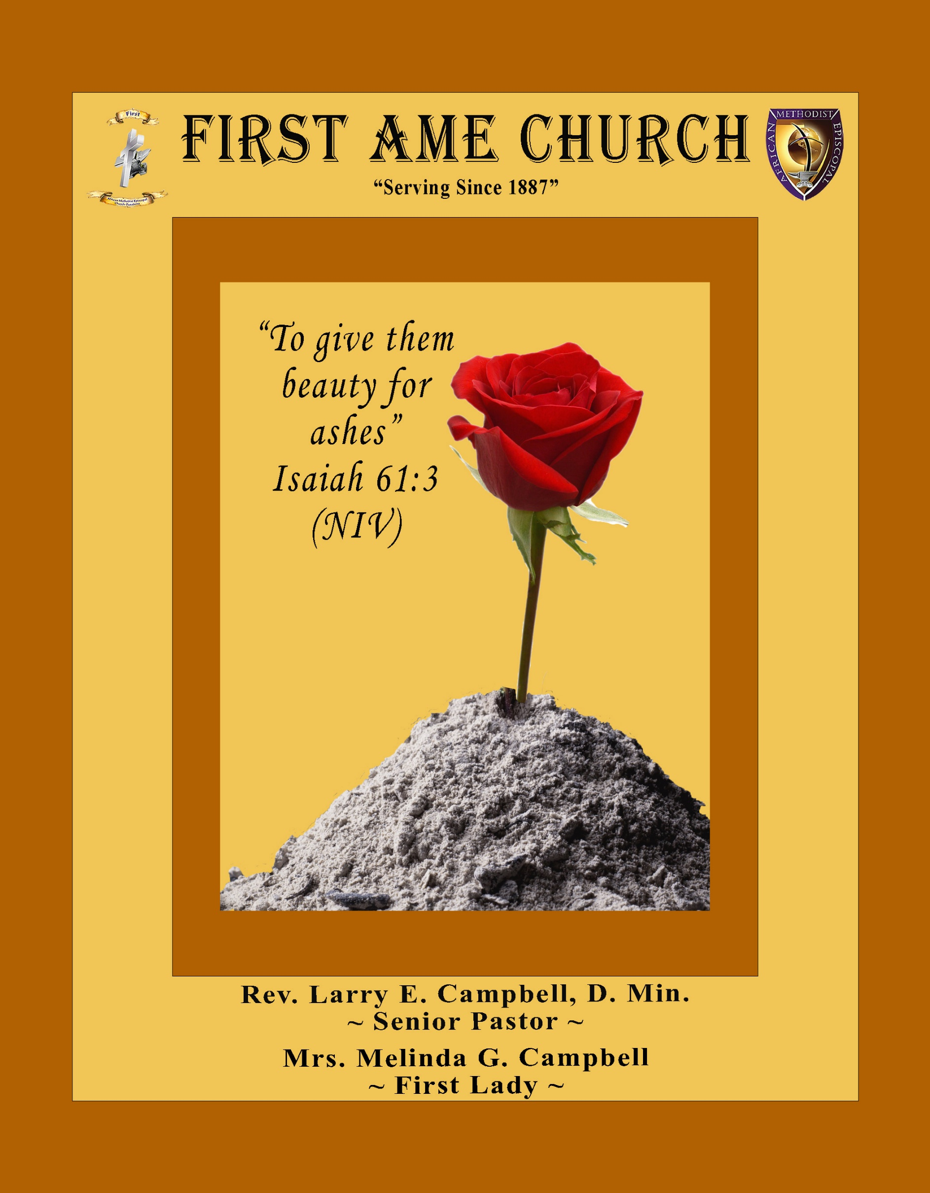
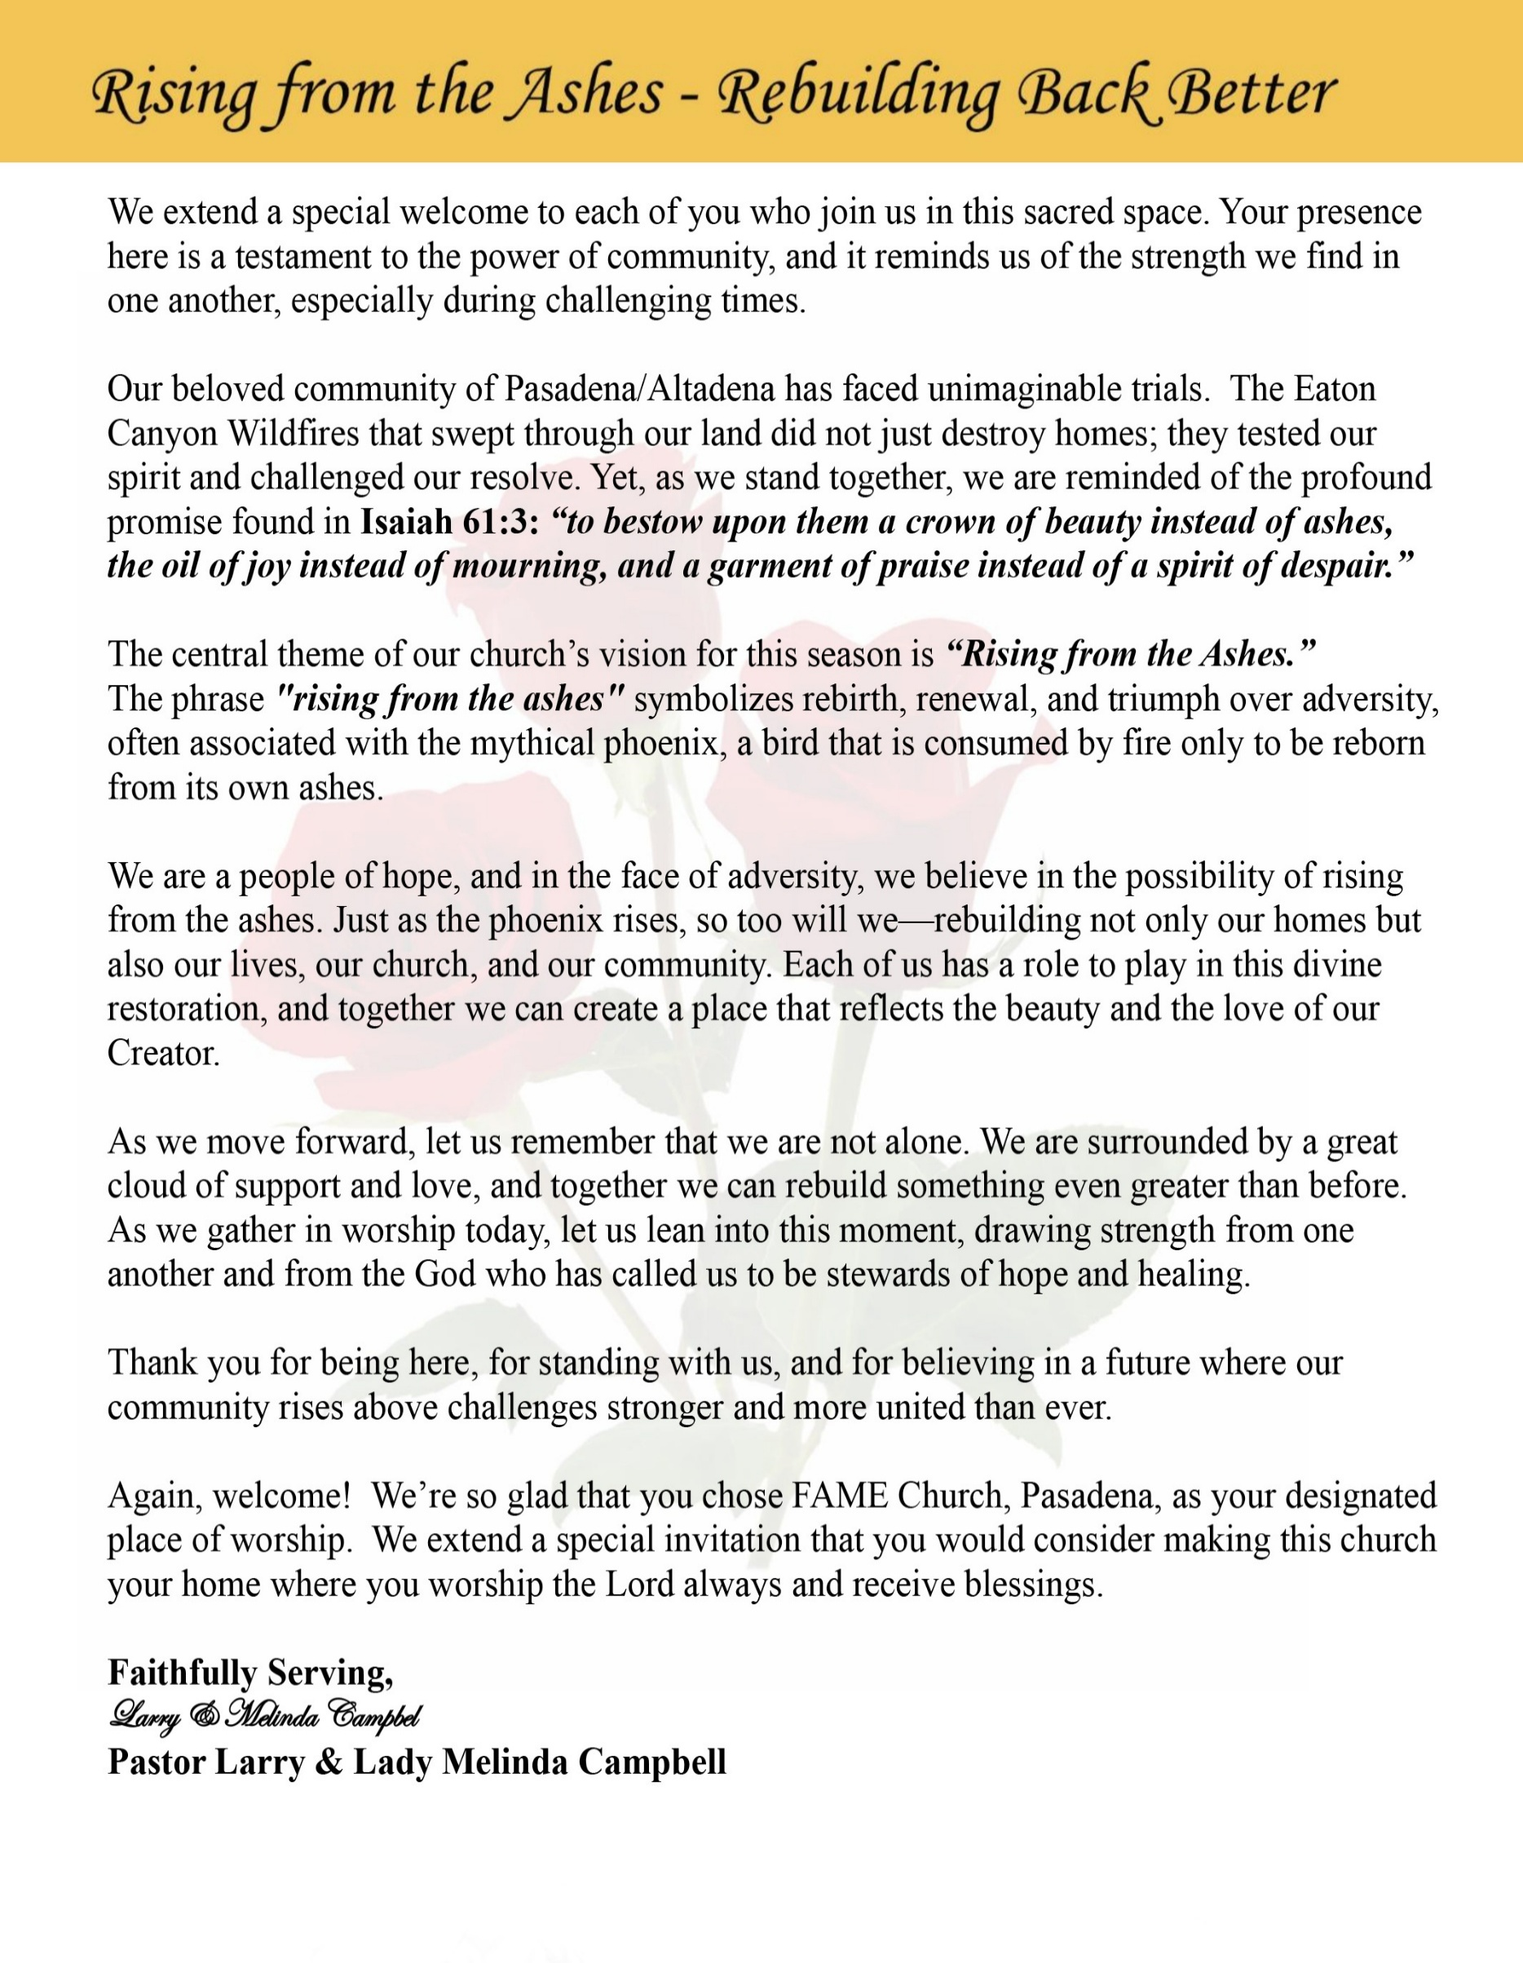

Sunday, December 28, 2025 | 9:30 a.m.

Rt. Rev. Francine A. Brookins, Esq., Presiding Bishop
Rev. Miriam Burnett, MD, MPH, Supervisor of Missions
Rev. Roosevelt Lindsey, Jr., Presiding Elder

The Rev. Dr. Larry E. Campbell ~ Senior Pastor ~ Minister

Mobile: (951) 587-1894 ~ Email: larrycampbell@famepasadena.org

Our First Lady: Mrs. Melinda G. Campbell

The Reverend Dr. Jennifer Oliver ~ Itinerant Elder -
The Reverend Dr. Nikia Smith-Robert ~ Itinerant Elder (Affiliated)
The Reverend Lois Woodard ~ Itinerant Elder Superannuated (Retired)
The Reverend Rochelle Wright Moore ~ Itinerant Deacon
The Reverend Deborah West-Jones ~ Local Elder
The Reverend Philis J. Griffin, MDiv ~ Local Elder
Dr. Phyllis Beech ~ Evangelist
The Reverend Van E. White ~ Executive Assistant
Community Resource Center Director ~ Ms. Kischchen Hazelton Venerable
Church Administrative Assistant: Ms. Letha Rhymes

Church Office Hours:
Tue, Wed 9:00am - 5:00pm, Thurs 9:00am - 3:00pm & 4:00pm - 7:30pm, Fri 9:00am -3:00pm.
Closed for Lunch Daily: 12:00pm - 1:00pm.

Music Ministry
Dr. Timothy Davis, Minister of Music
Bro. Jimmy Watlington, Percussionist ~ Bro. Carlos Caldwell, Organist
Bro. Darien Dorsey, Keyboardist
Sis. Karen Law, Women’s Chorus Director ~ Sis. Tonia Graham, Children’s Choir Director
Bro. J. Renard Washington, New Generation’s Choir

FREE WI-FI service is available on the FAME Campus by accessing FAME 1700
Password: 6267980503

-3-

~ Order of Worship Experience ~

Warning: This order of worship is subject to change without warning or prior notice --- everything is governed by the Sovereignty of the Holy Spirit

+The Altar Call +

Praise & Worship

Doxology: “Praise God From Whom All Blessings Flow”

Call to Worship (Theme: God with Us-Still Here) Bro. Brian K. Williams
Leader: After the songs have faded and the decorations come down, after the gifts are
opened and the days return to routine—

People: God is still with us.

Leader: When the manger scene is packed away, and the journey feels long and
uncertain—

People: God is still with us.

Leader: The prophet declared, “The virgin shall conceive and bear a son, and shall call his
name Emmanuel.” (Isaiah 7:14)

People: Emmanuel—God with us, still here!

Leader: In our waiting and working, in our joy and our weariness, in our questions and our
calling—
People: God is still with us.

Leader: Jesus has come not only for a season, but to abide with us always.

People: “Lo, I am with you always, even to the end of the age.” (Matthew 28:20)

Leader: Come now, people of God—let us worship the One who was born among us,
walks beside us and remains faithful to us.

Unison: We come to worship Emmanuel— God with us, still here!

-4-

The Hymn of Praise A.M.E. Hymnal #106

O Come, All Ye Faithful

Tune: John F. Wade, 1710-1786

O come, all ye faithful, joyful and triumphant,
O come ye, o come ye to Bethlehem;
Come and behold Him, born the King of angels:

Refrain
O come, let us adore Him, O come, let us adore Him,
O come, let us adore Him, Christ, the Lord!

Sing, choirs of angels, sing in exultation,
O sing, all ye bright hosts of heaven above!
Glory to God, all glory in the highest;
Refrain

Yea, Lord, we greet thee, born this happy morning,
Jesus, to Thee be all glory given;
Word of the Father, now in flesh appearing;
Refrain

The Invocation Bro. Olden (Bubba) Denham

Ministry of Music The Male Chorus

Scripture Lesson
(Please Stand for the Reading of God’s Words)
Old Testament Bro. Melvin Sharpe
Isaiah 41:8-10 (New International Version) — God with Us: Still Here
8“But you, Israel, my servant, Jacob, whom I have chosen,
you descendants of Abraham my friend,
9 I took you from the ends of the earth,
from its farthest corners I called you.
I said, ‘You are my servant’;
I have chosen you and have not rejected you.
10 So do not fear, for I am with you;
do not be dismayed, for I am your God.
I will strengthen you and help you;
I will uphold you with my righteous right hand.

-5-

New Testament (Responsive Reading) Bro. Henry Sharp
John 1:1-14 (New King James Version) — God with Us—Still Here
Leader: In the beginning was the Word, and the Word was with God, and the Word
was God. ² He was in the beginning with God.

People: ³ All things were made through Him, and without Him nothing was made that
was made. ⁴ In Him was life, and the life was the light of men. ⁵ And the light
shines in the darkness, and the darkness did not comprehend it.

Leader: ⁶ There was a man sent from God, whose name was John. ⁷ This man came for
a witness, to bear witness of the Light, that all through him might believe.

People: ⁸ He was not that Light, but was sent to bear witness of that Light. ⁹ That was
The true Light which gives light to every man coming into the world.

Leader: ¹⁰ He was in the world, and the world was made through Him, and the world did not
know Him. ¹¹ He came to His own, and His own did not receive Him.

Unison: ¹² But as many as received Him, to them He gave the right to become children
of God, to those who believe in His name: ¹³ who were born, not of blood, nor
of the will of the flesh, nor of the will of man, but of God. ¹⁴ And the
Word became flesh and dwelt among us, and we beheld His glory, the glory as
of the only begotten of the Father, full of grace and truth.

The Summary of the Decalogue Bro. Antyone Sims

LEADER: From all that dwell below the skies…
SUNG: From all that dwell below the skies, Let the Creator’s praise arise; Let the
Redeemer’s Name be sung, through every land, by every tongue.
LEADER: Hear what Christ our Savior saith, Thou shalt love the Lord thy God with all thy
heart, with all thy soul, and with all thy mind. This is the first and great
commandment. And the second is like unto it: Thou shalt love thy neighbor
as thyself. On these two commandments hang all the law and the prophets.
SUNG: Glory be to the Father, and to the Son, and to the Holy Ghost; as it was in
the beginning, is now, and ever shall be, world without end. A~Men

-6-

Abbreviated Announcements/Visitor’s Welcome Bro. Dr. Brian K. Venerable

Congregational (Sing along) Hymn AME Hymnal #122
“Go, Tell It on the Mountain”

The Offertory — (Tithes/Gifts/Benevolent Offerings) Bro. Kenneth Caudle

Tithes and Offering Litany (Theme: God With Us — Still Here)
Leader: As we prepare to return to God a portion of what God has entrusted to us, we
remember that the same God who met us in the manger still walks with us every
day.

People: God is with us—still here.

Leader: When resources seemed scarce and the way uncertain, the Lord did not leave us
without provision.

People: God is with us—still here.

Leader: The Scripture declares, “The silver is mine, and the gold is mine, saith the Lord of
hosts.” (Haggai 2:8)

People: Everything we have belongs to God—still here.

Leader: We give not because we have excess, but because we trust the One who has
sustained us.

People: God is with us—still here.

Leader: Through valleys and victories, through endings and new beginnings, God has
proven faithful.

People: God is with us—still here.

Leader: As the Magi brought gifts to honor the Christ Child, we bring our tithes and
Offerings to honor Christ living among us.

People: We give in faith, for God is with us—still here.

Leader: Let us give with grateful hearts, open hands, and expectant spirits.

Unison: We give because God is with us—still here!

-7-

The following Electronic GIVING Platforms are creditable methods to GIVE to FAME:

#1. GIVELIFY - Mobile Giving App available on the App Store. It’s easy to set up, just follow the guidelines.

#2. Cash App: $FirstAMEPASADENA

#3. Mail in your Tithes & Offering - If you would like to mail your tithes and offering by check or money order, please send it to: First AME Church, 1700 N. Raymond Avenue, Pasadena, CA 91103.

#4. Drop off your Tithes & Offering - During business hours in the basket outside of the office.

Choral Response: “All things come of Thee, O Lord; and of Thine own have we given Thee. Amen.”

Sermonic Selection The Male Chorus

Proclamation of The Word Bro. Christian Washington

The Invitation (Public/Private)

How to Join First A.M.E. Church of Pasadena
PROFESSION OF FAITH. If you have never been a member of any church, you may join by professing Jesus Christ as your personal Lord and Savior.

RENEWAL OF VOWS. If you have been a member of a church at one time, but have been in active, you may join by renewing your faith in Jesus Christ as Lord and Savior.

TRANSFER. If you are a member of another African Methodist Episcopal Church and you are in good standing, you may join by requesting that your membership be transferred to the First African Methodist Episcopal Church of Pasadena.

AFFILIATE MEMBER. Sometimes an individual has reasons for keeping /his/her membership in another church but would like to be an active member of First African Methodist Episcopal Church, too. This is possible as an affiliate member. __________________________________________________________________________________________

The Doxology

The Benediction

-8-

Scripture of the Day
God With — Still Here. ““So do not fear, for I am with you; do not be dismayed, for I am your God.” – Isaiah 41:10

Quote of the Day
“God, Who is everywhere, never leaves us. Yet He seems sometimes to be present, sometimes to be absent. If we do not know Him well, we do not realize that He may be more present to us when He is absent than when He is present.” ― Thomas Merton

Thought of the Week
“And surely I am with you always, to the very end of the age.” — Matthew 28:20b
There are moments when life feels quiet—too quiet.
Prayers seem unanswered - Strength feels low - Hope feels delayed.
And in those moments, the enemy whispers, “God has left you.”
But Advent reminds us of a deeper truth: God with us—still here.
God did not come to us in Jesus just to make a brief appearance.
Emmanuel was not a seasonal visit.
It was a declaration of permanence.
God is still here when the miracle hasn’t shown up yet.
Still here when grief lingers.
Still here when faith feels fragile.
The manger tells us God entered our world.
The cross tells us God stayed.
The resurrection tells us God remains.
You may feel overlooked, tired, or unsure—but your feelings are not facts.
The promise stands: “I will never leave you nor forsake you.”
God with us— Still walking— Still strengthening— Still loving.
And if God is still here, then hope is still alive.

Humor of the Week
The Butcher and Chicken:
There is a story about a lady that went to the butcher to buy a chicken for her family’s dinner. The butcher had but one chicken left. She asked him to weigh it and it was clear that it was on the small side. When she asked if he had another chicken, he said sure and took the chicken with him into the back room. A few minutes later he returned with the same chicken and laid it on the scale along with a little extra pressure from his thumb.
The lady was not overly impressed with this bird either, so she said, I’ll take both chickens.

HOME DAILY BIBLE READINGS
December 29, 2025 – January 4, 2026 (Week 15, Proverbs)
Monday Day 99 1 Kings 15-1, Psalm 40:9-13
Tuesday Day 100 1 Kings 18-20, Psalm 40:14-17
Wednesday Day 101 1 Kings 21-22, Psalm 41:1-6
Thursday Day 102 2 Kings 1-5, Psalm 41:7-13
Friday Day 103 2 Kings 6-11, Psalm 42:1-7
Saturday Day 104 2 Kings 12-14, Psalm 42:8-11
Sunday Day 105 2 Kings 15-17, Psalm 43

-9-

ANNOUNCEMENTS

BIBLE STUDY/PRAYER MEETING SESSIONS
Please note that ALL Weekly Bible Study Prayer Meeting Sessions are suspended on Wednesday, December 31^{st,} in observance of New Year’s Day. All Classes will resume on Wednesday, January 7, 2026

The FAME Community Resource Center
Holiday Hours (New Year's Day) 11:00 am – 3:00 pm
Lunch will be served on New Year's Day
12:00 p.m. to 3:00 p.m.
Everyone is Welcome!

20/20 (14.0)
The 20/20 initiative is a Church-wide fundraising project managed by the Stewards. This project was established to assist with our Annual Connectional Budget. Financial gifts donated through the 20/20 initiative are added to our collected conference claims and assist greatly in meeting the first and second half of our Connectional Budgetary obligations. The Steward Board is requesting 150 participants for the conference year 2025-2026. The first half of our budget is due in February 2026. In addition to the 18 officers and we are asking 132 people to give 20 dollars per week for 20 weeks in addition to your regular tithes, gifts and offerings. Please mark your envelopes 20/20 and allocate $20.00. Our goal is to raise $60,000. Again, this will satisfy all budgetary needs on the conference level without utilizing any operational funds. Please see or contact any Steward to participate; we are looking forward to your commitment.

Men's Ministry - BIBLE STUDY
Time: Tuesday, January 6, 2026 | 6:00 p.m.
Meeting ID: 894 7536 6487
Passcode: 465177
One tap mobile: +16699006833,,89475366487#,,,,*465177# US (San Jose)

Women's Ministry - BIBLE STUDY
Time: Tuesday, January 6, 2026 | 6:00 p.m.
Meeting ID: 857 0061 9461; Passcode: 933892
One tap mobile +16699006833,,85700619461#,,,,,,0#,,933892# US (San Jose)

Virtual Steward Board Meeting
Thursday, January 8, 2026 | 7:00 p.m.

Community Food Pantry
Friday, January 9, 2026 —9:00 a.m. to 11:00 a.m.

-10-
-

ANNOUNCEMENTS (Continued)

Special Sons of Allen Ministry – Men’s Breakfast
“Iron Sharpens Iron” (Proverbs 27:17)
All men of First AME Church, Pasadena are earnestly requested to attend a Special Sons of Allen Ministry Men’s Breakfast as we gather for fellowship, encouragement, and vision.
Saturday, January 10, 2026
9:00 a.m. – 11:00 a.m.
Location: [Church Fellowship Hall]
This gathering is being convened at the request of our Pastor, who is calling every man of FAME Pasadena to come together to plan and organize the Men’s Ministry for the Conference Year. As Scripture reminds us, “Iron sharpens iron, and one man sharpens another” (Proverbs 27:17). Together, we will strengthen one another through prayer, dialogue, and shared purpose.
Come ready to be sharpened, encouraged, and equipped as we build a Men’s Ministry that is strong in faith, unified in brotherhood, and committed to service.
Your presence strengthens the whole body.
Breakfast will be served.

Senior Ministry In-Person Gathering
Tuesday, January 13, 2026| 11:30 a.m.
Church Fellowship Hall

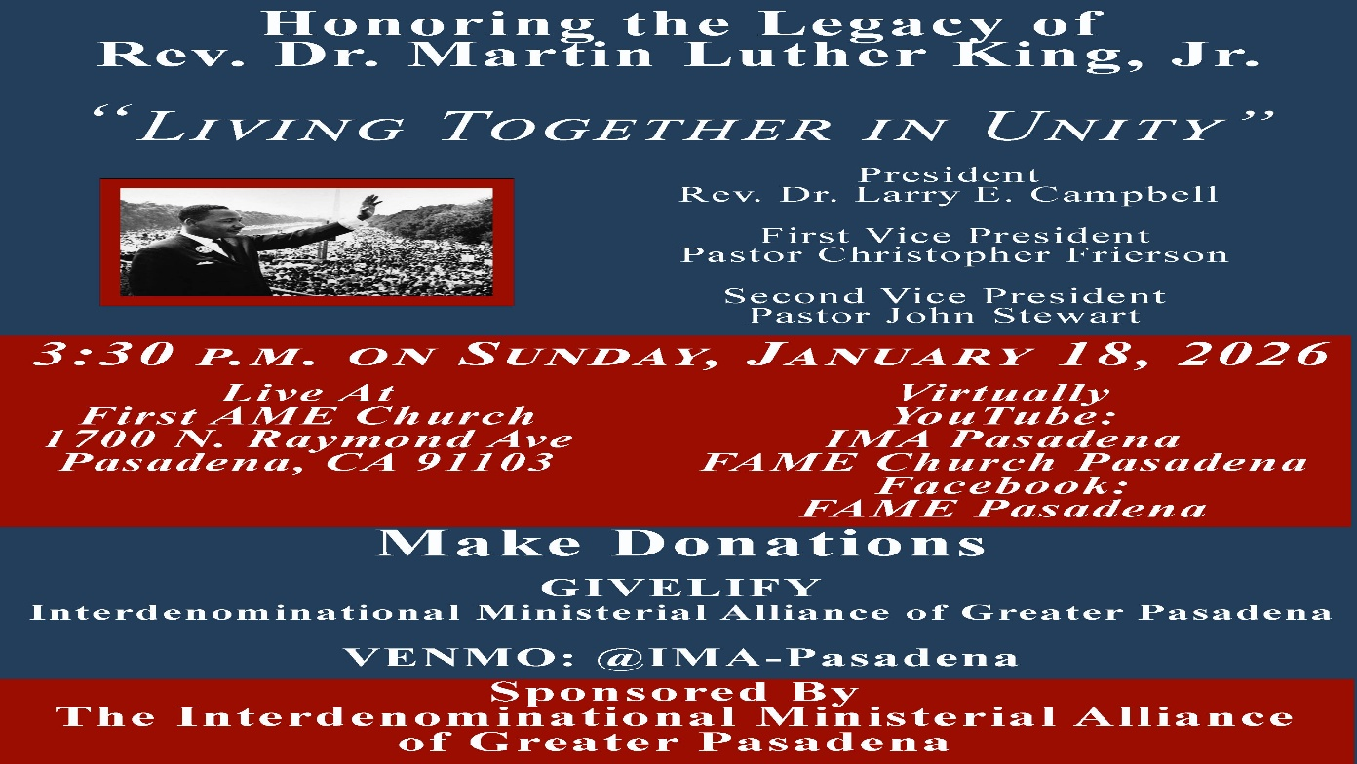

-11-

ANNOUNCEMENTS (Continued)

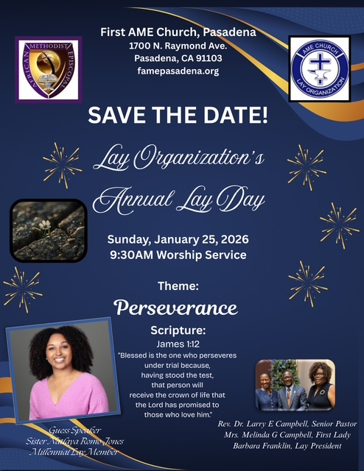

-12-

Prayer Request(s)
Please notify the Church Office of Sick & Shut-in additions, deletions, or status/address changes.

Bishop Francine A. Brookins, Esq. Supervisor Miriam Burnett, MD
Presiding Elder Roosevelt & Dr. Kaye Lindsey Rev. Dr. Larry & Melinda Campbell
Richard Craig Hazel Clark Erica Woodard Jason Shirley Joshua Shirley Julian Shirley Ayanna Terry Cheryl Jamerson Gwendolyn Flowers Andrea Anderson Ocilda Files Danielle Clark Donita Towler Rev. Charles Brooks Doris Bailey Kimberly Woods Cynithia Grace Zechariah Robinson Diane Jordan Teresa Thompson Raymond Morrison Glen Scott Victoria Moore Mary Glizer Christopher McCarthy Wilma Haynes Jewell Malloy Calle Burns Noel Johnson Brittney Petty Taylor Family Deborah Burton Nettie McChristen Jacquelyn Walker Selene Cox Thomas Scotton
Rev. Rochelle Moore Lorene Butler Stella Pulliam Colette Blizzard Carita Smith Joyce Johnson The Eaton Canyon Fire Victims The Caple Family Cheryl Jameson Andrew Oliver Barbara McPheeter

College Students

Let’s continue to support and pray for our beloved College Students

Isaiah Crowell Alecia Davis Jade Williams Chase Johnson Grant Blizzard

Tyler Johnson Richard Jones Tyrikk Lawson Makia Rose Talbert Isaiah Ringo Journey Rogers Elyse Sharp Kylee Sharp Zion Otano Elise Tervalon Grace Jones Jordan Patterson Kimberly Robinson Donovan Williams Jasmine Collins Brandon Bates Gabriel Blizzard

Sick and Shut-Ins
Bettina Ayers Pasadena Meadows Nursing Home, 150 Bellefontaine St., Pas., CA 91105
Bobby Thomas 1052 E. Morada Place, Altadena, CA 91001
Carrie Wynne Senior Living Heritage, 161 N. Hemet St., Hemet, CA 92545
Doris Curd 11619 Woodcock Avenue, San Fernando, CA 91340
Edmund Riddle Active Care Mission Bay, 2440 Grand Avenue, San Diego, CA 92109
Eleanor Towler 975 E. Union Street, Unit #417, Pasadena, CA 91106
Elois Blizzard P. O. Box 3646, So. Pasadena, CA 91031
Emily Cormier-Ross 2549 La Fiesta Avenue, Altadena, CA 91001
Ernestine English 26 W. Fair Oaks Drive, Pasadena, CA 91103
Frederick Smith 1055 N. Vignes St., Los Angeles, CA 90012
Fred Caple 5549 Hamill Ave, San Diego, CA 92120
Gloria Cubit Clay 11745 Pierce St., Lake View Terrace, CA 91342
Hugh Hamberry 19225 Chole Rd., Apple Valley, CA 92307
Jackie Johnson 641 W. Mariposa, Altadena, CA 91101
Josephine Brown 15607 Saddleback Rd, Riverside, CA 92506
Jessie Smith 7980 Mayten Avenue, Apt 3050 Rancho Cucamonga, CA 91730-8113
Linnie G. Nollie 2250 E. New York Drive, Altadena, CA 91001
Malika G. Hendry P. O. Box 94082, Pasadena, CA 91109
Mildred Lewis C/O Hazel Rohr, 884 W. Jane Court, Upland, CA 91786
Norma Burnett 618 Fairview Avenue, Unit #228, Arcadia, CA 91007
Opal Hampton 1030 Chevron Court, Pasadena, CA 91103
Paul Ratliff P.O. Box 40407 Pasadena, CA 91114
Ruthie Hopkins 1155 Via Verde , San Dimas, CA 91773
Virlyn Grant 15122 Orange Ave., Paramount, CA 90723
Wanda Nelson 3618 N. Fair Oaks Avenue, Altadena, CA 91001
William Hilliard 7504 Wynstone Pl., Fontana, CA 92336
Zell L. Hill 375 Barthe Drive, Pasadena, CA 91103

-13-

Sermon Notations

Scripture: _____________________________________________________________

Subject: _______________________________________________________________

Points of the Message: ___________________________________________________
_______________________________________________________________________
_______________________________________________________________________
_______________________________________________________________________
_______________________________________________________________________
_______________________________________________________________________
_______________________________________________________________________

Main Ideas of the Sermon: ________________________________________________
_______________________________________________________________________
_______________________________________________________________________
_______________________________________________________________________
_______________________________________________________________________
_______________________________________________________________________

Illustrations I want to remember: _________________________________________
_______________________________________________________________________
_______________________________________________________________________
_______________________________________________________________________
_______________________________________________________________________
_______________________________________________________________________
_______________________________________________________________________

What should I do as a result of this Sermon? ________________________________

_____________________________________________________
_____________________________________________________
_____________________________________________________
_____________________________________________________

-14-

