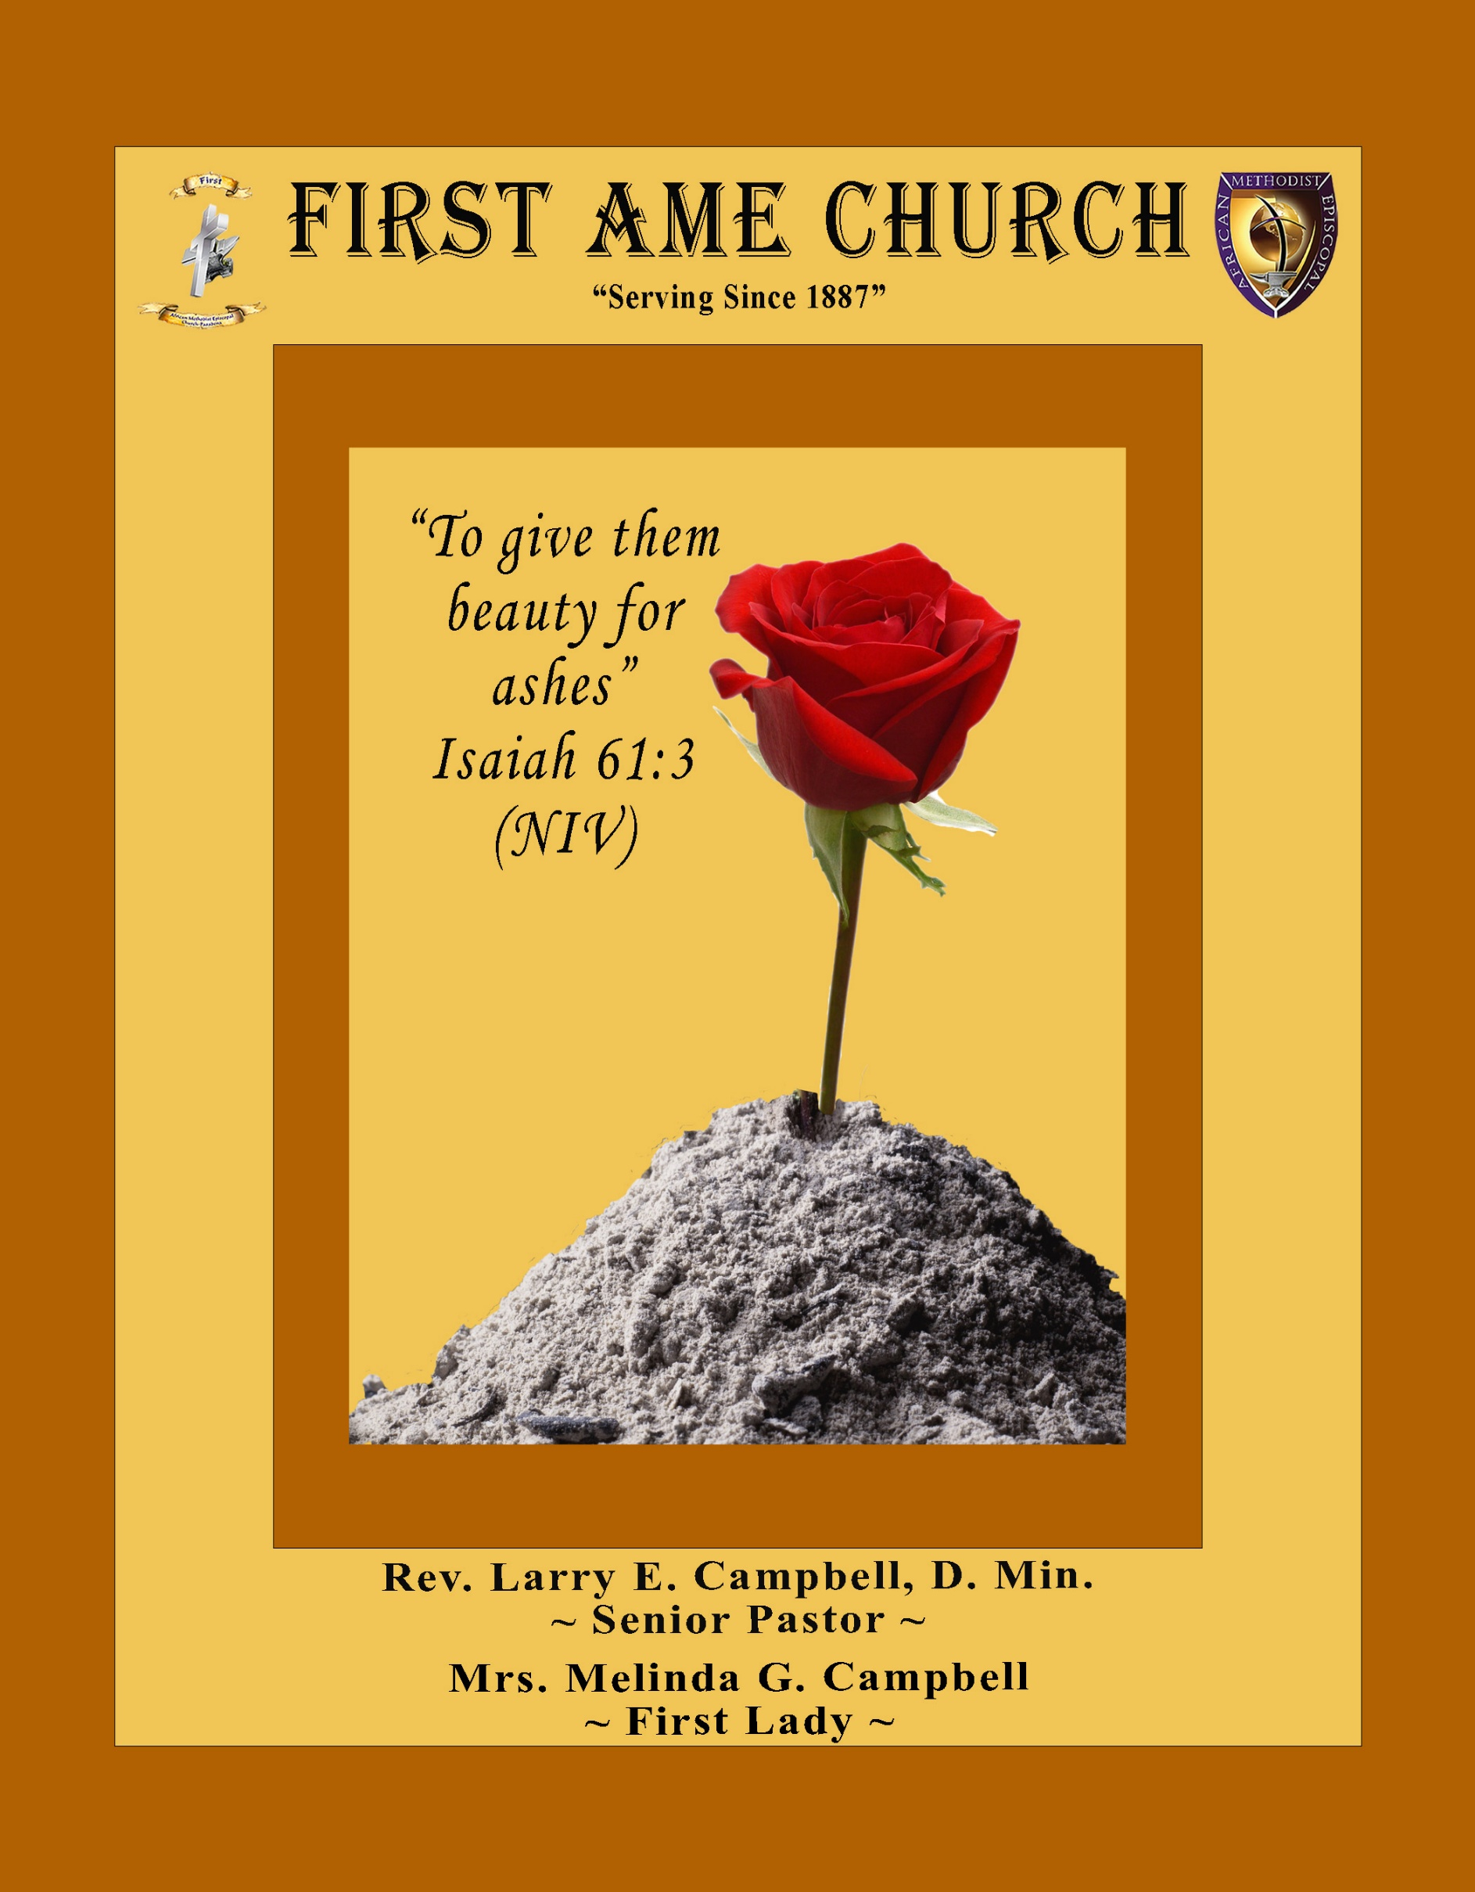
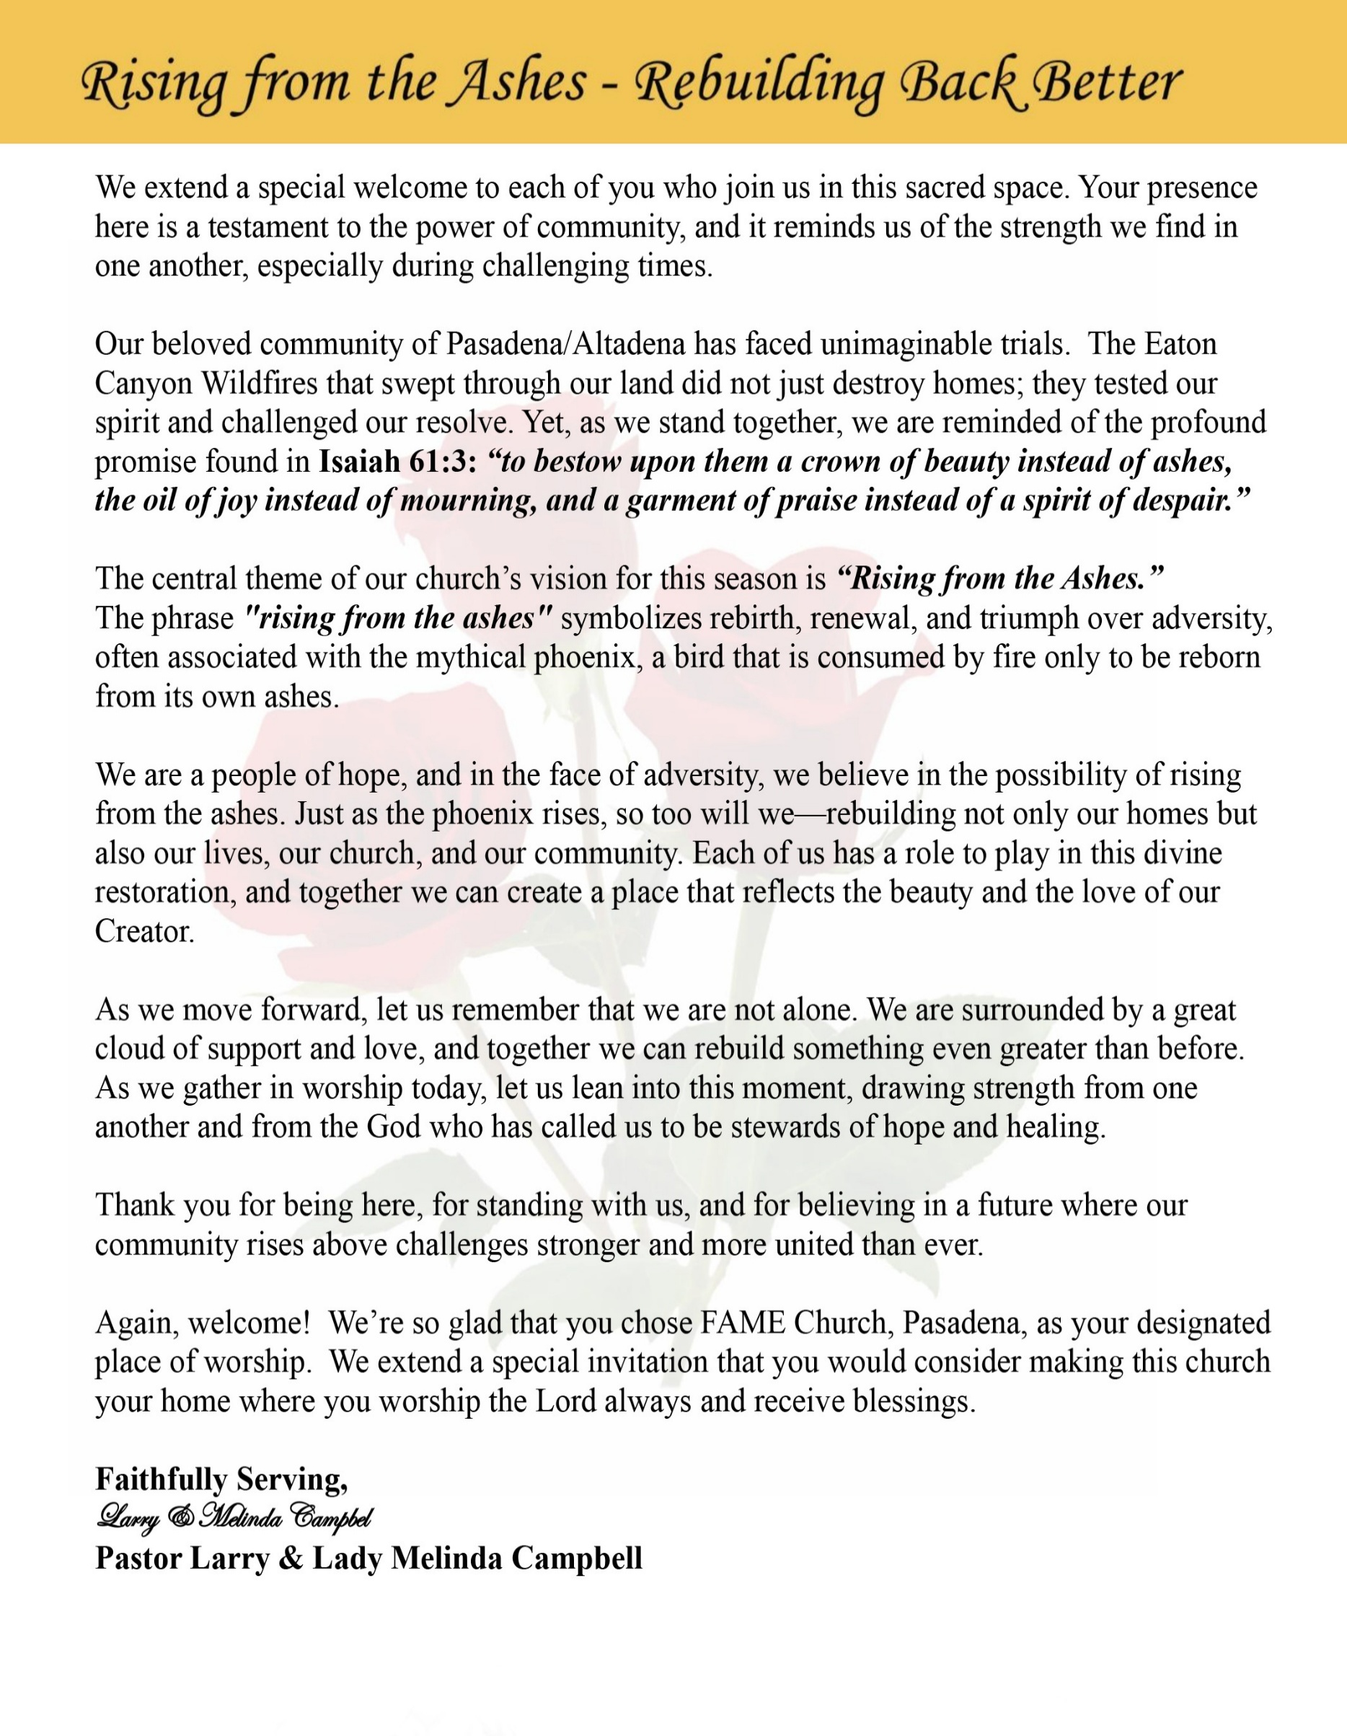

Sunday, December 21, 2025 | 9:30 a.m.

Rt. Rev. Francine A. Brookins, Esq., Presiding Bishop
Rev. Miriam Burnett, MD, MPH, Supervisor of Missions
Rev. Roosevelt Lindsey, Jr. Presiding Elder

The Rev. Dr. Larry E. Campbell ~ Senior Pastor ~ Minister

Mobile: (951) 587-1894 ~ Email: larrycampbell@famepasadena.org

Our First Lady: Mrs. Melinda G. Campbell

The Reverend Dr. Jennifer Oliver ~ Itinerant Elder -
The Reverend Dr. Nikia Smith-Robert ~ Itinerant Elder (Affiliated)
The Reverend Lois Woodard ~ Itinerant Elder Superannuated (Retired)
The Reverend Rochelle Wright Moore ~ Itinerant Deacon
The Reverend Deborah West-Jones ~ Local Elder
The Reverend Philis J. Griffin, MDiv ~ Local Elder
Dr. Phyllis Beech ~ Evangelist
The Reverend Van E. White ~ Executive Assistant
Community Resource Center Director ~ Ms. Kischchen Hazelton Venerable
Church Administrative Assistant: Ms. Letha Rhymes

Church Office Hours:
Tue, Wed 9:00am - 5:00pm, Thurs 9:00am - 3:00pm & 4:00pm - 7:30pm, Fri 9:00am -3:00pm.
Closed for Lunch Daily: 12:00pm - 1:00pm.

Music Ministry
Dr. Timothy Davis, Minister of Music
Bro. Jimmy Watlington, Percussionist ~ Bro. Carlos Caldwell, Organist
Bro. Darien Dorsey, Keyboardist
Sis. Karen Law, Women’s Chorus Director ~ Sis. Tonia Graham, Children’s Choir Director
Bro. J. Renard Washington, New Generation’s Choir

FREE WI-FI service is available on the FAME Campus by accessing FAME 1700
Password: 6267980503

-3-

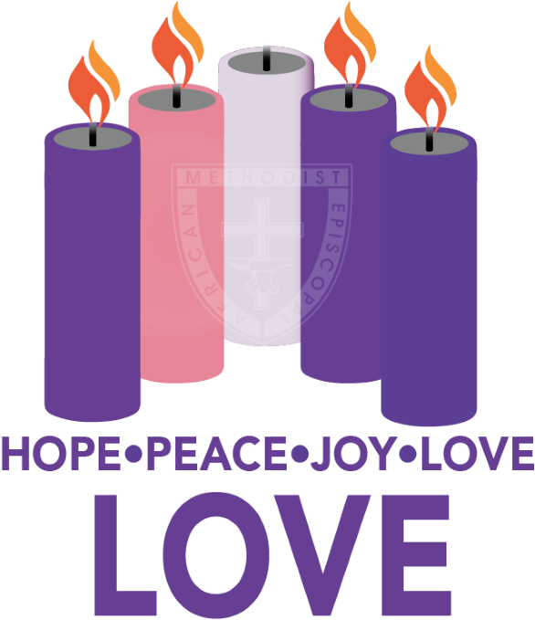

~Altar Call~
Praise & Worship

Doxology: “Praise God From Whom All Blessings Flow”

The Advent Candle Lighting “Dana Dynamite” Hazelton - YPD President and the
Youth: Miss Luna Roman-Smith, Miss Brooklyn Cole,
Mr. Brandon Bates, & Miss Nia Robert
Family Member: Last Sunday we lit the candle of JOY. We light it and the candles of HOPE and
PEACE again as we remember that Christ, who was born in Bethlehem, will
come again to fulfill all of God’s promises and bring us everlasting peace & joy.

The candles for hope, peace, and joy are lighted.

Family Member: The fourth candle of Advent is the Candle of LOVE. God’s love is a perfect
love. It holds nothing back. God, in love, gives us everything we need to live
a life of hope and peace.

Congregation: The bible says that “God so loved the world that God gave God’s only
Child, so that whoever believes should not perish, but have eternal life.”
Jesus shows us God’s perfect love.

Family Member: This is what love is like: Love is patient, love is kind and envies no one. Love is
never boastful or conceited, rude or selfish. Love is not quick to take offense, it
keeps no records of wrongs, it does not gloat over other people’s troubles, but
rejoices in the right, the good, and the true. There is nothing that love cannot
face, there is no limit to its faith, to its hope, to its endurance.

Congregation: Love never ends. We light the candle of love to remind us that Jesus
brings us God’s love and shows us how to love others.

The candle for LOVE is lighted

Family Member: Love is like a light shining in a dark place. As we look at this candle, we celebrate the love we find in Jesus Christ.

ALL: Let us pray: Thank you God for the love you give us. We ask that as we
wait for all your promises to come true, and for Christ to come again,
that you would remain present with us. Help us today, and everyday to
worship you, to hear your word, and to do your will by sharing your love
with each other. We ask it in the name of the one who was born in
Bethlehem. Amen.

-4-

Congregational Christmas Carols

Hark! The Herald Angels Sing
Hark! The herald angels sing, “Glory to the newborn King;
Peace on earth, and mercy mild, God and sinners reconciled!”
Joyful, all ye nations, rise, Join the triumph of the skies;
With the’ angelic host proclaim, “Christ is born in Bethlehem!”
Hark! The herald angels sing, “Glory to the new-born King!”

Christ, by highest heaven adored; Christ, the ever lasting Lord!
Late in time behold Him come, Off spring of the virgin’s womb,
Veiled in flesh the God-head see; Hail th’ incarnate Deity,
Pleased as man with men to dwell, Jesus, our Emmanuel.
Hark! The herald angels sing, “Glory to the new-born King!”

Hail the heaven-born Price of Peace! Hail the Sun of Righteousness!
Light and life to all He brings, Risen with healing in His wings,
Mild He lays His glory by, Born that man no more may die,
Born to raise the sons of earth, Born to give them second birth
Hark! The herald angels sing, “Glory to the new-born King!”

Angels We Have Heard on High
Angels we have heard on high Sweetly singing o’er the plains,
And the mountains in reply Echo back their joyous strains,

Refrain
Glo- ri-a in ex-cel-sis De-o,
Glo-ri-a in ex-cel-sis De-o.

Shepherds, why this jubilee? Why your joyous strains prolong?
Say what may the tidings be, Which inspire your heavenly songs?
Refrain

Come to Bethlehem and see Him whose birth the angels sing;
Come, adore on bended knee Christ the Lord, the newborn King.
Refrain

See within a manger laid Jesus, Lord of heaven and earth!
Mary, Joseph, lend your aid, With us sing our Savior’s birth.
Refrain

The Invocation Mr. Grant Blizzard

Ministry of Music The Praise Team

-5-

Scripture Lesson

(Please Stand for the Reading of God’s Words)

Old Testament Princess Scholar Jeffery
Isaiah 9:6-7 New International Version — Prophetic Promises of Love and Peace
⁶ For to us a child is born, to us a son is given, and the government will be on his shoulders.
And he will be called Wonderful Counselor, Mighty God, Everlasting Father, Prince of Peace. ⁷ Of the greatness of his government and peace there will be no end.
He will reign on David’s throne and over his kingdom, establishing and upholding it with justice and righteousness from that time on and forever. The zeal of the Lord Almighty
will accomplish this.

New Testament Mr. Lester Robert Jr.
John 3:16-21 New King James Version — (God’s Love)
¹⁶ For God so loved the world that He gave His only begotten Son, that whoever believes in Him should not perish but have everlasting life. ¹⁷ For God did not send His Son into the world to condemn the world, but that the world through Him might be saved.
¹⁸ “He who believes in Him is not condemned; but he who does not believe is condemned already, because he has not believed in the name of the only begotten Son of God. ¹⁹ And this is the condemnation, that the light has come into the world, and men loved darkness rather than light, because their deeds were evil. ²⁰ For everyone practicing evil hates the light and does not come to the light, lest his deeds should be exposed. ²¹ But he who does the truth comes to the light, that his deeds may be clearly seen, that they have been done in God.”

-6-

Abbreviated Announcements
Visitors’ Welcome Miss Luna Roman-Smith

Musical Selection The Praise Team

The Offertory — (Tithes/Gifts/Benevolent Offerings) Bro. Ray Bolton, Steward

Litany — The Gift That Love Brings
Leader: In this Advent season, we remember that love came down—
God gave His Son for the life of the world.

People: Thanks be to God for the gift of love.

Leader: Because God gave first, we give in faith and gratitude.

People: Our giving is an act of love.

Leader: Through our tithes and offerings, God’s love continues to bless and serve
others.

People: We offer our gifts with joyful hearts.

Leader: Let us now present our tithes and offerings, remembering the gift that love
brings.

All: We give because God has given to us. Amen.

The following Electronic GIVING Platforms are creditable methods to GIVE to FAME:

#1. GIVELIFY - Mobile Giving App available on the App Store. It’s easy to set up, just follow the guidelines.

#2. Cash App: $FirstAMEPASADENA

#3. Mail in your Tithes & Offering - If you would like to mail your tithes and offering by check or money order, please send it to: First AME Church, 1700 N. Raymond Avenue, Pasadena, CA 91103.

#4. Drop off your Tithes & Offering - During business hours in the basket outside of the office.

Choral Response: “All things come of Thee, O Lord; and of Thine own have we given Thee. Amen.”

-7-

Christmas by the Book
Children & Youth
Special Presentation

Sermonic Selection The Praise Team

Proclamation of The Word Pastor Larry E. Campbell

The Invitation (Public/Private)

How to Join First A.M.E. Church of Pasadena
PROFESSION OF FAITH. If you have never been a member of any church, you may join by professing Jesus Christ as your personal Lord and Savior.

RENEWAL OF VOWS. If you have been a member of a church at one time, but have been in active, you may join by renewing your faith in Jesus Christ as Lord and Savior.

TRANSFER. If you are a member of another African Methodist Episcopal Church and you are in good standing, you may join by requesting that your membership be transferred to the First African Methodist Episcopal Church of Pasadena.

AFFILIATE MEMBER. Sometimes an individual has reasons for keeping /his/her membership in another church but would like to be an active member of First African Methodist Episcopal Church, too. This is possible as an affiliate member. __________________________________________________________________________________________

The Doxology

The Benediction

-8-

Scripture of the Day
God’s Love. “This is how God showed his love among us: He sent his one and only Son into the world that we might live through him. ¹⁰ This is love: not that we loved God, but that he loved us and sent his Son as an atoning sacrifice for our sins.. – 1 John 4:9-10

Quote of the Day
“Though we are incomplete, God loves us completely. Though we are imperfect, He loves us perfectly. Though we may feel lost and without compass, God's love encompasses us completely. ... He loves every one of us, even those who are flawed, rejected, awkward, sorrowful, or broken.” -- Dieter F. Uchtdorf

Thought of the Week
Scripture: “In this the love of God was revealed among us: God sent His only Son into the world so that we might live through Him.” — 1 John 4:9
Advent is the season when we remember that God’s love did not remain an idea or a feeling — it was revealed. God showed us love by sending Jesus into the world, not after everything was fixed, but while the world was still broken. Love came down, stepped into our mess, and made a home among us.
This Advent love reminds us that God’s heart is not distant from our pain. Jesus was born into uncertainty, poverty, and danger, yet God chose that moment to say, “I am with you.” That means wherever you are this season — hopeful or hurting, joyful or weary — God’s love has already found you.
Advent also teaches us that God’s love gives life. When fear drains us and disappointment weighs heavy, the love of God restores us from the inside out. Christ did not come merely to visit us, but so that we might truly live.
As we wait for Christmas, Advent invites us to slow down and receive this revealed love anew. Let it shape how you see yourself and soften how you treat others. The love that came to us in Jesus is the same love God wants to flow through us today.

Humor of the Week
I heard about this man named Bubba. He lived way out in the country. There was a stray dog that kept showing up at his house. His wife said "Bubba, you have to put the dog in the truck, take him out to the woods and drop him off. That's where he lives." Bubba took him a mile down the road, dropped him off. When he came home, the dog was walking up the driveway. Practically beat him back home.
It happened again and again. His wife said "Bubba, you have to take him way out. Drive him around in circles. Get him mixed up." Bubba took him an hour away. Criss crossed country roads he had never driven before. Dropped him off.
Two hours later, he calls his wife from the truck. He said "Did the dog come back?" She said "Yes he's walking up the driveway." He said "Do me a favor, put him on the line. I need directions."

HOME DAILY BIBLE READINGS
December 22, 2025 – December 28, 2025 (Week 14, Psalms)
Monday Day 92 2 Samuel 8-12, Psalm 38:9-16
Tuesday Day 93 2 Samuel 13-15, Psalm 38:17-21
Wednesday Day 94 2 Samuel 16-18, Psalm 38:1-4
Thursday Day 95 2 Samuel 19-21, Psalm 39:1-6
Friday Day 96 1 Kings 1-5, Psalm 39:7-13
Saturday Day 97 1 Kings 6-9, Psalm 40:1-4
Sunday Day 98 1 Kings 10-14, Psalm 40:5-8

-9-

ANNOUNCEMENTS

A Christmas Message

Beloved First AME Church Family,
Grace and peace to you in the name of our Lord and Savior, Jesus Christ. As we celebrate the birth of our Savior this Christmas season, we are reminded that God’s greatest gift to the world was love wrapped in flesh—Jesus Christ, Emmanuel, God with us.

Christmas invites us to pause and reflect on the miracle of God’s love made visible in a manger. In a world often marked by uncertainty, division, and weariness, the birth of Christ assures us that God is still present, still powerful, and still purposeful. The light that shined in Bethlehem continues to shine in our lives, our families, our church, and our community.

We are deeply grateful for your faithfulness, prayers, and commitment to the ministry of First AME Church, Pasadena. Your love, generosity, and resilience reflect the very spirit of Christ and make our church a beacon of hope and healing. Together, we continue to serve, uplift, and love in ways that honor God and bless others.

As you gather with loved ones this season, we pray that your hearts will be filled with peace, your homes with joy, and your lives with renewed hope. May the love that came down at Christmas strengthen you, guide you, and remind you that you are never alone.

From our family to yours, Merry Christmas and may the blessings of Christ be with you today and always.

With love and gratitude,
Rev. Dr. Larry & Lady Melinda Campbell

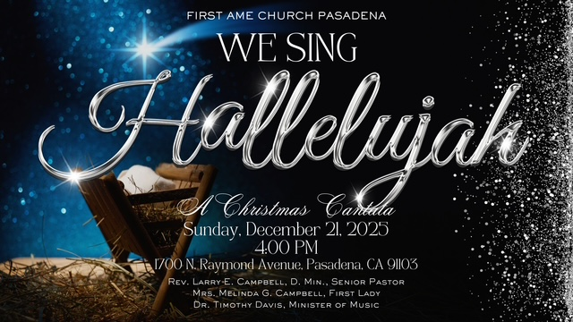

-10-

ANNOUNCEMENTS (Continued)

BIBLE STUDY/PRAYER MEETING SESSIONS
Please note that ALL Weekly Bible Study Prayer Meeting Sessions will be suspended on Wednesday, December 24th and Wednesday, December 31st in observance of the Christmas and New Year’s holidays.

The FAME Community Resource Center
Holiday Hours (Christmas Day) 9:00 am – 3:00 pm
We Will be Serving Lunch on Christmas Day
12:00 p.m. to 3:00 p.m.
Everyone is Welcome!

20/20 (14.0)
The 20/20 initiative is a Church-wide fundraising project managed by the Stewards. This project was established to assist with our Annual Connectional Budget. Financial gifts donated through the 20/20 initiative are added to our collected conference claims and assist greatly in meeting the first and second half of our Connectional Budgetary obligations. The Steward Board is requesting 150 participants for the conference year 2025-2026. The first half of our budget is due in February 2026. In addition to the 18 officers and we are asking 132 people to give 20 dollars per week for 20 weeks in addition to your regular tithes, gifts and offerings. Please mark your envelopes 20/20 and allocate $20.00. Our goal is to raise $60,000. Again, this will satisfy all budgetary needs on the conference level without utilizing any operational funds. Please see or contact any Steward to participate; we are looking forward to your commitment.

Men's Ministry - BIBLE STUDY
Time: Tuesday, January 6, 2026 | 6:00 p.m.
Meeting ID: 894 7536 6487
Passcode: 465177
One tap mobile: +16699006833,,89475366487#,,,,*465177# US (San Jose)

Women's Ministry - BIBLE STUDY
Time: Tuesday, January 6, 2026 | 6:00 p.m.
Meeting ID: 857 0061 9461; Passcode: 933892
One tap mobile +16699006833,,85700619461#,,,,,,0#,,933892# US (San Jose)

Senior Ministry In-Person Gathering
Tuesday, January 13, 2026| 11:30 a.m.
Church Fellowship Hall

-11

ANNOUNCEMENTS (Continued)

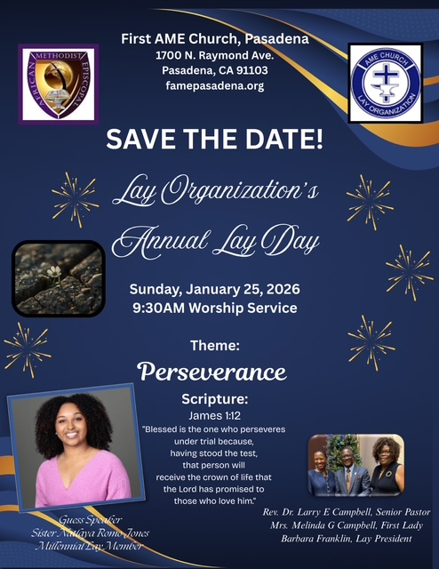

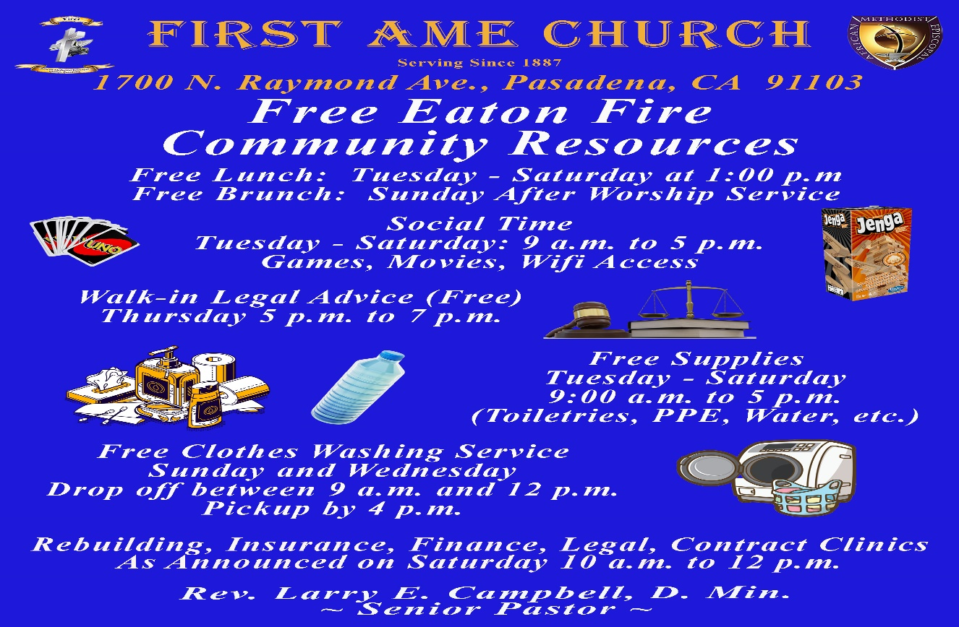

-12-

Prayer Request(s)
Please notify the Church Office of Sick & Shut-in additions, deletions, or status/address changes.

Bishop Francine A. Brookins, Esq. Supervisor Miriam Burnett, MD
Presiding Elder Roosevelt & Dr. Kaye Lindsey Rev. Dr. Larry & Melinda Campbell
Richard Craig Hazel Clark Erica Woodard Jason Shirley Joshua Shirley Julian Shirley Ayanna Terry Cheryl Jamerson Gwendolyn Flowers Andrea Anderson Ocilda Files Danielle Clark Donita Towler Rev. Charles Brooks Doris Bailey Kimberly Woods Cynithia Grace Zechariah Robinson Diane Jordan Teresa Thompson Raymond Morrison Glen Scott Victoria Moore Mary Glizer Christopher McCarthy Wilma Haynes Jewell Malloy Calle Burns Noel Johnson Brittney Petty Taylor Family Deborah Burton Nettie McChristen Jacquelyn Walker Selene Cox Thomas Scotton
Rev. Rochelle Moore Lorene Butler Stella Pulliam Colette Blizzard Carita Smith Joyce Johnson The Eaton Canyon Fire Victims The Caple Family Cheryl Jameson Andrew Oliver Barbara McPheeter

College Students

Let’s continue to support and pray for our beloved College Students

Isaiah Crowell Alecia Davis Ahmad Harris Jade Williams Chase Johnson Grant Blizzard

Tyler Johnson Richard Jones Tyrikk Lawson Makia Rose Talbert Isaiah Ringo Journey Rogers Elyse Sharp Kylee Sharp Zion Otano Elise Tervalon Grace Jones Jordan Patterson Kimberly Robinson Donovan Williams Jasmine Collins Brandon Bates Gabriel Blizzard

Sick and Shut-Ins
Bettina Ayers Pasadena Meadows Nursing Home, 150 Bellefontaine St., Pas., CA 91105
Bobby Thomas 1052 E. Morada Place, Altadena, CA 91001
Carrie Wynne Senior Living Heritage, 161 N. Hemet St., Hemet, CA 92545
Doris Curd 11619 Woodcock Avenue, San Fernando, CA 91340
Edmund Riddle Active Care Mission Bay, 2440 Grand Avenue, San Diego, CA 92109
Eleanor Towler 975 E. Union Street, Unit #417, Pasadena, CA 91106
Elois Blizzard P. O. Box 3646, So. Pasadena, CA 91031
Emily Cormier-Ross 2549 La Fiesta Avenue, Altadena, CA 91001
Ernestine English 26 W. Fair Oaks Drive, Pasadena, CA 91103
Frederick Smith 1055 N. Vignes St., Los Angeles, CA 90012
Fred Caple 5549 Hamill Ave, San Diego, CA 92120
Gloria Cubit Clay 11745 Pierce St., Lake View Terrace, CA 91342
Hugh Hamberry 19225 Chole Rd., Apple Valley, CA 92307
Jackie Johnson 641 W. Mariposa, Altadena, CA 91101
Josephine Brown 15607 Saddleback Rd, Riverside, CA 92506
Jessie Smith 7980 Mayten Avenue, Apt 3050 Rancho Cucamonga, CA 91730-8113
Linnie G. Nollie 2250 E. New York Drive, Altadena, CA 91001
Malika G. Hendry P. O. Box 94082, Pasadena, CA 91109
Mildred Lewis C/O Hazel Rohr, 884 W. Jane Court, Upland, CA 91786
Norma Burnett 618 Fairview Avenue, Unit #228, Arcadia, CA 91007
Opal Hampton 1030 Chevron Court, Pasadena, CA 91103
Paul Ratliff P.O. Box 40407 Pasadena, CA 91114
Ruthie Hopkins 1155 Via Verde , San Dimas, CA 91773
Virlyn Grant 15122 Orange Ave., Paramount, CA 90723
Wanda Nelson 3618 N. Fair Oaks Avenue, Altadena, CA 91001
William Hilliard 7504 Wynstone Pl., Fontana, CA 92336
Zell L. Hill 375 Barthe Drive, Pasadena, CA 91103

-13-

Sermon Notations

Scripture: _____________________________________________________________

Subject: _______________________________________________________________

Points of the Message: ___________________________________________________
_______________________________________________________________________
_______________________________________________________________________
_______________________________________________________________________
_______________________________________________________________________
_______________________________________________________________________
_______________________________________________________________________

Main Ideas of the Sermon: ________________________________________________
_______________________________________________________________________
_______________________________________________________________________
_______________________________________________________________________
_______________________________________________________________________
_______________________________________________________________________

Illustrations I want to remember: _________________________________________
_______________________________________________________________________
_______________________________________________________________________
_______________________________________________________________________
_______________________________________________________________________
_______________________________________________________________________
_______________________________________________________________________

What should I do as a result of this Sermon? ________________________________

_____________________________________________________
_____________________________________________________
_____________________________________________________
_____________________________________________________

-14-

