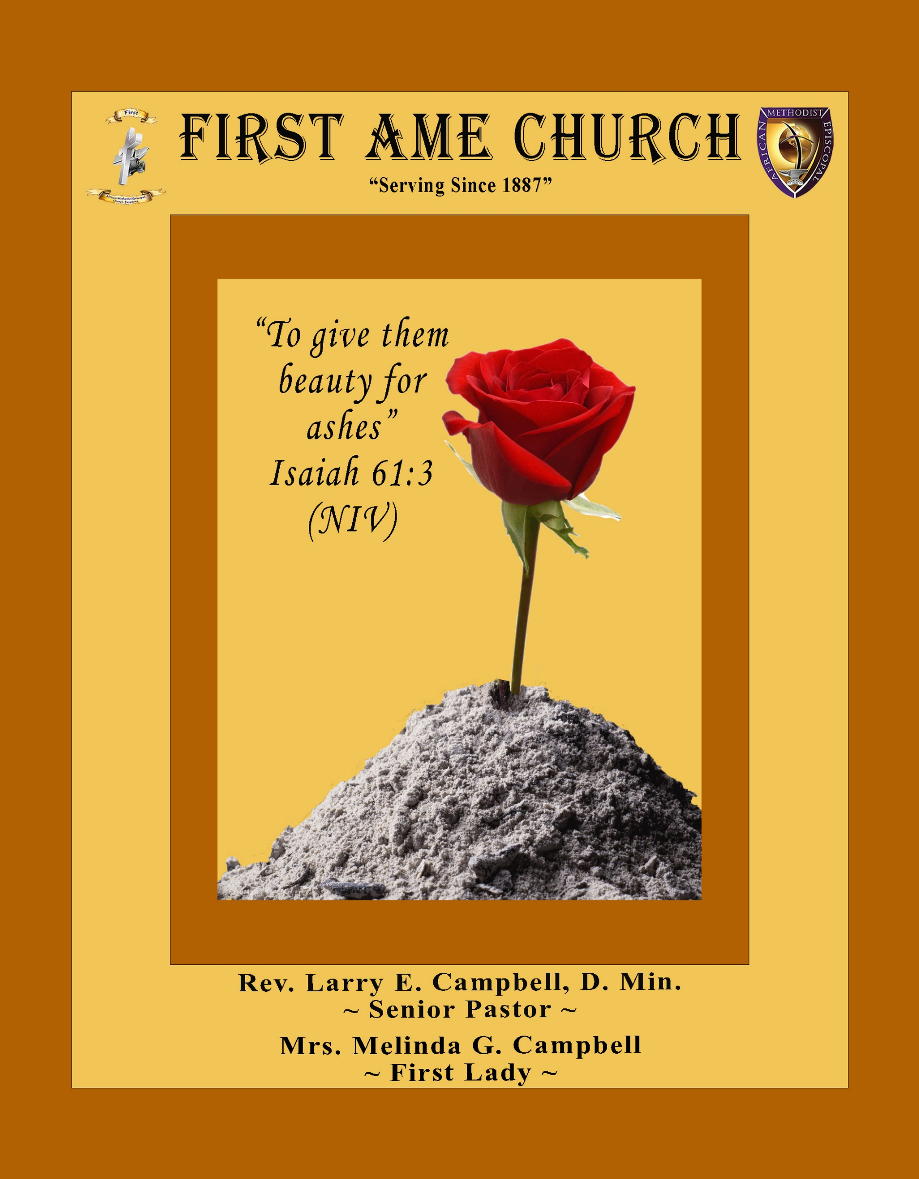

**Sunday, August 24, 2025 | 9:30 a.m.**

**Rt. Rev. Francine A. Brookins, Esq, Presiding Bishop**

**Rev. Miriam Burnett, MD, MPH, Supervisor of Missions**

**Rev. Roosevelt Lindsey, Jr. Presiding Elder**

**The Rev. Dr. Larry E. Campbell ~ Pastor/Minister**

**Mobile: (951) 587-1894 ~ Email: larrycampbell@famepasadena.org**

**Our First Lady: Mrs. Melinda G. Campbell**

The Reverend Dr. Jennifer Oliver ~ Itinerant Elder -

The Reverend Dr. Nikia Smith-Robert ~ Itinerant Elder (Affiliated)

The Reverend Lois Woodard ~ Itinerant Elder Superannuated (Retired)

The Reverend Rochelle Wright Moore ~ Itinerant Deacon

The Reverend Deborah West-Jones ~ Local Elder

The Reverend Philis J. Griffin, MDiv ~ Local Elder

Dr. Phyllis Beech ~ Evangelist

**The Reverend Van E. White ~ Executive Assistant/ Youth Coordinator**

**Church Administrative Assistant: Ms. Letha Rhymes**

**Church Office Hours:**

Tue, Wed 9:00am - 5:00pm, Thurs 9:00am - 3:00pm & 4:00pm - 7:30pm, Fri 9:00am -3:00pm.

Closed for Lunch Daily: 12:00pm - 1:00pm.

**Music Ministry**

Dr. Timothy Davis, Minister of Music

Bro. Jimmy Watlington, Percussionist ~ Bro. Carlos Caldwell, Organist

Bro. Darien Dorsey, Keyboardist

Sis. Karen Law, Women’s Chorus Director ~ Sis. Tonia Graham, Children’s Choir Director

Bro. J. Renard Washington, New Generation’s Choir

**FREE WI-FI service is available on the FAME Campus by accessing FAME 1700**

**Password: 6267980503**

**-3-**

**~ Order of Worship Experience ~**

**Warning: This order of worship is subject to change without warning or prior notice --- everything is governed by the Sovereignty of the Holy Spirit**

~ Altar Call ~

Praise & Worship

Doxology: “Praise God From Whom All Blessings Flow”

**The Call to Worship Dr. Paul Price**

**Leader:** I was glad when they said unto me, let us go into the house of the Lord, our feet shall stand within Thy gates O Jerusalem! **(Psalm 122:1)**

**People:** For a day in Thy courts is better than a thousand. I had rather be a doorkeeper in the house of my God than to dwell in the tents of wickedness. **(Psalm 84:10)**

**Leader:** Because of the house ofthe Lord our God, I will seek Thy good.

**(Psalm 122:9)**

**People:** Those that be planted in the house of the Lord, shall flourish in the courts of our God. **(Psalm 92:13)**

**Leader:** Blessed are they that dwell in Thy house. Lord, I have loved Thy habitation, the place where Thy honor dwelleth. **(Psalm 26:8)**

**People:** For the Lord is in His holy temple; let all the earth keep silence before Him.

**(Habakkuk 2:20)**

**Leader:** Let the words of my mouth and the meditation of my heart, be acceptable in Thy sight, O Lord my strength and my redeemer. **(Psalm 19:14)**

**Unison:**  O Sing unto the Lord a new song, for He has done marvelous things. Make a

joyful noise unto the Lord, all the earth, sing His praises. **(Psalm 98:1, 4)**

**-4-**

**The Hymn of Praise A.M.E. Hymnal**

**O How I Love Jesus**

**Author: Frederick Whitfield**

**1** There is a name I love to hear,  
I love to sing its worth;  
it sounds like music in my ear,  
the sweetest name on earth.

**Refrain:  
O how I love Jesus,  
O how I love Jesus,  
O how I love Jesus,  
because he first loved me!**

**2** It tells me of a Savior's love,  
who died to set me free;  
it tells me of his precious blood,  
the sinner's perfect plea.

**[Refrain]**

**3** It tells of one whose loving heart  
can feel my deepest woe;  
who in each sorrow bears a part  
that none can bear below.

**[Refrain]**

**The Invocation Bro. De’ Allgo Vega**

**Musical Selections The Male Chorus**

**-5-**

**Scripture Lesson**

**(Please Stand for the Reading of God’s Words)**

**Old Testament Bro. Paul Gibson**

**Isaiah 54:10-17 (New King James Version) — Divine Security**

**10**For the mountains shall depart and the hills be removed, but My kindness shall not depart from you, Nor shall My covenant of peace be removed,” says the Lord, who has mercy on you. **11**“O you afflicted one, tossed with tempest, *and* not comforted, behold, I will lay your stones with colorful gems, and lay your foundations with sapphires.  
**12**I will make your pinnacles of rubies, your gates of crystal, and all your walls of precious stones. **13**All your children *shall be* taught by the Lord, and great *shall be* the peace of your children. **14**In righteousness you shall be established; You shall be far from oppression, for you shall not fear; And from terror, for it shall not come near you.  
**15**Indeed they shall surely assemble, *but* not because of Me. Whoever assembles against you shall fall for your sake.

**16**“Behold, I have created the blacksmith who blows the coals in the fire, who brings forth an instrument for his work; And I have created the [[b](https://www.biblegateway.com/passage/?search=Isaiah%2054%3A10-17&version=NKJV#fen-NKJV-18740b)]spoiler to destroy.  
**17**No weapon formed against you shall prosper, And every tongue *which* rises against you in judgment You shall condemn. This *is* the heritage of the servants of the Lord, And their righteousness *is* from Me,” Says the Lord.

**New Testament Bro. Bishop Cohen**

**Luke 18:35-42 (New International Version) — A Blind Beggar Receives His Sight**

**35**As Jesus approached Jericho, a blind man was sitting by the roadside begging. **36**When he heard the crowd going by, he asked what was happening. **37**They told him, “Jesus of Nazareth is passing by.”

**38**He called out, “Jesus, Son of David, have mercy on me!”

**39**Those who led the way rebuked him and told him to be quiet, but he shouted all the more, “Son of David, have mercy on me!”

**40**Jesus stopped and ordered the man to be brought to him. When he came near, Jesus asked him, **41**“What do you want me to do for you?”

“Lord, I want to see,” he replied.

**42**Jesus said to him, “Receive your sight; your faith has healed you.”

**-6-**

**The Summary of the Decalogue Bro. Kenneth Caudle**

|  |
| --- |
| **LEADER: From all that dwell below the skies…** |
| **SUNG:** From all that dwell below the skies, Let the Creator’s praise arise; Let the  Redeemer’s Name be sung, through every land, by every tongue. |
| **LEADER**: Hear what Christ our Savior saith, Thou shalt love the Lord thy God with all thy  heart, with all thy soul, and with all thy mind. This is the first and great  commandment. And the second is like unto it: Thou shalt love thy neighbor  as thyself. On these two commandments hang all the law and the prophets. |
| **SUNG:** Glory be to the Father, and to the Son, and to the Holy Ghost; as it was in  the beginning, is now, and ever shall be, world without end. **A~Men** |

**Abbreviated Announcements/Visitor’s Welcome Dr. Brian K. Venerable**



**Congregational *(Sing along)* Hymn AME Hymnal #200**

***Blessed Quietness; Holy Quietness***

**-7-**

**The Offertory *(Tithes ~ Gifts ~ Benevolent Offerings)* Bro. Zacharie De Johnette**

**The following Electronic GIVING Platforms are credible methods to GIVE to FAME:**

**#1. GIVELIFY** - Mobile Giving App available on the App Store. It’s easy to set up, just follow the guidelines.

**#2. Cash App: $FirstAMEPASADENA**

**#3. Mail in your Tithes & Offering - If you would like to mail your tithes and offering by check or money order, please send it to: First AME Church, 1700 N. Raymond Avenue, Pasadena, CA 91103.**

**#4. Drop off your Tithes & Offering - During business hours in the basket outside of the office.**

**Choral Response: *“All things come of Thee, O Lord; and of Thine own have we given Thee. Amen.”***

**Children’s Church Dismissal**

**Sermonic Selection** **The Male Chorus**

**Proclamation of The Word Pastor Larry E. Campbell**

**The Invitation (Public/Private)**

**How to Join First A.M.E. Church of Pasadena**

**PROFESSION OF FAITH.** If you have never been a member of any church, you may join by professing Jesus Christ as your personal Lord and Savior.

**RENEWAL OF VOWS.** If you have been a member of a church at one time, but have been in active, you may join by renewing your faith in Jesus Christ as Lord and Savior.

**TRANSFER.** If you are a member of another African Methodist Episcopal Church and you are in good standing, you may join by requesting that your membership be transferred to the First African Methodist Episcopal Church of Pasadena.

**AFFILIATE MEMBER.** Sometimes an individual has reasons for keeping /his/her membership in another church but would like to be an active member of First African Methodist Episcopal Church, too. This is possible as an affiliate member. **__________________________________________________________________________________________**

**The Doxology**

**The Benediction**

**-8-**

**Scripture of the Day**

**Speak Up!.** **“*Speak up for those who cannot speak for themselves, for the rights of all who are destitute. 9Speak up and judge fairly; defend the rights of the poor and needy.”* Proverbs 31:8-9**

**Quote of the Day**

***“In the end, we will remember not the words of our enemies, but the silence of our friends.”***

***—* Dr Martin Luther King Jr.”**

**Thought of the Week**

**Speak up!*****“There is…a time to be silent and a time to speak.”*****Ecclesiastes 3:1, 7**

The Bible has a lot to say about not criticizing and passing judgment. But there are times when “silence isn’t golden,” it’s deadly. For example: (1) Silence is deadly when you use it as a passive, retaliatory means of expressing your anger or displeasure. That’s called “emotional manipulation.” Jesus said, “If your brother sins against you, go and tell him his fault between you and him alone. If he hears you, you have gained your brother” (Mt 18:15 NKJV). Jesus is recommending assertive behavior by commanding us to take the initiative in addressing the “trespass.” Trespassing is the unauthorized crossing of a boundary, and many times we feel like we’ve been trespassed against or wronged. However, rather than addressing the issue directly with the offender we resort to sulking and pouting. Jesus says, “Don’t do that!” Your lack of communication can leave the wrongdoer unaware of their behavior and make them more likely to repeat it. (2) Silence is deadly when you fail to defend someone against unwarranted criticism or vicious rumors. Don’t let fear of alienation and rejection cause you to let slander and character assassination go unchallenged, especially when you’re aware of facts to the contrary. (3) Silence is deadly when it results in your making an undesirable decision by default. The fact is, silence can indicate consent. Prayer was taken out of public schools in the United States because the majority stayed silent instead of speaking up. The Scripture says, “There is…a time to be silent and a time to speak.” So have the courage of your convictions and speak up!

**Humor of the Week**

An 88-year-old man came to the hospital and said to the doctor, “Doctor, my 18-year-old wife is pregnant with my child.”

The doctor paused and said, “There was a master bear shooter in a village. He never missed a shot.

But one day he was in a hurry and took his umbrella instead of his rifle by mistake.

When he encountered a bear, he still didn’t realize his mistake and pointed the umbrella and shot the bear.

The bear lay dead with a bullet in his heart!”

The old man said, “That’s stupid! The bullet must have been shot by another person.”

“That’s exactly right,” said the doctor.

**HOME DAILY BIBLE READINGS**

**August 25, 2025 – August 31, 2025 (Week 49, Joy)**

Monday Day 337 Ephesians 3-4, Proverbs 15

Tuesday Day 338 Ephesians 5-6, Proverbs 16 Wednesday Day 339 Philippians 1-2, Proverbs 17

Thursday Day 340 Phillipians 3-4, Proverbs 18

Friday Day 341 Colossians 1-2, Proverbs 19

Saturday Day 342 Colossians 3-4, Proverbs 20

Sunday Day 343 1 Thessalonians 1-2, Proverbs 21

**-9-**

**ANNOUNCEMENTS**

**Official Board Meeting**

**Thursday, August 28, 2025 | 6:00 p.m.**

**The Zoom link will be provided under a separate notification**

**Homegoing Service**

**It is with deep respect and heartfelt remembrance that we announce the Homegoing service for Reverend Joan Taylor.**

**Service Details**

**·         Date: Saturday, August 30, 2025**

**·         Time: 10:30 a.m.**

**·         Location: First AME Church, Pasadena**

**Officiants**

**·         Officiant: Rev. Dr. Larry E. Campbell**

**·         Eulogist: Rev. Dr. Mary S. Minor**

**Interment**

**·         Location: Mountain View Cemetery**

**·         Time: 1:30 p.m.**

**Repast**

**·         The repast will take place in the church fellowship hall following the family's return from the burial.**

**We invite family, friends, and all whose lives were touched by Reverend Joan Taylor to join us in honoring her legacy and celebrating her life of faith and service.**

**The Olivia Wilson Women’s Missionary Society**

**Will lead us in Worship on Sunday, August 31, 2025**

**Men's Ministry - BIBLE STUDY**

**Time: Tuesday, September 2, 2025 | 6:00 p.m.**

**Meeting ID: 894 7536 6487**

**Passcode: 465177**

**One tap mobile: +16699006833,,89475366487#,,,,*465177# US (San Jose)**

**Women's Ministry - BIBLE STUDY**

**Time: Tuesday, September 2, 2025 | 6:00 p.m.**

**Meeting ID: 857 0061 9461; Passcode: 933892**

**One tap mobile +16699006833,,85700619461#,,,,,,0#,,933892# US (San Jose)**

**-10-**

**ANNOUNCEMENTS (Continued)**

**WEEKLY BIBLE STUDY CLASSES**

Please note that our weekly Bible Study classes (Wednesday Bible Study sessions and Wednesday Prayer Service sessions) will resume on

**Wednesday, September 3, 2025**

**⚠️ Temporary Church Campus Closure ⚠️**

**Dear Church Family,**

**Please be advised that the church campus will be temporarily closed for fumigation from Monday, September 8, through Wednesday, September 10, 2025. For safety reasons, no entry will be allowed during this period. We apologize for any inconvenience and appreciate your understanding as we take these necessary steps to maintain a safe and healthy environment for our congregation. Regular activities and services will resume on Thursday, September 11, 2025.**

**Thank you for your cooperation and continued support.**

**Budget Submission**

**All Auxiliary and Organization Presidents must submit their 2025-2026 draft budgets to Sis. Kischchen Hazelton Venerable by Friday, September 18, 2025.**

**Baptismal Sunday**

**The Sacrament of Baptism will be held on Sunday, September 21, 2025. All Baptismal Candidates must attend a virtual Baptism class on Wednesday, September 17, 2025 at 6:00 p.m.**

**Join Zoom Meeting**

[**https://us**](https://us)**02web.zoom.us/j/82924063785?pwd=cSbgvkGq9fJVsam2Mb44Nxi2CnZtso.1**

**Meeting ID: 829 2406 3785 | Passcode: 518877**

**CHURCH CONFERENCE**

**Annual State of the Church**

Pastor Campbell will present the **FAME Church Family** with an official “State of the Church” Address at **7:00** **p.m. on Tuesday, October 15, 2025**. The presence of the entire church membership is requested to be in attendance.

**Join Zoom Meeting**

[**https://us**](https://us)**02web.zoom.us/j/83805216493?pwd=P06tWYxk7Ds86Sy71ZdqHXzD27RVqn.1**

**Meeting ID: 838 0521 6493 | Passcode: 905424**

**One tap mobile:**

**+16699006833,,83805216493#,,,,*905424# US (San Jose)**

**+16694449171,,83805216493#,,,,*905424# US**

**\*\*\* Each Ministry President or designated representative will present the Top FIVE Significant Accomplishments of this Annual Conference Year. \*\*\***

**-11-**

**ANNOUNCEMENTS (Continued)**

**FAME CHURCH ANNIVERSARY**

**Celebrating 138 years**

**of**

**Faithful Service unto God and Humankind**

**Sunday, September 14, 2025 | 9:30 a.m.**

***“Faith that can’t be Burned”***

**Guest Preacher: Rev. Latisha Stewart-Smith**

**-12-**

**Prayer Request(s)**

**Please notify the Church Office of Sick & Shut-in additions, deletions, or status/address changes.**

**Bishop Francine A. Brookins, Esq. Supervisor Miriam Burnett, MD**

**Presiding Elder Roosevelt & Dr. Kaye Lindsey Rev. Dr. Larry & Melinda Campbell**

Richard Craig Hazel Clark Erica Woodard Jason Shirley Joshua Shirley Julian Shirley Ayanna Terry Aloura Clarke Gwendolyn Flowers Andrea Anderson Ocilda Files Danielle Clark Yolanda Oliver Brittany Shepherd Rev. Charles Brooks Doris Bailey Kimberly Woods Cynithia Grace Zechariah Robinson Diane Jordan Teresa Thompson Raymond Morrison Glen Scott Victoria Moore Christopher McCarthy Cheryl Jamerson Wilma Haynes Jewell Malloy Calle Burns Noel Johnson Vanessa Robinson Charles Ludd, Sr. Rev. Rochelle Moore Richelle Niara Vogel Catherine Graham Brittney Petty

Taylor Family Alford Family Spurill Family Deborah Burton **The Eaton Canyon Fire Victims**

Lorene Butler

**College Students**

**Let’s continue to support and pray for our beloved College Students**

Isaiah Crowell Alecia Davis Ahmad Harris Jade Williams Chase Johnson

Tyler Johnson Richard Jones Tyrikk Lawson Makia Rose Talbert Isaiah Ringo Elyse Sharp Kylee Sharp Zion Otano Elise Tervalon Grace Jones Kimberly Robinson Donovan Williams Jasmine Collins Brandon Bates Gabriel Blizzard

Grant Blizzard Jordan Patterson Journy Rogers

**Sick and Shut-Ins**

|  |
| --- |
| **Andrew Oliver** 1405 N. Roosevelt Ave., Pasadena, CA 91104 |
| **Bettina Ayers**  Pasadena Meadows Nursing Home, 150 Bellefontaine St., Pas., CA 91105 |
| **Bobby Thomas** 1052 E. Morada Place, Altadena, CA 91001 |
| **Carrie Wynne** Senior Living Heritage, 161 N. Hemet St., Hemet, CA 92545 |
| **Doris Curd** 11619 Woodcock Avenue, San Fernando, CA 91340 |
| **Edmund Riddle** Active Care Mission Bay, 2440 Grand Avenue, San Diego, CA 92109 |
| **Eleanor Towler** 975 E. Union Street, Unit #417, Pasadena, CA 91106 |
| **Elois Blizzard** P. O. Box 3646, So. Pasadena, CA 91031 |
| **Emily Cormier-Ross** 2549 La Fiesta Avenue, Altadena, CA 91001 |
| **Ernestine English** 26 W. Fair Oaks Drive, Pasadena, CA 91103 |
| **Frederick Smith** 1055 N. Vignes St., Los Angeles, CA 90012 |
| **Fred & Francis Caple** 5549 Hamill Ave, San Diego, CA 92120 |
| **Gloria Cubit Clay** 11745 Pierce St., Lake View Terrace, CA 91342 |
| **Hugh Hamberry** 2518 N. Marengo Avenue, Altadena, CA 91001 |
| **Josephine Brown** 15607 Saddleback Rd, Riverside, CA 92506 |
| **Jessie Smith** 7980 Mayten Avenue, Apt 3050 Racho Cucamonga, CA 91730-8113 |
| **Linnie G. Nollie** 2250 E. New York Drive, Altadena, CA 91001 |
| **Malika G. Hendry** P. O. Box 94082, Pasadena, CA 91109 |
| **Mildred Lewis** C/O Hazel Rohr, 884 W. Jane Court, Upland, CA 91786 |
| **Norma Burnett** 618 Fairview Avenue, Unit #228, Arcadia, CA 91007 |
| **Opal Hampton** 1030 Chevron Court, Pasadena, CA 91103 |
| **Paul Ratliff** 1015 E. Athens St. Altadena, CA 91001 |
| **Ruthie Hopkins** 1155 Via Verde , San Dimas, CA 91773 |
| **Virlyn Grant** 15122 Orange Ave., Paramount, CA 90723 |
| **Wanda Nelson** 3618 N. Fair Oaks Avenue, Altadena, CA 91001 |
| **William Hilliard** 313 E. Loma Alta Dr. Altadena, CA 91001 |
| **Zell L. Hill** 375 Barthe Drive, Pasadena, CA 91103 |

**-13-**

**Sermon Notations**

**Scripture: _____________________________________________________________**

**Subject: _______________________________________________________________**

**Points of the Message: ___________________________________________________**

**_______________________________________________________________________**

**_______________________________________________________________________**

**_______________________________________________________________________**

**_______________________________________________________________________**

**_______________________________________________________________________**

**_______________________________________________________________________**

**Main Ideas of the Sermon: ________________________________________________**

**_______________________________________________________________________**

**_______________________________________________________________________**

**_______________________________________________________________________**

**_______________________________________________________________________**

**_______________________________________________________________________**

**Illustrations I want to remember: _________________________________________**

**_______________________________________________________________________**

**_______________________________________________________________________**

**_______________________________________________________________________**

**_______________________________________________________________________**

**_______________________________________________________________________**

**_______________________________________________________________________**

**What should I do as a result of this Sermon?** ________________________________

_____________________________________________________

_____________________________________________________

_____________________________________________________

_____________________________________________________

**-14-**

