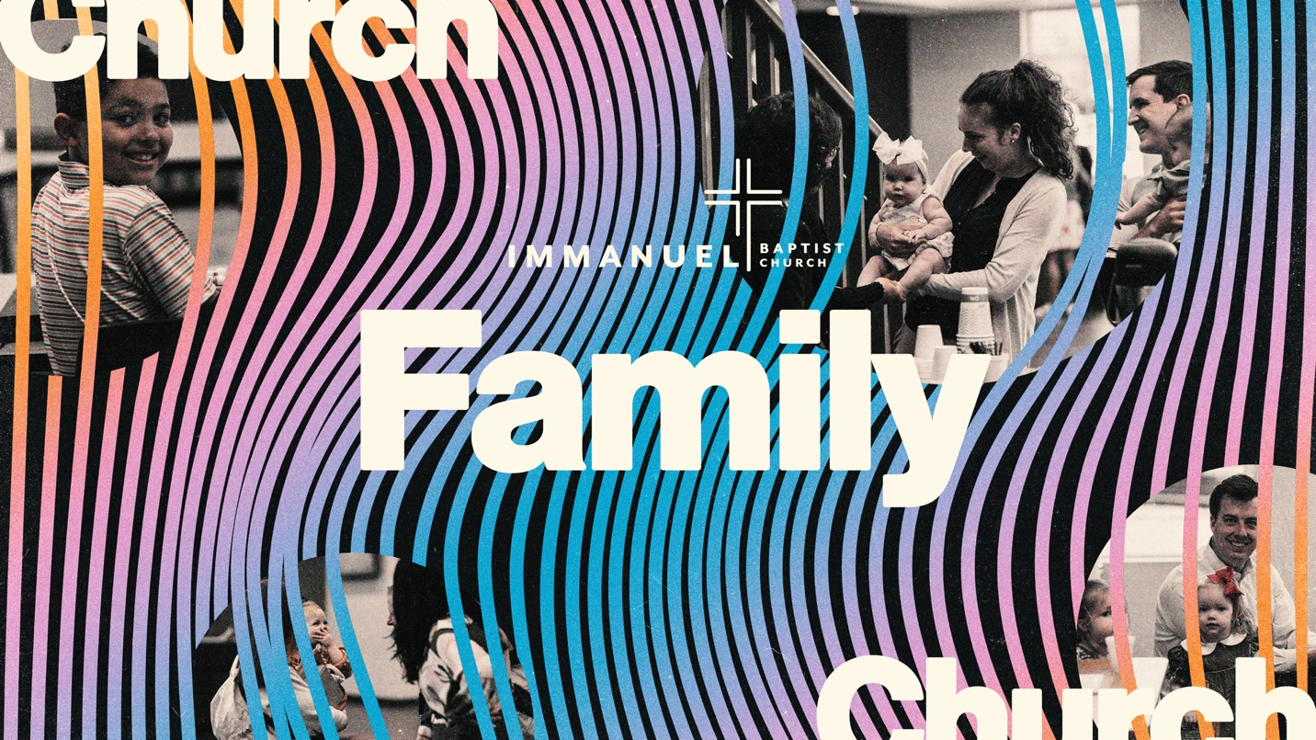
Immanuel Baptist Church
Series: The Church is a Family
Lesson: We are CHildren of God
May 4, 2025
INTRODUCTION TO SERIES:
The Bible tells us that the church is a family—not just like a family—but a family. In this 4-week series, we are going to explore what this means. We hope to answer questions like:

- Lesson 1: How do we become children of God?
- Lesson 2: How does the New Testament teach about the church as family?
- Lesson 3: As a church family, how does the Bible tell me to treat others?
- Lesson 4: How should I view my relatives and household in light of the church being a family?

A series like this for Immanuel can be helpful. To be honest, Immanuel seems like one of the most family-oriented churches around. There are many generational families represented within Immanuel. Of course, families whether nuclear, step, adoptive, generational, etc. all attending church together is a special thing. However, while as wonderful as this is, the danger is that we can neglect or fail to see the church as my family. It is possible to think my household family is my only family. It is helpful to remember that I am called to be family to fellow church members as well.
Our “Church is a Family” curriculum will not follow exactly with Pastor John’s sermons. For this next month, John currently has planned some stand-alone sermons relating to our High school senior graduation and also some sermons on parenting. In effort to align with a similar theme, we’ve chosen a series on how the church is a family.
INTRODUCTION TO LESSON:
To begin our series, we want to explain the theological basis for how a person becomes a child of God. We are given the opportunity to become children of God through Jesus. What did Jesus do to accomplish this? How can I become adopted into God’s family? How does this work?
Text and Explanation

Galatians 4:4-7
⁴ But when the fullness of time had come, God sent forth his Son, born of woman, born under the law, ⁵ to redeem those who were under the law, so that we might receive adoption as sons. ⁶ And because you are sons, God has sent the Spirit of his Son into our hearts, crying, “Abba! Father!” ⁷ So you are no longer a slave, but a son, and if a son, then an heir through God.

THEOLOGICAL BASIS #1: JESUS IS GOD’S SON

These verses succinctly explain that the reason we are children of God is because God accomplished it for us through His Son, Jesus. The Father and the Son made a way for us to be family. In God’s perfect timing, He sent forth His Son. Because a family relationship exists within the Father and the Son, so we too can become a family.
John 1:14 and 18 communicate the Sonship of Jesus. These verses read, “And the Word became flesh and dwelt among us, and we have seen his glory, glory as of the only Son from the Father, full of grace and truth… No one has ever seen God; the only God, who is at the Father's side, he has made him known.” At Jesus’ baptism, a voice from heaven announced that Jesus was God’s Son (Mt. 3:17). The voice from heaven was heard again at the Transfiguration and recorded by Peter, James, and John (Lk. 9:35). Then once more, the week prior to Jesus’ final week (12:1, 17-30).
More than there being a voice from heaven, Jesus personally claimed to be God’s Son. John 3:16 records Jesus famously saying, “For God so loved the world that he gave his Only Son, that whoever believes in him should not perish but have eternal life.” John 10:36 also records Jesus’ words: “Do you say of him whom the Father consecrated and sent into the world, ‘You are blaspheming,’ because I said, ‘I am the Son of God’?”
The ultimate proof of Jesus’ Sonship comes at His resurrection. Romans 1:3-4 state, “…concerning his Son, who was descended from David according to the flesh and was declared to be the Son of God in power according to the Spirit of holiness by his resurrection from the dead, Jesus Christ our Lord.”

THEOLOGICAL BASIS #2: JESUS, AS GOD’S SON, WAS BORN OF A WOMAN AND BORN UNDER THE LAW.

The means through which Jesus became man as God’s Son was through the virgin birth. Jesus, in the virgin birth, was born to Mary and conceived by the Holy Spirit (Lk. 1:35; Mt. 1:18). Again, succinctly, our Galatian’s passage says He was “born of a woman, born under the law.” As man, He lived under the law. This means that He lived under the same standards that we are held under. Just as we are tasked to obey God’s law, so was Jesus. Apart from Jesus becoming man and being under the law, we would not have the opportunity to become children of God. Without Jesus being born of a woman, our salvation could not have been achieved.
In the Old Testament, if people are to have a relationship with God, then people need to adhere to God’s law. People had to meet God on His holy terms. However, what is clear in the Old Testament is that no one was able to keep God’s law. In effect, the law revealed that every human has a sinful heart and nature. People’s sinful hearts found expression in disobeying God’s law.
Marvelously, the good news of Jesus is that He obeyed the law Himself and fulfilled the law’s requirements for sin to be atoned. Where we failed to obey, Jesus successfully obeyed. He achieved a righteousness that we could not attain on our own. Furthermore, not only did Jesus remain sinless, Jesus also died to pay the penalty of our sins. He satisfied the just payment that the law requires in order for sins to be forgiven. It’s marvelous! Indeed, in Jesus’ death and resurrection, we can be redeemed and forgiven from our sinful acts and our sinful nature.
Through our faith in Jesus, Paul tells us that we can move from enemies of God and slaves to sin to now sons and daughters of God. In accomplishing our redemption, Jesus makes it possible for us to become children of God.
Hebrews 2:10-18 supports this truth. Admittedly, this passage can have some confusing elements, yet the overall idea if pretty clear. In the passage, the author of Hebrews gives explanation that Jesus is a perfect savior because He shared in flesh and blood. And since Jesus became a perfect savior as a one who took on flesh, He is not ashamed to call us brothers. Hebrews 2:10-18 reads,
¹⁰ For it was fitting that he, for whom and by whom all things exist, in bringing many sons to glory, should make the founder of their salvation perfect through suffering. ¹¹ For he who sanctifies and those who are sanctified all have one source.^{[b]} That is why he is not ashamed to call them brothers,^{[c]} ¹² saying,
“I will tell of your name to my brothers;
in the midst of the congregation I will sing your praise.”
¹³ And again,
“I will put my trust in him.”
And again,
“Behold, I and the children God has given me.”
¹⁴ Since therefore the children share in flesh and blood, he himself likewise partook of the same things, that through death he might destroy the one who has the power of death, that is, the devil, ¹⁵ and deliver all those who through fear of death were subject to lifelong slavery. ¹⁶ For surely it is not angels that he helps, but he helps the offspring of Abraham. ¹⁷ Therefore he had to be made like his brothers in every respect, so that he might become a merciful and faithful high priest in the service of God, to make propitiation for the sins of the people. ¹⁸ For because he himself has suffered when tempted, he is able to help those who are being tempted.
Again, Hebrews 2:10-18 has parts that could be hard to understand and we don’t want to take the space to dissect it in detail, but the overall gist is clear enough: Christ is our brother because He saved us. Since He is the Son of God and we too are children of God, that means, He is our brother.

THEOLOGICAL BASIS #3: WE BECOME LEGITIMATE CHILDREN OF GOD BECAUSE WE RECEIVE THE SPIRIT OF THE SON.

Catch this! We are legitimate children of God because we have received the Spirit of the Son!
So… be sure to follow this: because Jesus is the Son of God, and because believers have the Spirit of the Son within them, believers therefore really are children of God. When we consider the doctrine of the Trinity, we recognize that God is one and yet there are three Gods and each God is fully God. Admittedly, this truth is mind-blowing and seems incomprehensible. Again…One God. Three Gods. Each God is fully God. The Holy Spirit, as the third member of the Trinity, is one with Jesus. Jesus, as God’s Son, gives us His Holy Spirit to dwell within us. We therefore have the Spirit of the Son living within us! Galatians 4:6-7 states, “And because you are sons, God has sent the Spirit of his Son into our hearts, crying, ‘Abba! Father!’⁷ So you are no longer a slave, but a son, and if a son, then an heir through God.” Romans 8:15-16 is a parallel passage and states the same: “For you did not receive the spirit of slavery to fall back into fear, but you have received the Spirit of adoption as sons, by whom we cry, “Abba! Father!” The Spirit himself bears witness with our spirit that we are children of God.”
Other Scriptures also stress this truth.

- 1 John 3:1 - “See what kind of love the Father has given to us, that we should be called children of God: and so we are.”
- John 1:12-13 reads, “But to all who did receive him, who believed in his name, he gave the right to become children of God, who were born, not of blood nor of the will of the flesh nor of the will of man, but of God.
- Ephesians 2:19 says, “So then you are no longer strangers and aliens, but you are fellow citizens with the saints and members of the household of God.”

Discussion Questions:
- Does the truth of being a child of God, stir up any particular emotion or attitude about your relationship with God?

- The truth that we are a brother to Jesus, as Hebrews stated, is perhaps less talked about. Does this truth seem confusing in any way?

- Our Galatians passage contrasts the idea of sonship with being a slave. Compare and contrast a child and a slave. What are all the differences that you can think of?

- What do you think are the benefits of being a child of God?

- On a scale from 1-10, how hard is it for you to remember that you are a child of God? Are there certain contexts or situations where it is harder than others?

- How easy on a scale from 1-10, is it forget that others are also children of God? Does that ever happen? If so, what contexts are situations impact you?

Conclusions or Application
As a church family, we have no grounds for boasting
In a church family, because we all entered by faith alone through the work of the Father, Son, and Spirit, there is no ground for boasting over anyone else. No one has entered the family of God by any merit of their own. God gets the glory! Believers are equally loved by God and true children of God. When the Bible teaches on the household of faith, the activity of God is stressed. In fact, the same is true for our relatives and households. A child does not do anything to be physically born into their particular family. Neither does a child technically choose to adopt a set of parents. Rather, parents choose to give birth to children. And parents choose to adopt children. A similar principle in explained in the Bible—God does the action. Notice these verses and who does the action:
- Hebrews 2:10, 17-18 – ¹⁰ For it was fitting that he, for whom and by whom all things exist, in bringing many sons to glory, should make the founder of their salvation perfect through suffering…¹⁷ Therefore he had to be made like his brothers in every respect, so that he might become a merciful and faithful high priest in the service of God, to make propitiation for the sins of the people. ¹⁸ For because he himself has suffered when tempted, he is able to help those who are being tempted.
- John 1:12-13 - …he gave the right to become children of God, who were born, not of blood nor of the will of the flesh nor of the will of man, but of God.
- Ephesians 1:4-5 - even as he chose us in him before the foundation of the world, that we should be holy and blameless before him. In love he predestined us for adoption to himself as sons through Jesus Christ, according to the purpose of his will,
- Gal. 4:4-6 - God sent forth his Son, born of woman, born under the law, ⁵ to redeem those who were under the law, so that we might receive adoption as sons. ⁶ And because you are sons, God has sent the Spirit of his Son into our hearts, crying, “Abba! Father!”

