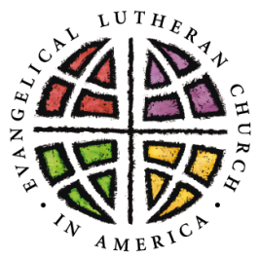
WHITNALL PARK LUTHERAN CHURCH
REGISTRATION FORM
2025 - 2026

Circle All That Apply: Sunday School First Communion Confirmation Youth Group

Child’s Name _________________________________ Preferred Name _______________________

Age _______ Birthdate (MM/DD/YYYY) ________________ Grade Entering (School) ___________

Name of School________________________________ Date of Baptism (MM/DD/YY) ___________

Address ___________________________________City, State, Zip____________________________

Youth’s Cell (__)_________________Email______________________________________________
Mother’s Name________________ Cell (__ )______________ Email_________________________
Father’s Name ________________ Cell (__)______________Email___________________________
Mother’s Employment_______________________________________________________________
Father’s Employment________________________________________________________________
Emergency Contact & Phone __________________________________________________________

Important Needs (allergies, special needs, etc.) ___________________________________________

Brothers and Sisters Name__________________ Age _________

Name__________________ Age _________

Name__________________ Age _________

Special Interests (Sports, Music, Scouts, Art, Books, etc.) __________________________________
__________________________________________________________________________________

Additional information you would like us to know? ________________________________________ ___________________________________________________________________________________

**I give permission to take my student’s photo during church projects and events and used on the church website without identification. Circle: Yes No

**We value the help of our incredible parents and/or teacher volunteers on Sundays and Youth Events to provide the best experience for our kids. Are you available when needed? Circle: Yes No

Parent Signature _______________________________________ Date ________________

