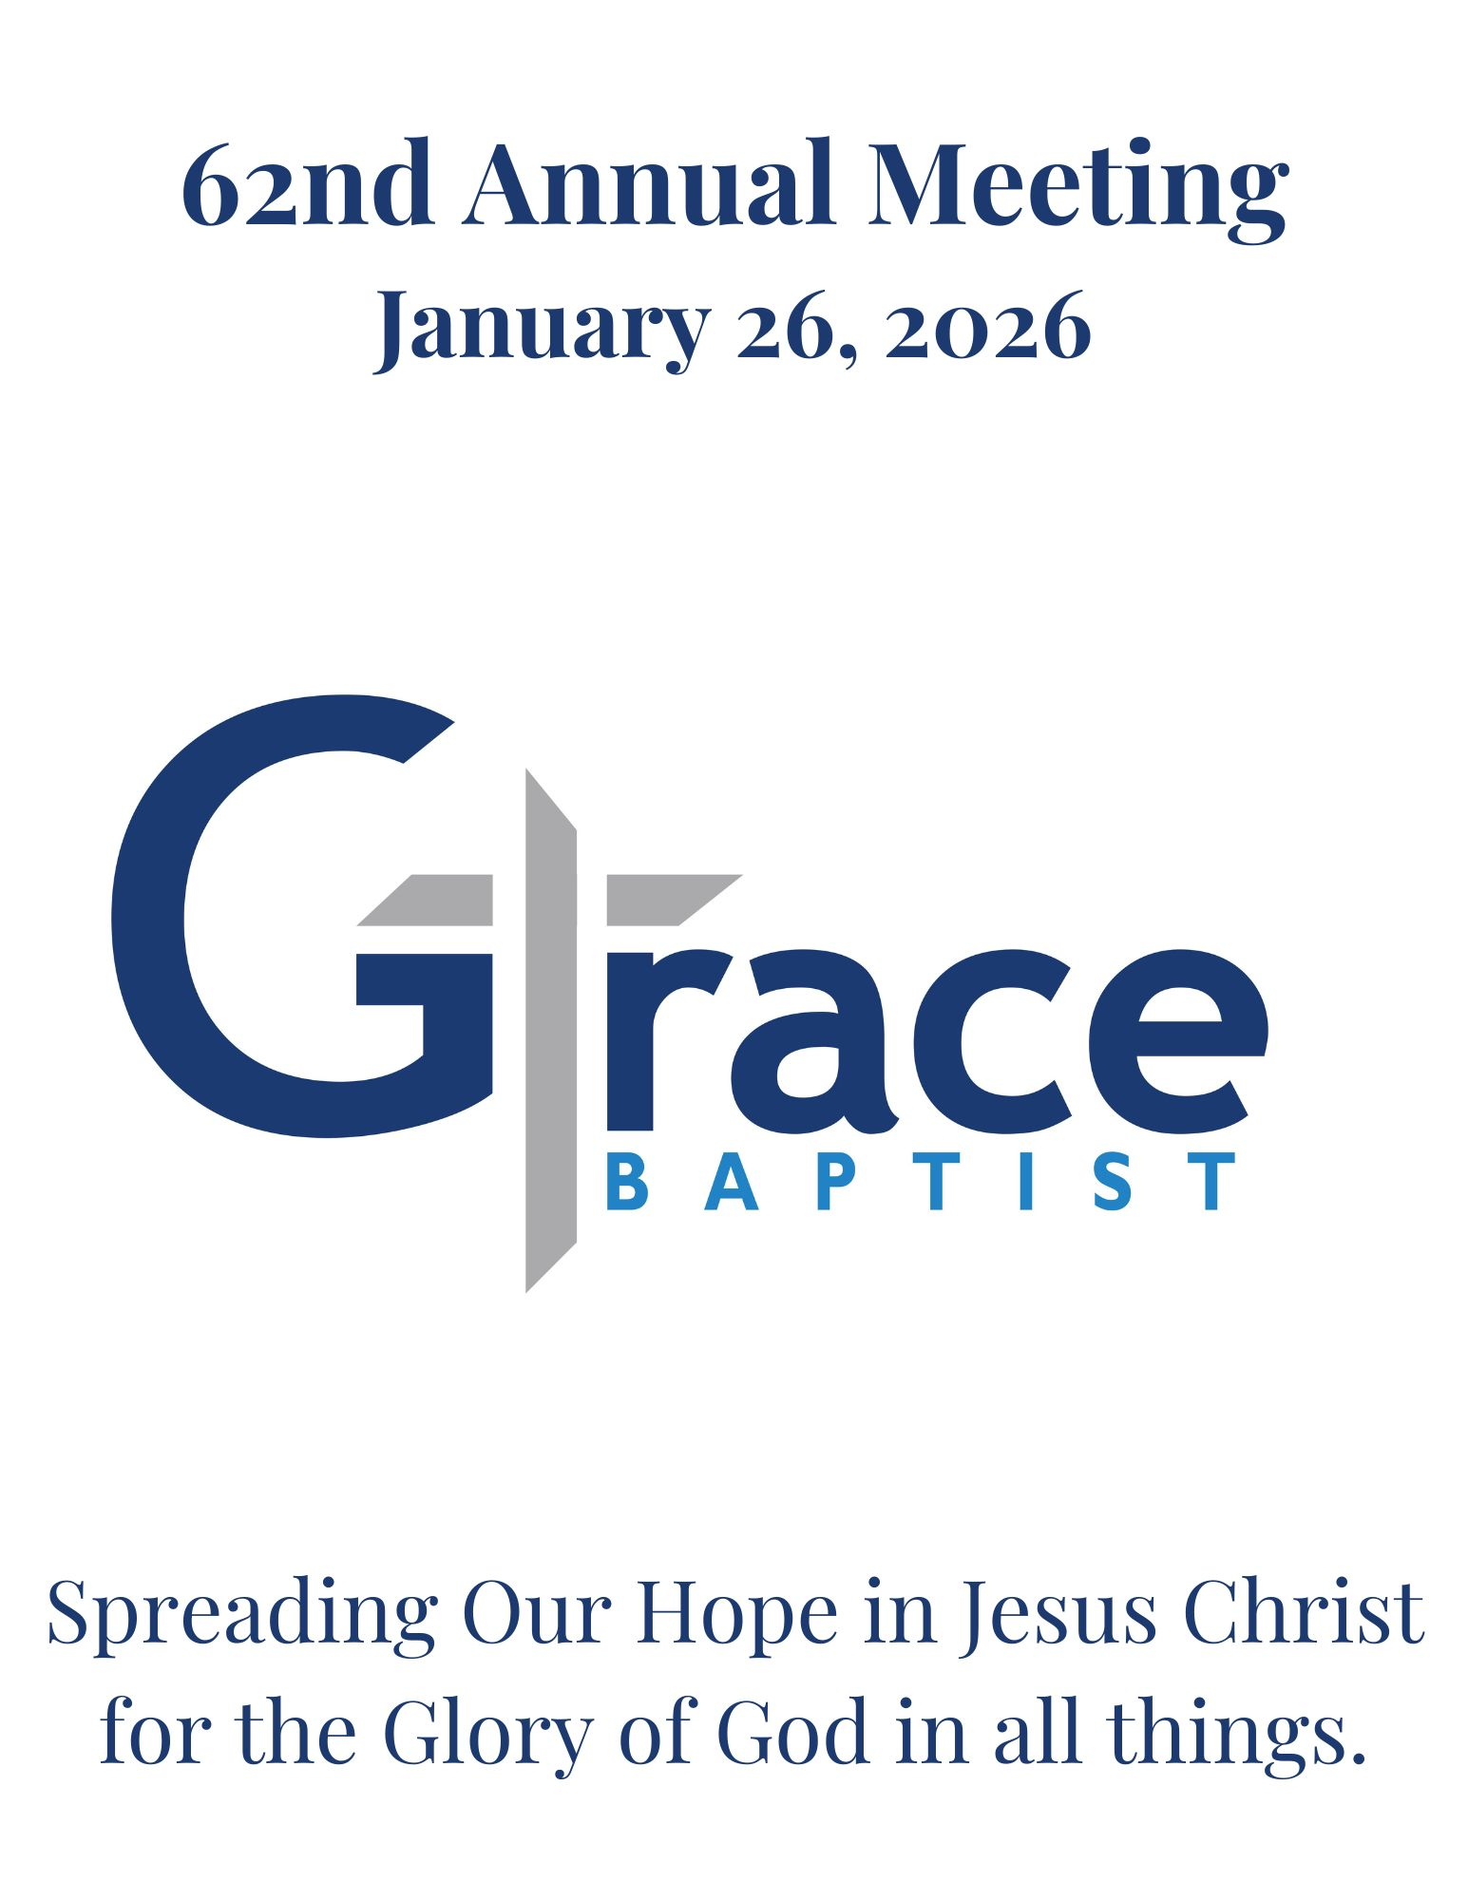
Table of Contents

Elders Report………………………………..3

2026 Grace Ministry Vision………………...4-6

Ministry Reports…………………………...7-12

2026 Budget Proposal Notes……………..13-14

2026 Proposed Budget……………………15-18

2025 Budget vs Actuals…..………………19-22

Clerks Report………………………………...23

2025 Annual Meeting Minutes…………...24-26

2025 Grace Ministry Vision……………...27-29

2026 Grace Ministry Family……………...30-34

Elders Report

The Elders regular ministry in 2025 focused on several items:
- Regular prayer for the Grace family.
- Leading Grace Groups
- Meeting with Deacons and coordinators and ministry teams to communication the Grace Vision and to aid them in ministry planning

As 2025 began we started the year with 14 deacons and 7 coordinators who led 18 ministry teams. The elders and staff rejoice to have so many beloved partners in ministry who work so hard. Many of the ministry reports in this annual report describe their ministry in 2025. During the spring we also called Pastor Doug Frazell to serve as an Associate pastor concentrating on outreach, discipleship, and fundraising. Calling Pastor Doug is a three-year process where we hope to use less reserve funds each year until Pastor Doug is fully funded in the regular budget. The spring also included multiple meetings with elders, deacons, and the congregation to consider how some new challenges and opportunities (e.g., Increase worship attendance, Waverly Christian School, and others) impacted our upcoming building design plan.

The elder team consisted of Pastor Jim, Paul Shepard, Karl Korporal, and Dan Bolin. Rob Stewart had completed his three-year term and didn’t feel called to continue as elder, though he continues to teach and serve in the Sunday Alive ministry. RJ Herra attended a number of elder meetings as part of serving as an internship to learn about leadership in the local church. In 2025 Karl Korporal finishes a three-year term and will take a break in 2026. Grace has been blessed to enjoy Karl’s elder leadership for over 12 years. We look forward to some elder nominations at the 2026 annual meeting.

In 2025 our regular elder meetings included staff pastors – Doug and Josh as well. Our regular meeting consists of strategizing about the Grace mission, discussing Grace worship services, shepherding needs, elder ministry training, prayer, and wrestling through the scriptures. What a joy to work together with Karl, Paul, Dan, Doug, and Josh. The sermon texts provide ways for us to pray for Grace but also give us direction as we consider both the shepherding needs and ministry opportunities of Grace. The elders and staff also oversee grace groups, visit Grace family members as part of shepherding, participate in men’s discipleship ministry and communicate with the deacons and ministry teams.

In 2026 we look forward to starting our fundraising for our building expansion. We hope to increase elder training, mentoring lay leaders, and inviting new elders into the team. We will continue to expand the number of Grace Groups. Grace groups provide opportunities for the Grace family to build spiritual friendships, pray for one another, encourage each other toward faithfulness to Christ, talk with each other about God’s Word and work in their life, and care for each other during struggles and crisis. We are honored to serve and lead the Grace family. We enjoy friendships, partnerships, and many joys as we see God working in your lives. We are thrilled with the new people God has brought our way, the new members, the baptisms, and the spiritual growth we see in our beloved church family.

The 2026 Grace Ministry page that follows the elder report describes the Grace vision and emphasis for 2026. We covet your prayers and partnership as we work together.

Paul Shepherd
Karl Korporal
Dan Bolin
Jim Lee

2026 Grace Ministry Vision:

- Grace Family Mission: Spreading our Hope in Jesus Christ for the Glory of God in all things!
Every Ministry activity falls into one of these four priorities:

Worship: Delighting in God through the ministry of the Word and prayer.

Community: Living the ‘one-another’s’ as we Pursue our mission TOGETHER

Discipleship: All ages established in the faith and equipped to serve

Mission: Spreading our hope in Jesus locally & globally

- 2026 Ministry Focus:
What are we asking God to do?
What we aim to do believing God will work in our working.

As the staff and elders and deacons considered the strengths, weaknesses, and opportunities for Grace ministry, below are the key items that the elders and staff believe God desires us to focus on in 2026. Ministry teams will work on specific work goals for their area. These focuses do not define all of Grace family ministry, rather these areas will receive extra ministry focus in 2026:

Prayer Ministry

Facility Design

Intergenerational Discipleship Ministry

Mentoring lay leaders

Local Outreach

For Each of the 4 core priorities we identify and describe the ministry that reflect this priority, plus we describe the 2026 emphasis (IN BOLD BELOW) for each ministry priority.

- 2026 Worship
- We aim for God-glorifying, biblically saturated, & Christ-exalting worship that includes preaching and participation, with undistracted excellence, that involves our heads (reason and truth) and our hearts (affections and delight). We plan for congregation participation in testimony, Scripture reading, and prayer, plus ministry moments, heritage/legacy moments, and communion in the Worship service.

- Gospel Transformation: Intentional ministry efforts aimed to help the Grace family treasure Christ , live God’s gospel, and pursue a transformed life through the renewal of their minds.

- PRAYER: We aim to increase regular prayer for staff, worship, ministries, teams, and the Grace family.

- 2026: Community
- Grace groups: Our main ministry to encourage one another to follow Christ and to live the ‘one-another’ commands of Scripture. We aim to train and encourage the group leaders and to increase the number groups as needed to shepherd the Grace family. We continue to aim at 100% of the church family involved in Grace groups.

- Expanding and Equipping Grace Deacons and teams to multiple member ministry. Re-organization of ministry teams and training men and women servant leaders who are able to lead ministry teams. Reshaping some staff responsibilities and hiring of additional staff for ministry administration, discipleship, and outreach.

- FACILITY DESIGN: A regular effort to communicate building design and the budget and raise the funds, beginning of with the first 420,000 in the 2025 budget.

- 2026: Discipleship Ministry:
- The age-related and segment discipleship ministries (ALIVE & PULSE, Women’s, Men’s) will use these church-wide focuses to shape their 2025 ministry efforts.

- INTER-GENERATIONAL DISCIPLESHIP MINISTRY: intentional efforts at inter-generational (older-to-younger) interpersonal discipleship among the Grace family and in Grace families.

- MENTORING/ LAY LEADERS & SEMINARY: Mentoring and internships among the Grace family to train lay-leaders & potential future pastors

- 2026 Mission Outreach
- Personal Local Ministry: Increased focus on personal ministry to people outside of the Grace family - through relationships, community involvement, and service.

- Global Partners and Global Pastoral Training: Partnership with TLI and pastor Jim to train new global pastors.

- LOCAL OUTREACH: Increased local ministry to people outside of Grace through the gospel outreach team and the mercy outreach team.

- 2026 Giving & Growth
- To see Grace family giving increase by 10% in 2026
- 20% increase in the number of people coming to some ministry of the Grace family.
- To see a 10% increase in the number of people becoming part of the Grace Family (membership)

Ministry Reports

Facilities team Ministry report
The facility team is happy to report that during 2025 we were able to continue to work on our mission to maintain and enhance the facilities that the Lord has provided for us.
2025 God brought us some challenges that we were able to work through.
We were able to work on many projects including minor plumbing repairs, lighting fixtures, door rearrangements, electrical repairs, ceiling tiles, furnace repairs, improved emergency exit lights and new fire extinguishers.
There were some major changes to our facility that included building new offices for Jessica and Doug as well as replacing the roof on the church as well as the parsonage.
Our goal in 2026 is to continue to serve our God by being good stewards of the gifts that we are given. We hope to be able to make improvements by making plans for updating our heating and cooling systems, repairing sections of the parking lot and continuing maintenance work.
“But when the goodness and loving kindness of God our Savior appeared, he saved us, not because of works done by us in righteousness, but according to his own mercy, by the washing of regeneration and renewal of the Holy Spirit, whom he poured out on us richly through Jesus Christ our Savior,”
Titus‬ 3‬:4-6‬‬‬‬‬‬‬‬

ALIVE Sunday Morning Children’s Ministry In 2025 our ministry focused on coming alongside families to help encourage them in raising the next generation for Christ. We are thankful for the great response we had to our major events like Family Night Out, Vacation Bible School, and Parents Night Out. We enjoyed hearing all the great feedback from these events and building memories with the families at Grace. In 2026 we hope to continue to use our ministry to help families and be an encouragement to them.

ALIVE Wednesday Evening
In 2025 we continued going through the New City Catechisms. We ended the spring just beginning to explore the 10 commandments and started them again in the fall. We also do 5 Global weeks during the year where we learn about a continent, a missionary whom we support, and a snack from another culture. We are thankful for around 30 children joining us on Wednesday Evenings. We are super grateful for all the workers on our Wed evening team who have come alongside us this fall and made the program run well.
We also are working on learning memory verses in order to earn a treat at the end of the year. The children are doing good most of them know our 2025 theme verse 1 Timothy 2:5
We had fun doing the Fall Kickoff and look forward to doing that again next fall.
In 2026 we will move out of the 10 commandments into questions about the law & God. We will have a fun end of the year party in May.

Mercy Outreach Ministry Report
In 2025, the M.O team focused on sharing Christ-centered care to our church family and those in the community by offering tangible and urgent needs to reflect hope and love.
We are thankful for our partnership Alternatives Pregnancy Center and hosting both the Baby Bottle Drive in January and the Christmas Tree family gifts in December. We also partner with C.A.N. as a distributor for gas cards. We are grateful for the church family in giving to the Benevolence fund so we could assist Grace Family members and families in the community in need.
Highlights this year were the team praying over the gas cards to be distributed.
Team member Kerri Karjsens also volunteered to give a “May Day” basket to a church family member in the nursing home. They had a wonderful visit together and it was a sweet moment.
It is amazing to see people bring forward family names to bless with Thanksgiving Baskets. Our goal was 20 baskets and we received the complete list days before distribution.
In 2026 we hope to repeat a similar schedule of events from 2025.
We will be pursuing the giving of clothes via a partnership with Trinkets in Togs. We will ask if they can create a voucher for people in need to purchase clothing/shoes.
We may also look into doing a clothing drive next summer as we are aware that clothing is a need in the community.

Global Ministry Report
In 2025 our ministry focused on global missions. Each month we prayed for different mission partners. These partners were highlighted in the church emails so that the entire church was able to participate. We are thankful that the entire Grace family joined us in prayer for our
Partners.
We enjoyed a spring global lunch in March, when we ate food typical of the Democratic
Republic of Congo. It was a highlight to Zoom with Rebekah Moyer in the DRC after we ate our
meal. We supported our gathering at Secret Church, where nearly 30 people studied the gospel
of Matthew and joined in intense prayer for the persecuted church around the world.
We were encouraged by letters from Rebekah regarding her work in the DRC, as well as seeing the children at VBS contribute money to a project for Rebekah there. We were blessed by a visit from missionaries Jesse and Sarah in July.
In 2026, we hope to increase awareness of our global missions by working with the Welcome
Team to place our mission maps and information in a space where it is more visible. We will
continue the monthly prayer partners

Hospitality
In 2025, our ministry focused on making the church feel as warm and welcoming as its
people. We are thankful for our wonderful team, all of whom have servant hearts and
take joy in serving the lord with their time and resources. We enjoyed working together
to decorate the church for all the seasons, to start the process of redoing the foyer,
creating a welcome table, and working with other teams to help them accomplish their
goals inside of the church. In 2026 we hope to continue to pursue our mission of making
the church feel as warm and welcoming as its people, finish our work on the foyer and
welcome table, and implement organized solutions to a handful of currently
disorganized systems within the church (namely storage).

Gospel Outreach
In 2025, the Gospel Outreach Team focused on opportunities to connect with our neighbors in the community to share the light and love of Jesus Christ. We are thankful for the Lord bringing together so many people at Grace to help with the Easter Egg Hunt and the Harvest Festival events, as well as a summer block party that was held. We are encouraged by the number of community members who participated in each of these events, and look forward to our team planning meeting in early 2026, at which time we will strategize and plan for more opportunities to share the Gospel in our community.

Pulse
In the Spring of 2025 we finished out our series on Solid Foundation 2.0. We were working through the end of the New City Catechism, and we ended with Question 52: “What hope does everlasting life hold for us?” This prompted us leaders to desire to do a series on The Afterlife, which we successfully began in the Fall.
We are thankful for God’s grace and providence in the students' growth in their understanding of God at the core of who He is. We asked and answered the simple questions to help us to know Him, what His Word says, and why He created us.
We enjoyed the Ignite Youth Leadership Conference in March with 4 leaders, and 9 students. We had a successful Christmas party, as well as a successful day out to Lost Island Theme Park.
In 2026 we hope to finish our first series: The Afterlife (6 weeks on Hell, 7 weeks on Heaven), and then we’ll move into a series on The Upper Room (John 13-17 for 13 weeks), and then we’ll close out the year with Lessons from the Lives of Flawed Saints (6 weeks). The third week of every month we are doing a hymn sing. We pick a hymn, look at its context, author, history, and scriptural ties, and then sing it together.

Pulse Plus
In the Spring of 2025 we finished our series on Hard Sayings; we looked at some of the most difficult texts from Scripture and helped bring peace to our minds and understanding of these texts, by God’s grace and the Spirit’s power. We also looked at how we contend for the faith when faux-Christians and Liberals aim to undermine the true meaning of Scripture.
We are thankful for God’s grace and providence in the students' growth in their understanding of God, especially in some of the difficult and more obscure texts from Scripture.
We enjoyed going to the Ignite Youth Leadership Conference in March with 4 leaders, and 9 students. We also enjoyed a successful Christmas party.
In 2026 we hope to continue in the series we are already in by making a continued effort of focusing on 1 Corinthians 4:18, “We look not to the things that are seen but to the things that are unseen. For the things that are seen are transient, but the things that are unseen are eternal.” In following the reality of this passage carried out in everyday Christian life, we are aiming to help the students see our unseen God. Asking questions like; “How may God be known?” “Has God Spoken?” And “What is the deity of Christ?”

Women’s Ministry
Throughout the year 2025, we have seen many opportunities for fellowship and spiritual growth together. A new thing that we tried this year was we invited women to host a handful of other women into their home over a meal they prepared. Between these dinners, Bible studies, women’s conferences and other various small group gatherings that occurred, the women of Grace were invited to join where their interests aligned. We will finish our year with our annual Christmas meal, which is always well received and attended. Our prayer was that these gatherings provided more connections with women that they may not have had before. We hope to continue offering opportunities where ladies of all ages can connect and grow on a personal and spiritual level.

Care Team
In 2025 we started the Care team. This team's focus has been continuing Rose Meyer’s birthday and anniversary card ministry, sending cards of encouragement to Grace Family members, as well as visits to shut-ins. We enjoyed being able to send Christmas Cards to the young adults that are in college. We are thankful for the donations of cards to this ministry. In 2026 we plan to continue doing the same things.

Young Adults
In 2025 our ministry focused on Young Adult Discipleship. A big part of that process has been Pastor Frazell getting to know this wonderful group of young people. A bi-monthly study of 1 Peter began in June, with Doug taking over this ministry, and continues into 2026. The group meets 2x a month in the Frazell home and both Doug and his wife Allison have enjoyed walking with this group. We have seen many of the college kids jump in and join us during the summer months as well as holiday breaks…and the group has done significant outreach to Wartburg and other area college kids to invite them to not only our Bible Study but to church as well. Pastor Frazell has spent a large chunk of his ministry time getting to know the young adults, particularly the men, in one on one and group settings and seen many areas of growth in individuals as well as had the privilege to walk with many through challenging times. He is encouraged by the work the Lord is doing in sanctifying this group as well as seeing their hunger to know God by His Word. Our desire in 2026 is to continue to train this group, pastor this group, and encourage this group of God’s flock through the study of His word(1 Peter), prayer, and discipleship conversations. It has also been a blessing to see how many young adults desire to serve in the Grace body and remains a goal to grow in 2026…including the college age. We praise God for His work in this ministry!

Men’s Ministry
The purpose of men’s ministry is:
To build a community of men who equip and encourage each other to:
live as ‘courageous Christ-centered servants who take the initiative to spread the hope of Jesus and live for God’s glory in their personal life, in their families, their church, their jobs, and the greater world’.

In 2025 we formulated a men’s team consisting of: Pastor Doug, Pastor Jim, Thayne Boyer, Isaac Stultz, Doug Karsjens, Mark Deming, and Chuck Tinsley. This team partnered with Doug and Jim to map out a plan for men’s ministry in 2025.

Our ministry focused on two elements:

- Connection Events/Activities
Purpose: Cultivate – make connections, build friendships
Plant – Seeds of truth planted into hearts
Reap – Opportunities to invite others to trust Christ
In 2025 we began with ‘cultivating events” e.g., summer Barbecues.

- Living as Men: This was/is our regular monthly meeting. We eat, discuss God’s truth as to how men live to treasure Christ, and finish in prayer for each other. In the spring of 2025, we continued our focus on what God’s Word said on men’s habits of grace (prayer, Bible medication, friendships) and our roles as father, husband, and church member. In the fall of 2025, we began a yearlong study on the Attributes of God will go to the summer of 2026. We focus on what God’s Word says about a particular attribute of God, plus how that attribute contributes to God’s Saving work and how that attribute shapes the way we live.

In 2026, the men’s team will take responsibility to oversee and coordinate all the logistics of men’s ministry under the leadership of a men’s’ deacon The pastoral staff will work in partnership with the deacon to identify teaching topics and the pastors will both teach and train others to teach.

In addition to Connection Events/Activities and Living as Men, we will place an emphasis on Intergenerational Discipleship, mentoring, and strengthening spiritual friendships.

Here is the mission strategy for Holly Long’s ministry to women. Currently, she has a full schedule serving 7 women. The team of Pastor Jim, Paul & Alison Shepherd, Carolina Wilson, Jean Deming, and Sydney Herra, have met several times and provide guidance.

Miyshor Ministries
Rest, Rhythm, & Renewal in Jesus Christ

Miyshor Ministries exists to disciple individuals stuck in pain
(e.g., trauma, crisis, chronic illness) so they delight in Jesus Christ,
regardless of circumstances.

And this is eternal life, that they know YOU the only true God, and Jesus Christ whom you have sent.
John 17:3

Come to me, all who labor and are heavy laden, and I will give you rest. Take my yoke upon you, and learn from me, for I am gentle and lowly in heart, and you will find REST FOR YOUR SOULS. For my yoke is easy, and my burden is light.” Matthew 11:28-30

Our strategy at Miyshor Ministries includes:
- Learning from God’s word both who God is & who we are in Jesus Christ
- Learning daily rhythms for rest and renewal in our walk with Christ so we might glorify God with our soul, mind, and strength.

Why?
- We believe Jesus Christ came so that uneven, rough, realities in our life
might become a level plain – a Miyshor!

Every valley shall be lifted up, and every mountain and hill be made low; the uneven ground shall become level, and the rough places a plain. And the glory of the LORD shall be revealed, and all flesh shall see it together, for the mouth of the LORD has spoken.
Isaiah 40:4-5

- We believe God calls us to renew our minds by God’s Spirit with God’s Word,
and this renewal transforms how we think, what we love,
& how we glorify God in our bodies.

I appeal to you therefore, brothers, by the mercies of God,
to present your bodies as a living sacrifice, holy and acceptable to God, which is your spiritual worship.
Do not be conformed to this world, but be transformed by the renewal of your mind, that by testing you may discern what is the will of God, what is good and acceptable and perfect.*
Romans 12:1-2

Therefore, as you battle discouragement, distraction, or defeat we at Miyshor Ministries desire to come alongside you so God might deepen your rest and restore your joy in Jesus Christ and in God our Father.
2026 Budget Proposal Notes

This budget proposal involved several steps:
- The elders, deacons, and coordinators discussed the ministry vision & budget.
- The deacons, coordinators and ministry teams presented proposed numbers based on ministry plans.
- The elders reviewed the entire budget based on ministry goals and plans and developed an initial draft.
- The initial draft budget was reviewed by elders and deacons and coordinators.
- We invite you to review the proposed budget. The elders and deacons will summarize the vision and goals and answer questions on the budget at the annual meeting on Sunday January 25^{th.}

Income: (Prayed for/projected Income):
- The projected total giving consists of general fund + global faith promise.
- The general fund giving is projected to be 10% above 2025 budget to meet the challenge of our staff expansion plan.
- Our staff expansion plan is a 3 year plan with the goal of funding all of Pastor’s Doug’s salary in our regular budget after 3 years. In the first year, 2025, we planned for our 2025 budget to use $37,600 out of reserves and praise God we only needed to use $22,400. Our 2026 budget projects to use $16,558 from our reserves.
- We proposed the global faith promise budget to be approximately 10% of our total giving.
- We set a goal for projected benevolence budget.

Expenses:
- 6000 Adults:
Slight increases here. We reduced the total amount allowed for mileage for Director of women’s ministry (Susan Beichley) based on anticipated mileage reimbursement.

- 6100 – Community Outreach
Slight increases here.

- 6200 Hospitality
Slight changes here.

- 6300 Ministry Support and Resources
No changes

- 6400 Missions/Global Outreach
No major changes here.

- 6600 Office Expenses
Slight increases here.

- 6800 Pastoral Care:
Slight increases here

- 6900 Payroll
- The elders propose:
- The full-time pastoral staff uses the WSR school schedule with education and experience plus a recent salary survey of BCI pastors. The three pastors were comparable to the school district and Pastor Josh and Pastor Jim were slightly behind the average BCI pastors given education and experience.
- The elders propose a COLI (cost of living increase) equal to the Government COLI of 2.8% for Jessica, Jim, and Doug. The elders propose a 5% increase for Josh to bring him into average range for BCI Associate Pastors.

- 7000 Repair and Maintenance
Slight increases here for facility projects.

- 7100 & 7200 Insurance and Utilities
Slight utility increases.

- 7300 Worship & Prayer
Slight increases here for technology needs

- 7400 Youth & Children
We propose an increase in Pulse and Alive and the nursery because of the increased ministry efforts because of the number of kids we are serving and reaching

- 8000 - Faith Promise Support
- Our global mission budget increases slightly to reflect 10% of our total budget.
- A portion of our Faith-promise budget that is undesignated in 2026 is for Training Leaders International and Pastor Jim’s teaching trips and left undesignated in anticipation of future support for Rebekah Moyer in missions or additional an additional mission partner.

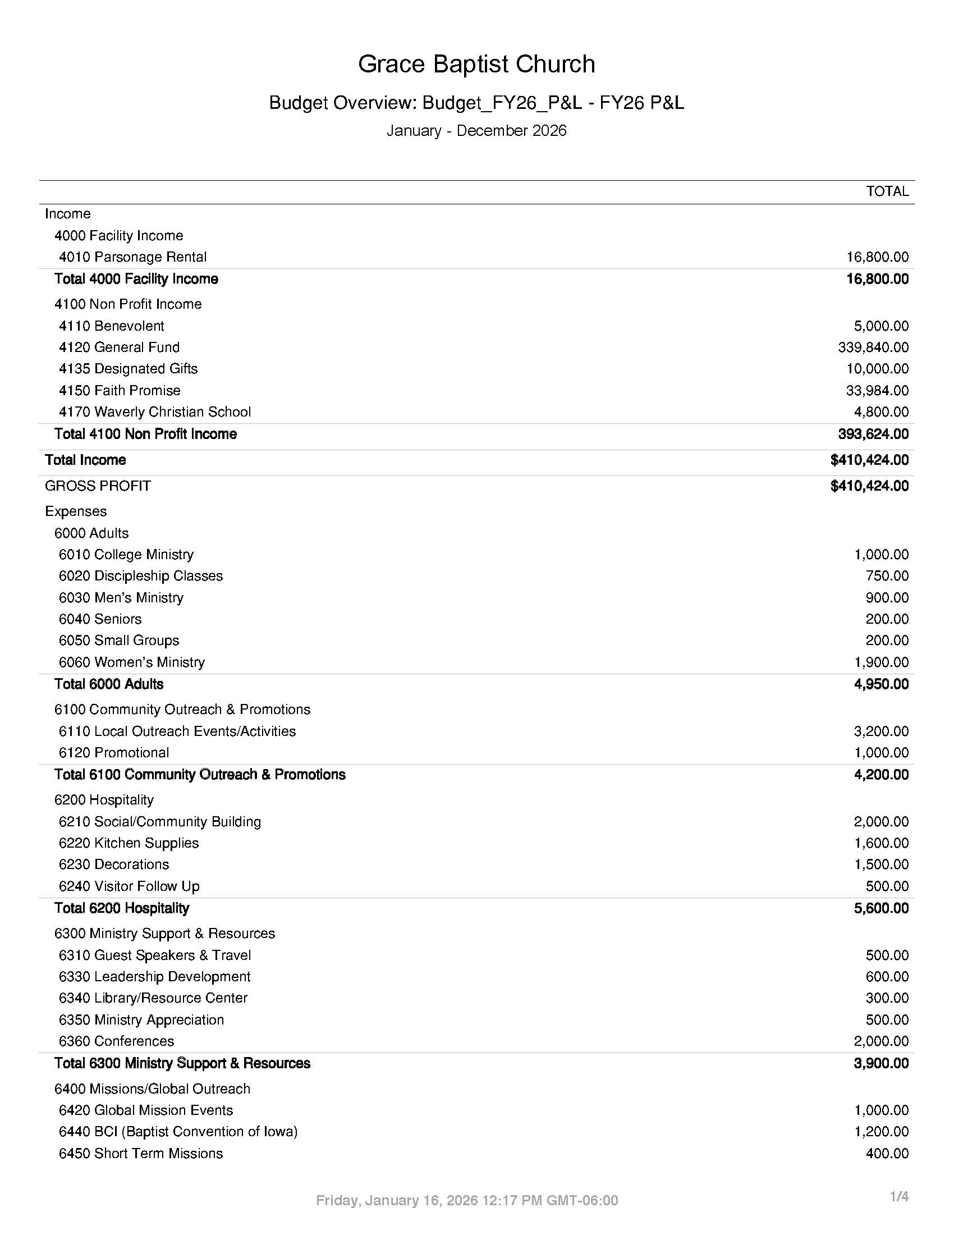

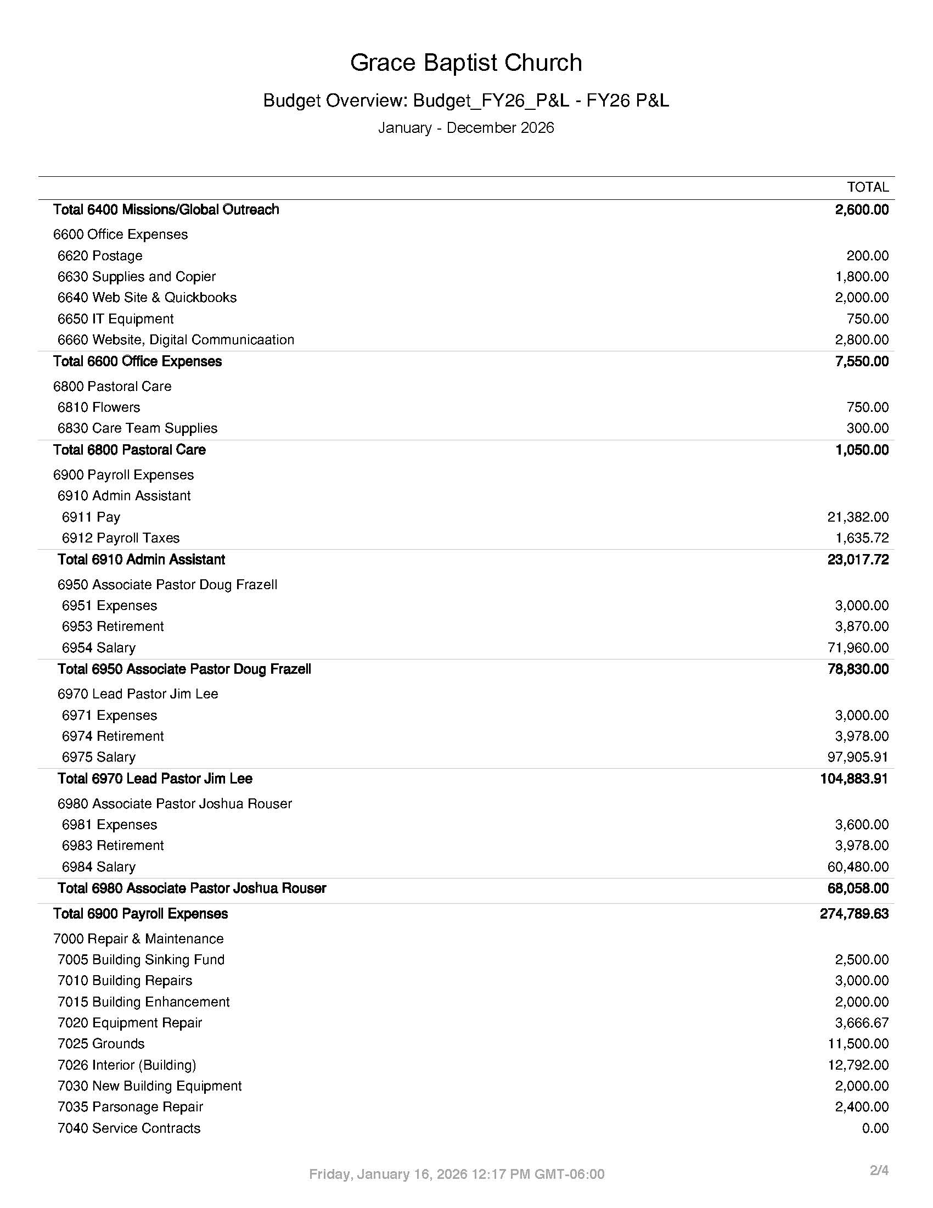

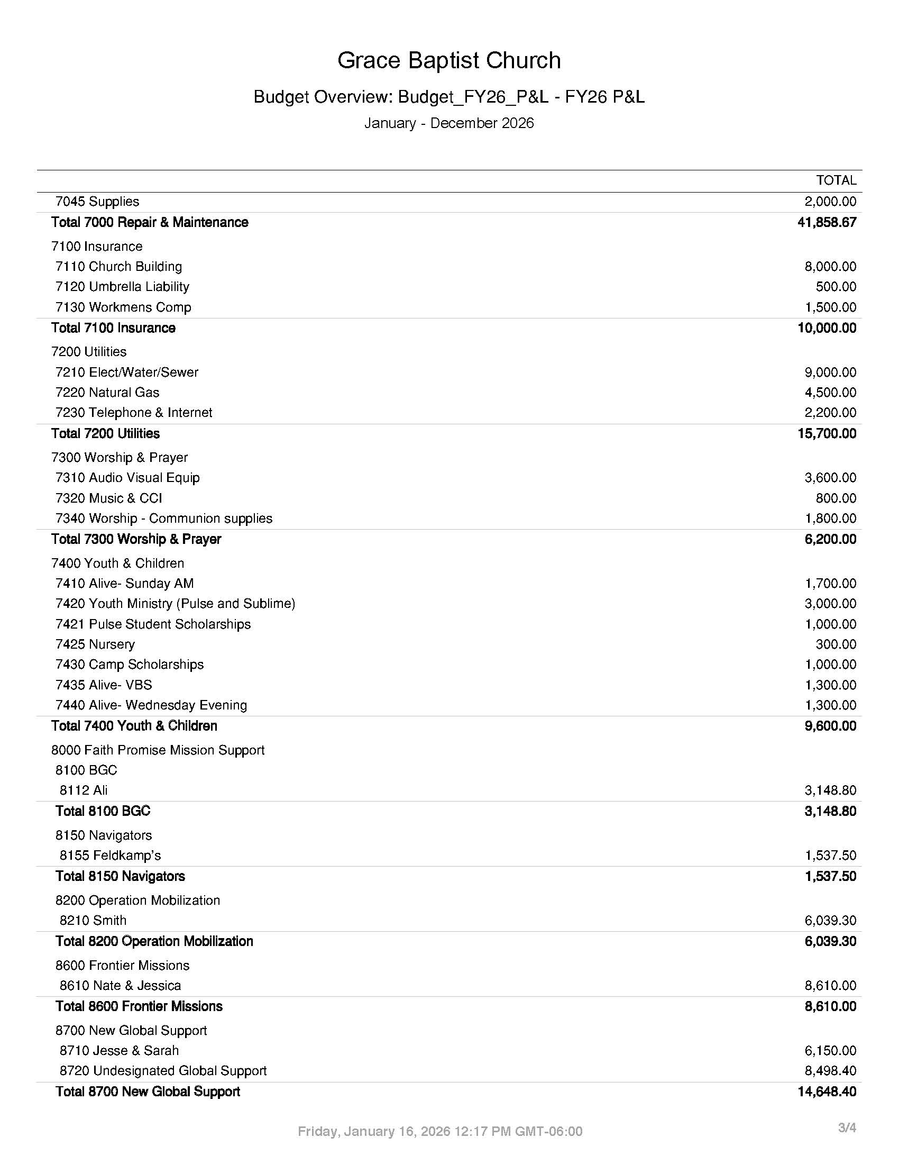

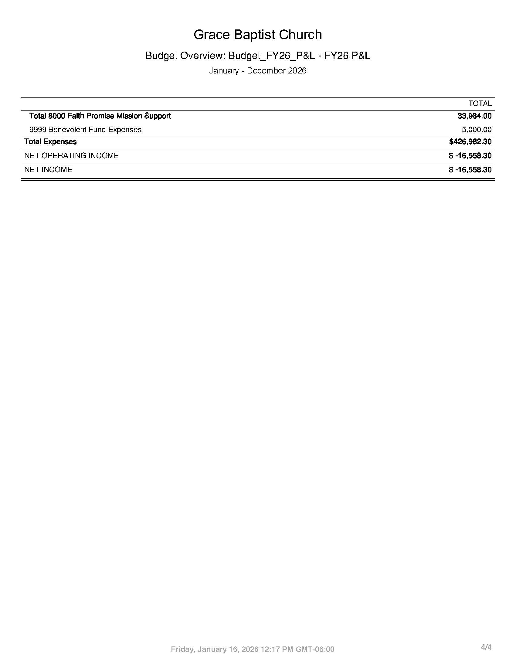
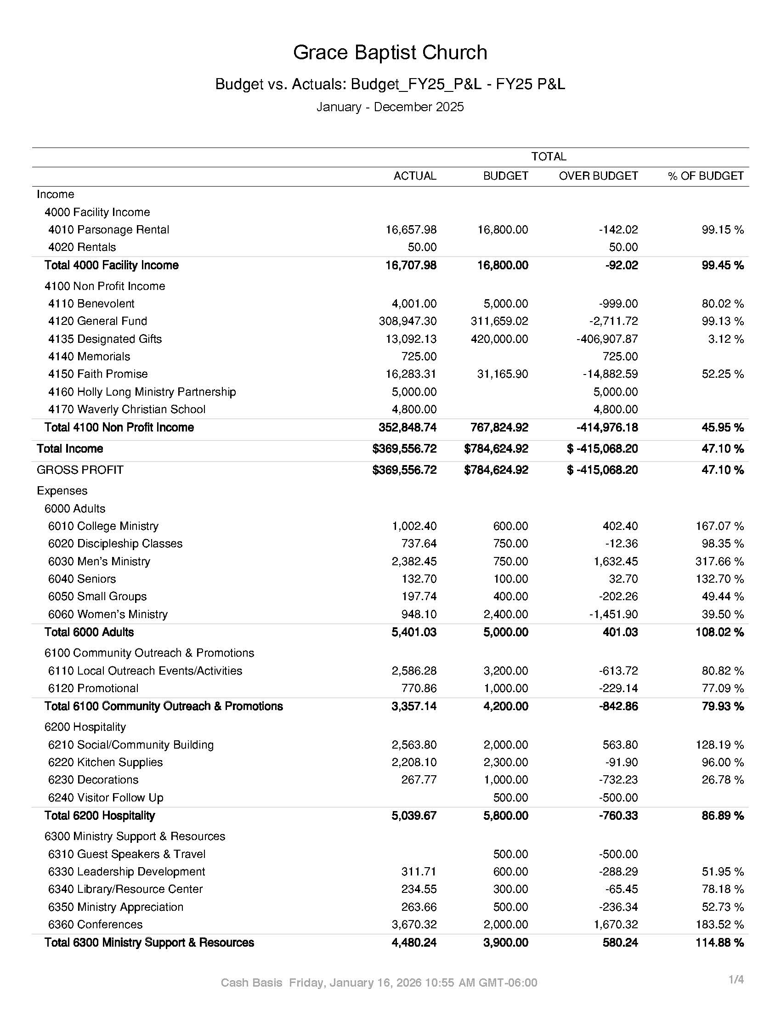

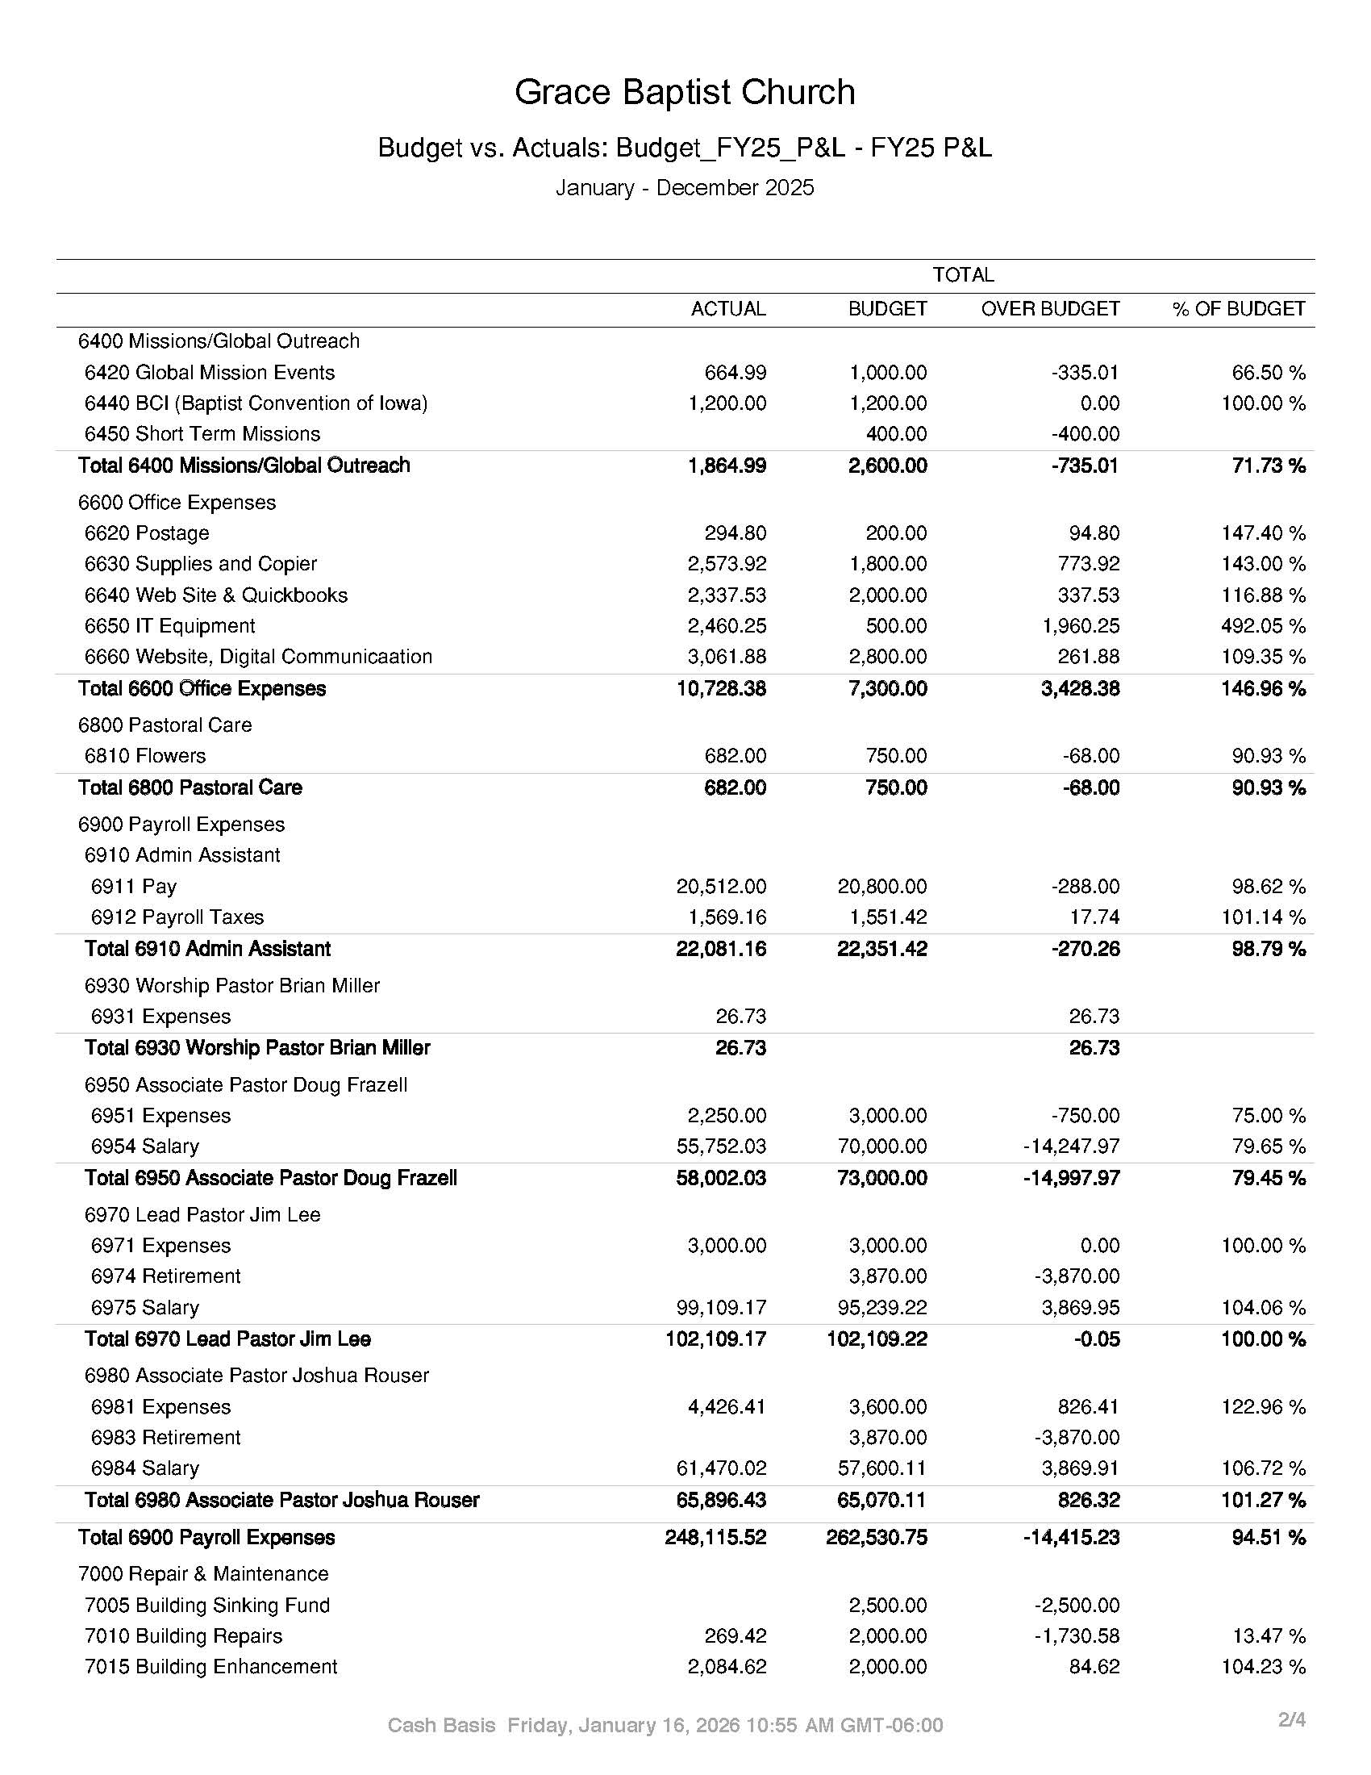

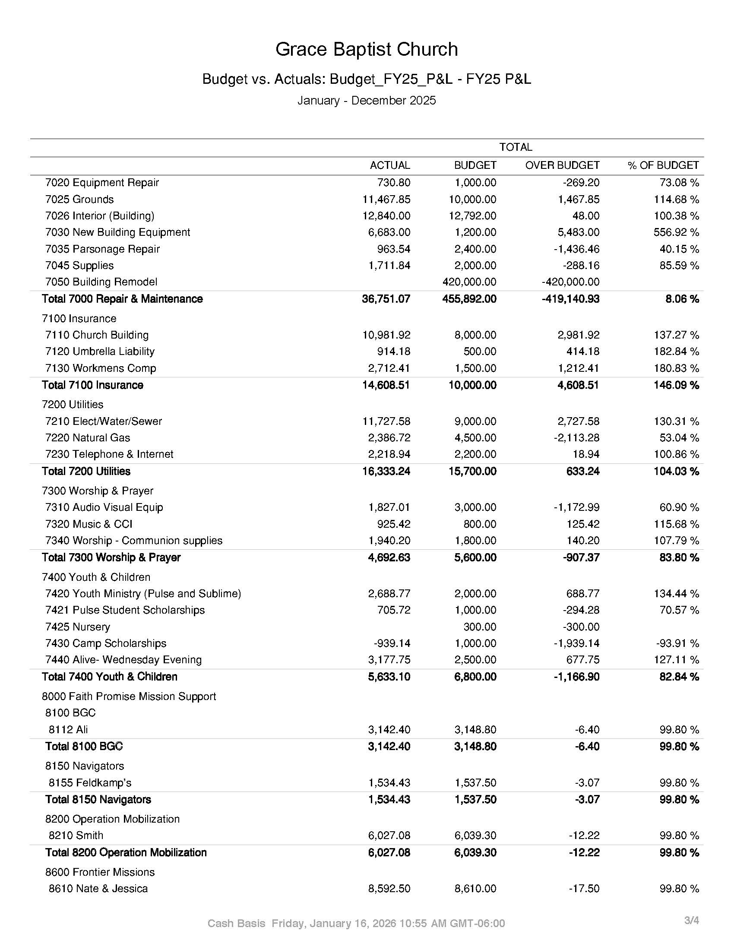

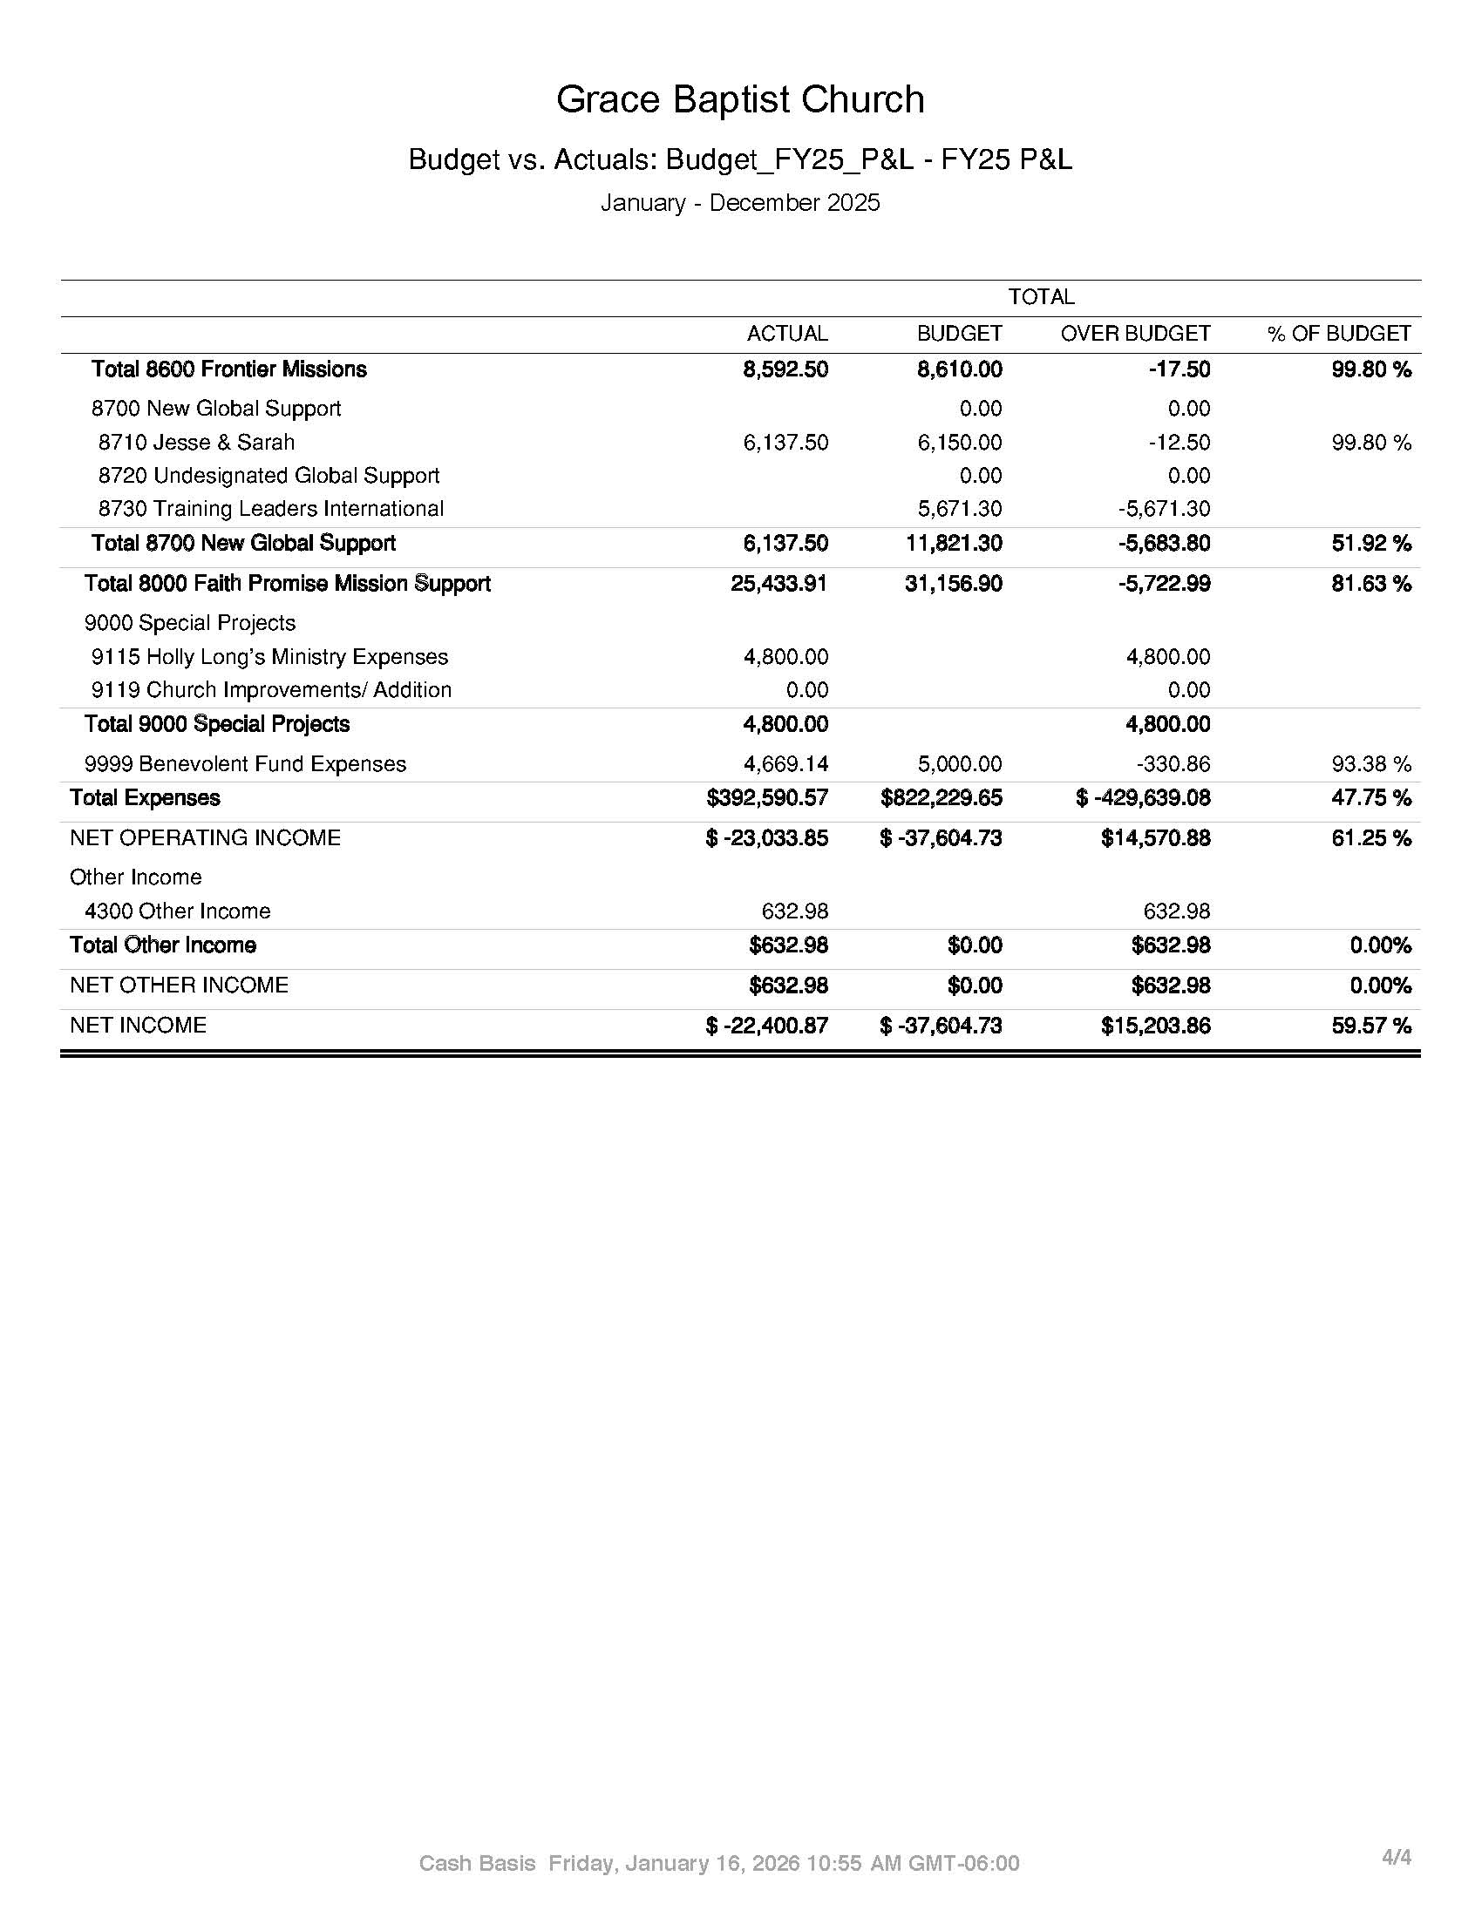

Clerk’s Report

Membership Total as of January 1, 2025: 122

Births in 2025:
-Isabella Brown
-Graham Cook

Baptisms: 13
-Kaylee Moyer -Daniel Roth
-Chloe Baldwin -Charles Tinsley
-Nick Allen -Wyatt Landers
-Joshua Ray -Leon Garbes
-Nora Shepard -Laura Heise
-Hazel Shepard -Samuel Deming
-Matthew Roth

Welcomed into Membership: 9

-Josh Tock -Blake Yanda
-Katie Tock -Connie Yanda
-Wyatt Landers -Trevor Yanda
-Cortney Landers -Ollivia Yanda
-Holly Long

2025 Annual Meeting - January 26, 2025

Jessica Kruger and Katie Stewart took notes.

Matt Ray appointed Jessica Kruger as the clerk to take the notes from the meeting

Matt Ray opened the meeting in Prayer.

Paul Shepard thanked all who served in 2024.

Pastor Jim presented the Big Picture Vision for 2025.
-The four priorities that every ministry fits into
-Ministry focus for 2025

Pastor Jim shared who will serve as Elder, Deacons, and Teams in 2025
-Thanked Rob Stewart for his service as an Elder as his term is up and will not be coming back for a second term.
-At this time there is not a need to appoint a new elder. The elders are working with some people to serve in the future.
-Introduced the new Prayer Team
-Hospitality will now have a New Deacon Role (R.J. and Sydney Herra) as well as a new Kitchen Director (Laurie Albright). The goal of this team is to make Grace as warm and friendly as the people.
-Introduced the new Admin Team. The Deacon is Lynn Bolin. This team will help contact new members and recruit volunteers for the ministry.
-Facility Team will now be divided into three teams to help each focus on smaller areas. Indoor Deacon - Mike Gilstrap, Outdoor Director - Scott Heise, House Deacon - Tim Lalk
-Introduced the new Care Team that will focus on hospital visits and meals when the Grace Groups are not able to.
-Grace Groups will be adding one more group this year. The Korporals are starting a new group with the Demings and the Karsjens will be helping the Moyers.
-Pastor Josh shared that ALIVE will now have a Sunday Morning (Katie Stewart) and a Wednesday Evening (Katrina Hecht) deacon. Also he shared the need for more workers.
-Pastor Josh shared that the Young Adults Team needs a coordinator.
-Introduced the Mercy Outreach team with the new deacons Spencer and Sheen Leisinger.
-Pastor Josh introduced the new Gospel Outreach team. Deacon: Jean Deming
-Pastor Josh introduced the new Global Outreach Deacon: Randy Beichly
-Jessica gave a report about the School Logistics team. They have been meeting since October. The purpose of the team is to figure out the “what”. She shared the process the team goes through to make decisions. Frequently asked questions that have been asked: What is the school paying - Overages on utilities and paper products will be paid for by the school. We will be charging the school $1,200 each month during the school year to cover this cost. The school has their own insurance and will take care of their own cleaning and snow removal. Security measures are being talked through. The team is working the kinks out of set up and take down.

Matt Ray shared the current and new deacons. Ballots were passed out to affirm the new deacon positions. Randy Beichley and Thayne Boyer counted the votes. 61 ballots were cast and all were unanimously affirmed.

Matt Ray reviewed the 2024 Giving and Growth.
-There was a 10% increase in giving
-There was a 20% increase in people coming to a ministry event or service
-There was a 10% increase in Grace Group attenders

Pastor Jim reviewed the 2024 Budget and Expenses.
-Carolina Wilson asked if we met our 2024 expenses through the 2024 giving. Pastor Jim replied yes, we did spend $16,000 over budget but it was money that was agreed upon to spend.
-Thanked the Grace Family for generously giving.

Matt Ray reviewed the 2025 Proposed Income and 2025 Ministry and Budget Review.
-Pastor Jim shared that the Adult ministry budget will stay basically the same
-Pastor Josh shared that the Community Outreach is increasing by $500 to reach more people in the community and that the Hospitality budget will stay the same.
-Jessica shared that the copy budget has gone up because of the increase in children in the ALIVE ministry needing more copies as well as the cost of supplies going up.
-Pastor Josh shared that the ALIVE budget will not increase and the Pulse budget will have some increase.
-Pastor Jim shared that the Worship budget will increase for new equipment that is needed.
-Dan Bolin shared about the Global Budget. Rebekah Moyer does not have a line in the budget because she is supported through the Southern Baptist Convention. There will be an increase to the others. TLI will also take up some of the undesignated funds.

Pastor Jim introduced the 2025 Staff Budget.
-Proposal for a 3rd Pastor. He could fill ministry opportunities that are available as well as: Administrative Leadership, Discipleship, Fundraising (instead of paying a company), and outreach.
-There is money in savings for three years of salary for this position. This would mean that some of that money would not roll over to the building fund.
-Wendy Brooks asked why the new assistant pastor’s salary would be more than the current Assistant Pastor. Pastor Jim answered that it was because he would have more education in the areas that he would be hired to oversee. Also we follow the WSR salary schedule and BCI salary recommendations.
-Gail Moyer asked that with the lack of space we already have, where would this new pastor have an office? Pastor Jim answered that most of the ministry time for all of the pastors takes place out of the office and the pastors are willing to share an office if they need to.
-Rebecca Eness asked if this would be a full time position. Pastor Jim answered that it would be.
-Christine Ray asked where the rent money for the parsonage goes. Pastor Jim answered that it goes into the pool of income.
-Pastor Jim stated that worship is not included in the new position. The Worship Team is working well and doesn't need a pastor in that role right now.

Staff left the meeting and Karl Korporal led the discussion about staff salaries.
-Thanked the staff for their service.
-Grace uses WSR and BCI to give guidance on how to set salaries.
-Proposed that both pastors get a 7.5% increase: 2.5% COLI and 5% to help with taxes and benefits.
-Propose that Jessica goes from 15 to 20 hours and get a 5% increase.
-Paul Shepard brought the staff back in.
-Rob Stewart prayed for the Teams, Deacons, Leaders, Pastors, and Elders.
-Dan Bolin continued in prayer for the Pastors.
-Karl asked for a round of applause as a sign of thanks for the pastors.

Pastor Jim reviewed the building remodel.
-Phase 1 - Worship/Sanctuary has been done.
-Phase 2 - Hospitality/Entry - Cost estimated at 1.8 million dollars

Pastor Jim introduced some new thoughts.
-Design team first met two years ago when the needs were different.
-In that time the need for a Gym/Rec space has been shared.
-Would we do this before or after phase 2?
-Outreach and new staff could have more ministry opportunities with this.
-The sanctuary is getting fuller on Sundays and the only way to add on is to go out into the fellowship hall.
-A gym would cost less than phase 2
-Pernella Monaghan asked where the gym would go. Pastor Jim answered that it would go to the south of the church building.
-Wendy Brooks mentioned that this would line up with the school well. Pastor Jim mentioned that while it does the school is not the driving force for this or other things when it comes to our Grace mission.
-Joseph Moyer asked how much this would cost. Pastor Josh answered that it would cost less than Phase 2.
-Pastor Jim reminded everyone that this is still very much in the research phase and nothing is settled.

Jessica presented the digital church directory.
-Round of applause for Crystal Jones for taking the pictures.
-There will be printed copies available soon for a small fee.

Pastor Jim thanked the kitchen help. He also thanked Jessica for all her hard work on the meeting .

Matt Ray reminded everyone that voting on the budget would take place on February 2nd.

Matt Ray had everyone stand and sing a hymn to close the meeting.

2025 Grace Ministry Vision:

- Grace Family Mission: Spreading our Hope in Jesus Christ for the Glory of God in all things!
Every Ministry activity falls into one of these four priorities:

Worship: Delighting in God through the ministry of the Word and prayer.

Community: Living the ‘one-another’s’ as we Pursue our mission TOGETHER

Discipleship: All ages established in the faith and equipped to serve

Mission: Spreading our hope in Jesus locally & globally

- 2025 Ministry Focus:
What are we asking God to do?
What we aim to do believing God will work in our working.

Grace prioritizes four key areas as we pursue our Grace Family mission: Worship, Community, Discipleship and Mission.

As the staff and elders and deacons considered the strengths, weaknesses, and opportunities for Grace ministry, below are the key items that the elders and staff believe God desires us to focus on in 2025. Ministry teams will work on specific work goals for their area. These focuses do not define all of Grace family ministry, rather these areas will receive extra prayer and focus in 2025:

Prayer Ministry

Gospel Transformation

Expanding and Equipping Grace Deacons and teams to multiple member ministry.

Facility Design:

Intergenerational Discipleship Ministry

Mentoring lay leaders

Global Pastor Training

Outreach Expansion

- 2025 Worship
- We aim for God-glorifying, biblically saturated, & Christ-exalting worship that includes preaching and participation, with undistracted excellence, that involves our heads (reason and truth) and our hearts (affections and delight). We plan for congregation participation in testimony, Scripture reading, and prayer, plus ministry moments, heritage/legacy moments, and communion in the Worship service.

- Gospel Transformation: Intentional ministry efforts aimed to help the Grace family treasure Christ , live God’s gospel, and pursue a transformed life through the renewal of their minds.

- Prayer: We aim to increase regular prayer for staff, worship, ministries, teams, and the Grace family.

- 2025: Community
- Grace groups: Our main ministry to encourage one another to follow Christ and to live the ‘one-another’ commands of Scripture. We aim to train and encourage the group leaders and to increase the number groups as needed to shepherd the Grace family. We continue to aim at 100% of the church family involved in Grace groups.

- Expanding and Equipping Grace Deacons and teams to multiple member ministry. Re-organization of ministry teams and training men and women servant leaders who are able to lead ministry teams.

- Facility Design: A regular effort to communicate building design and the budget and raise the funds, beginning of with the first 420,000 in the 2025 budget.

- 2025: Discipleship Ministry:
- The age-related and segment discipleship ministries (ALIVE & PULSE, Women’s, Men’s) will use these church-wide focuses to shape their 2025 ministry efforts.

- Inter-generational discipleship ministry: intentional efforts at inter-generational (older-to-younger) interpersonal discipleship among the Grace family and in Grace families.

- Mentoring: Mentoring and internships among the Grace family to train lay-leaders & potential future pastors

- 2025 Mission Outreach
- Personal Local Ministry: Increased focus on personal ministry to people outside of the Grace family - through relationships, community involvement, and service.

- Global Partners and Global Pastoral Training: Partnership with TLI and pastor Jim to train new global pastors.

- Outreach Expansion:
- Formulate a mercy outreach team and increase intentional ministry efforts to the poor and broken.
- Formulate a Gospel outreach team to coordinate events and ministry outreach.
- A 3rd Staff pastor that will focus on a specific ministry outreach – e.g., sports, counseling.

- 2025 Giving & Growth
- To see Grace family giving increase by 10% in 2025
- 20% increase in the number of people coming to some ministry of the Grace family.
- To see a 10% increase in the number of people becoming part of the Grace Family (membership)

2025-2026 Grace Ministry Family

Elders
Oversight of Staff, church family, church mission, & church beliefs, focusing on the ministries of prayer, the Word in Sunday worship, discipleship class, and Grace Groups.

Karl (affirmed in 2023)*
*Karl’s 3-year term is complete and at this time he will serve as an official elder.
The elders will propose names for prayerful consideration at the annual meeting.

Dan (affirmed in 2024)
Paul (affirmed in 2024)
Pastor Jim (staff elder)

Deacons:
Don Boyle, Worship Service

RJ & Sydney Herra, Hospitality

Lynn Bolin, Admin – Volunteer Coordinator

Brian Eness, Finance

Mike Gilstrap, Facility-Indoor

Tim Lalk, Facility – House

Katie Stewart, Alive-Sunday*
Emily Boyle, Alive-Sunday (Nominated)
*Katie’s service term is complete.
The elders nominate Emily Boyle for Alive Sunday Deacon in 2026

Katrina Hecht, Alive-Wednesday

Kat Moyer, Women’s’ Ministry*
Susan Beichely, Women’s Ministry (Nominated)
*Kat’s service term is complete.
The elders nominate Susan Beichley for Women’s Ministry Deacon in 2026

Spencer & Sheen Leisinger, Mercy Outreach

Jean Deming, Gospel Outreach*
*Jean’s service term is complete.
The elders will nominate a Gospel Outreach Deacon at the annual meeting.

Randy Beichley, Global Outreach

Coordinators, Ministry Teams & Ministries:

WORSHIP:

Worship Service Team:
Overseeing the ministry of music, audio, video, and digital in the Sunday morning worship service.
Deacon: Don Boyle
Sound Coordinator: Mike Aissen
Digital Coordinator: Katrina Hecht
Communication Coordinator: Jessica K.
Staff Contact: Jim
Elder: The Elder Team
Team: Erin Aissen, Jack Moyer, Jaela Deming, James Aissen, Kat Moyer, Kit Karsjens, Lisa Allen, Maleah Deming, Mark Brown, Marlee Boyle, Makana Miller, Matt Ray, Nathan Hecht, Pernella Monaghan, Rachel Moyer, Randall Deming, RJ Herra, Shirley Hulbert, Val Wilkening

Prayer Team:
Praying for the staff, the elders, the deacons and ministry teams, and the ministries of the Grace family.

Coordinator: Thayne Boyer
Elder: Dan Bolin
Staff Contact: Jessica
Team:

COMMUNITY:

Hospitality: Ministries that aim to make Grace (people & place) warm, friendly, and welcoming. Core hospitality ministries include welcome greeters, fellowship time, kitchen, facility enhancement, decorations for entryway, fellowship hall, and worship sanctuary, ministry Sunday morning displays.
Sunday Morning Deacon: RJ & Sydney Herra
Kitchen Coordinator: Laurie Albright
Elder: Paul
Staff Contact: Jessica
Team: Alison S., Crystal, Julie Boyle, Allison F.

Admin. Team: Communication between staff and volunteers
Deacon/Volunteer Coordinator; Lynn Bolin
Elder: Pastor Jim
Staff Contact: Jessica
Team: Pastor Josh

Finance Team: Oversight of financial accounts, giving, expenses, and records.
Deacon/Treasurer: Brian Eness
Elder: Karl Korporal
Staff Contact: Jim
Team: Kim Stewart (Recording Secretary)
Jessica: Check Writer
Matt Ray (optional Check signer)

Facility Team: Maintenance and repair for Grace properties.
Indoor Deacon: Mike Gilstrap
House Deacon: Tim Lalk
Outdoor Coordinator: Scott Heise
Elder: Karl Korporal
Staff Contact: Jessica
Team: Ryan Roach, Randall Deming, Dominic Deming, Rory Allen, Harold M.

Care Team: Facilitating personal immediate care(e.g., hospital and home visits) to the church family in partnership with the elders, the Grace groups and the staff.
Deacon:
Elder: Jim
Staff Contact: Jessica
Team: Wendy, Carolina, Ruth, Mary A.

Grace Groups: groups within the Grace family that meet for spiritual friendships, encouragement, prayer, and living the ‘one-another’s of God’s Word.

Elder: The Elder Team
Staff Contact: Jim
Leaders: Rommels, Leisingers, Bolins, Rays, Stuarts, Shepards, Korporals, Lees, Rousers, Korporals, Demings, Moyers (H & K), Karsjens, Gilstraps, Rousers,

DISCIPLESHIP:

Alive – Sunday: Sunday morning ministries to kids in nursery – 4th Grade.

Deacon: Emily Boyle (Nominated)
Nursery Coordinator: Charity Moyer
Elder: Paul
Staff Contact: Pastor Josh
Team Teachers: Katie Stewart, Katrina Hecht, Matt Ray, Lynn Bolin, Chris Trammel, Ben Kruger, Susan Beichley, Jessica Kruger

Team Helpers: Rob Stewart, Erin Aissen, Ruth Tibbot , Darrel Anderson, Brian Eness, Randy Beichley, Rebecca Lalk, Nathan Hecht, Liam Stewart, Bohdy Miller, Amara Bolins, Esther Miller, Asher Lalk, Leah Lalk, Bj Kruger

Alive-Wednesday; Wednesday night ministries to kids in nursery – 4th Grade.

Deacon: Katrina Hecht
Nursery Coordinator: Charity Moyer
Elder: Paul
Staff Contact: Pastor Josh
Team: Katie, Darrel, Lynn, The Wallers, Nathan

Pulse: Ministries to equip students in 5 – 12th grade to spread the hope of Jesus and live for God’s glory in all things.
Staff Contact: Josh
Team: Matt Ray, James Aissen, Val Wilkening, Sheen Leisinger

Women’s Ministry Ministries to equip women to spread the hope of Jesus and live for God’s glory in all things.
Deacon: Kat Moyer
Elder: Jim
Staff Contact: Susan B.
Team: Diane R., Christine T., Alison S., Lynn B., Shelley

Men’s Ministry Ministries to equip men to spread the hope of Jesus Christ and live for God’s glory in all things.
Elder: Karl
Staff Contact: Jim
Team: Doug K, Isaac S., Mark D., Doug F., Chuck T., Thayne B.

Young Adults: Ministries to equip young adults (ages 18-35) to spread the hope of Jesus Christ and to live for God’s glory in all things.
Coordinator:
Elder: Pastor Jim
Staff Contact: Pastor Josh

MISSION:

Mercy Outreach Ministries that aim to spread the love and hope of Jesus Christ to those broken and hurting both within and without of the Grace family. Primary ministries include benevolence, thanksgiving baskets, financial assistance (benevolence).
Deacon: Spencer & Sheen Leisinger
Elder: Pastor Jim
Staff Contact: Pastor Josh
Team: Jeff and Diane, Kerri, Ashley T.

Gospel Outreach Partner with the ministries of the Grace family to provide events and activities that plant seeds of truth and communicate the gospel of Jesus Christ to those outside of Grace. Primary ministries focus on church events such as harvest party, plus assisting kids, pulse, and adult ministries with outreach training and events. .
Deacon:
Elder: Pastor Jim
Staff Contact: Pastor Josh
Team: Jean C., Darrel A. Jaela D.

Global Outreach Provide prayer, care, and communication to the global partners of Grace and helping equip the Grace family towards greater involvement (prayer, giving, sending, going) in global ministry.
Deacon: Randy Biechley
Elder: Dan Bolin
Staff Contact: Jim
Team: Val Wilkening, Katrina Hecht, Crystal Jones

School Logistics Team Facilitate communication and partnership between the Grace family ministry teams and the Waverly Christian School that uses the Grace facilities during the week, so both ministries thrive to Glorify God in their respective missions.
Elder: Jim
Staff Contact: Jessica,
Team: Mark Brown, Katie S., Kim S. Mark Deming, Ryan Roach

