**📘 Why Homework is Ineffective for Elementary-Age Children**

**1. 📊 Minimal Academic Benefit in Early Grades**

Multiple studies have shown that traditional homework has **little to no academic impact** for young children:

* **Harris Cooper et al. (2006)** – A meta-analysis found that **homework had no measurable benefit on academic achievement** for students in elementary school.
* **Alfie Kohn** – Synthesizing dozens of studies, he concludes that **homework in early grades is often counterproductive**, potentially harming motivation and curiosity.

🔍 **Key point**: Homework doesn't improve test scores or content retention in young children.

**2. 🧠 Cognitive Science: Working Memory Is Limited**

* **Working memory** is the brain’s short-term holding system. For children, its capacity is smaller than adults—usually only **3 to 5 pieces of information**.
* Once full, **no new learning can occur** until some of that information is processed or forgotten.

Example: Assigning homework can overload this fragile system, making the effort fruitless or frustrating.

🔍 **Key point**: Homework often exceeds children's working memory limits, especially after a cognitively demanding school day.

**3. 💤 The Brain Needs “Offline” Time for Learning**

When children aren’t consciously focused—during play, rest, or sleep—the brain enters its **offline mode**, essential for true learning:

**🧩 Memory Consolidation**

* The brain strengthens memories and moves information from short-term (hippocampus) to long-term (neocortex) storage during:
  + **Sleep**
  + **Quiet reflection**
  + **Free play**

**🔄 Default Mode Network (DMN)**

* The **DMN** activates when children are not doing structured tasks. It supports:
  + Internal reflection
  + Connecting new ideas to old ones
  + Creativity and emotional regulation

**📚 Offline Processing**

* “Doing nothing” is often when the brain is **doing its most important work**—integrating, sorting, and tagging experiences and knowledge.

🔍 **Key point**: Homework cuts into the time when the brain naturally processes learning. Children need **downtime more than drill time** to truly absorb what they learned at school.

**4. ⚖️ Homework May Do More Harm Than Good**

* Can cause **stress and conflict** at home.
* May lead to **negative attitudes toward learning**.

**✅ What to Do Instead**

Focus on activities that support natural learning rhythms:

* **Reading for enjoyment** (not logs or quizzes)
* **Play-based exploration**
* **Unstructured downtime** and conversation
* **Family time** that fosters emotional connection

**Deep Dive: The Default Mode Network (DMN) and Why It Matters**

**🔍 What is the Default Mode Network?**

The **Default Mode Network (DMN)** is a large-scale brain network that becomes active when we’re **not focused on external tasks**—in other words, when the brain is “at rest.”

It’s most active during:

* **Daydreaming**
* **Mind-wandering**
* **Free play**
* **Quiet reflection**
* **Sleep and rest**
* **Creative thinking or storytelling**

The DMN involves several key brain regions:

* **Medial prefrontal cortex**
* **Posterior cingulate cortex**
* **Inferior parietal lobule**
* **Hippocampus** (involved in memory formation)

**🧩 What Does the DMN Do?**

The DMN is central to several **high-level cognitive functions** critical for child development:

| **Function** | **How DMN Supports It** |
| --- | --- |
| **Memory consolidation** | Replays and integrates recent learning |
| **Self-awareness** | Helps children reflect on their experiences |
| **Social understanding** | Supports empathy, theory of mind, perspective-taking |
| **Emotional regulation** | Allows children to process feelings and experiences |
| **Creativity & problem-solving** | Generates new ideas and insights |
| **Meaning-making** | Helps connect new knowledge with prior understanding |

**🛑 What Happens When DMN Time Is Cut Short?**

When children's schedules are overly structured or filled with tasks like homework:

* Their brains don’t get **enough time to “digest” the day’s learning**.
* They lose **opportunities for internal reflection and connection-making**.
* Their ability to form **deep, long-term memories** may be weakened.
* Their **emotional processing** and **creativity** can be stifled.

Think of the DMN like a **mental filing system**. If it doesn’t have time to operate, all the new knowledge from the day stays in a messy pile instead of being stored where it belongs.

“Just like our bodies need rest to recover and grow, our brains need quiet time to make sense of the day. That’s when the DMN kicks in—doing the behind-the-scenes work that makes learning stick. Too much homework can actually interrupt that process.”

**📌 Summary**

| **Argument** | **Supporting Research/Concept** |
| --- | --- |
| Academic benefit is minimal | Cooper et al. (2006), Kohn |
| Young brains have limited “holding space” | Working Memory theory (Cowan, Baddeley) |
| Downtime is critical for processing | DMN, Memory Consolidation research |
| Homework may harm motivation | Education psychology and family studies |

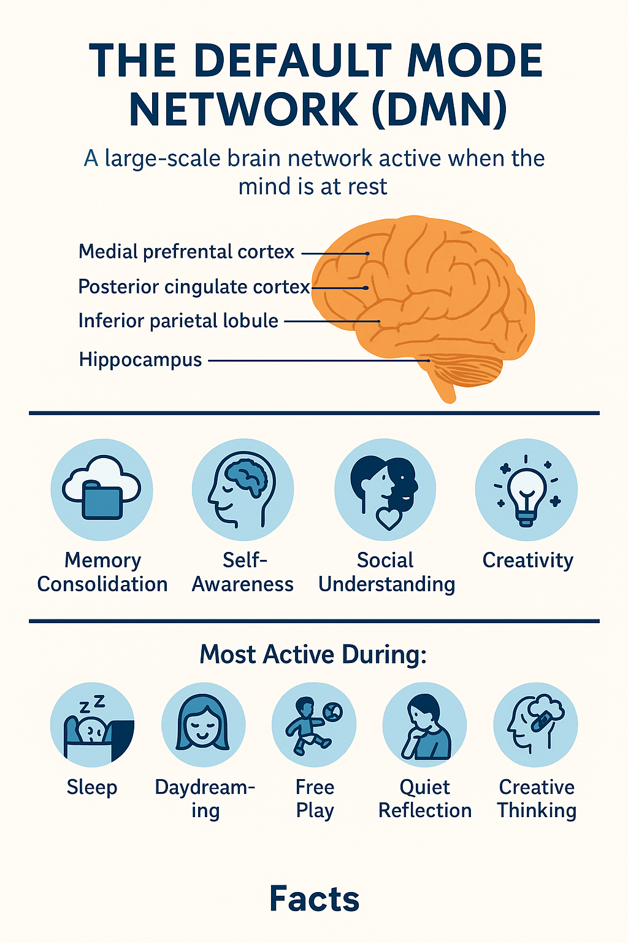

S

Top of Form

Bottom of Form