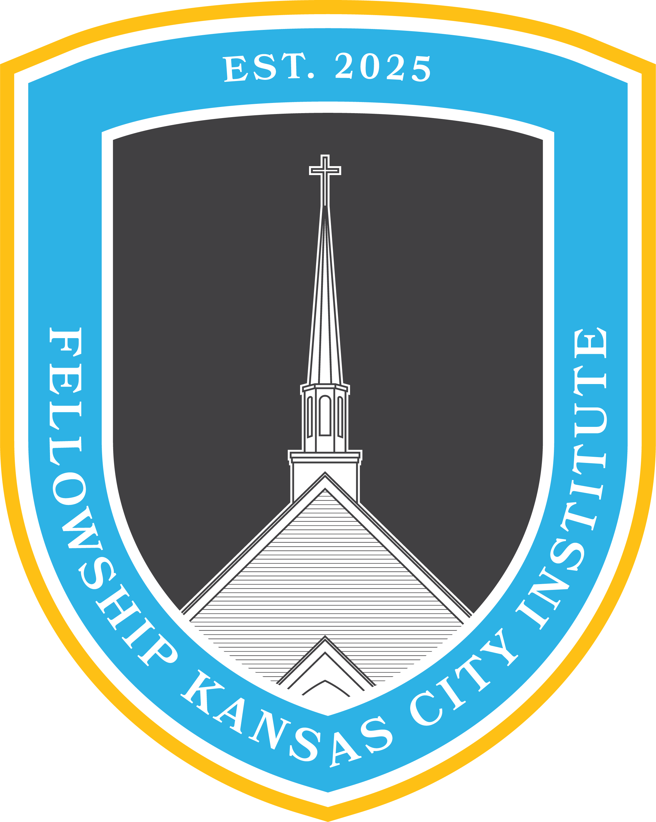

**Metanarrative of Scripture**

6:00 pm–7:30 pm / Sundays

Fall 2025

**I. Course Description**

A study of the Bible’s unified story that progresses, integrates, and climaxes in the Gospel. This course will provide a Biblical basis for reading Scripture holistically, as well as train the participant to read individual books of the Bible in light of the Bible’s redemptive story.

**II. Course Objectives**

Church members who complete this course should be able to:

1. Articulate a biblical position on the nature of Scripture, particularly as it relates to it’s internal unity.
2. Explain the grand story of the Bible⎯from Genesis to Revelation⎯and understand how the story progresses within the canon.
3. Trace specific themes, events, characters, and ideas presented within the Bible, showing their development across Scripture and their fulfillment in the Gospel.

**III. Suggested Reading** (*Order: Beginner, Intermediate, Advanced*)

1. **Schreiner, Patrick.** The Kingdom of God and the Glory of the Cross: Short Studies in Biblical Theology. Wheaton, IL: Crossway, March 31, 2018. (160 pp.)
2. **Hamilton, James M. Jr.** What Is Biblical Theology?: A Guide to the Bible’s Story, Symbolism, and Patterns. Wheaton, IL: Crossway, November 30, 2013. (128 pp.)
3. **DeRouchie, Jason S.** Delighting in the Old Testament: Through Christ and for Christ. Wheaton, IL: Crossway, February 13, 2024. (368 pp.)

**IV. Requirements for Certification**

1. **Attendance**
   1. Church members must attend at least 2/3 classes of the course to be considered for the class certificate.
2. **Scripture Reading**
   1. Church members must meditate on the assigned Scripture readings for the course, prior to the respective class.
3. **Lesson Assignment**
   1. Church members must commit to teaching a component of this course to a family member, friend, or colleague not in attendance in the course. The lesson should highlight a portion of the course material, explaining the Gospel through the lesson.

**V. Course Organization**

|  |  |  |  |
| --- | --- | --- | --- |
| **Week** | **Topic** | **Scripture Reading**  **(Required)** | **Suggested Reading**  **(Optional)** |
| **1** | **Biblical Mandate:**  Comprehending the Nature of Scripture | 2 Peter 1:20-21  2 Timothy 3:15-16  Luke 24:1-53 | * **Hamilton** (1-2) * **DeRouchie** (Introduction & Part One) |
| **2** | **Biblical Metanarrative:**  Understanding the Grand Story of the Bible | Genesis 1-3  Revelation 20-22 | * **Hamilton** (3-5) * **DeRouchie** (Part Two) |
| **3** | **Biblical Method:**  Interpreting the Parts in Light of the Whole | Acts 7:1-53 | * **Hamilton** (6-9) * **Schreiner** (Whole Book) |

**VI. General Information**

* This course is not intended to replace the gathering of the church on Sunday morning or your personal devotion time in God’s Word and prayer.
* For questions about the course or course content please contact Pastor Tyler and/or Pastor Landon: [Tyler@fellowshipkc.com](mailto:Tyler@fellowshipkc.com) / [Lsmith@fellowshipkc.com](mailto:Lsmith@fellowshipkc.com)