July 2025
Upcoming Events
July 3rd - Bible Study @ 1 PM
July 4th - 4th of July
July 6th - AM Service @ 10:30 AM
July 11th - Food Truck Friday/Fireworks
July 13th - AM Service @ 10:30 AM
July 17th - Bible Study @ 1 PM
July 20th - Connection 101 Class @ 9:30 AM
July 20th - AM Service @ 10:30 AM

July 27th – AM Service @ 10:30 AM
July 31st - Bible Study @ 1 PM
1670 Highway M ~ Barnhart, MO ~ 63012 ~ 636-464-2344
www.parktonassembly.com


Please do not bring food or drinks into the sanctuary. Water is the only exception


Parkton Assembly is now offering free WiFi. To connect, open your WiFi option on your smart phone or tablet, click on ParktonGuest. The password is John3:16


We have a free gift for you! We are excited to share that our church has access to an extensive, video library called RightNow Media! It’s like the "Netflix of Video Bible Studies" and has a HUGE library of faith-based videos that you can access whenever and wherever you want—on your phone, tablet, computer, or on your TV at home. You will have FREE access to thousands of video resources to help you with parenting, marriage, discipleship and more. It includes content for all ages and stages of life, and all of your family members are invited to set up their own accounts as well. To gain access text Rightnow PAOG to 49775

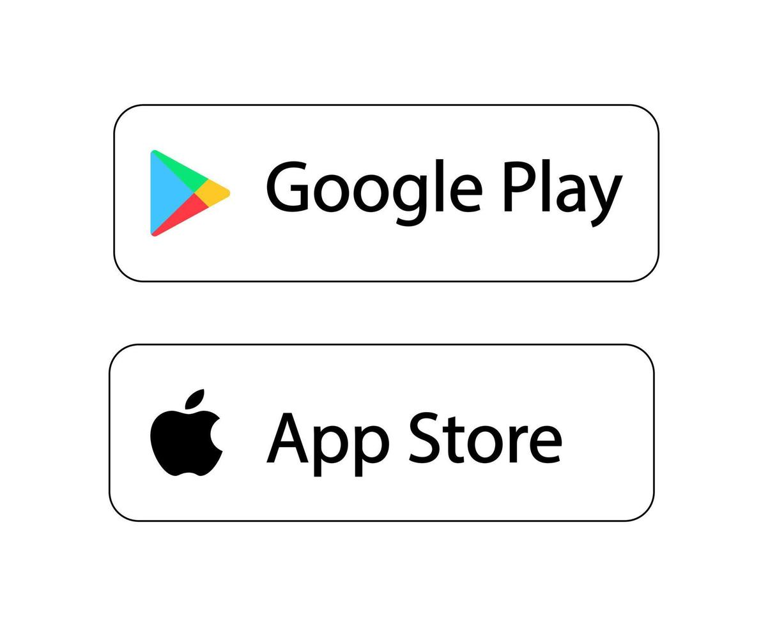
Have you downloaded our new church app yet? Our new church apps are available in the google play store and the apple store. Just search “Parkton Assembly of God” and click download. Our new apps are filled with great resources including access to our sermons and the Bible.

Having trouble hearing the service? Come to the sound booth and we will happily supply you with a listening device. Remember to return it to the sound booth personnel at the conclusion of service

Parkton Assembly
Of God
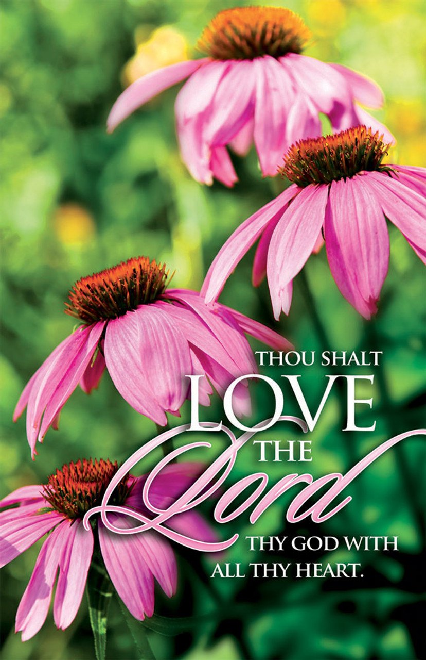

July 20, 2025



We would like to welcome you to Parkton Assembly of God. If you are a guest this morning; thank you for spending your time with us. We hope you enjoy the presence of the Lord.
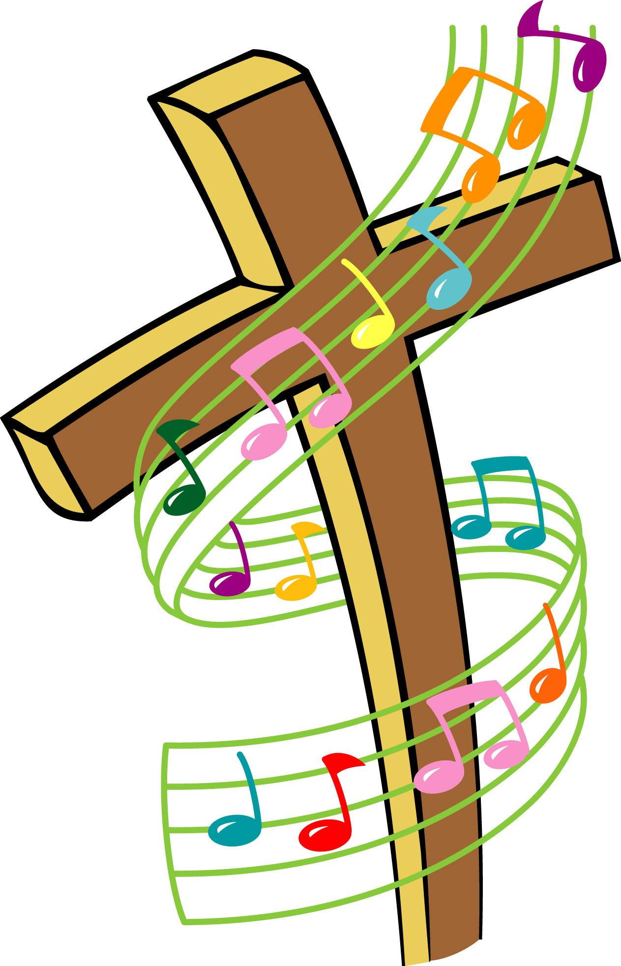
We have something for everyone here at Parkton Assembly of God! Please join us for the following services, study sessions and classes throughout the week. We can’t wait to see you there!
Sunday
Sunday School -------------------9:30 AM
Sunday Worship ----------------10:30 AM
Children’s Church ------------- 10:30 AM

Wednesday
Epic Youth ------------------------6:00 PM
Impact Zone ---------------------- 6:00 PM

Every other Thursday (see calendar for dates)
Bible Study-----------------------1:00 PM

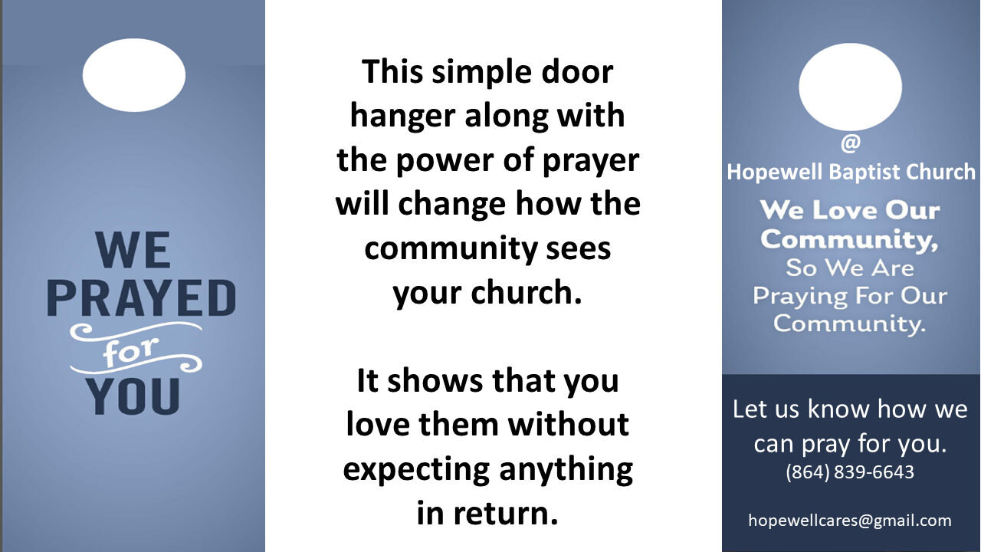
Our Pray and Go initiative is taking off and we are scheduled the first Saturday of each month at 9:00 AM to go out and pray. We need all of you to spread the love of our Lord in our community so check out the Pray and Go table in the sanctuary if you would like to join us for a prayer outing or if you would like to help pray over the prayer requests that we receive in our email.

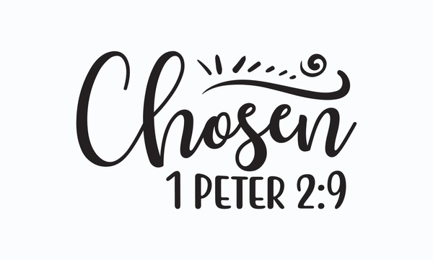

.

Want to give online? Scan this QR code and it will take you directly to our giving site. Thank you for your generous donation.

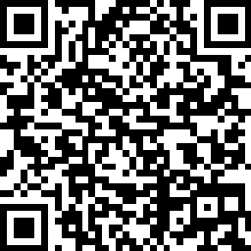
Are you new to Parkton today? We are so glad you decided to spend time with us. Please take a minute to register your attendance with us today by scanning this QR code.

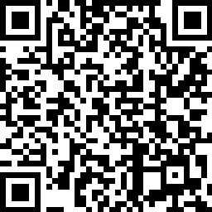
Are you a regular attendee or member at Parkton? If so, please register our attendance today by scanning this QR code.

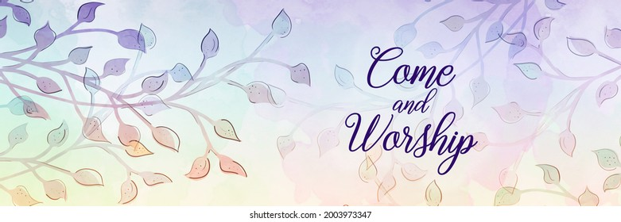

Interested in learning more about our amazing church? Sign up for the STEPS Connection 101 class by scanning the QR code here. The first class starts on Sunday, July 20th at 9:30 AM. We hope to see you all there!

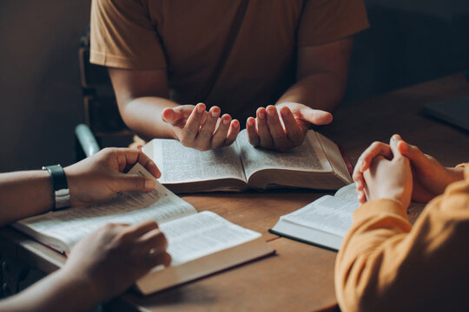
Join us for a time of fellowship, reflection, and spiritual growth at our bi-weekly Bible study! Whether you’re new to scripture or have studied for years, this is a welcoming space to explore God’s Word together, share your views, ask questions, and deepen your faith. Come connect with others, gain fresh insights, and be encouraged as we journey through the Bible, one verse at a time. All are welcome!


Are you or someone you know crafty? Do you like to make things with your hands? We are looking for some fantastic crafters that would be interested in having a booth at our final Food Truck Friday of the season on Friday, September 12th. Please reach out to the church office, message us on Facebook, or reach out to Kayla Tidwell to sign up or for more information.

