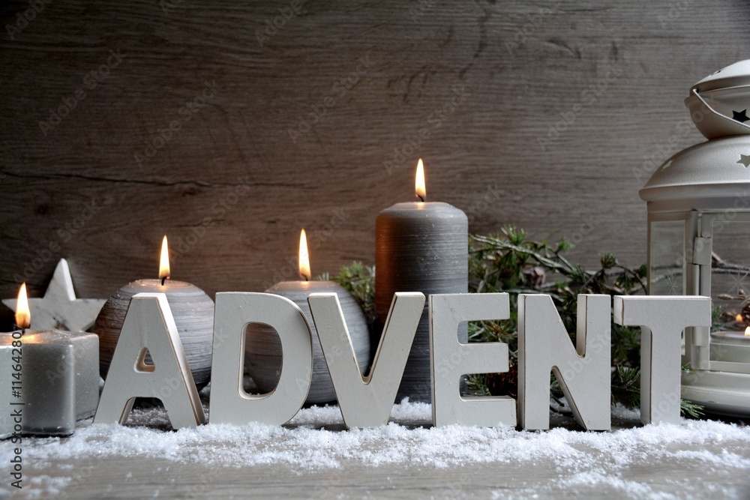

November 29th - 10:30am - Erwin Christmas Parade ‘Miracles on Main Street’
12:00pm - After the Parade, Pairs and Spares Sunday School Class invites you to come
decorate Centenary UMC.

November 30th - 9:45am - Sunday School
10:55am - Worship Service, 1st Sunday of Advent HOPE
1:30pm - Van leaves for the Barter Theater for ‘How the Grinch Stole Christmas’.

December 7th - 9:45am - Sunday School
10:55am - Worship Service, 2nd Sunday of Advent PEACE
CHRISTMAS CANTATA, “A New and Glorious Morn!” by Lloyd Larson

December 9th - 5:00pm - Care & Share Board Meeting
6:00pm - Care & Share Christmas Party for Staff, Board Members, Volunteers and ALL
THE FAMILIES!

December 14th - 9:45am - Sunday School
10:55am - Worship Service, 3rd Sunday of Advent JOY
12:00pm - Christmas Party in the Fellowship Hall.
Please bring holiday goodies/finger foods/snacks to share!

December 17th - 5:30pm - UCMA Service of Darkness & Light/Blue Christmas Service
7:00pm - Erwin Nativity Parade

December 18th - 11:30am - UWIF Christmas Luncheon at Penny Jone’s.

December 19th - 10:00am - Head Start Christmas Party in the Fellowship Hall.

December 21st - 9:45am - Sunday School
10:55am - Worship Service, 4th Sunday of Advent LOVE

December 24th - 4:00pm - Christmas Eve Service

JESUS IS THE REASON FOR THE SEASON

